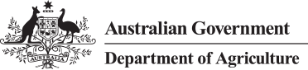

INTERIM INSPECTOR-GENERAL OF BIOSECURITY

Arrangements for oversight of horse biosecurity risk management

March 2014

No. 2013–14/06
Table of Contents

Introduction 3
Routine reporting to IIGB by the Department of Agriculture 3
Inspection of Werribee post–arrival quarantine facility 4
Future reporting arrangements 5

Introduction
- Since 2008, the Department of Agriculture (the department) has allocated significant resources to the on-going monitoring and improvement of the management of biosecurity risks related to the importation of horses.
- As part of its response to the Review of Australia’s Quarantine and Biosecurity Arrangements (the Beale Review), the Australian Government agreed to establish a statutory office of the Inspector-General of Biosecurity (IGB).
- In July 2009, pending finalisation of enabling legislation, the Australian Government appointed an Interim Inspector-General of Biosecurity (IIGB). This role subsumed that of the Interim Inspector-General of Horse Importation (IIGHI) as recommended by Commissioner Callinan in the 2008 Report of the Equine Influenza Inquiry.
- The Beale Review recommended the role of IGB have a broader remit than the previous role of IIGHI, encompassing the oversight of biosecurity risk management for all imported goods and live animals.
- In addition to the wider brief, the IIGB has continued to pay close attention to the biosecurity risks associated with the importation of horses to Australia.
- In 2011 the IIGB developed a methodology to assist in balancing the IIGB’s broader annual work program with the responsibility to audit horse PEQ facilities. The methodology is applied on a quarterly basis to determine the need for IIGB desktop reviews or audits of overseas pre–export quarantine (PEQ) facilities (Attachment A).

Routine reporting to IIGB by the Department of Agriculture
- Previously the department has provided the IIGB, on request, details of projected horse shipments into Australia and the names of all department-approved offshore horse PEQ facilities. This information was of limited value to the IIGB in terms of risk assessment and is no longer sought from the department.
- A PEQ facility is classified as approved if the department has given it an approval status of Full Approval. PEQ facilities are approved for a two-year period. In certain circumstances the department will approve a PEQ for shorter periods, mainly to allow trade to continue while non-critical non-compliances are resolved.
- Since June 2011, the Animal Import Operations Branch (AIOB) has undertaken a series of audits and inspections to assess the appropriateness for granting re–approval of several horse PEQ facilities in USA, Europe, Japan and Hong Kong. Reports of these audits have been provided to the IIGB. The IIGB has the ability to raise any queries and, if necessary, undertake independent audits and inspections of these facilities.
- Since May 2012 the department has provided the IIGB with regular updates on:
- the status of each department–approved PEQ facility. This includes information on all currently approved facilities, those for which approval has expired and new applications for approval
- horse import numbers including individual details, import permits and details of PEQ and post–arrival quarantine (PAQ) facilities used for each animal.

Inspection of Werribee post–arrival quarantine facility
- On 1 July 2013, Dr Michael Bond was appointed as IIGB. In September 2013, to familiarise himself with border biosecurity operations for horses, the IIGB accompanied the department’s program area (AIOB) auditor during a biennial audit of the Werribee International Horse Centre (Werribee), an approved PAQ facility for horses imported into Australia.
- The IIGB has been provided with a copy of the resulting audit report. The report notes one area of concern and some opportunities for improvement in risk management procedures at the Werribee facility.
- The area of concern relates to whether any leftover horse feed that was on board the inbound flight can be used to feed horses during PAQ.
  - The cause of confusion was ambiguity in the Standard Operating Procedure (SOP) for disposal of in–flight horse feed and the methods listed for disposal on the Register of Imported Goods.
  - The SOP and the Register of Imported Goods were amended to clearly outline the requirements for disposal of in–flight feed, which cannot be used during PAQ.
- The AIOB audit recommended opportunities for improvement in three areas:
  - Modifications to the PAQ facility: Any requests for modifications at the PAQ facility, including associated amendments to the SOP, are to be submitted to the department for assessment and approval.
  - Training of and communication with private veterinarians: The department recommended enhanced training for private veterinarians operating at the PAQ regarding the consequences of biosecurity breaches.
  - Photographs of the PAQ facility: The future inclusion of photographs in the SOP will enhance departmental officers’ understanding of fencing and/or building arrangements at the PAQ.
- Overall, the report concludes that the Werribee facility is managed with a high-level of compliance with PAQ requirements. The IIGB agrees with the report’s conclusion and the suggested opportunities for improvement.

Future reporting arrangements
- In order to implement a more routine, structured approach to the oversight of the management of biosecurity risks related to the import of horses, the IIGB will review the following information on a quarterly basis:
- approval status of offshore PEQ facilities for importing horses to Australia, including information on all approved, expired and new applications
- horse import numbers including horse details, import permits, PEQ and PAQ facilities used for each animal
- any PEQ facility audit reports prepared by the department during the previous three months.
- The IIGB will undertake regular inspections of biosecurity controls in place at PAQ facilities used for importing horses to Australia. As far as practicable, the IIGB proposes to undertake these inspections with minimal prior notification to the facility.
- During the inspections, the IIGB will pay particular attention in assessing the level of understanding PAQ personnel have of biosecurity controls and risk management procedures in place at each PAQ facility.
- The suggested future inspection and routine reporting arrangements have been discussed and agreed with the Animal Import Operations Branch of the department.

[Signed]

Dr Michael Bond
Interim Inspector-General of Biosecurity
25 March 2014

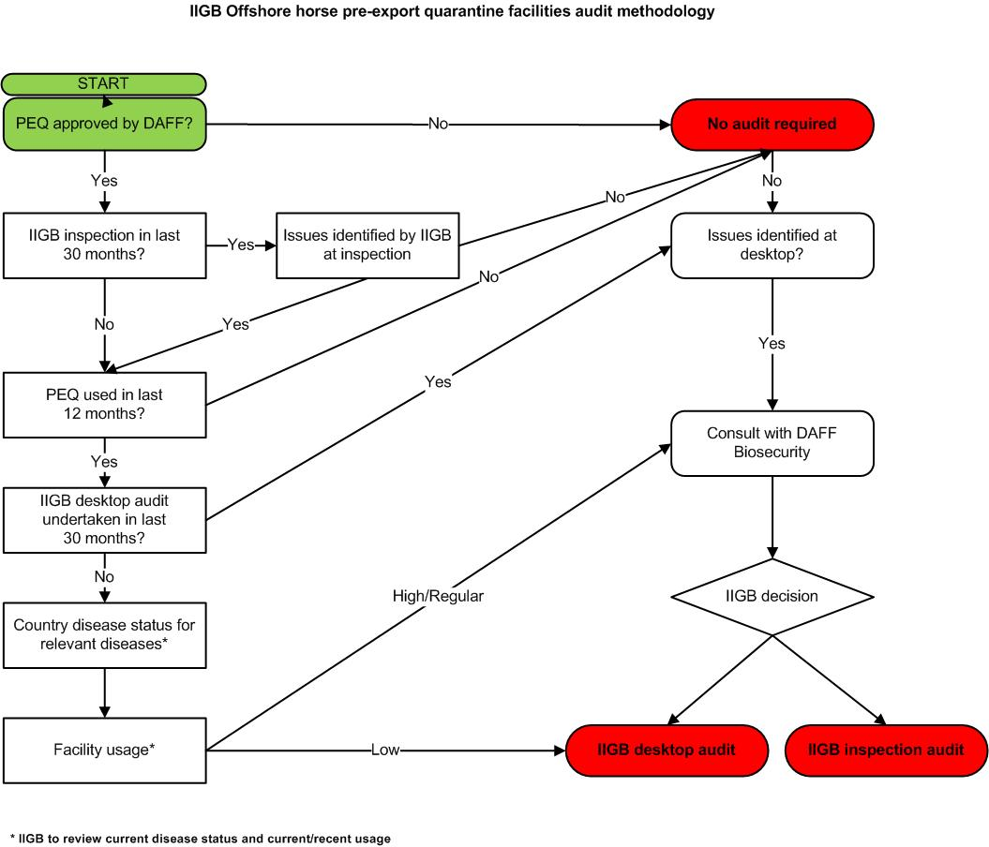

private veterinarians, grooms, stable hands etc.

