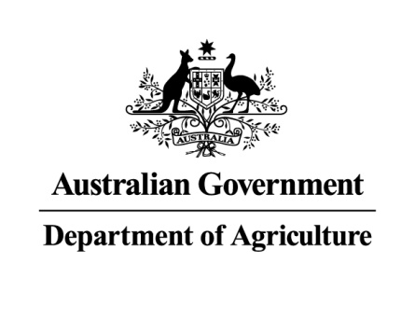 INTERIM INSPECTOR-GENERAL OF BIOSECURITY
Effectiveness of biosecurity controls for imported animal breeding material (mammalian semen and embryos)
Interim Inspector-General of Biosecurity

Audit report

November 2014

No. 2014–15/02
Contents
Summary 3
Introduction 3
Purpose 5
Scope 5
Key findings 6
Conclusion 12
Recommendations 13
Methodology 18
Case studies 19
Out of scope 19
Observations and findings 20
Pre-border controls 20
Border controls 27
Case studies 40
Appendix A: Agency response 46
Appendix B: Relevant information on exporting countries: Germany and the Netherlands 49
Map 53
Figures 54
Tables 67
Glossary 77
References 80

Summary

Introduction
- The Australian Government’s biosecurity system aims to minimise the risk of entry and establishment of exotic pests, weeds and diseases that could significantly harm the Australian economy and environment.
- In recent years, the Department of Agriculture’s systems of managing quarantine risks across the biosecurity continuum (pre-border, border and post-border) have placed increasing emphasis on pre-border measures to address offshore risks. A longstanding and preferred method of mitigating quarantine risk offshore is to ensure that documentation accompanying imported consignments certifies that appropriate treatments have been carried out or that the goods are free from contamination, pests or diseases.
- The department has primary responsibility for managing Australia’s biosecurity regime across the whole biosecurity continuum. The Australian Government has regulatory responsibility for pre-border and border activities, while state and territory governments are responsible for post-border activities such as surveillance and response (ANAO 2012).
- The Interim Inspector-General of Biosecurity (IIGB), as part of his audit work plan, examined the effectiveness of the department’s biosecurity controls for importing animal breeding material (mammalian semen and embryos) into Australia.
- Semen for buffalo, cattle, cats, deer, dogs, elephants, giraffes, goats, horses, mice, rats and sheep may be imported from specified countries. Pig semen imports are not permitted from any country. Embryos of cattle, deer, goats, mice, rats and sheep may be imported from specified countries.
- Australia imports approximately 4800 bovine embryos and 1 000 000 doses of bovine semen annually. The semen is for unrestricted use, generally for commercial breeding purposes. Neither the semen nor the embryos are destined for laboratory testing, research or other restricted end uses. Bovine semen constitutes 97 per cent of semen doses imported into Australia. The main exporters of animal breeding material to Australia are member countries of the European Union (EU), Canada, New Zealand and the United States of America (USA); the latter three countries and Australia are members of the Quadrilateral Group (QUADS group), an international alliance aimed to strengthen the management of animal health. Between January and October 2012, around 60 per cent of consignments imported into Australia originated in QUADS countries. About 290 permits to import animal breeding material for in vivo use were active in 2012. These permits were held by 62 businesses or individuals, with one private business holding about one-third of the permits.
- The department implements various management measures to minimise biosecurity risks under the Quarantine Act 1908 and subordinate legislation, including the Quarantine Proclamation 1998. The Quarantine Act governs importation of animal breeding material (semen and embryos) into Australia. Under the Quarantine Act, live animals and viable animal products are prohibited imports, unless the Director of Quarantine (or delegate) has issued an import permit.
- Countries approved for export of animal breeding material, and for which the department has developed import conditions, are listed at 4.20 (ruminants) and 4.21 (non-ruminants). Import conditions are published on the department’s import conditions database (ICON).
- For importation of animal breeding material, consideration of the level of biosecurity risk is based on the department’s import risk analysis (IRA) for animal breeding material (DAFF 2011b). An IRA for individual products (such as bovine semen) from a particular country assesses specific biosecurity risks and identifies appropriate risk management measures to be applied in meeting Australia’s appropriate level of protection. The department has completed IRAs for:
- bovine embryos and semen from Argentina
- bovine embryos and semen from Brazil
- ovine/caprine semen and embryos from Canada, the USA and the EU.
- IRAs have not been used extensively in the history of trade in animal breeding material and are not the only means of providing confidence that disease risks are managed appropriately, especially when the trade has a long history. Where an IRA has not been undertaken, the department manages biosecurity risks associated with entry of imported animal breeding materials through:
- on-going surveillance of global risks
- science-based IRA to underpin import policy
- approval and auditing of exporting countries, including competent authorities
- pre-border and border controls for importation
- collaborative networks
- intelligence gathering
- bilateral relationships
- history of trade.
- The department has also developed guidelines, policy documents and scientific reviews (see 5.5) dealing with importation of animal breeding material. These complement IRAs and help identify potential sources of biosecurity risks and measures for managing them.
- For semen and embryos, it is necessary to address much of the biosecurity risk by consideration of each exporting country’s disease status and performance of the relevant competent authority, together with the integrity of the accompanying documentation. At the border, it is not feasible to impose any random testing regime for diseases. Consequently, any subsequent (retrospective) change in a country’s disease status can pose a potential biosecurity risk to Australia.

Purpose
- This audit aims to inform the Australian Government Minister for Agriculture about the effectiveness of the department’s biosecurity controls in managing risks associated with importation of animal breeding material (semen and embryos). As the department must address many generic risk management issues irrespective of the species of animal, the IIGB focused this audit activity on large-volume import materials (bovine semen and embryos and equine semen) and a small-volume product (canine semen).

Scope
- To examine the department’s risk identification/assessment processes and controls (pre-border and border) for managing identified biosecurity risks of importing animal breeding material into Australia for commercial breeding purposes (not semen or embryos imported for laboratory testing, research or other restricted end uses), including:
- risk profiling, surveillance and offshore accreditation of pre-export procedures to address risks before reaching Australia’s borders
- identifying requirements for importing animal breeding material, specifically mammalian semen and embryos, and the adequacy of these requirements in managing biosecurity risks
- assessing the communications strategy (and activities) for conveying biosecurity risks and management of risks associated with importing mammalian semen and embryos
- assessing verification systems that the department has in place to ensure compliance with import conditions.
- The IIGB undertook a desktop review of the department’s approval processes for exporting countries, including competent authorities and verification procedures for monitoring operations offshore. The IIGB inspected and assessed border controls conducted by the department’s operational staff in the South East (Melbourne) and North East (Brisbane) regions. The IIGB also inspected commercial export premises in three EU member states—France, Germany and the Netherlands. It was decided not to conduct an in-country assessment in North America because of negotiations regarding animal breeding material then underway at the animal health QUADS forum.
- This audit focused on the effectiveness of biosecurity controls for animal breeding material (mammalian semen and embryos) imported into Australia. Examination of the department’s pre-border control systems targeted those in operation for member states of the EU. Examination of the department’s border control system for imported animal breeding material considered importation from all approved countries.

Key findings

Assessment and approval of competent authorities
- Biosecurity risk management measures for specific animal breeding material imported from a particular country are supported by the department’s IRA, history of trade, international collaborations, networks, intelligence and bilateral relationships. Those measures also include requirements for:
- assessing the competent authorities in each exporting country
- assessing an exporting country for freedom from specific animal diseases
- disease testing by appropriate agencies or organisations
- handling and further processing/aggregation of collected semen and embryos
- storage and transport.

Assessment of exporting countries
- The department exercises strict control over animal breeding material by permitting imports from a limited number of countries. Countries permitted to export animal breeding material to Australia include EU member states, Switzerland, Norway, New Caledonia, New Zealand, Canada and the USA. The department has protocols with all permitted (approved) countries for export of animal breeding material to Australia. Australia is a member of the QUADS group that promotes understanding and awareness of biosecurity risks in animal breeding material with international trade partners.
- The IIGB noted that since its initial approval of exporting countries, the department has not undertaken any in-country assessments. However, QUADS countries have recently agreed to allow a series of assessment visits to inspect their respective collection and processing facilities and relevant biosecurity measures. This is a significant development because most animal breeding material is imported from QUADS countries, particularly the USA.
- The EU member states do not have internal processes to assess the performance of their collection and processing facilities for export to non-EU countries, including Australia. The department relies on EU standards as they apply to intra-EU movements and import of animal semen and embryos into EU member states. Any additional specific biosecurity requirements that the department sets are implemented by the competent authorities in the exporting country.

Import risk analyses
- The department has completed relatively few IRAs for animal breeding material. The IIGB noted that IRAs have not been used extensively for import of animal breeding material and are not the only means of providing confidence that disease risks are managed appropriately, especially when there is a long history of trade. The department does undertake regular surveillance of animal health status in exporting countries. It applies appropriate control measures for import of animal breeding material from approved countries.
- Some countries were approved for export of animal breeding material to Australia more than 35 years ago. However, the department has not undertaken in-country assurance activities in these countries; for all approved countries for which no formal IRAs exist, it is suggested that the department should document its assessment of risks in a transparent manner and publish these findings on its website. This would assist in ensuring biosecurity controls remain effective in achieving Australia’s appropriate level of protection.

Dependence on competent authorities and third parties
- The department relies heavily on the integrity and comprehensiveness of controls exercised by the competent authorities in the exporting countries in ensuring consignments of animal breeding material are fully compliant with Australian import requirements. The competent authorities approve and audit facilities and inspect and supervise pre-collection, collection, processing and storage stages for the export of animal breeding material. They also endorse animal health export certification stating that Australia’s import requirements, consistent with a valid import permit, have been met.
- Similarly, the department also relies on third-party arrangements in some exporting countries. For export of bovine semen to Australia from the USA, testing and examination of donor animals is performed by Certified Semen Services Inc., an industry-based corporation that regulates the US artificial insemination industry according to standards set by the US Department of Agriculture. The various noncompliance incidents (measured against import requirements) for bovine semen consignments from the USA, have related mostly to deficiencies in accompanying documentation; this illustrates the benefits of the department maintaining ongoing communication and consultation with competent authorities in approved countries.

Clearance procedure
- Consignments of imported animal breeding material and used, empty liquid nitrogen shipping containers are profiled for clearance into Australia and inspected by department officers in their respective regions. Clearance by the department relies on assurances provided by in-country competent authorities and importers that import conditions have been met. This includes a veterinary certificate (consistent with the World Organisation for Animal Health’s Terrestrial Animal Health Code) endorsed by an approved or a government veterinarian in the exporting country. If accompanying documents do not meet import requirements, the consignment is referred to the department’s Animal and Biological Import Assessments Branch. If the issue is considered serious, the department seeks follow-up verification from the competent authorities of the exporting country. In some cases, if the biosecurity risk is assessed to be low, the Director of Quarantine (or delegate) may issue a certificate of equivalence, allowing the consignment to be released from quarantine.

Inconsistent import conditions
- Because the animal health status of approved countries varies, it is not feasible to impose uniform import requirements for all approved countries and for all types of animal breeding material. However, the IIGB noted some anomalies in import requirements listed on ICON. For example, under import requirements for controlling foot-and-mouth disease (FMD), female donor animals harvested for bovine embryos imported from Canada, the USA and New Caledonia are required to be continually resident and free from any quarantine restrictions in these countries for at least 90 days immediately before the first collection of embryos. In contrast, the same period of continual residency applies to both male and female donor animals in Norway, Switzerland and EU member states. The sex of the donor is not specified across all exporting countries, for purposes of bluetongue vaccination. These inconsistencies in import requirements may confuse importers and make it difficult for department officers to verify compliance during document inspection on arrival. It is suggested that the department review all such inconsistencies on its ICON database and ensure that listed conditions are readily verifiable at the border.

Import requirements
- The ICON database stipulates specific requirements for certain diseases of quarantine concern for imported bovine semen from EU member states. Diseases include FMD, ovine Johne’s disease, epizootic haemorrhagic disease of deer, infectious bovine rhinotracheitis/infectious pustular vulvovaginitis, bluetongue virus and Schmallenberg virus. The ICON database also lists diseases of quarantine concern that may be transmitted via canine semen, including brucellosis and leptospirosis (specified serotypes). The department mandates veterinary certification (endorsed by an approved or a government veterinarian in the exporting country); for some diseases, the department requires reports (tabulated results or laboratory reports) that must state freedom of donor animal(s) from these diseases. For import clearance, a department officer verifies the accuracy of veterinary certification.
- For imported equine semen from approved countries, the department mandates that competent authorities approve centres/facilities in their country where equine semen is collected and processed for export to Australia. To ensure semen was collected at an approved centre, the department requires an Approval of equine semen collection centre for export to Australia (Certificate 1) to accompany each consignment. The department regularly undertakes assessment of approved equine semen collection facilities in exporting countries; the department does not assess semen collection facilities for animal breeding material from other species.
- Further, import conditions for equine semen specify compulsory testing of donor animals for contagious equine metritis, equine infectious anaemia and equine viral arteritis. The department requires that each equine semen consignment be accompanied by a Veterinary certificate for the export of equine semen to Australia (Certificate 2) endorsed by an approved or a government veterinarian in the exporting country, in addition to reports for disease testing undertaken by an approved laboratory.

Noncompliant consignments
- To facilitate a risk–return approach instead of mandated intervention targets, the department analysed trends in noncompliant frozen (equine) and livestock (bovine) reproductive material imported into Australia during 2012. The highest rate of noncompliance (measured against import conditions for the individual commodity) was for animal breeding material imported from the EU, followed by the USA. Twenty-six per cent of equine and livestock reproductive material imports into Australia did not comply with Australian import conditions, thus posing a potential biosecurity risk to Australia. Eighty-six per cent of consignments identified as noncompliant failed at least one pre-border criterion associated with either accuracy of accompanying documentation or veterinary certification (Table 1).
- Most noncompliance related to deficiencies in accompanying documentation. In meetings with officials in Germany and the Netherlands, the IIGB discussed circumstances that have led to noncompliance and was assured that greater attention will be given to these factors in the future. The IIGB noted that the exporting premises he visited in Germany, the Netherlands and France maintained satisfactory biosecurity controls for exporting mammalian semen and embryos.

Release of consignments
- Within Australia, the IIGB undertook fieldwork in the South East (Melbourne) and North East (Brisbane) regions. For the other regions that receive imported animal breeding material, the IIGB developed a questionnaire to ascertain how consignments are dealt with. It was noted that in one region, consignments were released on presentation of scanned, photocopied or faxed copies of required documentation, without the originals being sighted. The department’s minimum documentation policy states that an importer must present either the original documents, certified copies of the originals supplied by the exporter or a statutory declaration by the importer. In the absence of originals, the authenticity of copies of originals cannot be confirmed.
- The IIGB understands that, while consignments are still in transit, importers or agents often arrive at the front desk of one of the department’s regional offices and present scanned, photocopied or faxed copies of original documents. However, following arrival of the consignment, if clarification or additional information is needed, the department has only one approved quarantine facility in the South East Region where consignments can be securely stored in liquid nitrogen until staff can verify compliance with import permit conditions. The IIGB noted that in the South East and North East regions, department officers often direct such consignments be stored at either nearby domestic artificial breeding facilities or designated premises that are not formally approved by the department.

Transport for verification inspection
- After arrival at an Australian port, consignments are handed over from an airline bond store to the importer/agent for transport to the department’s regional office (or designated inspection premises) for verification inspection. Although a movement direction is issued for each consignment and the consignment remains sealed, the IIGB considers this might pose a biosecurity risk if the importer/agent mistakenly considers the consignment as having been released and uses or distributes the material without verification and formal release by a department officer. However, the IIGB was informed that quarantine breaches of this nature have not been reported.

Communication of biosecurity risks
- The department actively participates in forums to promote understanding and awareness of biosecurity risks in the animal breeding material trade. These include:
- undertaking regular policy reviews and import risk analyses and issuing ICON alert notices
- facilitating a consultative group (the Ruminant Genetics Trade Advisory Group) for import and export-oriented Australian livestock genetics industries
- communicating on a range of issues with overseas government counterparts and importers of genetic material
- participating in international meetings that set standards for international trade in genetic material, such as the International Embryo Transfer Society Health and Safety Advisory Committee and Regulatory Subcommittee of the International Embryo Transfer Society.
- The department also participates in reviews of AUSVETPLAN (ARMCANZ 1999), Australia’s guidelines for agencies and organisations involved in an emergency animal disease response. The reviews involve consultation with stakeholders of imported animal breeding material.

European Commission’s Food and Veterinary Office
- The IIGB undertook fieldwork in three EU countries: France, Germany and the Netherlands. The IIGB noted that the European Commission’s Food and Veterinary Office (FVO) monitors uniform implementation of EU animal health legislation and standards by member states, as well as compliance with EU import requirements by non-EU countries, including Australia exporting to the EU. Member states apply EU legislative requirements and standards and ensure the health status of donor animals and collection and processing of animal breeding material. They also apply these legislative requirements to the export of animal breeding material to non-EU member countries, including Australia. The IIGB noted that most Australian import requirements are covered under current EU standards as they apply to intra-EU movements and import of animal semen and embryos into EU member states. Any additional specific biosecurity requirements the department sets are implemented by the competent authorities in the exporting country.

Performance management of European Union member states
- The IIGB noted that the FVO conducts periodic reviews of competent authorities in EU member states. The reviews ensure control systems for animal breeding material are consistent with relevant European Council (EC) directives. Reviews include inspection of selected approved artificial breeding centres. These FVO reviews focus on intra-EU movements and imports of animal breeding material and donor breeding animals from non-EU countries. The IIGB noted that neither the FVO nor the member states (in the case of this assessment activity, Germany) undertake any assessment or verification reviews of their performance regarding controls and certification for exports of animal breeding material to non-EU countries such as Australia.

Information management
- The IIGB noted that the animal artificial breeding industry in Australia is scattered across the country and the department has not imposed requirements for recording data about the movement, use and disposal of semen and embryos by importers or end users. Recording of such data would facilitate quick trace forward, traceback and recall of any particular batch of semen or embryos and/or application of control measures of inseminated/implanted recipient animals, should such actions be required. This would be consistent with the Beale review, that emphasised the need for strategic intelligence to underpin the risk–return approach to biosecurity:
Australia can only know which risk pathways and commodities are most threatening if it has collected and analysed relevant information. Good strategic intelligence on the animal and plant pest and disease status of neighbouring countries and trading partners is vital. This information ensures that biosecurity agencies can respond appropriately, including possibly modifying import requirements (Beale et al. 2008, p. 161).
- This would require the department to take a collaborative approach with industry and state and territory agriculture departments in developing and maintaining an electronic register for real-time tracing of imported consignments within Australia.

Conclusion
- The import pathway for animal breeding materials creates significant potential disease risks similar to imported vaccines and veterinary therapeutics. Risk factors include the exotic disease agents that can contaminate animal breeding material, especially semen, and the ease with which transmission pathways to susceptible host animals is facilitated through physical insemination/implantation in live animals. In addition, the fact that animal breeding material can be stored for a long time and distributed widely and quickly, a major failure in an import control system (especially pre-border) could pose considerable biosecurity risks to Australia, with serious consequences.
- To address biosecurity risks from exotic disease agents contaminating animal breeding material, the department relies on the performance and integrity of veterinary services in exporting countries, including third parties. The department also actively participates in various forums (especially the QUADS group) to promote understanding and awareness among international partners of biosecurity risks in the animal breeding material trade.
- Importation of animal breeding material in Australia has a relatively long history, with no reported serious incidents. An important control for highly contagious FMD is that the department only permits import of animal breeding material from FMD-free countries (without vaccination). The department identifies new and emerging risks in exporting countries through effective surveillance and intelligence gathering; and quickly implements corresponding controls, including banning imports from countries if their risk status changes. However, the department has undertaken very limited assurance activities within exporting countries to ensure that collection/processing facilities and relevant biosecurity measures comply with Australian import requirements.
- This report includes some examples of noncompliance detected by the department at the border. Most were related to deficiencies in accompanying documentation. Several other incidents that constitute moderate noncompliance were either reported by the veterinary service in exporting countries or by importers/exporters. In the absence of a traceability mechanism post-release, it would be difficult to confirm whether a consignment contaminated with a significant biosecurity risk had been accidently released.
- Overall, it appears that the department is managing biosecurity risks associated with animal breeding material in an appropriate manner; this is reflected in the lack of serious incidents over the long history of the trade. However, this report does identify a need for some improved controls for biosecurity risks associated with importing animal breeding material and makes recommendations aimed at achieving that goal.

Recommendations
Recommendation 1
paragraph 5.36 | The department should develop a central compliance register to monitor the performance of exporters of animal breeding material; the register should be available to all department officers involved in verification inspection at ports of entry.  Department’s response: Agree-in-principle.
Recommendation 2
paragraph 5.43 | The department should ensure that staff conducting verification inspections adhere to the minimum document requirements policy.  Department’s response: Agree.
Recommendation 3
paragraph 5.49 | The department should consider collaborating with industry and state agencies to develop a practical, cost-effective process that enables post-release tracking of all imported semen and embryos.  Department’s response: Agree-in-principle.
Recommendation 4
paragraph 5.54 | The department should review import conditions listed in the ICON database for all animal breeding material to ensure clarity, consistency, scientific accuracy and usefulness for verification at the border.  Department’s response: Agree.

[signed]
Dr Michael Bond
Interim Inspector-General of Biosecurity
27 November 2014

Acknowledgement: All fieldwork and much of this audit were conducted under the supervision of the previous IIGB, Dr Kevin Dunn. Since this initial work, some significant developments in management of biosecurity risks for semen and embryos have necessitated amendments to the report and recommendations. Responsibility for the final content of this report rests with the current IIGB.
Background and context

Biosecurity risks
1.1 The risk of spreading animal diseases from country to country is a major barrier to trade in animals and animal products (MacDiarmid 2011). Unregulated importation of animal breeding material could expose Australia to outbreaks of several potentially devastating exotic animal diseases. Causative agents of a wide range of diseases of major livestock species (cattle, sheep, pigs and horses) can be transmitted between animals through mating/breeding, artificial insemination or embryo transfer. Table 2 lists major ruminant diseases transferrable through contaminated semen and/or embryos.
1.2 Australia is free from major diseases such as foot-and-mouth disease (FMD) (since 1872), rinderpest (since 1923), contagious bovine pleuropneumonia (since 1967), bovine brucellosis (since 1989), bovine tuberculosis (since 1997), bovine spongiform encephalopathy (no recorded instances) and rabies (since 1867). Outbreaks of exotic animal diseases are not common in Australia, but when they occur they can be disruptive and costly. For example, in the event of a large multi‐state FMD outbreak, ABARES (2013) estimates revenue losses of between $49.3 billion and $51.8 billion over 10 years. These revenue losses account for approximately 99 per cent of direct economic costs, with the remaining 1 per cent being the cost of disease control.

Australian artificial breeding industry
1.4 Artificial breeding centres hold valuable elite breeding stock, store and supply genetic material and serve as commercial supply facilities for imported genetic material. The Australian artificial breeding industry comprises a diverse group of individually and cooperatively owned, independent enterprises with no overarching national integration or control.
1.5 Artificial breeding centres and service facilities are scattered throughout rural Australia. Other artificial breeding activities take place on individual livestock properties, outside the confines of licensed or approved artificial breeding centres. No legislative controls or industry codes of practice cover unlicensed operations or on-farm enterprises, which now account for a large proportion of artificial breeding operations in Australia (ARMCANZ 1999). Artificial breeding is used with cattle, sheep, goats, pigs and horses and, to a limited extent, dogs, deer, zoo and endangered species.
1.6 Imported semen or embryos are initially received and stored at licensed or approved artificial breeding centres. From these centres they are distributed to other artificial breeding centres, artificial breeding sub-centres, commercial licensed artificial insemination technicians (inseminators), veterinarians and individual livestock producers/farmers. Requirements for the training, licensing and operation of artificial breeding centres, sub-centres and inseminators vary between jurisdictions, in accordance with local legislation or regulations.

Key stakeholders
1.7 Key stakeholders in the Australian animal artificial breeding industry include livestock and companion animal breeders, breed societies (or similar bodies), artificial breeding companies, private veterinarians, artificial breeding technicians, individual importers, state agriculture agencies and the Australian Government Department of Agriculture (Rickards & Nicol 2012).

Australian entry ports
1.8 The Central East (Sydney) and South East (Melbourne) regions are the major ports of entry into Australia for animal breeding material. Much smaller quantities are received at Northern (Cairns, Darwin), North East (Brisbane) and South West (Adelaide, Perth) regions. The IIGB noted that once released from quarantine, no records are kept of where semen or embryos are distributed.

Status of an exporting country’s veterinary services
1.9 A nation’s veterinary service provides the backbone for effective animal health and disease control. A competent official veterinary service, working in coordinated structural relationships with private veterinary and livestock industry sectors, is needed to ensure that export controls and certification of consignments of semen and embryos are valid and verifiable.
1.10 The World Organisation for Animal Health (OIE) states that:
Veterinary services are at the very core of prevention, control and eradication of animal diseases. As such, their ability to effectively safeguard the livestock sector from such diseases will be crucial for the protection both of public health and of rural livelihoods (OIE 2012).
1.11 Across the public and private sectors, veterinary services should have the capacity and capability to prevent, detect and control animal diseases in accordance with international standards in the OIE’s Terrestrial Animal Health Code (OIE 2012).
1.12 Good veterinary governance policies and their implementation by national veterinary services, which are the essence of a global public good, must be supported by appropriate veterinary legislation and sufficient human, administrative, managerial, technical and financial resources (Schneider 2011).

Surveillance and intelligence gathering
1.13 The department identifies new and emerging risks for imported animal breeding material in several ways, including:
- email alerts or bulletins from international disease monitoring services (such as ProMED-mail)
- notifications by a member country of the OIE
- information received by the department directly from overseas governments
- internet scanning and alert (‘foresighting’) services covering the media and scientific literature
- national and overseas intergovernmental scientific networks and committee memberships (such as the National Arbovirus Monitoring Programme and the International Embryo Transfer Society)
- information provided or specific concerns raised by industry with the department.
1.14 The department also assesses new reproductive processing, storage or diagnostic technologies that may affect animal health status and identification and traceability of genetic/breeding material, including sex-sorted semen, mixed sire semen, diluents and laboratory media, cryopreservation, tank disinfection, labelling of containers (straws, vials and pellets) for breeding material, identity or parentage verification by DNA testing and diagnostic tests for diseases.

Communication of biosecurity risks
1.15 The department’s communication strategy for conveying biosecurity risks includes:
- reviewing policy and import risk analyses (IRAs) and publishing alert notices on its import conditions database (ICON)
- hosting the Ruminant Genetics Trade Advisory Group, a consultative group for livestock genetics industries, with representatives from the department, state government and commercial bovine, ovine and caprine semen and embryo collection centres in Australia
- communicating regularly with overseas government counterparts and importers about short and long-term issues relating to import and export of genetic material—improving understanding and awareness of the risks of trade
- attending international forums that set standards for international trade in genetic material, such as OIE and the International Embryo Transfer Society’s Health and Safety Advisory Committee and Regulatory Subcommittee. Department officers attend annual society meetings to discuss scientific and trade related issues, present Australia’s viewpoint and gather intelligence
- reviewing AUSVETPLAN (ARMCANZ 1999), Australia’s guidelines for agencies and organisations involved in an emergency animal disease response, through extensive consultation with stakeholders of imported genetic and breeding material.

Animal Health Quadrilateral Group (QUADS)
1.16 In 2009 QUADS established a germplasm project to compare and better understand standards, animal health issues and certification practices in member countries (Australia, Canada, New Zealand and the USA) with respect to trade in ruminant genetics. The aim was to improve each member country’s biosecurity control systems to aid future trade through improved risk assessment, harmonisation and networks.
1.17 Since 2009, member countries have agreed to develop terms of reference and share documentation on national systems for germplasm certification/assurances and relevant questionnaires, where applicable. Work in progress includes identifying key points of difference between QUADS countries, and differences and points of agreement with the OIE’s Terrestrial Animal Health Code (OIE 2012). The IIGB noted that QUADS member countries have begun a program of in-country mutual assessment and verification of their competent authorities (for biosecurity risk management).
1.18 The Office of the Chief Veterinary Officer acts as the Australian coordinator for all animal health QUADS group activities and is a member of the group’s Emergency Management Working Group. The Office of the Chief Veterinary Officer facilitates development of national policies and strategies and the provision of scientific advice to minimise the effects of diseases on Australia’s animal population.
1.19 In 2012, before organising in-country assessments as part of this report, the IIGB sought advice from the department. At the time, the QUADS group was negotiating cooperative systems of assessment to ensure compliance with OIE standards for animal breeding material exported by its member countries. Based on department advice, the IIGB decided not to conduct an in-country assessment in North America at that time.

Methodology
  - Methodology for this assessment activity included:
- an entry meeting with key stakeholders to enable the IIGB to
- communicate the objectives and scope of the assessment activity
- outline responsibilities
- identify risks to the assessment activities and any appropriate mitigation strategies
- seek background information about verification and clearance procedures for imported animal breeding material at the border
- provide an opportunity for all parties to discuss the assessment activities and seek points of clarification from the IIGB about the proposed processes
- preparation of background material relating to biosecurity risks and management of risks associated with importation into Australia of animal breeding material
- desktop review of relevant department data and documentation (such as standard operating procedures, work instructions, communications material, import conditions, import permits and veterinary certificates) and inspection and verification procedures relevant to the import control system for animal breeding material(s) at the border
- desktop audit of the department’s approval processes for overseas semen and embryo collection and processing facilities and verification of the processes used to monitor operations, including exporters meeting the required standards and, where applicable, being certified by in-country competent authorities
- selection of case studies
- fieldwork (domestic and overseas) to observe and verify the department’s procedures and operations
- exit interviews with stakeholders to
- provide an overview of initial assessment findings
- provide an opportunity for stakeholders to correct any misinterpretation of data and provide additional evidence and feedback on the assessment process
- outline the process of release and response of the issues paper and draft report
- development of a preliminary assessment report with key findings and recommendations for the department’s relevant biosecurity area(s) to check
- finalisation of the preliminary assessment report and provision to the Secretary of the Department of Agriculture, seeking official response from the department
- development of the final report and delivery, with the department’s formal comments, to the Australian Government Minister for Agriculture
- publication of the finalised assessment report on the department’s website (subject to the Minister’s approval).
Case studies

Pre-border
  - More than 1 000 000 doses of semen and embryos from different mammalian species are imported into Australia annually from approved countries. In 2012 the IIGB undertook assurance activities at selected exporting facilities in:
- France—to review the effectiveness of biosecurity controls for exporting bovine breeding material to Australia
- Germany—to review the effectiveness of the country’s veterinary services and to assess biosecurity controls relevant to exportation of bovine breeding material to Australia
- the Netherlands—to review the effectiveness of biosecurity controls for exporting canine breeding material to Australia.

Border
  - The IIGB assessed high volume (Melbourne, South East Region) and low volume (Brisbane, North East Region) entry ports in Australia to learn how departmental staff inspect and release animal breeding material and to assess documentation on relevant biosecurity risk management. The IIGB provided a questionnaire to veterinary officers in the other regions that receive imported animal breeding material, to ascertain how incoming consignments are handled.
Out of scope
- This assessment activity did not examine:
- the merits of import risk analysis (IRA) for animal breeding material or policies on the importation of animal breeding material
- imports of live breeding animals or other animal breeding material such as non-mammalian fertilised eggs
- post-border surveillance activities undertaken by state or territory authorities
- likelihood of and circumstances surrounding possible illegal importation of animal breeding material.
The audit team
Auditors Dr Naveen Bhatia and Mr Ajay Singh assisted the IIGB to undertake this audit.

Observations and findings
Pre-border controls

International standards and codes
- Australia, as a member of the OIE, aims to ensure safe international trade in animals and their products.
- The OIE publishes the Terrestrial Animal Health Code (OIE 2012), consistent with its mandate to improve animal health worldwide. The OIE regularly updates its standards as new scientific information becomes available.
- Australia relies on offshore measures to manage risks to animal health from diseases transmitted by semen and embryos. Australia must also meet the requirements of the World Trade Organization’s Agreement on the Application of Sanitary and Phytosanitary Measures and base its biosecurity measures on international standards, guidelines and recommendations, where they exist.
- Where appropriate, the department adopts OIE Terrestrial Animal Health Code recommendations for international trade in semen and embryos. The department contributes to developing and amending relevant chapters of the code and the Manual of diagnostic tests and vaccines for terrestrial animals and makes submissions to the OIE and its scientific commissions.
- Australian import conditions for semen and embryos may require the country of export to meet disease-free status under the OIE code. Relevant diseases covered by the code include FMD, African horse sickness, rinderpest, vesicular stomatitis, contagious bovine pleuropneumonia, lumpy skin disease and Rift Valley fever.
- Australian import conditions may refer to a standard in the exporting country for supervising, collecting, handling, processing or storing semen and embryos. For example, EU directive 88/407/EEC on exports of bovine semen from the USA and the EU.

Criteria for approval of exporting countries
- The IIGB reviewed the department’s guidelines for approval of countries to export animals and their products to Australia, noting that the guidelines were developed in 1999 and covered terrestrial, aquatic and avian species and their products. Where conditions for importation of animal products are developed as a result of a generic IRA, import permits are only issued for imports from countries that the department has specifically approved.
- It was noted that Australia imports ruminant semen and embryos from a limited number of countries, under agreed bilateral protocols. These countries, which the department recognises as free from FMD without vaccination, include Switzerland, Norway, New Caledonia, New Zealand, Canada, the USA and member states of the EU. The IIGB noted that most of these countries also have long histories of trade in these commodities with Australia.
- Generally, the department grants approval based on an assessment of the ability of the in-country competent authorities to provide informed and reliable certification that Australia’s quarantine requirements have been met during the export process. The approved country approach provides a mechanism for rapid introduction of new controls on imports from a particular country in the event of a change in the animal health status of that country or where the department detects a breach of quarantine requirements, such as fraudulent certification (DAFF 1999b).
- In assessing a country’s animal health status, Australian authorities require evidence of that country’s animal health status, disease zoning controls and veterinary and regulatory services as set out in the Terrestrial Animal Health Code (OIE 2012), including:
- animal health status of the country
- effectiveness of veterinary services and other relevant certifying authorities
- legislative controls over animal health such as quarantine policies and practices
- standard of reporting to the OIE of major contagious disease outbreaks
- effectiveness of veterinary laboratory services, including compliance with relevant international standards
- effectiveness of systems for control over certification/documentation of products intended for export to Australia.
- The animal quarantine policy memorandum 1999/62 (DAFF 1999a) provides guidelines for approval of countries to export animals and their products to Australia.

Countries with an established export trade
- The department would normally approve, without additional assessment, countries that have a history of exporting animals/products in compliance with Australia’s sanitary requirements. All approved countries remain under general review. In an emergency, approvals would be suspended; for example, bovine, ovine and caprine embryos were permitted for import from the Republic of South Africa until permits were suspended following an outbreak of FMD in 2011. Similarly, outbreaks of FMD resulted in suspension of imports of:
- ruminant breeding material from the United Kingdom in 2007
- bovine semen from Argentina and Brazil in late 2004 and 2005
- ruminant breeding material from several EU member states in 2001.
- The department may lift suspension of permits and allow import of breeding material from these countries to recommence if the exporting country:
- regains its former FMD-free status in accordance with OIE requirements
- satisfies an evaluation by Australia (as with the United Kingdom in 2008).
- The department monitors the performance of approved countries by:
- monitoring reports of OIE-listed diseases and notifying relevant Australian authorities of changes in disease status, including any incursions of disease that might affect bilateral trade in animals/products
- routinely collecting intelligence on disease, from sources such as scientific literature and internet postings, overseas posts, visits and inspections and liaison with other Australian veterinary authorities (including chief veterinary officers of Australian states and territories).

Countries with no established export trade
- After receiving an import proposal for import of animal breeding material from a country with no established trade, consistent with Part 6A of Quarantine Regulations 2000, the Director of Quarantine may make an administrative decision to conduct an IRA.
- For new market access requests, the department would conduct an IRA to assess quarantine risks associated with the proposal. Risk management measures to address these risks may then be recommended as part of this process.
- The department’s Import risk analysis handbook sets out the processes required to commence and complete a risk analysis.

Criteria for approval of export facilities
- The department does not accredit or approve particular collection and processing facilities or procedures for semen and/or embryo collection in the country of export. Where there is an appropriate Australian standard (for example, relating to inspection requirements) the exporting country is expected to follow a standard that would provide an equivalent outcome to that provided by the Australian standard (DAFF 1999b).
- Where the competent authorities have previously assessed and approved the certifying and/or veterinary services in the exporting country, the department would normally base approval of collection and processing facilities on advice from the competent authorities that the facility meets the department’s requirements. For example, where an overseas facility exports equine semen, the department requires the in-country competent authorities to approve the centres/facilities where the semen is collected and processed for export to Australia. To ensure the semen was collected at an approved centre, the department requires that each consignment be accompanied by an Approval of equine semen collection centre for export to Australia (Certificate 1) form.

Countries approved for export
- Australia has import conditions for ruminant breeding material, including:
- bovine semen and bovine embryos (in vivo derived) from all member states of the EU, Switzerland, Norway, New Caledonia, the USA, Canada and New Zealand
- in vitro derived bovine embryos from New Zealand
- cervine (deer) semen and embryos from all member states of the EU and New Zealand
- ovine and caprine semen and embryos (in vivo derived) from all member states of the EU, the USA, Canada and New Zealand
- giraffe semen from New Zealand and the USA.
- Australia has import conditions for non-ruminant breeding material, including:
- equine semen from Canada, certain member states of the EU (Austria, Belgium, Denmark, Finland, France, Germany, Ireland, Italy, Luxembourg, the Netherlands, Portugal, Spain, Sweden and the United Kingdom), New Zealand, Switzerland and the USA
- dog and cat semen from rabies-free countries and countries where rabies is well controlled
- reproductive material (embryos, ova and semen) from laboratory rats and mice
- elephant semen from member states of the EU, Singapore and the USA.
- The department’s ICON database lists 33 countries approved for export of bovine semen and embryos to Australia. Similarly, 19 countries are approved to export equine semen, and 91 to export canine semen.

Pre-border biosecurity controls
- Quarantine requirements exist for import into Australia of animal breeding material from approved countries only. Semen and embryos for export must be collected at collection centres accredited/approved by the competent authorities in an exporting country and managed according to the Terrestrial Animal Health Code (OIE 2012) or equivalent national standards. To minimise biosecurity risks associated with animal breeding material, Australia requires full compliance with its import conditions.
- The department began collecting noncompliance data for animal reproductive material in January 2012. Between January and December 2012, approximately 26 per cent of the imported consignments of animal breeding material (bovine and equine) were noncompliant (Figure 1). Noncompliance is assessed against import requirements listed on respective import permits issued by the department; most incidents related to deficiencies in documentation. Some instances of noncompliance represented a failure of pre-border controls. These were either reported to the department (or the importer) by the competent authorities (or the exporter) after consignments of animal breeding material had been exported to Australia or were recorded by department officers at the border during verification inspections. A small number of noncompliant consignments had been cleared through the department’s quarantine processes. Examples of noncompliance are discussed in 4.25 to 4.33.

Donor identification
- In 2009, before semen collection and export from Canada, ear tags attached to a donor animal fell off and were attached to another animal, leading to incorrect identification of the donor animal.
- In 2009 semen from a warmblood horse, which was registered against the wrong sire, was exported from Germany.

Sampling and/or invalid assay for disease testing
- In 2013 incorrect samples (seminal fluid instead of semen) were used to test for infectious bovine rhinotracheitis in a bovine semen consignment imported from the USA.
- In 2013 an incorrect test for Schmallenberg virus was used for a bovine semen consignment from Germany. The department requires a virus neutralisation test or approved indirect enzyme-linked immunosorbent assay (I-ELISA) test for antibodies to Schmallenberg virus; however, the veterinary certificate accompanying the consignment stated that the competitive C-ELISA test had been used; this is not approved for testing for Schmallenberg virus in blood samples.

Certification by a competent authority
- In 2012 a consignment of bovine semen, which was collected in Hungary, was exported from Germany under a German health certificate.
- In 2012 the veterinary certificate accompanying a consignment of embryos from the Netherlands failed to declare that the ova had been fertilised by semen imported from the USA.

Reporting by competent authority after release of potentially contaminated semen
- In November 2010 a consignment of 1000 doses of bovine semen was exported to Australia from the USA. The results of post-collection disease testing done on the donor bull were not included on the accompanying veterinary certificate. However, subsequent unrelated testing in the USA showed that the donor bull was positive for bovine virus diarrhoea. The department became aware of this importation only when notified by the exporting country in May 2011. Meanwhile, the semen had been cleared from quarantine in Australia.
- These instances of breakdown in compliance potentially could have exposed Australia to exotic diseases transferrable through use of contaminated breeding material. The department started collecting data on noncompliant consignments detected at the border from January 2012. As no record of movement, use and disposal of imported animal breeding material exists, there remains the possibility of an outbreak of exotic animal disease from infected batches of semen and/or embryos that may have been cleared through Australian quarantine and stored at artificial insemination/breeding centre(s) and/or on farm. Freezing can maintain infectious organisms for prolonged periods, and there is a risk of transfer of infection through use of contaminated frozen semen or embryos that have been stored for an extended period.
- Given the relatively high noncompliance rates from countries exporting large volumes of breeding material, the IIGB proposes that the department continues recording all instances of noncompliance, raising them with the in-country competent authorities within reasonable timeframes and seeking clarification and assurances for future consignments. The IIGB expects competent authorities, as regulatory bodies, to ensure that processing premises have systems in place to ensure that biosecurity associated with export consignments are addressed, consistent with Australian import requirements.

Dependence on competent authorities and third parties
- The department relies on the integrity and effectiveness of competent authorities in exporting countries (Figure 2). Competent authorities play a critical role in the export of animal breeding materials to Australia by applying a range of biosecurity control measures, including:
- approving and auditing collection facilities
- approving and auditing storage centres
- approving and auditing disease testing laboratories
- approving embryo collection veterinary teams who oversee collections from donor animals
- supervising pre-collection, collection, processing and storage stages of animal breeding material
- overseeing and ensuring compliance with
- their country’s legislative requirements
- OIE standards
- third-party standards in trade
- Australia’s import requirements before export of animal breeding material to Australia
- endorsing veterinary certificates for export consignments (done by a veterinarian employed by the local government; for example, at länder or state level in Germany (Map 1)
- maintaining up-to-date records of centres (between collection and export) for tracing purposes.
- Some exporting countries were approved for supply of animal breeding material to Australia more than 35 years ago. The IIGB noted that the department has not undertaken any follow-up audits of competent authorities in approved countries (Table 3). Most of the animal breeding material is imported from QUADS countries. In 2013, these countries agreed to a series of assurance visits to inspect their respective collection and processing facilities and relevant biosecurity measures. This is an important initiative, which is strongly supported.
- The department also relies on third-party arrangements in some exporting countries. For example, for export of bovine semen from the USA, testing and examination of donor animals is performed by Certified Semen Services Inc. (CSS), an industry-owned company, according to standards set by the US Department of Agriculture. Given the noncompliance incidents for bovine semen consignments from the USA, mostly related to documentation, it would appear beneficial for the department to consult with such third parties, while undertaking assurance activities in QUADS countries. It is noted that CSS has formal links with a Victorian company, to provide a CSS Semen Identification and Sire Health Auditing Service in Australia.
- The IIGB concurs with a recent departmental internal audit report on the effectiveness of pre-border biosecurity programs, which highlighted the challenge in re-evaluating/validating accredited third parties:
Maintaining the accreditation of a supplier or competent authority is difficult as the re-validation process is resource intensive and impacted significantly by changes in demand and trade patterns.
Where the accredited third party has not been revalidated for some time, there is the potential for increased risk that processes may be relied upon which may no longer meet Australia’s quarantine requirements (DAFF 2012, p. 8).
- Mandatory onshore testing for various actionable/quarantinable diseases could be conducted on random samples drawn from imported animal breeding material; this would strengthen biosecurity but would add significantly to the cost of the commodity and is therefore not a viable option. Ideally, a comprehensive review process should include periodic visits to selected countries (based on the volume of trade) to inspect control systems, including selected approved export facilities. This would enhance assurance in the department’s control system for animal breeding material and reinforce the commitment to good governance. The IIGB acknowledges the department’s concern that this would incur significant costs and also possibly raise concerns amongst trading partners.
- The recent agreement between QUADS member countries to undertake a series of verification visits to inspect their respective collection/processing facilities and biosecurity measures should provide a far greater level of assurance for traded animal breeding material between those countries.

Border controls

Legislation
- Importation of semen or embryos is governed by the Quarantine Act 1908 and regulations. The Quarantine Act provides for the Governor-General to prohibit, under Quarantine Proclamation 1998, importation of goods if importation of those goods into Australia is likely to introduce diseases or pests.
- Under the Proclamation, animal semen, embryos or ova are listed as prohibited biological material (Part 4, Table 11) that must not be imported into Australia unless the Director of Quarantine has granted a permit to import.

Import risk assessments, guidelines, policies and scientific reviews
- An IRA identifies and classifies potential biosecurity risks and recommends risk management measures for trade, as outlined in the Import risk analysis handbook 2011 (DAFF 2011b). IRAs are based on scientific principles and conducted within a consultative framework.
- The department’s IRA for importation of animal breeding material identifies measures for managing biosecurity risks associated with importing such materials. However, IRAs have not been used extensively for animal breeding material imported from countries with well established animal health management systems and a long history of trade. The department has not conducted an IRA for ruminants and/or non-ruminants exported from major exporting countries and trading partners such as Canada and the USA. The department has published two IRAs on breeding material from approved countries:
- Import risk analysis report on the importation of bovine semen and embryos from Argentina and Brazil into Australia, Part 1: Bovine semen (DAFF 1999c) and Part 2: Bovine embryos (DAFF 1999d)
- Import risk analysis report on the revision of import policy related to scrapie (DAFF 2000).
- The department has also developed guidelines, policy documents and scientific reviews on importation of animal breeding material. These documents complement IRAs and help identify potential sources of biosecurity risks and their management measures. Documents include:
- policy review of bluetongue risks associated with importation of cattle, sheep, goat and deer semen and embryos from the EU and cattle semen and embryos from Switzerland and Norway (DAFF 2011a)
- scientific review of camelid embryos from the USA
- scientific review of cervine (deer) embryos and semen from Poland
- scientific review of elephant semen
- scientific review of giraffe semen from New Zealand
- scientific review of giraffe semen from the USA
- scientific review of laboratory rats and mice and their genetic material
- scientific review of leptospirosis and implications for quarantine policy
- scientific review of ruminant genetic material from the EU.
- For imported animal breeding material, the type of analysis (rapid assessment, review or IRA) the department would undertake would depend on:
- prevalence and rate of spread of the disease agent in the exporting country
- pathogenicity of the disease agent
- suitability and reliability of disease detection systems, including laboratory testing
- likelihood of transmission of a disease agent through genetic/breeding material
- potential of establishment and spread of the disease agent within Australia.
- Part 6A of the Quarantine Regulations 2000 deals with IRA.

Import requirements
- Animal reproductive material is a prohibited commodity and requires an import permit before it is permitted into Australia.
- Import permit applications are assessed by the department’s Animal and Biological Import Assessments Branch. Once granted, a permit is generally valid for 12 months for multiple consignments. Exceptions to this are:
- Permits for sheep and goat semen or embryos from the USA, Canada or the EU are valid for six months for one consignment only.
- Permits for laboratory rodent semen and embryos are valid for six months for multiple consignments.
- Permits for giraffe semen are valid for two years for multiple consignments.
- The department’s ICON database provides information on import requirements for types of breeding material from individual animal species and from specific countries of export. Requirements include official veterinary certification that must attest to all departmental conditions being met, such as:
- animal health status
- approved collection and processing centres for equine semen
- mandatory disease testing of donor animals
- sanitary processing and use of tanks/containers for transport of semen and embryos.
For example, the ICON database lists quarantine requirements for importing bovine semen from member states of the European Union.
- Australia imports approximately 1 000 000 doses of cattle semen and 4800 bovine embryos annually. Between 1 January and 31 December 2012, about 290 permits to import animal breeding material were active. These permits were held by 62 businesses or individuals, with one business holding one-third of the permits (Table 4).
- Major exporters of mammalian (animal) breeding material to Australia include the USA, New Zealand, the United Kingdom, Germany and Canada (Table 5).
- The department issues an import permit for one species from one approved country. For importation of animal reproductive material from more than one species and/or from more than one approved country, a separate import permit application must be lodged.

Administrative controls
- Importation of animal breeding material is managed nationally by the department’s Biosecurity Animal Division, which works closely with the Compliance Division.
- The Biosecurity Animal Division is responsible for assessing import permit applications for animal breeding material and live animals, provides department officers with technical advice about importation and with entry management instructional material to facilitate imports.
- Relationships, roles and responsibilities of the Biosecurity Animal and Compliance divisions and regional offices are outlined in Figure 3.

Post-entry quarantine
- Imported animal breeding materials do not require post-entry quarantine as no testing is undertaken on the imported material on arrival. However, during fieldwork at the department’s regional offices, the IIGB noted that accompanying documentation is often deficient (Table 1), requiring additional documentation or clarification. The department advises the importer of specific requirement(s) that must be met before a departmental officer undertakes a verification inspection of imported consignments. On some occasions, it can require one day to a few weeks, for the importer to obtain the required information from the exporter/supplier. In the meantime, the relevant consignments are stored at designated premises.
- Smaller consignments are inspected at the department’s regional offices. For verification inspection and/or topping up (with liquid nitrogen) of larger consignments, the importer/agent transports them to designated inspection premises. The IIGB noted that the same premises are also used for inspection of live animals (most of which are non-ruminants) imported into Australia.

Quarantine-approved premises
- At all ports of entry, imported genetic material is often temporarily stored at convenient premises, commercial or private. The department has approved one of these facilities as a Classification 5.1 Laboratory: Quarantine Containment Level 1 (Type of Facility—Microbiological). This commercial facility provides short-term storage of imported consignments of animal breeding material and consignments intended for export. The department regularly assesses the facility’s compliance with national standards. However, the IIGB noted that:
- Legal advice to the department found no (legal) benefit to using this quarantine approved premises for imported animal breeding material over storing the material under seal and quarantine direction at any convenient premises.
- No criteria are in place for approval of quarantine approved premises to store imported animal breeding material. (Arrangements were made for approval of this facility as quarantine approved premises, as a temporary measure for storage of breeding material while workplace health and safety arrangements at the facility were resolved).

Border clearance and verification inspection
- The department uses two interlinked electronic information management systems for recording and clearing animal breeding material at the border: the Australian Import Management System (AIMS), managed by the department, and the Integrated Cargo System (ICS), managed by the Australian Customs and Border Protection Service (Customs).
- Goods imported into Australia are classified under the Customs Tariff Act 1995. A memorandum of understanding between the department and Customs establishes and supports the collaborative working relationship and defines their respective border protection and biosecurity responsibilities (DAFF 2011c).
- The department uses AIMS to profile and target imported consignments as part of arrival clearance procedures. Department officers at the first port of arrival are responsible for clearing imported consignments in their region.
- The IIGB was unable to verify clearance processes for consignments of animal breeding material as none were booked for inspection at the time of his visits. However, the IIGB visited inspection premises that the department uses and gathered detailed information from officers, including a step-by-step description of the verification inspection procedure. The department’s verification and clearance procedure for imported animal breeding material is described in 5.26 and Figure 4.
- From the selected records reviewed during fieldwork at regional offices, the IIGB noted that the department’s verification system is based on documentary evidence that accompanies consignments:
- copy of a valid permit to import animal breeding material
- health certificate of donor animal(s) endorsed by an approved veterinarian
- certificate of approval of the semen/embryo collection centre for export to Australia (for equine semen only)
- laboratory reports for disease testing (where required)
- description of the breeding material on health certificate(s)
- quantities of straws/ampoules
- sterilisation record of the shipping container (if re-used)
- importer and exporter details
- airways bill numbers/invoices/packing lists.
- Department officers based in regional offices play a crucial role in clearing imported consignments by:
- implementing work instructions
- examining consignments of imported animal breeding material
- facilitating topping-up of containers with liquid nitrogen (when required)
- making decisions about consignments to be ordered into quarantine or released
- managing importer compliance with conditions for importation of animal breeding material
- seeking certificate of equivalence from the department’s Animal and Biological Import Assessments Branch (when required).
- Steps required for border clearance and verification inspection of consignments of imported animal breeding material are as follows:
- The exporter sends a copy of the airways bill number, commercial invoice, government-to-government certification and packing list to the importer. The importer/agent advises the department veterinary officer of the estimated arrival date at the port of entry and supplies relevant documentation (a copy or originals) for review.
- The importer/agent makes a declaration in the ICS entry before or while the consignment is being shipped. This declaration, used by Customs and the department, is allocated a unique alphanumeric number that enables both agencies to electronically track and manage the shipment through the linked ICS and AIMS databases. This importer/agent also gives the department a 72-hour notification of intention to import frozen reproductive material; however, notification is not a requirement of the permit conditions.
- In the ICS, the importer/agent declares what tariff code the product is being imported against, enabling the department to profile commodities that are or could be of biosecurity risk. If the shipment is profiled, the import information is passed electronically from the ICS to the department’s AIMS database. The real-time capability of AIMS enables the department to hold and manage a shipment for quarantine purposes.
- Once the shipment has arrived, the importer/agent contacts the department and provides staff with appropriate documentation. A department officer confirms the validity of the import permit and reviews documentation to ensure it complies with import conditions. If any deficiency is noted in the supplied documentation, the officer asks the importer/agent for additional information or clarification. At this stage, the importer may contact the exporter to obtain additional information or clarification.
- The unique tracking number allocated in step b) is used to track the consignment through post-entry quarantine. AIMS is updated at various points to reflect any directions imposed and decisions taken before the consignment is released from quarantine. The importer/agent is also able to track movement of the consignment using the airways bill number.
- On the appointed day, if documentation is assessed as satisfactory, a department officer issues ‘movement directions to inspection premises’ to the importer/agent, which the importer/agent presents to the cargo terminal operator (CTO).
- The department officer enters comments in AIMS, adding a movement line for the goods. However, the direction specifies that cryogenic tanks can only be moved from the CTO to the department’s regional office for inspection on the same day. If the inspection is on a different day, the tank is held at CTO until the day of inspection.
- A representative from the CTO verifies the status of the shipment in the ICS and releases the container to the importer/agent to arrange for movement to the department’s designated inspection area. The representative from the CTO updates the ICS, noting release of the container from the CTO.
- The importer/agent transports and presents the container and relevant documentation at the department’s designated inspection premises for verification inspection.
- At the department’s regional office (port of entry), the veterinary officer signs a delivery document that the agent maintains as their job sheet. The department officer notes the date and time of presentation of the consignment and retains a copy of the agent’s job sheet on a departmental file.
- The veterinary officer confirms that container seal numbers are consistent with those noted on the original veterinary certificate. The seal is then cut or removed and the importer/agent helps verify the contents of the container.
- The veterinary officer makes a quarantine entry in AIMS, adding the goods/seal verification and inspection lines.
- If the accompanying documentation meets all requirements noted on the import permit and passes the verification inspection, the department issues a release from quarantine notice.
- Where a consignment fails verification inspection or the department’s quarantine requirements cannot be fulfilled, the department issues an order into quarantine. Similarly, the department issues a seizure notice for small quantities of noncompliant straws if the importer confirms they do not want noncompliant straws re-exported. At this stage, the consignment in question may be referred to the department’s Animal and Biological Import Assessments Branch.
- The Director of Quarantine (or delegate) may issue a certificate of equivalence to allow the consignment to be released from quarantine if an alternative condition can be met that manages the biosecurity risk equivalent to the condition listed on the import permit.
- Any consignments not re-exported are treated as quarantine waste and dealt with by the department for safe destruction.

Transportation
- Imported consignments of semen and embryos are received in insulated cryogenic containers to ensure viability of the breeding material during storage and transportation. The Work instruction for live animal reproductive material: import clearance directs that:

Upon arrival at the airfreight facility, the importer will move the container from the point of entry to the nearest [Department of Agriculture] office for examination. In order to do this they must have in their possession a standard live animal movement direction (DAFF 2010, p. 5).
- There appear to be some potential biosecurity risks inherent in allowing the importer/agent to move consignments from airline bond to designated inspection premises. However this protocol has been in place for several years (and is used for other commodities imported into Australia); there are no reports of biosecurity breaches as a consequence of this procedure.
- Transportation of consignments of imported animal breeding material is only authorised through issuing a movement direction and sealing the containers with a department seal. However, the IIGB is concerned that a first-time or occasional importer may mistakenly interpret this procedure as release of goods from quarantine. Also, an importer may decide not to attend verification inspection at the designated inspection premises.

Rate of sampling
- The Work instruction for live animal reproductive material: import clearance requires department officers to examine the appropriate number of straws from each tank according to the standard sampling regimen (Table 6). The department officer may increase the sampling frequency if they have reasonable grounds to believe that the tank contains uncertified straws. Further, if uncertified straws are detected during inspection, all straws in the consignment must be examined. If codes on straws are not clearly marked or excess or unlabelled straws are found in a consignment, the department issues a seizure notice and, with the importer’s consent, all illegible, excess and unlabelled straws are discarded and treated as quarantine waste.
- This is the only quantitative verification of consignments that the department undertakes.

Noncompliant consignments: handling on arrival
- The department designates consignments of animal breeding material as noncompliant when one or more of the import permit conditions are not fulfilled. Based on Australia’s quarantine requirements, the department classifies any noncompliance of incoming consignments into four categories:
- documentation
- veterinary certificate
- inspection
- miscellaneous (Table 1).
- If a consignment does not meet any one of these criteria, the department deems it noncompliant and it must be either re-exported or destroyed (Figure 4). Of the four categories, documentation and veterinary certificate are pre-border requirements, while the inspection category is applied at the border.
- The IIGB examined the department’s data on noncompliant consignments of imported frozen bovine (semen and embryos), equine (semen only) and canine (semen only) breeding material imported into Australia between 1 January and 31 December 2012, and noted that:
- approximately 439 consignments were imported into Australia
- most animal breeding material imported was bovine semen, representing up to 97 per cent of the total doses imported
- Europe, the USA and Canada export the largest number of doses of bovine semen to Australia. These countries account for most of the noncompliant consignments of imported animal breeding material: Europe (38 per cent), the USA (19 per cent) and Canada (17 per cent) (Figure 5)
- More than 26 per cent of consignments of imported animal breeding material were noncompliant with import conditions, thus posing a potential biosecurity risk
- 86 per cent of noncompliant consignments were identified from errors and/or inconsistencies in documentation and/or the veterinary certificate, with maximum noncompliance reported for Europe for each category of noncompliance (Figure 6).
- Of the 439 consignments imported into Australia during 2012, 118 were noncompliant. This high rate of noncompliance mostly reflects deficiencies in accompanying documentation presented to the department at the time of verification inspection. This noncompliance rate dropped, after the department sought and received information or clarification from importers. However, the IIGB considers this rate of noncompliance is high for a commodity that carries potentially high biosecurity risks. The IIGB therefore recommends that the department conduct periodic desktop analysis of the compliance performance of exporters and certifying competent authorities; information gathered should be maintained on a register. Making this register accessible to all department officers involved in verification inspection at the border would enable them to quickly identify an exporter with a history of noncompliance.
Recommendation 1
- The department should develop a central compliance register to monitor the performance of exporters of animal breeding material; the register should be available to all department officers involved in verification inspection at ports of entry.
Department’s response: Agree-in-principle.
The department agrees that a central compliance register needs to be maintained and used to monitor the levels of compliance and to proactively address noncompliance with competent authorities. The department developed such a register in 2012 to monitor the performance of competent authorities certifying animal breeding material; the register is available to all departmental officers involved in inspections of animal breeding material at ports of entry.
The department considers that monitoring the compliance of certifying competent authorities is preferable to monitoring performance of individual exporters. It is the responsibility of competent authorities to ensure exporters are compliant.

Traceback and recall of released consignments of potential biosecurity concern
- Department records show that four consignments of animal breeding material, imported into Australia between March 2009 and June 2011, were found to be of potential biosecurity concern after their release from quarantine (Table 7). Circumstances leading to release of these four consignments by the department were:
- March 2009—A consignment of 4968 doses of bovine semen from Canada was released, based on documentation that appeared to comply with import requirements. In June 2009 the in-country competent authorities in Canada notified the department that this consignment originated from a donor animal that had been wrongly identified because the ear tags, after falling off the original animal, were placed on a wrong donor before semen was collected. In October 2009, after initiating traceback, the department retrieved 3121 doses, 1253 of which were placed in quarantine after they had been traced. 1306 doses had been used for insemination of recipient cows and the remaining doses were unaccounted for. After review, the department decided that both donor bulls had fully complied with health requirements in the import conditions. Testing for notifiable animal diseases was not required. This incident does indicate the benefits of an electronic recording system for real-time tracing of potentially high risk consignments that, after release are found to have been incorrectly described on veterinary certificates.
- June 2010—A consignment of bovine semen from the USA, containing 1000 doses was released from quarantine based on accompanying documentation that appeared to meet Australian import requirements. In May 2011 the in-country competent authorities notified the department that post-export testing at an independent laboratory had confirmed the presence of testicular infection with bovine viral diarrhoea virus. The IIGB noted the doses were not recalled; BVD is endemic in Australia. The department has accounted for 390 doses, with the remaining 610 doses unaccounted for.
- Between November 2010 and February 2011, three consignments with a total of 896 doses of ovine embryos imported from the Republic of South Africa were released from quarantine. In February 2011, the department was notified of an outbreak of foot and mouth disease in the Republic of South Africa. There was no established date of the outbreak so the department attempted traceback and recall of all ruminant embryos from South Africa collected from 1 November 2010. The department retrieved 759 doses and 137 doses had already been used for insemination. In addition, there were two consignments of ovine and bovine embryos that arrived in Australia in March 2011 with a total of 206 doses. These consignments were not released from quarantine and were detained at the port of arrival and eventually re-exported to South Africa.
- June 2011—A consignment of 80 000 doses of bovine semen and embryos imported from the EU was released from quarantine on documentation that declared that the material had been tested for Schmallenberg virus. In November 2011 the department was notified the testing had been done using an assay which is not approved by the department. The released doses were not recalled.
- The IIGB notes that in the cases discussed in 5.37, the department released consignments from quarantine based on documentation that appeared to comply with import requirements at that time. The department was not notified of breaches or noncompliance until several weeks or months after the release. Given that in some instances not all doses of imported material were retrieved and/or recalled, it is not possible to ascertain how the use of imported animal breeding material might have affected the recipient animals (and herds). In each of these instances, the department concluded there was no significant disease risk. However, it is reasonable to assume that such material can present potential biosecurity risks to Australian livestock industries. The IIGB did note that the import of these consignments took place within a relatively short time span (between March 2009 and June 2011) and the department did not begin routinely collating data on noncompliance until 2012. Before 2012 the department simply recorded incidents of noncompliance.
- These instances of weakness in pre-border controls illustrate the benefits of the department developing an electronic recording system for real-time tracking of movement of imported animal breeding material across the country (Recommendation 3).

Release of part of a consignment
- The IIGB noted that imported individual consignments may carry both semen and embryos from one species. If part of a consignment meets the department’s import requirements and passes routine verification inspection, it may be released from quarantine. The rest of the consignment is held under quarantine control (and secured with a tamper-proof seal) until the required documentation is provided and relevant biosecurity requirements fulfilled. The IIGB is satisfied with this practice; provided all biosecurity requirements are fulfilled and all imported consignments pass verification inspection.

Release of consignments on duplicate documents
- Consistent with the department’s minimum documentary requirements policy, before a consignment can be released, the importer must present the original documents, certified copies of the originals supplied by the exporter or a statutory declaration stating that the imported goods are consistent with a corresponding and valid import permit issued by the department.
- The IIGB noted some inconsistencies in the way regional offices use importer/agent documentation to approve the release of consignments. Some regions release consignments where only duplicate copies have been presented; this is on the understanding that the importer/agent will provide original documents as soon as possible after the release. However, in some cases, months elapse before original documents are provided. The IIGB recommends the department adopt a consistent approach across the regions for release of consignments from quarantine. The department may consider making it a requirement that importers/agents present only originals or certified originals, given that it is often difficult to ascertain whether a scanned copy is an exact replica of the original. Moreover, although outside the scope of this report, releasing consignments on duplicate copies, may give an importer a commercial advantage over competitors.
Recommendation 2
- The department should ensure that staff conducting verification inspections adhere to the minimum document requirements policy.
Department’s response: Agree.
The department is updating its instructional material to reflect the minimum document requirements policy more clearly. The department will also continue to monitor this aspect through its internal verification activities.

Clearance of returned empty containers
- An import permit is not required for empty containers that have been used for transporting semen and/or embryos. The IIGB noted that empty containers must be either accompanied by a sanitary certificate or, under the department’s supervision, be disinfected upon arrival.
- The IIGB also asked departmental staff engaged in clearing animal breeding material in regional offices about verification inspection procedures for empty, used cryogenic containers imported into Australia. He noted that staff verified accompanying documentation to ensure that the containers were treated and that the treatment methods employed satisfied the department’s requirements for biosecurity risks.

Record keeping
- Both regional centres assessed were found to maintain complete records of consignments of imported animal breeding material received in those regions.
- Artificial breeding activities in Australia are mainly done on-farm—outside the confines of licensed or approved artificial breeding centres. No legislative controls or industry codes of practice cover unlicensed operations/services or on-farm enterprises, which account for a significant proportion of all artificial breeding operations in Australia (ARMCANZ 1999). Government agencies do not record data on released imported animal breeding material, such as the address, number of consignments, number of doses in each consignment, species or disposal details.
- There is no Australian legislation or national standard that requires record keeping for stored imported animal breeding material and its consequent end use or disposal. However, given the biosecurity risks associated with the commodity, the IIGB recommends that the department, in collaboration with industry and state agencies, consider the possibility of developing a cost-effective register to enable post-release tracing of all semen and embryos. The IIGB noted that the National Biosecurity Information Framework (Schedule 3) of the Intergovernmental Agreement on Biosecurity (COAG 2012) provides an ideal platform for the department to facilitate a collaborative approach to collecting, collating, analysing, storing and sharing information about imported animal breeding material.
Recommendation 3
- The department should consider collaborating with industry and state agencies to develop a practical, cost-effective process that enables post-release tracking of all imported semen and embryos.
Department’s response: Agree-in-principle.
The department has considered this recommendation and is of the view that its existing manual traceback arrangements provide a practical and cost effective means of tracing imported semen and embryos when necessary. These processes have worked effectively on the occasions where the biosecurity risk has warranted traceback action. The department does not believe that a real-time electronic register for post release tracking of imported products is necessary. Such a system might enable slightly faster tracing of imported semen and embryos but would impose a significant cost and regulatory burden on industry.

Import conditions
- The department maintains the ICON database in the public domain, providing information about import conditions for more than 20 000 plant, animal, mineral and human commodities. Users can consult ICON to determine whether a commodity intended for import into Australia has quarantine prerequisites such as a permit and/or treatment. The IIGB noted some inconsistencies in import conditions for animal breeding material (semen and/or embryos). Examples are summarised in 5.51 to 5.53.

Inconsistent import conditions
- For import of bovine embryos from Canada, the USA and New Caledonia, only female donors must be continually resident and free from quarantine restrictions in the respective countries for at least 90 days immediately before initial collection of embryos. In contrast, for import of embryos from the EU, Switzerland and Norway, the same requirement applies to both male and female donors.

Vague import conditions
- Several import conditions listed on the department’s ICON database should be updated to clarify requirements. For example, for countries such as Switzerland, Norway and member states of the EU, the donor (male or female or both) is not specified to be tested for bluetongue vaccination.
- Given that the animal health status of approved countries varies and can change, it is not possible to apply one consistent set of import requirements to all approved countries and for all types of animal breeding material. However, the department should institute a regime for reviewing import conditions on the ICON database and updating requirements as and when new information for a commodity becomes available, such as using improved diagnostic procedures, disease free status, disease free zones, disease testing requirements (testing time frames), emergence of new diseases and definitions of donor animal across countries.
Recommendation 4
- The department should review import conditions listed in the ICON database for all animal breeding material to ensure clarity, consistency, scientific accuracy and usefulness for verification at the border.
Department’s response: Agree.
The department will schedule reviews of import conditions listed in the ICON database for all animal breeding material to ensure clarity, consistency, scientific accuracy and usefulness for verification at the border.
Case studies

Overseas fieldwork
- The IIGB met with senior representatives (and government officials who dealt with them) from:
- one commercial production and exporting business in France that exports bovine semen to Australia
- two commercial production and exporting businesses in Germany that export bovine semen and embryos to Australia
- one commercial production and exporting business in the Netherlands that exports canine semen to Australia.
- The IIGB also met with officials at the German Federal Ministry of Food, Agriculture and Consumer Protection. Discussions focused on how German authorities conduct risk profiling, surveillance and offshore accreditation of pre-export procedures to detect risks before animal breeding material reaches Australia.

European Commission’s Food and Veterinary Office
- The European Commission is responsible for ensuring community legislation on food safety, animal health, plant health and animal welfare is properly implemented and enforced. This is achieved in part by the commission’s Food and Veterinary Office, which through its audits, inspections and related activities:
- checks compliance with EU European Council requirements for food safety and quality, animal health and welfare and plant health legislation (EU directives) within the EU
- checks compliance with EU import requirements in non-EU countries exporting to the EU
- contributes to development of European Community policy in the food safety, animal health and welfare and plant health sectors
- contributes to development and implementation of effective control systems in the food safety, animal health and welfare and plant health sectors
- informs stakeholders of the outcome of its audits and inspections (FVO 2013).

Veterinary control in European Union member states
- Across member states, the veterinary control system is harmonised through various EU directives with which member states must comply. All member states have implemented national laws, regulations and administrative provisions necessary to comply with various EU directives.
- For example, 6.6 to 6.11 outline EU directives for general animal health requirements governing intra-EU trade and imports into the EU from non-EU countries of semen and embryos of domestic animals of the bovine, equine and canine species.

Bovine semen
- For bovine semen trade, EU directive 88/407/EEC harmonises:
- animal health conditions that must be satisfied for the purposes of intra-EU trade or imports of bovine semen
- conditions for approval from semen collection to storage.

Bovine embryos
- For bovine embryo trade, EU directive 89/556/EEC mandates:
- animal health conditions that must be satisfied for the purposes of intra-EU trade or imports of bovine embryos
- conditions for approval from embryo collection to storage.

Equine semen and embryos
- For equine breeding material trade, EU directive 92/65/EEC covers:
- animal health conditions that must be satisfied for the purposes of intra-EU trade or imports of equine semen and embryos
- conditions for approval from semen and embryo collection to storage.

Canine semen and embryos
- No specific EU directive exists for canine and feline breeding material trade (including live animals, semen, ova and embryos). However, EU directive 92/65/EEC prescribes animal health requirements for trade and import in the EU that are not covered by specific EU legislation (as is the case for cattle and swine, equidae, sheep and goats, poultry and hatching eggs, certain live ungulates and aquaculture products).
- In order to be traded, semen and embryos of ferrets, cats and dogs must meet conditions in EC Regulation no. 998/2003 that apply to non-commercial movement of pet animals.
- Unlike the situation for cattle and horses, no centralised registration system exists for dogs in the EU. However, in the Netherlands, dogs must be microchipped with a coded number that ensures easy identification of each dog and its pedigree. Most donor dogs for semen are sourced from either individual owners or Dutch kennel clubs. Live breeding dogs traded between EU countries are issued with dog passports. Belgium requires DNA testing of imported canine breeding material as evidence of a donor dog’s identification.

Export certification
- In Germany, veterinary officers in each state handle export certification of consignments for export from the EU to third countries (including Australia). To ensure Australian import requirements for animal breeding material are met, state veterinarians check commercial premises (engaged in collecting, processing and exporting bovine semen) in Germany against a comprehensive checklist. For example, the IIGB viewed a checklist obtained from a state veterinarian in Lower Saxony that covered:
- document control, including animal (bull) health certificates of imported animals in the facility, staff expertise, training records and standard operating procedures
- animal (bull) control, including register detailing information on breed, date of birth, identification number, health checks and quarantine status
- preliminary investigations on reintroduced bulls, including past history of diseases, such as tuberculosis, bovine leucosis, bovine virus diarrhoea/mucosal disease—conducted and recorded as per EU directive 64/432/EEC (notifiable diseases)
- premises control, including housing of bulls pre-quarantine, quarantine and post-quarantine, procedures for cleaning and sanitising the facility where bulls are housed, equipment used and authorised access to personnel
- semen control, including prescribed methods of semen collection followed, prescribed use of antibiotics in semen extenders, identification details of donor bulls (such as date of collection, breed), stipulated storage requirement at appropriate temperature before export, embryo storage as per EU directive 89/556/EEC, sealing of containers used for transportation and other purposes.

Assessment of integrity of semen from collection through to export
- The department relies on documentary evidence, such as veterinary certification, to ensure imported consignments are free from certain animal diseases. Australia imports around 1 000 000 doses of bovine semen and around 4800 doses of bovine embryos annually from various countries. The department must ensure that the integrity of the products is maintained, from collection to export.
- The IIGB inspected two commercial exporting premises in Germany. He observed donor bull quarantine facilities and discussed the complete process from bovine semen collection to export tank sealing and storage. The IIGB also discussed with relevant officials the quality assurance system at these premises.
- The IIGB is satisfied with the process used for each batch of freshly collected semen before and after it is packaged in tanks. For export to Australia, a veterinary certificate is prepared for every consignment. The certificate identifies the registered name of the donor animal, its breed, the herd book number and identification number, the date of collection, the straw identification (barcode) and the number of straws; the exporter presents the completed certificate to the state veterinary officer for endorsement.
- This process relies on the accuracy of veterinary certificates (and disease testing results) that accompany consignments of semen and embryos. The IIGB is satisfied that the process maintains the identity and separation of semen and embryos produced, stored and transported to Australia.

Post-collection assessment of donor animals
- The department’s biosecurity measures include requirements such as testing the health status of donor animals within a stipulated time after collection of semen and embryos. For example, before export of a consignment from Germany to Australia, each semen donor must be certified as being free of antibodies for Schmallenberg virus; the certification process is described in 6.18 and 6.19.
- For semen collected on or after 1 June 2011, the exporting establishment is to conduct a virus neutralisation test or an approved indirect enzyme-linked immunosorbent assay for antibodies to Schmallenberg virus. The blood sample for testing must be collected from the donor either between 14 and 60 days before the first collection or between 14 and 60 days after the last collection of semen.
- This assessment determines whether the donor was negative or positive for Schmallenberg virus antibodies. It gives a safety margin in the event of a major change in country disease status from around the date of collection to the time when a consignment, if already exported to Australia, is released. The IIGB noted that the semen (or embryos), packaged in straws, is stored in a cool room in the overseas establishment while the donor animal is assessed for freedom from specific diseases within specified periods. If tests confirm that the donor animal was disease free post collection, the consignment is cleared for export from the EU. During the IIGB’s visit, a state veterinary officer at a processing establishment confirmed that this procedure was used to test for all specified diseases of concern in consignments destined for export to Australia.

Management standards and controls at commercial exporting premises
- During his visits to four independent commercial exporting premises, the IIGB observed that in the case of exporting animal breeding material from the EU to Australia:
- Neither the FVO nor the member states audit the performance of their control systems in meeting import requirements for the export of semen or embryos from the EU to non-EU countries, including Australia. However, EU directives and controls used for import into the EU are followed for collection, processing and transport for export of animal breeding material to non-EU countries.
- Within the EU, the FVO audits member states to ensure that they apply EU legislation covering intra-community trade in semen and embryos. This includes approval of collection centres. Audits are also conducted in non-EU countries that export semen and embryos to the EU. The FVO publishes its future audit plans and summaries of audit findings on its official website.
- The official who assesses export premises is a veterinarian approved by the competent authorities in the exporting country. This official, whose duties relate to animal health, has knowledge of the premises and its operations. Once they are satisfied that the department’s import requirements have been met, the official endorses all consignments destined for the Australian market.
- Before approving premises for export of animal breeding material to Australia, the competent authority ensures that
- premises are managed efficiently and professionally by competent and experienced managers; factors considered include maintenance of the plant and whether equipment is in good working order, good record keeping of numbers and species of stocks held, dates of arrival and sources of stocks, records of significant mortalities, records of clinical signs and lesions and the results of laboratory testing and treatments
- premises have a system for handling donor animals to minimise the likelihood of disease/pest entry and spread within the premises
- donor animals held at the premises exhibit no signs of infectious disease or pests and are sourced from populations not associated with any significant disease or pest
- exporters are aware of conditions that apply to the export of animal breeding material to Australia (including the requirement that blood samples of donor animals be drawn at set requisite intervals before breeding material can be exported) and understand the restrictions that apply to such transactions.
- Competent authorities in the EU have the authority to suspend or withdraw export certification or approval of export premises if requirements are not met.
- Competent authorities in the EU are aware of their obligation to inform the OIE as soon as any outbreak of animal disease in the country is reported.
- All animals in a herd receive an identification number immediately after birth and are registered centrally. Government-controlled and independent herd testing organisations and independent data collection centres guarantee accurate data collection and breeding values of all livestock in Germany. To ensure effective traceback, all commercial premises have systems to identify donor animals before and after semen is collected.
- Testing of all blood specimens collected from donor animals is done at laboratories that are approved by the in-country competent authorities, which also audits these laboratories twice a year.
- Donor animals are kept within an enclosed area at the collection centre that can be readily cleaned and disinfected (Figure 7).
- A laboratory, located close to the collection area, has a window that opens on either side for quick and easy transfer of fresh semen from the collection area to the laboratory (Figure 8).
- Personnel attending the donor animals are trained for collection, change their outer clothing and footwear and wash thoroughly before handling the animals; suitable protective clothing and disinfection facilities are provided (Figure 9).
- For each semen collection, new disposable artificial vagina liners and collection vials are used.
- The collection centres kept detailed electronic records, including
- origin of the donor animals
- identification of all donor animals at the centre
- dates of entry to the centre
- health records/inspection dates and reports
- disease testing results
- treatments, therapeutics and prophylactics used.
- Semen destined for Australia is usually shipped in new containers or tanks, which are sold to the importer. If a consignment is shipped in a used container or tank, the container is thoroughly washed and disinfected with Virkon®. During his visit to a commercial exporting premises in Germany, the IIGB observed staff operating specialised equipment for cleaning used containers. Containers held upside down on a washing station were flushed with a high-pressure jet of water and then disinfected with Virkon® (Figure 10). This equipment was purchased on the advice of the country’s competent authorities. While the equipment used at a commercial export premises in France was simple by comparison, used containers were washed with water and disinfected in Virkon® before being re-used to package animal breeding material for export.
- All commercial premises visited by the IIGB had automated systems that added regulated doses of semen extenders. The semen was then packed in straws and transferred to cold storage for incremental cooling and final storage for export (Figure 11). Semen is usually stored at minus 18 °C until the results are known from testing for specific diseases on donor blood samples (collected after semen collection). Batches of straws of semen and embryos are discarded if the test results are positive.
- The IIGB is satisfied with the controls at all the commercial export premises he visited.
- The department relies on border inspection and verification processes to ensure compliance with Australia’s sanitary requirements. The department must satisfy itself that overseas production and exporting businesses conform to Australian standards and that audits by Australian authorities meet the equivalent standards and intensity expected by Australia’s competitors. The department has no strategic programme for risk assessment to monitor compliance in approved countries. No approved countries that currently export animal breeding material to Australia have been audited since their approval (Table 3).
- In 2012 and 2007 (European Commission 2012; 2007) FVO and Department of Agriculture officials together conducted an in-country audit of Australian collection and processing facilities engaged in exporting animal breeding material to the EU. Reports published on the FVO website indicate that FVO officials recorded instances of noncompliance that resulted in the Council of the EU tightening several directives.

Appendix A: Agency response
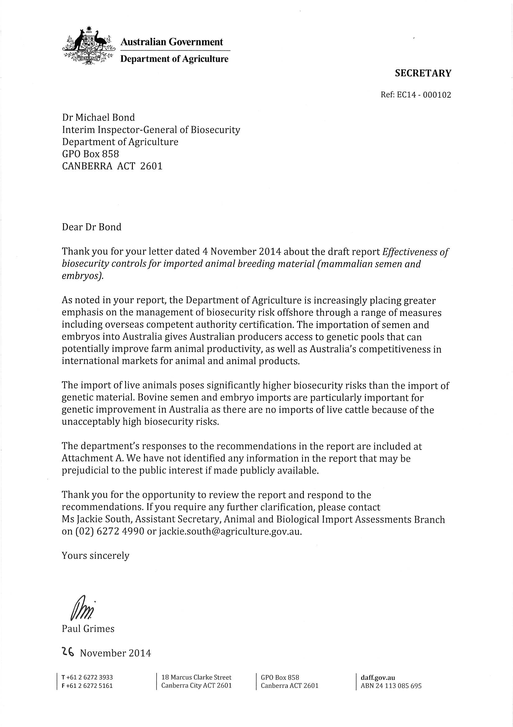
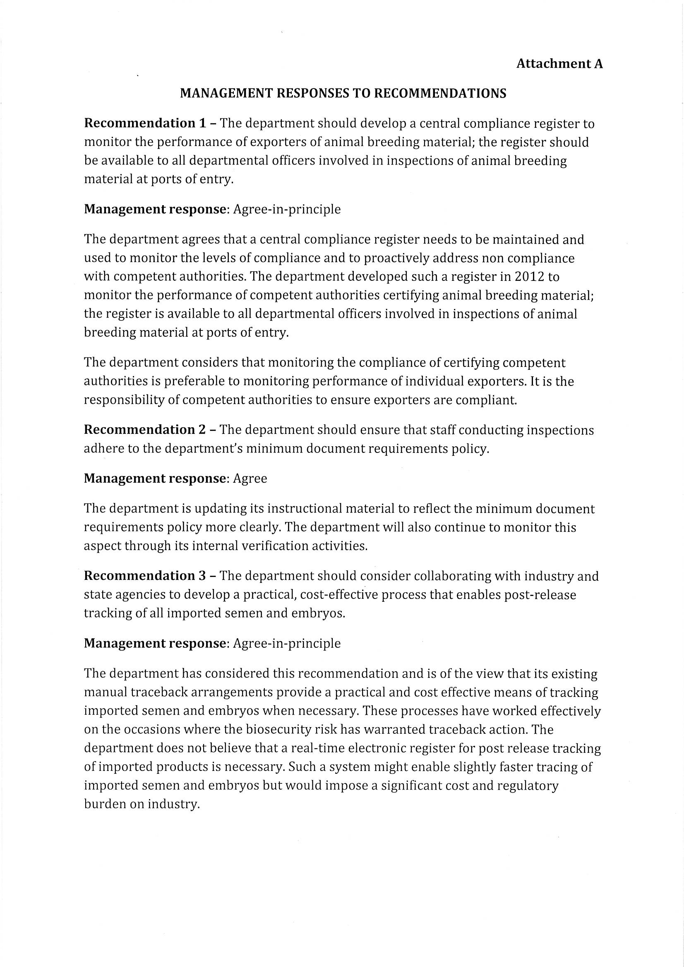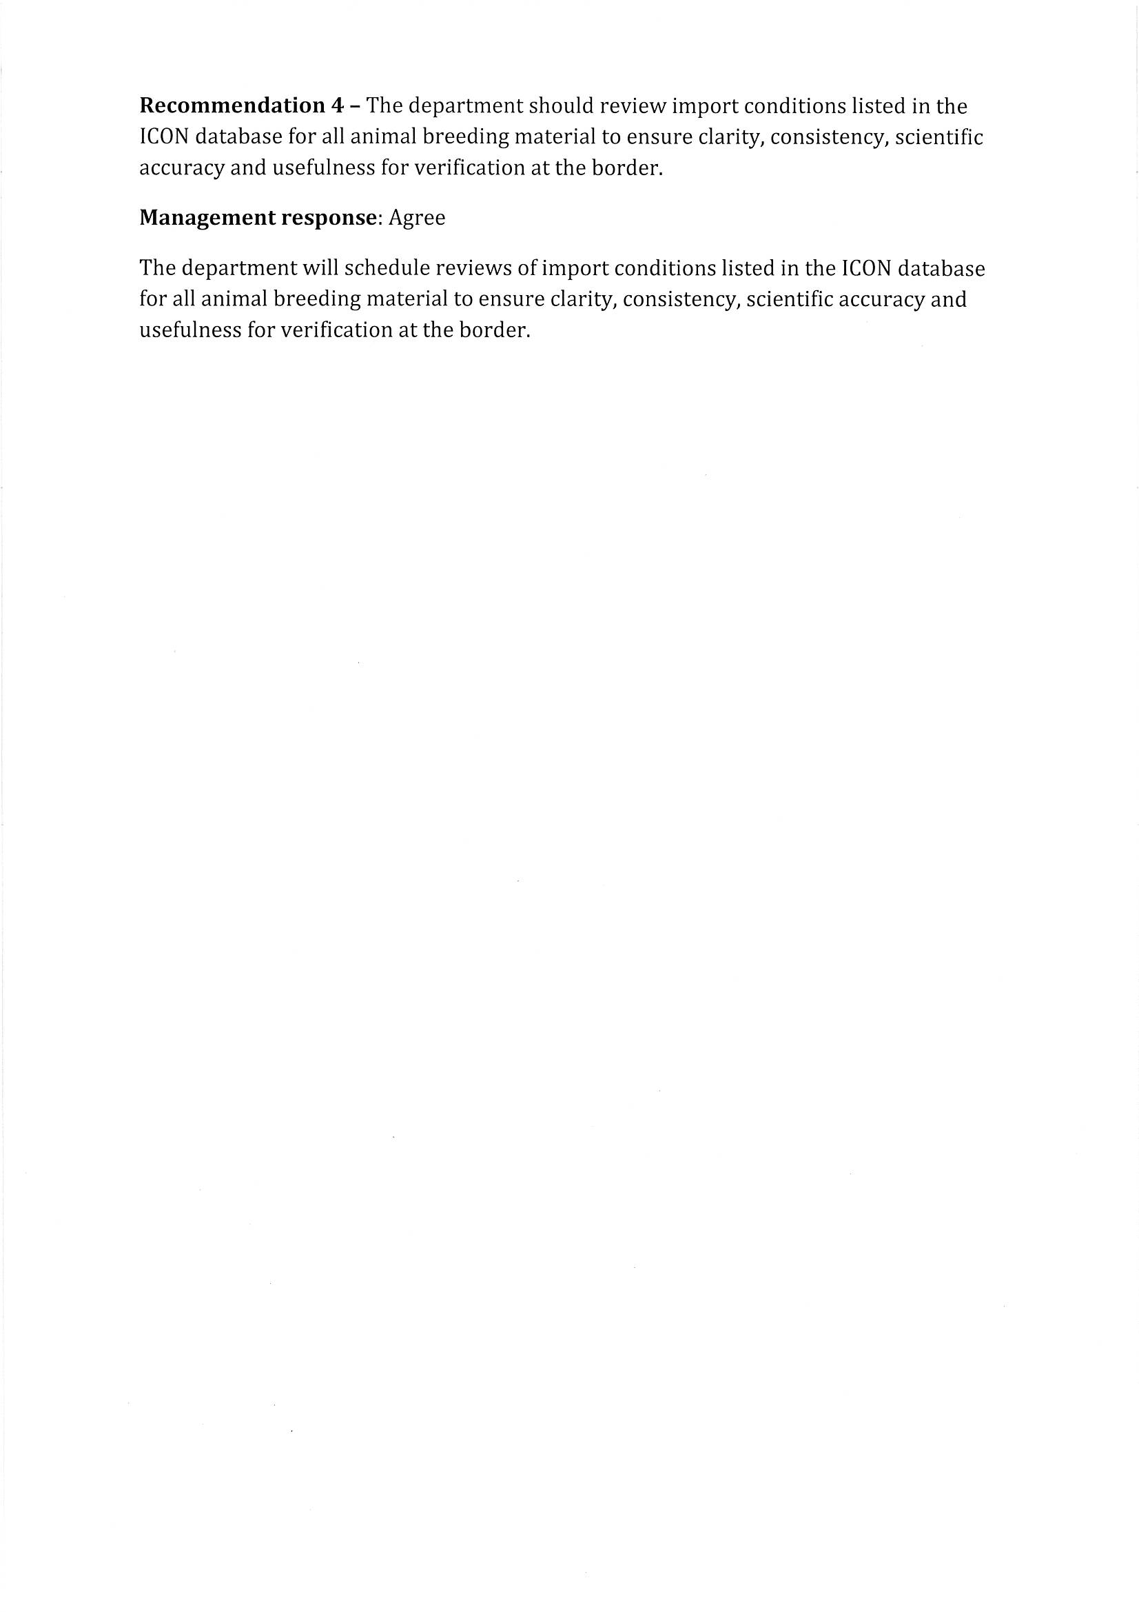

Appendix B: Relevant information on exporting countries: Germany and the Netherlands

Veterinary administration at the federal level in Germany
Germany was selected as a case study for evaluating the department’s assessment and approval processes for countries that export animal breeding material to Australia. The IIGB focused on the effectiveness of these processes in ensuring consistent and reliable compliance with Australia’s biosecurity requirements. Germany is one of the EU’s largest suppliers of animal breeding material to Australia.
The German Federal Ministry of Food, Agriculture and Consumer Protection (BMELV) consists of six departments. Veterinary administration at the federal level is covered by the Nutrition, Food Safety and Animal Health Department (Figure 12). The responsibilities of the BMELV include:
- promulgating national legislation, including law governing the veterinary profession
- developing European legislation
- representing technical matters in international organisations, such as the Food and Agriculture Organization of the United Nations, World Organisation for Animal Health (OIE) and the Codex Alimentarius Commission
- negotiating bilateral veterinary agreements and veterinary certificates
- advising federal authorities on veterinary issues.
Under the auspices of BMELV is the Federal Research Institute for Animal Health (Friedrich-Loeffler-Institut), one of several federal agencies that are legally independent under public law. Its main functions include:
- research in animal diseases, including characterisation and molecular analysis of animal viruses and bacteria
- diagnosis of notifiable animal diseases—national, EU and OIE reference laboratory
- epidemiology of outbreaks
- responsibility for the national Animal Disease Reporting System.
The IIGB met with the Chief Veterinary Officer, who represented the Nutrition, Food Safety and Animal Health Department and other BMELV staff. The IIGB noted that:
- Germany consists of 16 länder or states.
- The states are responsible for implementing veterinary laws and play an important role in lawmaking at federal and EU level through the Bundesrat (federal council).
- Each state has its own parliament, government and administration.
- Official veterinarians employed by local authorities monitor veterinary requirements at the farm and production facility level.
- Animal breeding legislation addresses artificial breeding centre facility and processing standards and disease controls. In Germany, the Animal Breeding Act and Animal Health Act are mostly harmonised and are administered at the federal level.

European Union animal health legislative framework
The EU animal health legislative framework, involving almost 50 basic directives and regulations and some 400 pieces of secondary legislation, underwent an external evaluation in 2004 to review the outcomes of EU action on animal health. This led to a new Animal Health Strategy in 2007. The Animal Health Law (2007) is the legal framework that supports the Animal Health Strategy for the EU. The operational objectives of this Animal Health Law (European Commission 2013) are to:
- integrate the new prevention-driven and incentive-oriented approach into the core of animal health policy
- provide for a clear and balanced distribution of roles and responsibilities between competent authorities, EU institutions, the farming sector, animal owners and others
- introduce disease categorisation as the basis for EU intervention
- provide effective mechanisms for a rapid response to disease events, including new challenges such as emerging diseases
- ensure effective emergency preparedness and early response to animal diseases and zoonoses, including use of vaccines as appropriate
- introduce simplified procedures, wherever possible, to release unjustified administrative burdens and costs on and meet the specific needs of small farmers and microbusinesses
- ensure the new legal framework provides enough flexibility to adapt smoothly to future scientific and technological developments
- reduce the risk of trade disruption by seeking an appropriate level of convergence with relevant international standards, while ensuring a firm commitment to high standards of animal health.
Separate from animal health legislation, breeding standards for horses, cattle, pigs, sheep and goats in Germany are covered under the Animal Breeding Act and its rules of application. This is consistent with relevant EU directives and is essentially aimed at enhancing the quality of animal breeding and products and conserving genetics for the main agricultural and equine breeds. Germany’s Animal Breeding Act:
- mandates implementation and documentation of breeding animals, and covers the type and scope of performance testing and recording in compulsory breeding programmes
- provides the basis for implementation and use of biotechnology in artificial insemination and embryo transfer
- restricts production and supply of livestock artificial breeding material for domestic and intra-EU trade to approved facilities only
- provides a legal basis for approval of breeding associations, breeding companies, insemination centres and embryo transfer institutes, along with approval of their breeding programmes, herd book regulations (herd book recording) and their area of activity (BMELV 2013).
The German Animal Breeding Act implements several guidelines and decisions of the EU (Table 8). Responsibility for implementing the Animal Breeding Act lies with the states. Breeding organisations are approved and monitored by the authorities responsible for animal breeding in each state.

Organisation of veterinary administration at state level in Germany
Lower Saxony (Niedersachsen), located in the northern part of Germany (Map 1), is one of Germany’s 16 states. Veterinary administration in Lower Saxony is the responsibility of the Ministry for Rural Area, Nutrition and Agriculture through the Lower Saxony State Office for Consumer Protection and Food Safety (Figure 13). Lower Saxony consists of 43 counties, with veterinary administration handled at farm and production facility level by local veterinary and food control authorities. In the case of animal artificial breeding facilities, local veterinarians are employed by the local government and authorised by the Lower Saxony State Office for Consumer Protection and Food Safety to implement official controls, including inspections, supervision, audits and export certification. This arrangement resembles the relationship between the New South Wales Department of Primary Industries and local veterinarians employed by various livestock health and pest authorities.
The IIGB chose Lower Saxony for his visit because it is Germany’s major animal production area. It is also home to several animal-related businesses, including leading export business houses for bovine semen and embryos, a bovine semen depot, bovine and equine artificial insemination centres, and several hatcheries, slaughterhouses and meat processing businesses.
Two commercial artificial breeding facilities for bovine semen were randomly chosen for inspection; both export bovine semen to Australia. Due to the limited time available to the IIGB to conduct inspections, no equine artificial breeding facilities were inspected. Further, unlike bovine artificial breeding facilities, most equine facilities do not operate all year round and much commercial activity centres on collection and use of fresh equine semen for domestic breeding.

Animal disease testing laboratories in Germany
The four government-approved laboratories in Lower Saxony that undertake animal disease testing of donor animals are:
- Lebensmittel- und Veterinärinstitut, Oldenburg
- Lebensmittel- und Veterinärinstitut, Braunschweig/Hannover
- LUFA Nord-West Institut für Lebensmittelqualität, Oldenburg
- Labor Dr Böse GmbH, Harsum.
The IIGB noted official advice that these laboratories comply with standards in relevant EU directives that control animal health requirements for intra-community trade and imports of animal breeding material (for example, EU directive 88/407/EEC and updated legislation that applies to deep-frozen bovine semen). Lower Saxony veterinary authorities verified that they have approved these laboratories to conduct disease testing required by the Department of Agriculture of donor animals that produce semen or embryos for export to Australia.

Official control of animal breeding material in the Netherlands
The Netherlands Food and Consumer Product Safety Authority (NVWA), which is part of the Federal Ministry of Economic Affairs portfolio, certifies all consignments for export to countries such as Australia. NVWA’s functions include:
- issuing export certificates
- inspecting throughout the food chain (from farm to fork)
- managing animal disease outbreaks and food-related incidents
- evaluating risk (by a separate and independent unit)
- communicating risk to the public
- conducting road checks to ensure compliance with agricultural rules and requirements
- investigating noncompliance relating to agricultural rules and requirements and fraud and other criminal acts.

Animal disease testing laboratory in the Netherlands
The only government approved laboratory in the Netherlands is the Central Veterinary Institute, in Lelystad. The commercial establishment the IIGB visited in the Netherlands sends all blood samples from donor animals to this laboratory for analysis.

Map
Map 1 Federal Republic of Germany showing 16 states
Source: Federal Ministry of Food, Agriculture and Consumer Protection, Germany

Figures
Figure 1 Noncompliant consignments imported into Australia between January and October 2012, by country and commodity
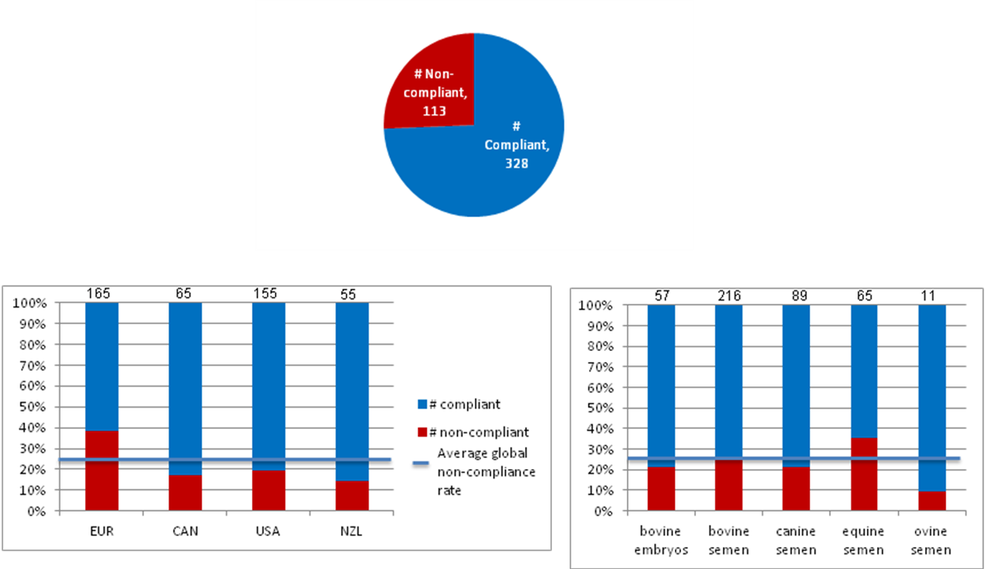
Source: Australian Government Department of Agriculture, Canberra
Figure 2 Department of Agriculture, control measures across biosecurity continuum for animal breeding material imported into Australiaª
ª relates mainly to animal breeding material for bovine, ovine, caprine and equine species and not intended to cover zoo animals, rabbits, dogs and cats
Source: Interim Inspector-General of Biosecurity, Canberra
Figure 3 Department of Agriculture, national and regional roles and responsibilities
Source: Interim Inspector-General of Biosecurity, Canberra
Figure 4 Department of Agriculture, clearance procedures for imported animal breeding material
Source: Interim Inspector-General of Biosecurity, Canberra
Figure 5 Rate of noncompliant consignments imported into Australia, by commodity and country of export, 2012
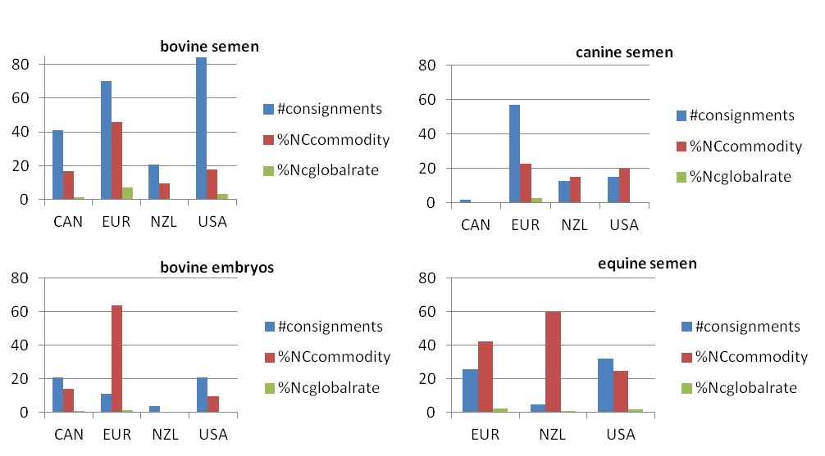
Source: Australian Government Department of Agriculture, Canberra
Figure 6 Noncompliant consignments imported into Australia, 2012
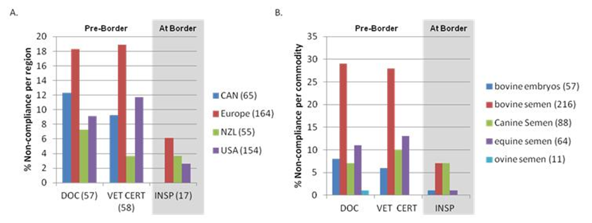
Source: Australian Government Department of Agriculture, Canberra

Figure 7 Compliant donor cattle enclosure, artificial insemination centre, Germany
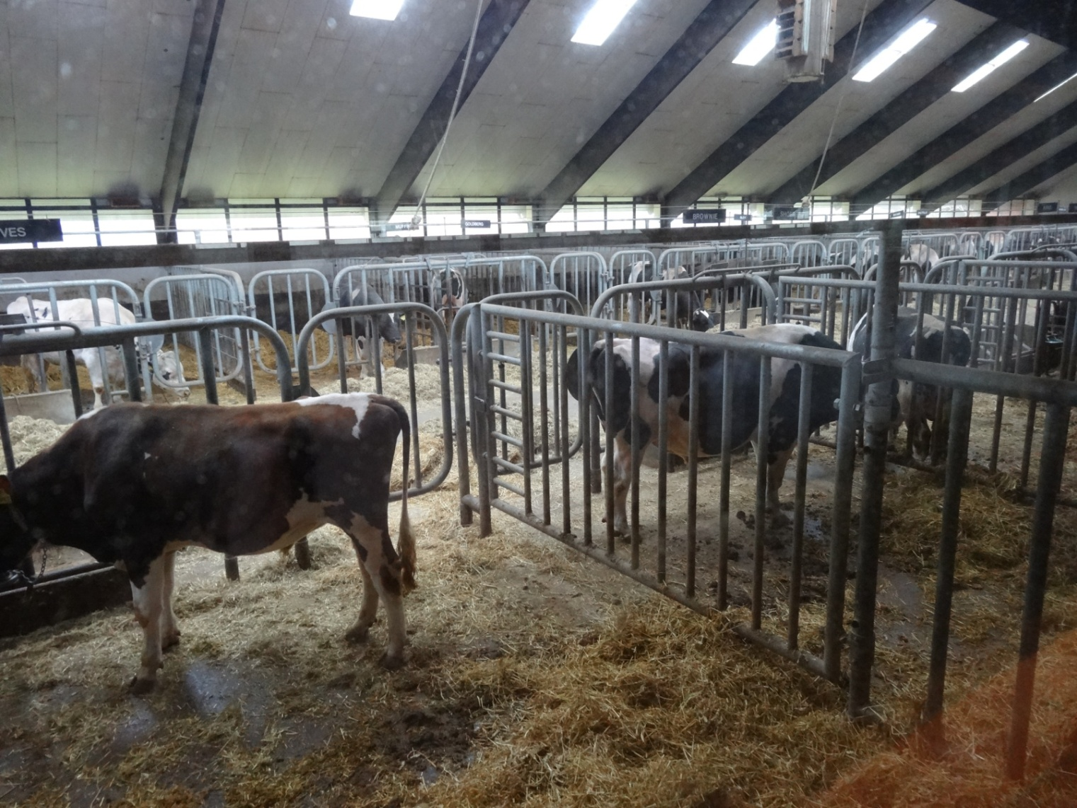
Note: Enclosure complies with Australian import requirements.
Source: Interim Inspector-General of Biosecurity, Canberra
Figure 8 Laboratory adjacent to semen collection area, artificial insemination centre, Germany
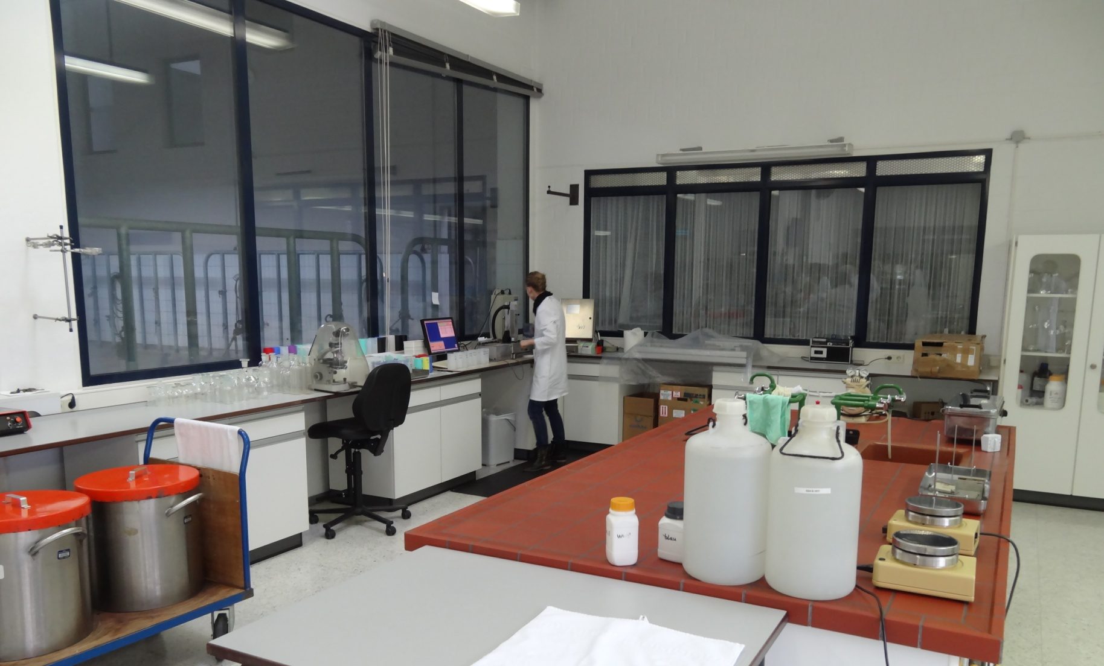
Source: Interim Inspector-General of Biosecurity, Canberra
Figure 9 Disinfection well, artificial insemination centre, Germany
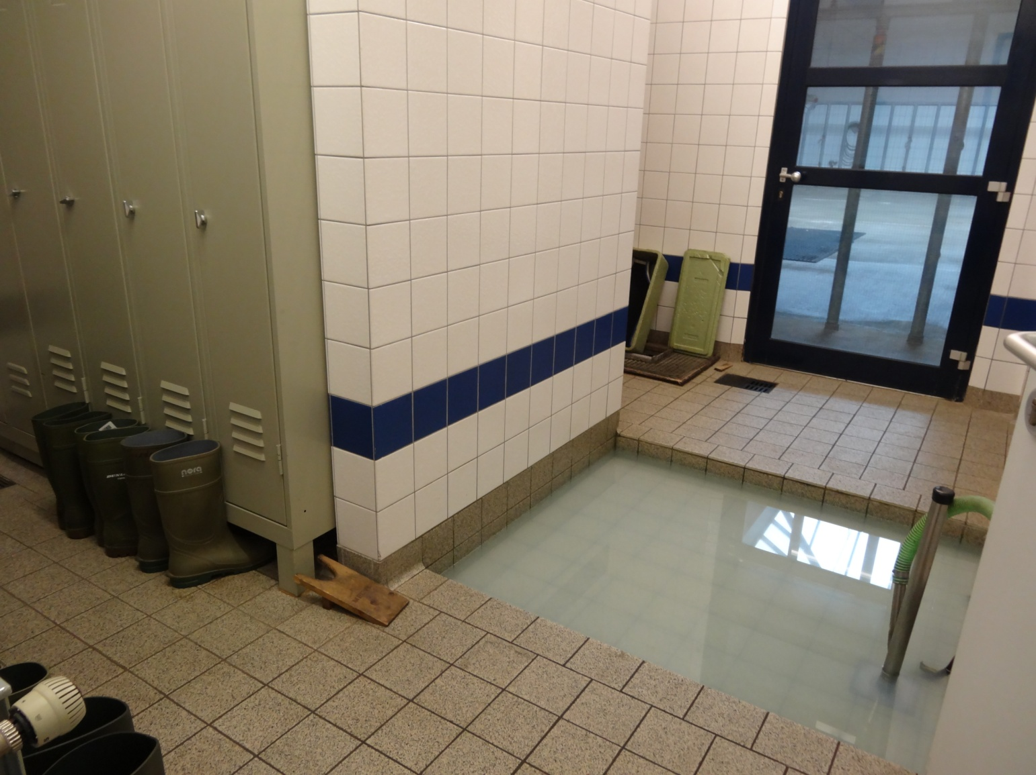
Source: Interim Inspector-General of Biosecurity, Canberra
Figure 10 Disinfecting used containers, artificial insemination centre, Germany
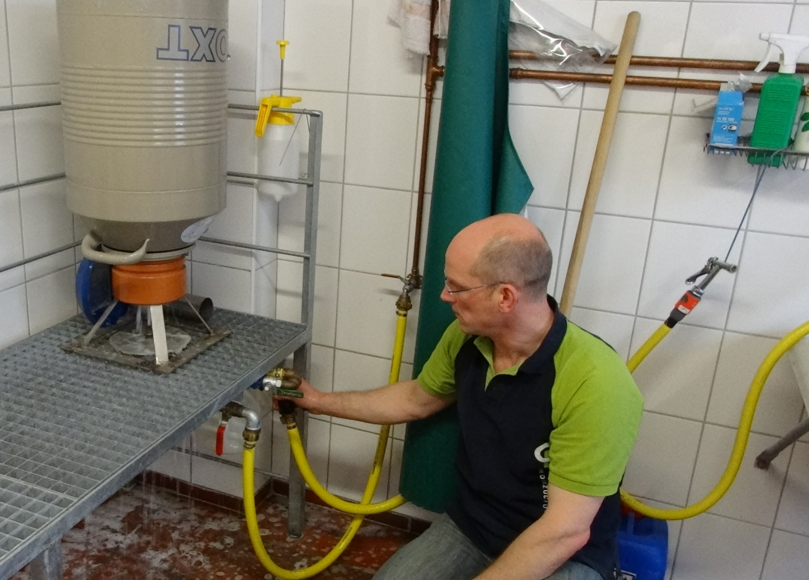
Source: Interim Inspector-General of Biosecurity, Canberra
Figure 11 Cool room for storing processed semen, artificial insemination centre, Germany
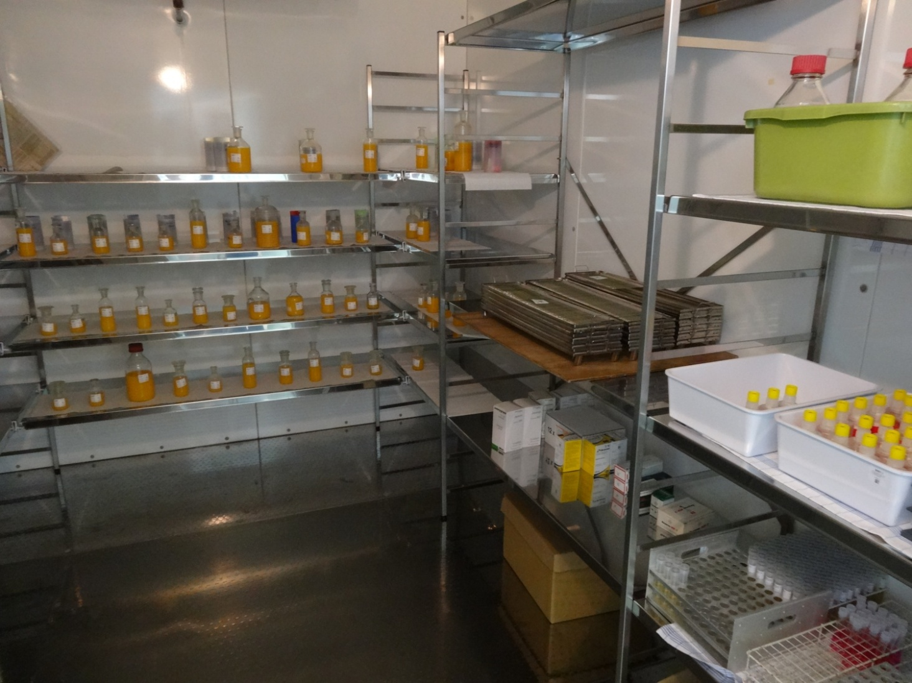
Source: Interim Inspector-General of Biosecurity, Canberra
Figure 12 Organisation of veterinary administration at federal level, Germany
Source: Federal Ministry of Food, Agriculture and Consumer Protection, Germany
Figure 13 Organisation of veterinary administration at state and county level, Germany
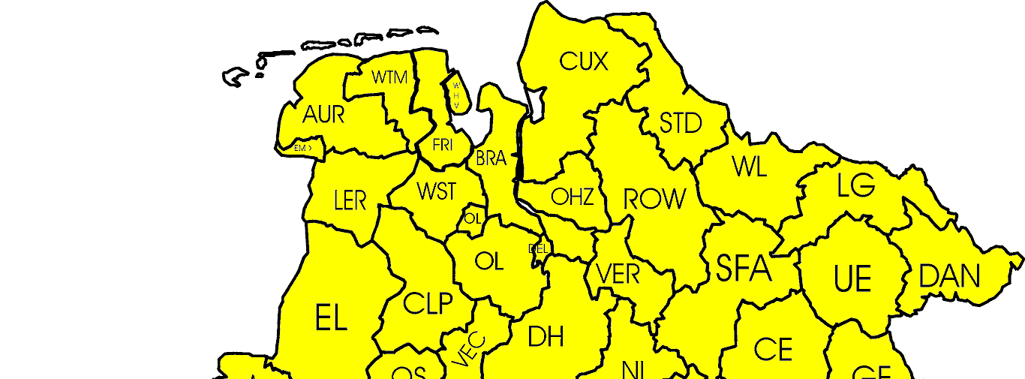
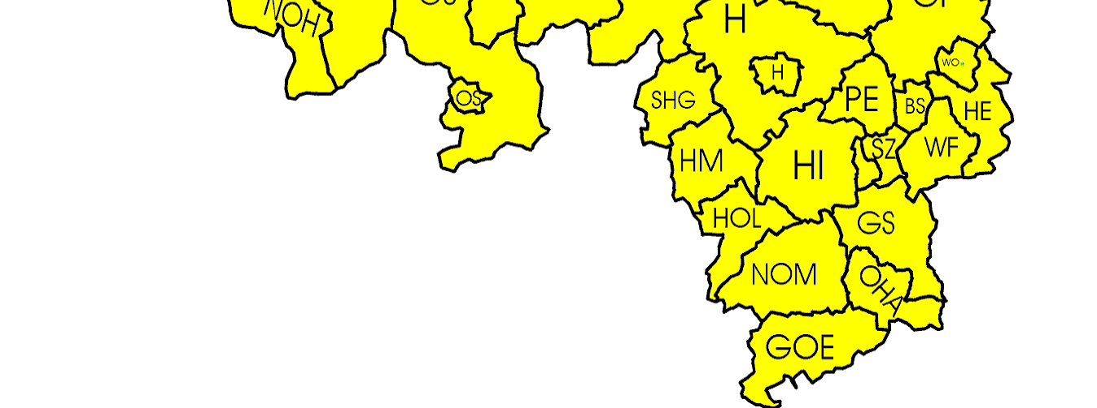
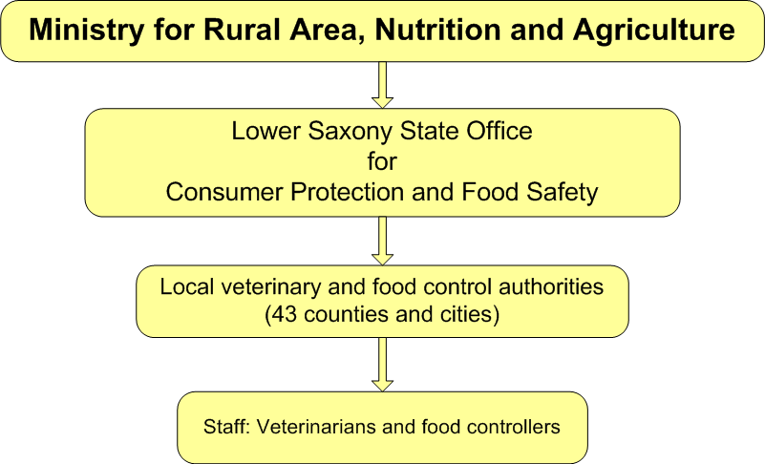

Source: Federal Ministry of Food, Agriculture and Consumer Protection, Germany

Tables
Table 1 Examples of noncompliance of animal breeding material imported into Australia
Category of noncompliance | Description | Border
Documentation
- Failure of 72 hours fresh/chilled notification of arrival (fresh semen only)  - Incorrect or invalid permit number  - Health certificate not signed and stamped as required  - Health certificate inconsistent with import permit or consignment | - Necessary to track and verify status of material from country of export to Australian port | Pre-border
Vet certificate
- Full identification not stated (for example, breed, herd/studbook number, ear tag, brand or microchip)  - Date/s of semen collection/s not stated  - Straw identification on documents inadequate  - Date of entry into pre-entry isolation not stated  - Date of entry to collection centre not stated  - Testing—incorrect dates  - Testing—incorrect test  - Comments on testing (for example, which disease)  - Shipping container not sterilised as per import permit  - Laboratory reports not submitted (where required) | - Documents material to be imported into Australia and disease status of animal/donor  - Necessary to maintain Australia’s biosecurity status.  - Issued from exporting country | Pre-border
Inspection
- Tamper seals not present or damaged or inconsistent with documents  - Presence of non-certified material in container (for example, semen extender)  - Uncertified, unlabelled or mislabelled straws present in consignment | - Performed at port of entry  - Ensures contents of shipment is not damaged and/or tampered with and that contents are as described on documents | At border
Miscellaneous
- Other observations not defined in previous criteria | - Other observations not defined in previous criteria | Pre-border or at border
Source: Australian Government Department of Agriculture, Canberra
Table 2 Diseases that can be transmitted by semen and in vivo and in vitro embryos
Disease | Diseases in OIE Code (2013) as relevant to semen  (Apply to chapter 4.6 in Volume 1 or disease chapters in Volume 11) | Diseases in OIE Code (2013) relevant to In -vivo embryos (Apply to chapter 4.7 in Volume 1or disease chapters in Volume 11) | Disease category in IETS for in-vivo produced embryos  (Category 1-4) | Diseases in OIE Code (2013) relevant to In-vitro embryos (Apply to chapter 4.8 and 4.9 in Volume 1 or disease chapters in Vol 11)
Multispecies
Bluetongue | Cattle, sheep and goats | Sheep and goats  Cattle (BTV 8) | Sheep - Category 2  Goats- Category 4  Cattle - Category 1 | Cattle, sheep and goats
Foot-and-mouth disease | Cattle, sheep and goats | Cattle | Sheep and goats - Category 3  Cattle - Category 1 | Cattle
Vesicular stomatitis | – | Cattle, sheep and goats | Cattle - Category 4 | –
Cattle
Bovine genital campylobacteriosis | Cattle | – | – | –
Bovine tuberculosis | Cattle | Cattle | Category 4 | Cattle
Bovine brucellosis | Cattle | Cattle | Category 1 | Cattle
Contagious bovine pleuropneumonia | Cattle | Cattle | – | Cattle
Enzootic bovine leukosis | Cattle | Cattle | Category 1 | Cattle
Infectious bovine rhinotracheitis/infectious pustular vulvovaginitis | Cattle | Cattle | Category 1  (Trypsin treatment required) | Cattle
Lumpy skin disease | Cattle | Cattle | Category 4 | Cattle
Trichomoniasis | Cattle | – | Category 4 | –
Bovine spongiform encephalopathy | – | – | Category 1 | –
Bovine viral diarrhoea | Cattle | – | Category 3 | –
continued …
Table 2 Diseases that can be transmitted by semen and in vivo and in vitro embryos continued
Sheep and goats
Ovine brucellosis | Sheep and goats | Sheep and goats | – | Sheep and goats
Johne’s disease | Sheep and goats |  | – | –
Contagious agalactia | Sheep and goats | – | – | –
Maedi-visna | Sheep and goats | – | Sheep - Category 3 | –
Ovine epididymitis | Sheep only | – | Sheep - Category 4 | –
Peste-des-petits ruminants | Sheep and goats | Sheep and goats | – | Sheep and goats
Scrapie | Sheep and goats | Goats | Goats - Category 4  Sheep - Category 1 | Sheep and goats
Caprine arthritis/encephalitis | Goats | – | Goats - Category 2 | –
Sheep and goat pox | Sheep and goats | – | – | –
Enzootic abortion of ewes | Sheep and goats | – | – | –
Bovine tuberculosis | Goats | – | – | –
Diseases not OIE listed but categorised by IETS as risk of disease transmission via in-vivo embryos
Campylobactor fetus | – | – | Sheep - Category 3 | –
Bovine spongiform encephalopathy | – | – | Goats - Category 3 | –
Haemophilus somnus | – | – | Cattle - Category 3 | –
Mycobacterium paratuberculosis | – | – | Cattle - Category 3 | –
Neospora caninum | – | – | Cattle - Category 3 | –
Ovine pulmonary adenomatosis | – | – | Sheep - Category 3 | –
Bovine anaplasmosis | – | – | Cattle - Category 4 | –
Enterovirus | – | – | Cattle - Category 4 | –
E.coli 09:K99 | – | – | Cattle - Category 4 | –
L. borgpetersenii serovar hardjobovis | – | – | Cattle - Category 4 | –
Akabane | – | – | Cattle - Category 4 | –
Border disease | – | – | Sheep - Category 4 | –
Bovine herpes- 4 | – | – | Cattle - Category 4 | –
Chlamydia psittaci (Q fever) | – | – | Cattle, sheep - Category 4 | –
Ureaplasma and Mycoplasma spp. | – | – | Cattle, goats - Category 4 | –
Parainfluenza-3 | – | – | Cattle - Category 4 | –
Note: For definitions of International Embryo Transfer Society categories, see the World Organisation for Animal Health’s Terrestrial Animal Health Code.
Source: World Organisation for Animal Health, Terrestrial Animal Health Code, volumes 1 and 2, 2013
Table 3 Department of Agriculture audits of countries approved for export of animal breeding material to Australia
Species and type of breeding material | Countries | Year first approved | Year last audited by the department (since approval)
Ruminant breeding material (semen and embryos)
Bovine (semen and embryos) | Animal Health Quadrilateral Group countries (Australia, Canada, New Zealand, and the USA) | Pre-1980 | Not audited
Bovine (semen and embryos) | Denmark, Sweden | 1986 | Not audited
Non-ruminant breeding material
Equine (semen only) | Switzerland | 1994 | Not audited
Equine (semen only) | Austria, Belgium, Denmark, Finland, France, Germany, Greece, Ireland, Italy, Luxembourg, the Netherlands, Portugal, Spain, Sweden and the United Kingdom | 1994 | Not audited
Equine (semen only) | Canada | 1997 | Not audited
Equine (semen only) | USA | 1998 | Not audited
Dog and cat (semen only) | Rabies-free countries and countries where rabies is well controlled | 1997 | Not audited
Giraffe (semen only) | USA | 2000 | Not audited
Giraffe (semen only) | New Zealand | 2001 | Not audited
Laboratory rat and mice (embryos, ova, semen) | All countries | 2003 | Not audited
Elephant (semen only) | Member states of the European Union | 2008 | Not audited
Elephant (semen only) | Singapore | 2008 | Not audited
Elephant (semen only) | USA | 2008 | Not audited
Source: Australian Government Department of Agriculture, Canberra
Table 4 Animal breeding material import permits held by entities and individuals, 2012
No. import permits | Holders of import permits a |  | Total
No. import permits | Businesses | Individuals | Total
1–5 | 34 | 16 | 50
6–10 | 2 | 0 | 2
11–15 | 5 | 0 | 5
16–20 | 4 | 0 | 4
21 or more | 1 | 0 | 1
Total | 46 | 16 | 62
a Represents all import permits for animal breeding material that were active on any day during the calendar year 2012
Source: Australian Government Department of Agriculture, Canberra
Table 5 Exporting countries, import permits held, 2012
Exporting countries | No. import permits | Percentage of total import permits
Austria | 3 | 1.0
Belgium | 7 | 2.4
Canada | 23 | 7.9
Czech Republic | 6 | 2.1
Denmark | 12 | 4.1
Finland | 6 | 2.1
France | 20 | 6.9
Germany | 27 | 9.3
Hawaiian Islands | 1 | 0.3
Hungary | 6 | 2.1
Ireland, Republic of | 6 | 2.1
Italy | 11 | 3.8
Netherlands | 19 | 6.6
New Zealand | 32 | 11.0
Norway | 1 | 0.3
Poland | 2 | 0.7
Portugal | 1 | 0.3
Slovakia | 1 | 0.3
South Africa, Republic of | 2 | 0.7
Spain | 2 | 0.7
Sweden | 7 | 2.4
Switzerland | 5 | 1.7
United Kingdom | 28 | 9.7
USA | 62 | 21.4
Total | 290 | 100
Source: Australian Government Department of Agriculture, Canberra
Table 6 Sampling rate for verification inspection of animal breeding material
No. straws/vials in tank | Minimum no. to be sampled from tank
No. straws/vials in tank | Normal sampling strategy a | Increased sampling strategy b
10 | 10 | 10
20 | 19 | 20
30 | 26 | 30
40 | 31 | 40
50 | 35 | 50
60 | 38 | 60
70 | 40 | 70
80 | 42 | 79
90 | 43 | 87
100 | 45 | 95
120 | 47 | 111
140 | 48 | 124
160 | 49 | 136
180 | 50 | 146
200 | 51 | 155
300 | 54 | 189
400 | 55 | 211
600 | 56 | 235
800 | 57 | 249
1 000 | 57 | 258
2 000 | 58 | 277
3 000 | 58 | 284
4 000 | 58 | 288
5 000 | 59 | 290
10 000 | 59 | 294
infinite | 59 | 299
a To ensure at least 95 per cent confidence of detecting an uncertified straw/vial if less than or equal to 5 per cent uncertified straws/vials in a tank. b To ensure at least 95 per cent confidence of detecting an uncertified straw/vial if less than or equal to 1 per cent uncertified straws/vials in a tank
Source: Australian Government Department of Agriculture, Work instruction: live animal reproductive material: import clearance, Canberra
Table 7 Summary of traceback of consignments released from quarantine, 2009–2012
Commodity | Issue | Doses imported | Doses inseminated or  implanted | Doses retrieved | Doses in storage | Date imported | Date notified of problem | Date last dose retrieved | Time elapsed between import and retrieval
Bovine semen, Canada | Donor misidentified | 4 968 | 1 306 | 1 868 | 1 253 | March 2009 | June 2009 | October 2009 | 7 months
Bovine semen from Jersey bull, USA | Contaminated with bovine viral diarrhoea virus (non-exotic strain) | 1 000 | n/a  (14 end users) | Not recalled | 390 | June 2010 | May 2011 | n/a | 11 months
Ovine and bovine embryos, Republic of South Africa | Foot-and-mouth disease outbreak (seroconversion) in KwaZulu-Natal | 1 102 | 137 | 759 | 206* | November 2010 | 28 February 2011 – notified of FMD in RSA** | n/a | 1 month
Bovine semen and embryos, European Union | Schmallenberg virus | Between 23 000 and 80 000  42 embryos | n/a (most used in non-vector areas) | Not recalled | n/a | June 2011 | November 2011 | n/a | 6 months
* These doses were re-exported to South Africa
** 4 March 2011 – the department was advised that the date of the outbreak could not be determined; the date for tracing of consignments was revised, and tracing commenced.
n/a not available
Source: Australian Government Department of Agriculture, Canberra
Table 8 German Animal Breeding Act, guidelines and decisions
European zootechnical legislation | Bovine | Equine
Basic directives of the European Council of the European Union, as listed in German legislation | R77/504 | RL90/427
Acceptance for breeding | RL87/328 | –
Acceptance for breeding | RL2005/24 | –
Recognition of breeding organisations | E84/247 | E92/353
Recognition of breeding organisations | – | E92/354
Entering into herd books | E84/419 | E96/78
Performance testing and genetic evaluation | E2006/427 | –
Pedigree certificates | E2005/379 | E96/79
Source: Federal Ministry of Food, Agriculture and Consumer Protection, Germany

Glossary
competent authority | Official service or authority established by the government of an exporting state, having the responsibility and competence for ensuring or supervising implementation of animal, plant or public health standards
compliance | Status whereby all aspects of product, facilities, people, programmes and systems meet regulatory requirements and, where applicable, importing country official requirements
consignment | Total quantity of imported reproductive material arriving at the same time in one or more canisters, nominated on a single quarantine entry covered by one or more health certificates
disease | Includes a micro‐organism, disease agent, infectious agent or parasite
ELISA | Enzyme-linked immunosorbent assay that uses an enzyme linked to an antibody or antigen as a marker for detecting a specific protein, especially an antigen or antibody. It is often used as a diagnostic test to determine exposure to a particular infectious agent, such as the Schmallenberg virus, by identifying antibodies present in a donor animal’s blood sample
EU directives | European Union (EU) directives are used to bring national laws of the member states into line with each other to achieve specific goals, and are particularly common in matters affecting the operation of the single market such as product safety standards
exotic pests and diseases | Pests and diseases affecting plants or animals (and possibly humans) that do not normally occur in a particular country or region
FAO | Food and Agriculture Organization of the United Nations, a specialised agency that leads international efforts to defeat hunger
FVO | Food and Veterinary Office of the European Commission (EC), responsible for ensuring EC legislation on food safety, animal and plant health and animal welfare is properly implemented and enforced
goods | as defined in the Quarantine Act 1908, goods are materials that have been imported and not released from quarantine, including animals, plants and other articles, substances and things such as containers
import permit | In relation to goods, a permit granted by the Director of Quarantine (or delegate) to import prohibited goods into Australia
import risk analysis | Process that enables the Australian Government to formally consider risks that could be associated with proposals to import new products into Australia; import risk analyses are conducted by the Department of Agriculture
inspection | Examination of products or systems for the biosecurity of animal, plant, food and human health to verify that they conform to Australian Government requirements
liquid nitrogen | Nitrogen gas in a liquid state at an extremely low temperature, used for transport and long-term storage of semen and embryos
minimum documentation policy | Department of Agriculture’s policy that defines minimum requirements that all documents presented to the department or industry must meet to support risk assessment of imported cargo and/or packaging, whether for quarantine or imported goods
OIE | World Organisation for Animal Health
pest | Any species, strain or biotype of the kingdoms Animalia (excluding human beings), Plantae, Fungi, Monera or Protista that has negatively affected or poses a likely threat of having an effect on other organisms
pre-border controls | Pre-border activities seek to prevent biosecurity risks reaching Australia’s border, including cooperation in multilateral forums, import risk analyses, intelligence gathering and quarantine and audit activities
prohibited goods | Those goods that are prohibited to be imported into Australia under the Quarantine Proclamation 1998, unless an import permit has been granted in respect of the goods or other requirements have been satisfied
QUADS group | Animal Health Quadrilateral Group, an alliance between Australia, Canada, New Zealand and the United States of America
quarantine | System of measures used to manage risks of entry and establishment of pests or diseases that threaten animal, plant or human health
quarantine approved premises | Places approved, under section 46A of the Quarantine Act 1908, as places where goods of a specified class that are subject to quarantine may be treated or otherwise dealt with
quarantine containment  level 1 | Whole space approved by the Department of Agriculture in accordance with Quarantine Approved Premises Class 5.1 criteria for a quarantine containment level 1 facility excludes lifts, stairs and corridors but may include lockable biosecurity storage areas outside or separate to the quarantine area where biosecurity activities are undertaken
release | Process of releasing a consignment of reproductive material at the conclusion of the inspection; release should only occur if documentation accompanying the consignment certifies that appropriate treatments have been carried out or that the goods are free from contamination, pests or diseases
risk assessment | Evaluation of the likelihood and the biological and economic consequences of entry, establishment or spread of a pest or disease within the territory of an importing country
risk management | Process of identifying, selecting and implementing measures that can be applied to reduce the level of risks
seal | Small device used by quarantine and Customs staff that can be fixed to a lock, door, gate or other fixture; it is usually numbered and cannot be removed without being destroyed
standard operating procedures | Document that outlines procedures for conducting significant operational activities, taking into account management of risk, legislation and workplace health and safety requirements
verification | Confirmation through provision of objective evidence that specified requirements have been fulfilled. Includes inspection and audit activities
veterinary services | Government and non-government organisations, veterinarians, veterinary paraprofessionals or aquatic animal health professionals who, under control and direction of the veterinary authority, implement animal health and welfare measures and other standards and recommendations in the Terrestrial Code and the Aquatic Animal Health Code; in most cases, the veterinary authority accredits or approves veterinary services to deliver delegated functions
work instruction | A succinct easy-to-understand document that complements a standard operating procedure and provides definitive guidance for performing specific operational tasks

References
ABARES 2013, Potential socio-economic impacts of an outbreak of foot-and-mouth disease in Australia, Australian Bureau of Agricultural and Resource Economics and Sciences, Canberra, available at data.daff.gov.au/anrdl/metadata_files/pb_pseiFMDd9abbl20131011_11a.xml.
ANAO 2012, Administration of the Northern Australia Quarantine Strategy, audit report no. 46, June 2012, Australian National Audit Office, Canberra, available at anao.gov.au/Publications/Audit-Reports/2011-2012/Administration-of-the-Northern-Australia-Quarantine-Strategy.
ARMCANZ 1999, Australian Veterinary Emergency Plan (AUSVETPLAN) 1999, Enterprise manual: artificial breeding centres, version 2.1, Agriculture and Resource Management Council of Australia and New Zealand, available at animalhealthaustralia.com.au/wp-content/uploads/2011/04/abcfinal.pdf (pdf 150.59kb).
Beale, R, Fairbrother, J, Inglis, A & Trebeck, D 2008, One biosecurity: a working partnership, Commonwealth of Australia, Canberra, available at daff.gov.au/about/publications/
quarantine-biosecurity-report-and-preliminary-response.
BMELV 2013, Animal genetic resources in Germany: National Programme for Conservation and Sustainable Use: recent activities and achievements, Federal Ministry of Food, Agriculture and Consumer Protection, Bonn, available at bmelv.de/SharedDocs/Bilder/EN/cover/AnimalGeneticRes.html?nn=309750.
COAG 2012, Intergovernmental Agreement on Biosecurity: an agreement between the Commonwealth of Australia, state and territory governments to strengthen the national biosecurity system, Council of Australian Governments, Canberra, available at coag.gov.au/node/47.
DAFF 2012, Effectiveness of pre-border biosecurity programs, internal audit report, May 2012, Department of Agriculture, Fisheries and Forestry, Canberra.
—— 2011a, Final policy review of the bluetongue virus risks associated with the importation of cattle, sheep, goat and deer semen and embryos from the European Union and cattle semen and embryos from Switzerland and Norway, April, Department of Agriculture, Fisheries and Forestry, Canberra, available at daff.gov.au/__data/assets/pdf_file/0007/2036518/2011-19a-BTV_Final_Policy_Review_Report.pdf (pdf 1.35mb).
—— 2011b, Import risk analysis handbook 2011, Department of Agriculture, Fisheries and Forestry, Canberra, available at daff.gov.au/__data/assets/pdf_file/0012/1897554/import-risk-analysis-handbook-2011.pdf (pdf 612.86kb).
—— 2011c, Memorandum of understanding. Collaborative cooperation. An arrangement for the collaborative working relationship between the Australian Customs and Border Protection Service and the Department of Agriculture, Fisheries and Forestry, Department of Agriculture, Fisheries and Forestry, Canberra, available at daff.gov.au/__data/assets/pdf_file/0003/1951473/MOU.pdf (pdf 302.14kb).
—— 2010, Work instruction: live animal reproductive material: import clearance, Department of Agriculture, Fisheries and Forestry, Canberra.
—— 2000, Import risk analysis report on the revision of import policy related to scrapie, final report, August, Department of Agriculture, Fisheries and Forestry, Canberra, available at daff.gov.au/ba/ira/final-animal.
—— 1999a, Animal quarantine policy memorandum 1999/62, 31 August, Department of Agriculture, Fisheries and Forestry, Canberra, available at daff.gov.au/__data/assets/pdf_file/0016/1330153/99-062.pdf (pdf 46.99kb).
—— 1999b, Guidelines for the approval of countries to export animals (including fish) and their products to Australia, Department of Agriculture, Fisheries and Forestry, Canberra, available at daff.gov.au/ba/ira/final-animal/export-animal-guidelines.
—— 1999c, Import risk analysis report on the importation of bovine semen and embryos from Argentina and Brazil into Australia, Part 1: Bovine semen, November, Department of Agriculture, Fisheries and Forestry, Canberra, available at daff.gov.au/__data/assets/pdf_file/0014/14324/00-003a.pdf (pdf 208.37kb).
—— 1999d, Import risk analysis report on the importation of bovine semen and embryos from Argentina and Brazil into Australia, Part 2: Bovine embryos, November, Department of Agriculture, Fisheries and Forestry, Canberra, available at daff.gov.au/__data/assets/pdf_file/0015/14325/00-003b.pdf (pdf 99.20kb).
European Commission 2013, Proposal for a regulation of the European Parliament and of the council on animal health, COM (2013) 260 final, Brussels, available at ec.europa.eu/prelex/detail_dossier_real.cfm?CL=en&DosId=202630.
—— 2012, Final report of an audit carried out in Australia from 30 January to 9 February 2012 in order to evaluate the animal health controls and certification procedures applicable to imports into the European Union of semen, ova and embryos of the bovine, ovine, caprine and equine species, report no. 2012-6329, European Commission Health and Consumers Directorate-General, Food and Veterinary Office, Brussels, available at ec.europa.eu/food/fvo/rep_details_en.cfm?rep_id=2896#.
—— 2007, Final report of a mission carried out in Australia From 1 to 14 February 2007 in order to evaluate the public health control systems and certification procedures for milk and products thereof as well as animal health conditions applicable to imports into the European Community of bovine semen and embryos, European Commission Health and Consumers Directorate-General, Food and Veterinary Office, Brussels, available at ec.europa.eu/food/fvo/rep_details_en.cfm?rep_id=1862.
FVO 2013, ‘Food and Veterinary Office—Introduction’, European Commission, Brussels, available at ec.europa.eu/food/fvo/index_en.cfm.
MacDiarmid, SC 2011, ‘The spread of pathogens through international trade. Introduction’, Revue scientifique et technique (International Office of Epizootics), vol. 30, pp. 13–17, available at http://www.unboundmedicine.com/medline/citation/21809751/The_spread_of_pathogens_through_international_trade__Introduction_.
OIE 2012, Terrestrial Animal Health Code, World Organisation for Animal Health, Paris, available at oie.int/international-standard-setting/terrestrial-code/access-online.
Rickards, PA & Nicol, DC 2012, ‘What Australia offers as a source of world leading genetics and genetic technologies’, paper presented at the International Beef Cattle Genetics Conference, Rockhampton, Queensland, 6–7 May, available at c.cld.pw/99/cms/files/Rickards&Nicol-FullPaper.pdf (pdf 430.40kb).
Schneider, H 2011, ‘Good governance of national veterinary services’, Revue scientifique et technique (International Office of Epizootics), vol. 30, pp. 325–38.

