An examination of the performance of the systems that the biosecurity divisions of the Department of Agriculture, Fisheries and Forestry has in place to manage biosecurity risks along entry pathways

Citrus canker

INTERIM INSPECTOR GENERAL OF BIOSECURITY
July 2011

No: 2010-11/04

Contents

Executive summary 3
Key findings 3
Recommendations 6
Conduct of the audit 7
The role of the IIGB 7
The IIGB’s program 7
Audit objective 8
Scope 8
Out of Scope 8
Methodology 8
Issues or observations observed that are outside the scope of this audit 9
Background and context 10
Citrus canker pathways 10
Risk management measures 11
Propagative material (including plants and budwood) pathway 11
IIGB inspection findings: Post entry quarantine processes Eastern Creek Quarantine Station 14
Citrus fruit – commercial imports pathway 15
Citrus leaves pathway 18
Illegally imported citrus fruit, leaves and propagating material pathway 19
Case study: Citrus fruit and leaves carried by air passengers 19
Movement of citrus fruit, leaves and propagating material through the Northern Australia Quarantine Strategy (NAQS) zone pathway 29
IIGB inspection findings: Northern Australia Quarantine Strategy Northern Region (Cairns) 32
Used fruit handling machine pathway 33
Case study: Used fruit handling machinery 33
Appendix A Definitions 35
Appendix B Reference material 39

Executive summary

As part of the Interim Inspector General of Biosecurity’s (IIGB) 2010-11 audit work plan, an examination was made of the effectiveness the systems that the Department of Agriculture, Fisheries and Forestry (DAFF) has in place to manage biosecurity risks along entry pathways to Australia.

This audit looked specifically at risk management measures that are in place to identify and control potential biosecurity risks along the entry pathways for citrus canker.

The following audit findings and recommendations are based on the examination of two specific case studies and the observations from two inspection visits. The supporting data analysis and audit outcomes of these case studies and inspection visits are outlined within the body of this report.

Key findings

Regulated pathway for citrus canker – post entry quarantine of imported citrus plants

The IIGB notes that a good system is in place to manage post entry quarantine along the regulated pathway for citrus canker.

The IIGB notes the benefits of the Eastern Creek Quarantine Station’s pursuit of NATA accreditation for its plant biosecurity laboratory. In this regard, the IIGB notes that he has seen the improvement in standards of diagnostic testing across many animal and plant laboratories operated by State/Territory and Australian governments which have obtained such accreditation.

The IIGB acknowledges that some key industry representatives have reviewed the Eastern Creek Quarantine Station procedural documentation for post entry quarantine for imported plants. However, it would be beneficial for others with relevant scientific and technical expertise (such as state agricultural departments or the CSIRO) to be included in peer review.

Specific recommendations relating to this pathway are outlined in the recommendations table at the end of this chapter. They are also included in the body of the report.

Pathway involving citrus fruit and leaves carried by air passengers

Quarantine officers at Australia’s international airports operate in a dynamic environment. The movement of large numbers of people and a broad range of items of quarantine concern across the border present many challenges. One of these challenges, detecting the high-level of citrus fruit and related items approaching the border, appears to be well-managed by the current approach.

Although there is a high-level of citrus fruit and related items approaching the border, it is not clear what level of biosecurity risk is associated with these items as they are routinely destroyed without being tested for pest or diseases. The IIGB believes that a period of laboratory analysis (for example, over a 10 day period once yearly at two international airports) on citrus fruit and related items seized through leakage surveys could:

- assist in gauging the biosecurity risk of items that have leaked through the initial detection activities
- better inform DAFF’s passenger screening profiles
- foster a closer relationship within DAFF between the Operational Science Program and quarantine officers
- better inform quarantine officers of how and why their efforts assist in stopping potential pest and disease entry by relating real examples of interceptions at the border.

DAFF should also monitor and review the implementation of the risk-return model, as it relates to passenger screening, to ensure that it continues to provide a high-level of assurance that items of a quarantine concern are detected and intercepted at the border.

Specific recommendations relating to this pathway are outlined in the recommendations table at the end of this chapter. They are also included in the body of the report.

Pathway involving movement of citrus fruit, leaves and propagating material through the Northern Australia Quarantine Strategy (NAQS) zone

The IIGB find that the biosecurity risks are well managed along this citrus canker pathway under the NAQS program. In particular, the IIGB finds that:

- The public awareness program is effective. The IIGB recognises its vital importance to the success of the NAQS program. In particular the Quarantine and AQIS corporate branding appear to be highly recognisable by local communities. Given the history and success of the NAQS program in dealing with several unique challenges of geographic and cultural dimensions, it is important to retain a high level of community engagement and understanding.
- The high number of Indigenous staff within the NAQS program is a strength, due to the credibility, respect and standing local staff have within their community. The IIGB found this can lead to good awareness of quarantine in the north and a high-level of compliance with quarantine requirements pertaining to movement of plant materials and other goods of biosecurity significance.
- Within the NAQS program, the close interaction of the scientists with procedures and operations is a strength.

The IIGB has identified a potential challenge in the way information and data continues to be captured and shared across the various agencies operating in Australia’s northern region.

Specific recommendations relating to this pathway are outlined in the recommendations table at the end of this chapter. They are also included in the body of the report.

Pathway involving used fruit handling machinery

Used fruit handling machines imported from citrus canker host countries could inadvertently transport infected plant parts.

However, the IIGB finds that DAFF’s risk management measures appear to be able to effectively limit the risk of imported used fruit handling machines inadvertently transporting plant parts infected with citrus canker.

The IIGB has no specific recommendations relating to this pathway.

signed

Dr Kevin Dunn
Interim Inspector General of Biosecurity

Recommendations

Number | Recommendation | DAFF management response
Regulated pathway for citrus canker – post entry quarantine
1 | That DAFF gives consideration to all its quarantine diagnostic laboratories obtaining relevant National Association of Testing Authorities (NATA) accreditation | Agree
2 | That DAFF encourages scientific and technical peer review of DAFF’s quarantine station operational manuals and materials on a regular basis (e.g. 3-yearly cycle) | Agree
Citrus fruit and leaves carried by air passengers pathway
3 | That DAFF considers undertaking periodic laboratory analysis for pests and diseases on citrus fruit and related items seized through leakage surveys | Agree-in-principle
4 | That DAFF ensures that the implementation of the risk return model, as it relates to passenger screening, is monitored and reviewed | Agree
Movement of citrus fruit, leaves and propagating material through the Northern Australia Quarantine Strategy (NAQS) zone pathway
5 | That DAFF gives consideration to how any future changes to communication activities (e.g. corporate branding) for DAFF might impact on the NAQS program | Agree
6 | That DAFF considers working with other agencies operating in Australia’s northern region on an appropriate (or amended) information and data sharing protocol | Agree

Conduct of the audit

The role of the IIGB

In 2008, the Australian Government agreed in principle to establish a statutory office of the Inspector General of Biosecurity. The role would be established under new biosecurity legislation, which is currently being developed.

On 1 July 2009, pending the enabling biosecurity legislation, the government appointed an Interim Inspector General of Biosecurity (IIGB).

The IIGB role is independent of DAFF’s biosecurity divisions. The IIGB reports to the Minister for Agriculture, Fisheries and Forestry and makes key findings and recommendations publicly available. The department provides administrative support to the IIGB through the Biosecurity Secretariat, a dedicated secretariat team in the Corporate Services Division.

The scope of the IIGB role covers the programs, systems and risk management measures that are the responsibility of DAFF’s biosecurity divisions – it does not routinely extend to the review of Australia’s biosecurity policy.

The IIGB’s program

The IIGB’s program of activities includes a comprehensive agenda of systems performance audits designed to provide assurance of biosecurity systems and risk management measures across Australia’s biosecurity continuum.

To form the program, the IIGB collates potential audit topics from a variety of sources, including:

- DAFF consultation
- industry consultation
- outcomes of other relevant reviews/inquiries (e.g. Australian National Audit Office and internal DAFF audits)
- observations from previous IIGB audits
- media coverage
- expert advice.

The IIGB prioritises the audit topics. This includes an indicative qualitative risk assessment to assess the impacts of and likelihood of breakdowns in the biosecurity systems being audited. The IIGB also considers the following factors:

- IIGB resources
- avoidance of duplication with other assurance/audit activities
- ensuring balance of effort and coverage over the biosecurity continuum and sectors
- ensuring balance of effort and coverage of the elements of the risk management processes outlined in the ISO 31000:2009 standard.

Audit objective

This audit examined the performance of the systems that DAFF has in place to manage biosecurity risks along entry pathways.

Scope

This audit was limited to DAFF’s risk management measures that are in place to identify and control biosecurity risks along certain identified entry pathways for citrus canker.

Out of Scope

This audit did not examine:

- compliance with standards for food under the Imported Food Control Act 1992
- emergency response mechanisms in place for a citrus canker outbreak
- post-border surveillance activities for citrus canker undertaken by state or territory authorities.

Methodology

The IIGB initially reviewed relevant background documentation within the scope of the audit. This review provided the broad overview for the audit focus.

The IIGB also undertook inspections of:

- the post entry quarantine processes for imported citrus plants at the Eastern Creek Quarantine Station
- the processes for managing quarantine risks associated with the movement of citrus fruit, leaves and propagating material through the Northern Australia Quarantine Strategy (NAQS) zone pathway.

The IIGB also selected two case studies to examine. The case studies were selected through a process that included data analysis, consultation with stakeholders and scenario review.

Case study | Why selected
Citrus fruit and leaves carried by air passengers | DAFF’s activities that assist in the detection of citrus fruit and leaves and related items (peel, leaves) carried by travellers at the border are key risk management measures to control biosecurity risks along a potential entry pathway for citrus canker
Used fruit handling machinery | The import conditions (permits) and inspections (both on and off shore) are risk management measures that are in place to control biosecurity risks along a potential entry pathway for citrus canker (leaves, plant parts).

The case studies were examined on behalf of the IIGB by an auditor from the Biosecurity Secretariat.

The methodology for the citrus fruit and leaves carried by air passengers case study included:

- document examination
- data review
- interviewing of key officers
- observation and verification of work practices.

The methodology for the used fruit handling machinery case study included:

- document examination
- data review.

The audit findings and recommendations are based on the IIGB’s inspection visits, as well as the examination of the case studies:

Issues or observations observed that are outside the scope of this audit

The findings and recommendations made in this audit are in accordance with the scope of the audit. Other issues or concerns - that may be outside the scope of the audit, but noted and observed by the IIGB during this audit process - can be reflected in the IIGB’s audit work program and/or provided via the IIGB’s correspondence to the minister and DAFF’s biosecurity divisions.

Background and context

Citrus canker, caused by the pathogen Xanthomonas axonopodis pv citri, is a bacterial disease of citrus trees, including grapefruit, lemons, limes and oranges. It is not an endemic disease in Australia, but outbreaks have occurred in the Northern Territory (1912, 1991, 1993) and Queensland (2004).

The 2004 outbreak in Queensland resulted in a large-scale response program that achieved eradication of the disease though the quarantine of farms and the destruction of a large number of citrus trees. The outbreak had a significant impact on the Queensland citrus industry and necessitated government (state and federal) and industry funded assistance and compensation packages to support recovery.

Citrus canker is believed to have originated in areas of South-east Asia and India and has since spread to most parts of the world.

Citrus canker can spread quickly. Establishment is possible in all citrus-growing areas; however the climate in Australia’s northern areas is likely to be optimal for establishment, as high temperatures and high precipitation favour the proliferation and spread of the disease.

Citrus canker pathways

Pathway identification

DAFF identifies the pathways through which citrus canker could enter Australia by:

- the ongoing review of scientific literature – for example, if a new host of citrus canker is reported in international literature, DAFF will review the available information and make changes if required
- consulting with citrus experts - such as citrus pathologists
- reviewing and analysing BSG interception data – for example, an analysis of interception data during the Sydney Olympics found that overseas citrus fruit with citrus canker was collected at the international airport.

DAFF identified pathways

DAFF has identified the following as potential pathways for the entry of citrus canker to Australia:

- propagative material (including plants and budwood)
- citrus fruit (commercial or in passenger baggage)
- leaves (legal)
- illegally imported citrus fruit, leaves and propagating material
- citrus fruit peel
- tourism.

Risk management measures

DAFF undertakes risk assessments to determine appropriate risk management measures to reduce the risk of citrus canker entering Australia through known pathways.

The following outlines DAFF’s risk management measures against the known entry pathways for citrus canker. The IIGB examined a number of these measures through inspections and case studies.

Propagative material (including plants and budwood) pathway

The key risk management measure to minimise biosecurity risks reaching Australia is contained with the Quarantine Act 1908 - it is the power vested in the Governor-General of Australia to prohibit by proclamation the introduction or importation of certain goods into Australia.

The Governor General has used this power to protect Australia from the risks associated with citrus propagative material by proclaiming (Quarantine Proclamation 1998) that the importation of a living plant is prohibited unless a permit is granted by the Director of Quarantine (the Secretary of the Department of Agriculture, Fisheries and Forestry) - the exception is orchid tissue culture in certain circumstances.

The proclamation has the effect of allowing DAFF to assess the risks associated with the importation of plants, including citrus propagative material, and to then implement risk management measures to control the associated risks. These controls range from refusing to grant an import permit (eliminating the risk) to granting an import permit with a range of risk management measures (e.g. disease testing, quarantine) to reduce any risk to appropriate levels that are required to be adhered to by the importer.

DAFF manages this through the import permit process.

Import permit process

DAFF assesses all import permit applications to determine the quarantine risks posed by the proposed import and whether conditions are required to reduce the level of identified risk to one that is acceptably low (e.g. fumigation with methyl bromide, inspection on arrival, growth of plants in post entry quarantine).

DAFF’s import process is supported by a publicly accessible database known as ICON. It contains the import conditions, which outline the risk management measures, for more than 20,000 plant, animal, microbial, mineral and human products. ICON has a dual purpose: firstly, it provides information to the public on the import process and the import conditions for commodities; secondly, it provides instructions to DAFF staff on the entry management process, including the risk management measures, for each commodity.

The process is also supported by online and manual permit systems and a range of forms. The systems are intended to support the consistent application of risk management measures for a specific plant. The process is also a way of collecting information about imports that can feed into the setting of risk management measures.

The general import conditions for citrus propagative material are:

- Only budwood is permitted, all other material (e.g. whole rooted plants) will not be permitted entry into Australia.
- All plant material must be fumigated with methyl bromide.
- All plant material must be treated by dipping in a solution of sodium hypochlorite.
- The budwood is required to be grown for a minimum of nine months in a DAFF post entry quarantine facility.
- During the post entry quarantine period, the budwood undergoes extensive disease testing and screening as well as visual inspections to confirm the absence of pests and diseases.
- During growth in quarantine plants are to be grown at temperatures of 22-24 degrees Celsius in order to favour disease expression.

The minimum requirement for consignments of citrus budwood to be imported into Australia is for two to three budsticks, with six to eight buds on each.

Post entry quarantine processes for citrus propagative material

On arrival in Australia, the consignment is assigned a tracking number that is referenced throughout its period of quarantine. DAFF quarantine officers then visually inspect the citrus budwood and destroy any with obvious signs of pests or diseases. Any required fumigation is also carried out at this stage. The budwood is then sent to the Eastern Creek Quarantine Station in Sydney for its period of post entry quarantine.

Imports of citrus plant material are only permitted to undergo post entry quarantine growth at the DAFF Eastern Creek Quarantine Station, where the expertise is available to perform the required disease screening and testing. Eastern Creek Quarantine Station personnel are skilled in the fields of entomology, plant pathology and biotechnology.

Eastern Creek Quarantine Station’s post entry quarantine operations for citrus propagative material are carried out in accordance with DAFF’s:

- import permit conditions
- Citrus post entry quarantine manual
- Process management manual (v.5).

The Citrus Post Entry Quarantine Manual provides details of the quarantine pests and their testing methods that citrus plant imports must be screened and tested for while they are undergoing growth in post entry quarantine. The manual is used by officers to ensure the consistent application of disease screening services to imported citrus plant material.

Plants are only released from quarantine once the required disease screening/testing has been completed and the plants are found to be negative for quarantine pests (e.g. citrus canker). During growth in quarantine, plants are subjected to disease elimination treatments (shoot-tip grafting), passive screening and active testing for citrus canker.

In the event of a detection of a significant plant pest/disease at ECQS, there are three general options:

- re-export
- treatment (continue quarantine, e.g. if re-grafting and re-indexing is necessary, depending on the test results)
- destroy.

These options are discussed in consultation with the exporter and importer.

DAFF advised that Plant Health Australia, the national coordinator of the government-industry partnership for plant biosecurity in Australia, has given endorsement of the current operations.

DAFF officers from Eastern Creek also attend regular Post-Entry Plant Industry Committee (PEPICC) meetings.

The Eastern Creek laboratory is also working towards National Association of Testing Authorities (NATA) accreditation for its QC2 laboratory, standard operating procedures and manuals, and training of staff.

The Eastern Creek Quarantine Station also has a process management manual that outlines how staff operate within the plant post entry quarantine facility. This includes:

- maintaining separate ‘green’ and ‘red’ zones (material is designated as red until staff is confident and satisfied that there is no quarantine risk)
- ‘hot’ and ‘cool’ houses (re controlled at different temperatures, for specific indexing programs, as per import condition requirements)
- ‘house to house’ hygiene for movement within and between individual greenhouses, sterilisation techniques
- staff hand-washing, footbaths, and wearing of laboratory coats which do not leave the secure area.

An annual audit is undertaken of the ECQS processes (and manual) as well as a quality assurance check on the local work instructions.

Eastern Creek Quarantine Station
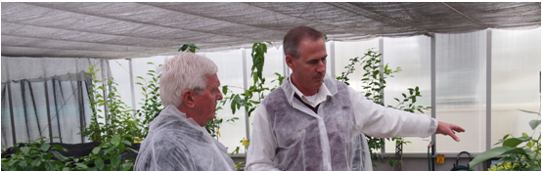

IIGB inspection findings
Post entry quarantine processes
Eastern Creek Quarantine Station

The IIGB visited the Eastern Creek Quarantine Station to inspect DAFF’s post entry quarantine processes for citrus plants as outlined above.

The IIGB notes that citrus canker has not been detected on imported citrus species cultivars at the Eastern Creek Quarantine Station.

The IIGB notes that a good system is in place to manage post entry quarantine along the regulated pathway for citrus canker.

The IIGB notes the benefits of the Eastern Creek Quarantine Station’s pursuit of NATA accreditation for its plant biosecurity laboratory. In this regard, the IIGB notes that he has seen the improvement in standards of diagnostic testing across many animal and plant laboratories operated by State/Territory and Australian governments which have obtained such accreditation.

The IIGB acknowledges that some key industry representatives have reviewed the Eastern Creek Quarantine Station procedural documentation for post entry quarantine for imported plants. However, it would be beneficial for others with relevant scientific and technical expertise (such as state agricultural departments or the CSIRO) to be included in peer review.

Recommendation 1

That DAFF gives consideration to all its quarantine diagnostic laboratories obtaining relevant National Association of Testing Authorities (NATA) accreditation.

Recommendation 2

That DAFF encourages scientific and technical peer review of DAFF’s quarantine station operational manuals and materials on a regular basis (e.g. 3-yearly cycle).

Eastern Creek Quarantine Station
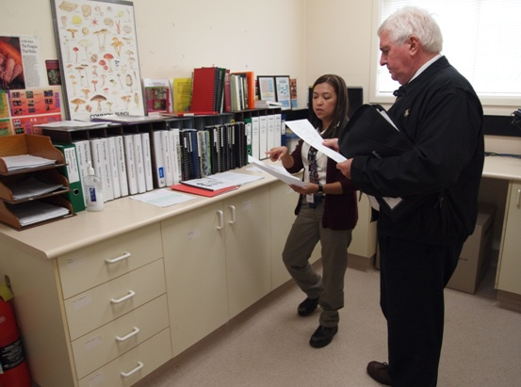

Citrus fruit – commercial imports pathway

DAFF manages the commercial import of citrus fruit through the import permit process.

Currently, imports of fresh citrus fruit are only permitted from countries or areas free of citrus canker.

The general import conditions for commercially imported fruit are:

- An original phytosanitary certificate, correctly completed and relating to the consignment, as per information in the International Plant Protection Convention.
- All consignments treated prior to export must have a commercial treatment certificate attached referencing the consignment.
- Any mandatory preshipment treatments carried out must have the treatment details included on the phytosanitary certificate or as otherwise stated in the ICON conditions under specific commodities.
- Each consignment must be packed in clean, new packaging.
- Timber packaging, pallets or dunnage in Full Container Loads containers or on flat racks will be subject to inspection and treatment on arrival, unless certified as having been treated by a DAFF approved method.
- All consignments (other than those pre-cleared in the country of origin under an arrangement approved by DAFF) are subject to inspection on arrival and any treatment necessary before release.
- Inspection must occur at the first port of call. With the exception of goods that are pre-cleared by DAFF offshore, no land-bridging of consignments will be permitted unless the goods have cleared quarantine.
- Open (door ajar) dry boxes that are used to ship produce that requires airing during transport are acceptable provided the containers are secured by replacing or closing the doors prior to movement from the wharf to the site of inspection. Alternative security can be provided by securely meshing, screening, covering with a heavy plastic sheet or tarping over the open containers.
- All fresh horticulture produce must be securely packaged at origin and packaging requirements must be adhered to. Any breach to the secure packaging requirements for airfreighted perishables will be addressed through additional verification of packaging at Cargo Terminal Operators on arrival in Australia, prior to movement to inspection sites for inspection and clearance.
- All consignments must be free of live insects, disease symptoms, trash, contaminant seeds, soil and other debris on arrival in Australia.
- If disease symptoms or pathogens are detected, then consignments must be held at the importer’s expense, Quarantine Plant Pathologist consulted on the identification and one or more options will be made available to the importer (external identification/re-export/destruction).
- If contaminants including unidentified plant material, seeds (other than the permitted commodity) or trash or soil are found on inspection the consignment must be held at the importer's expense and one below must made available to the importer (contaminants removed or produce reconditioned by a DAFF approved method/ external identification/re-export/destruction).

Inspection process

DAFF sampling and inspection protocols for fresh produce, including citrus fruit, is documented in the Fresh Produce Manual. The manual provides images and descriptions of some of the quarantine pests and diseases (including citrus canker) that the commodity is host to. This manual is available for all quarantine officers involved in the inspection of fresh produce.

Pre-clearance process – optional offshore inspection

DAFF offers an optional offshore (pre-clearance) inspection of certain citrus fruit imported from the USA (California or Arizona only) and New Zealand.

A preclearance inspection is undertaken by DAFF quarantine officers and replaces the quarantine inspection normally undertaken by DAFF at the port of arrival in Australia.

Produce that can be verified as being pre-cleared is not subject to further inspection on arrival in Australia, however DAFF undertakes random physical verification of consignments on arrival in Australia.

Pre-cleared citrus from the USA is required to have additional declarations endorsed on the Phytosanitary Certificate stating that:

- Citrus was produced in California or Arizona in accordance with the conditions governing the entry of fresh citrus fruits from California or Arizona to Australia.
- Pre-clearance inspection was undertaken in California or Arizona in accordance with the Work Plan for the pre-clearance of citrus fruits to Australia.

Import risk analysis

Import risk analysis assist DAFF in considering the level of biosecurity risk that may be associated with the importation or proposed importation of animals, plants or other goods into Australia. If the risks are found to exceed the level of risk that is acceptable to Australia, risk management measures are proposed to enable them to be reduced to the acceptable level. If the quarantine risks cannot be reduced to an acceptable level, the commodity is not allowed to be imported.

DAFF have completed the following import risk assessments related to the commercial import of citrus fruit citrus canker pathway:

- Final Import Risk Analysis Report for Fresh Unshu Mandarin Fruit from Shizuoka Prefecture in Japan 2009/17

DAFF’s policy allows mandarin fruit from four designated export areas in the Shizuoka Prefecture in Japan that were surveyed for over 40 years and found free of citrus canker, to be imported into Australia subject to risk management measures.

The conditions include a requirement that the designated export areas are surveyed at least twice a year and found free from citrus canker.

The following are mandatory measures:

- Unshu mandarin fruit for export to Australia to be sourced only from registered orchards within four designated export areas in Japan (Areas 1–4).
- Freedom from symptoms of citrus canker of the designated export areas for a minimum of two years prior to registration of orchards for export to Australia each season.
- Freedom from symptoms of citrus canker during the growing season based on monitoring of the registered export orchards after petal fall and prior to harvest.
- An additional survey of the export areas if a typhoon should be recorded at the meteorological station in Shizuoka City before the end of August of each year.
- Copper sprays in accordance with the unshu mandarin spray calendar for Japan for the registered export orchards.
- Control for citrus leafminer in accordance with the unshu mandarin spray calendar for Japan for the registered export orchards.
- Restrictions on movement of host material into the export areas.
- Post-harvest chemical treatment.

This audit did not examine the risk management measures along the entry pathway for the commercial import of citrus fruit.

Citrus leaves pathway

Fresh citrus leaves

Fresh citrus leaves are currently prohibited entry due to their high disease risks. Import permit applications are generally not approved for these products.

Dried citrus leaves

Non-commercial

DAFF inspects non-commercial consignments of dried citrus leaves on arrival in Australia.

The leaves are then subjected to heat treatment at 85 degrees Celsius for 8 hours.

If the leaves are not to be treated (refusal by importer, for example) then they are seized and either destroyed or re-exported.

Commercial

DAFF manages the commercial import of dried citrus leaves through the import permit process.

Consignments of dried citrus leaves are subject inspection on arrival in Australia. Consignments are also subject to mandatory heat treatment at 85 degrees Celsius for 8 hours.

Consignments may also be subject to methyl bromide fumigation.

This audit did not examine these risk management measures along the entry pathway for the legal import of citrus leaves.

Illegally imported citrus fruit, leaves and propagating material pathway

Case study
Citrus fruit and leaves carried by air passengers

Purpose of examining DAFF’s procedures for detecting citrus fruit and leaves carried by air passengers

DAFF’s activities that assist in the detection of citrus fruit and leaves and related items (peel, leaves) carried by travellers at the border are risk management measures to control biosecurity risks along a potential entry pathway for citrus canker.

Background

Citrus fruit and related citrus fruit items (for example, kaffir lime leaves) carried by air travellers entering Australia represent a pathway for the entry of exotic pathogens of citrus.

Xanthomonas axonopodis pv citri, the pathogen that causes citrus canker, has been detected on citrus fruit and related citrus fruit items (peel, leaves) intercepted by quarantine officers at the border.

DAFF undertakes passenger and accompanied baggage inspection to control the biosecurity risks associated by entry through this pathway.

Measuring citrus fruit and peel approaching the Australian border at airports – review of data

Amnesty bins

Amnesty bins are placed in every international airport, usually between the point of disembarkation and processing, and are a way for passengers to anonymously dispose of items of quarantine concern without penalty before passing through the border. It also provides DAFF with an indication of the type of commodities that arrive in Australia and have the potential to be carried across the border.

The Central East Region undertakes a survey of its amnesty bins every three months. For the period June 2009 to March 2011, citrus fruit and related items (peel, leaves) accounted for an average of 13.05 percent of the total content of the surveyed bins. This is represented in graph A.

Graph A
Central East Region
Amnesty Bin Survey
June 2009 to March 2011
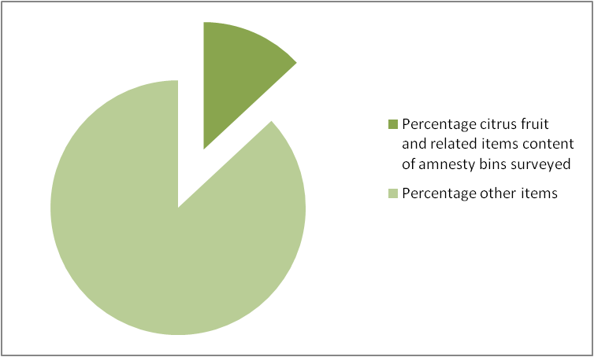

Seizures of citrus items from passengers

DAFF undertakes passenger and accompanied baggage inspection at its airports to detect items of quarantine concern.

Central East Region

During the period January 2010 to March 2011, Central East Region airport quarantine officers seized 8557 citrus fruit and related items from passengers – this equates to approximately 142 per week. Of that number sized, passengers did not declare a total of 2067 of these items – this equates to approximately 34 citrus items per week that, if not for the screening process, would most likely have entered Australia. The remaining 6490 citrus fruit and related items were declared by passengers, usually through a declaration on their Incoming Passenger Card, and disposed of by quarantine officers. This is represented in graph B.

Citrus fruit and related items accounted for 3.26 percent of all non-declared actionable quarantine items seized by quarantine officers at Central East Region airport. This is represented in graph C.

Graph B
Central East Region
Citrus fruit and related items seized from passengers
January 2010 to March 2011
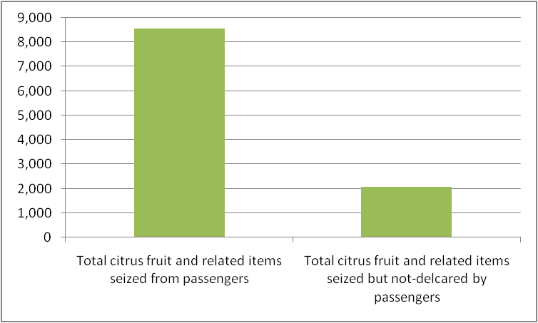

Graph C
Central East Region
Citrus fruit and related items seized from passengers as a percentage of all undeclared items seized
January 2010 to March 2011
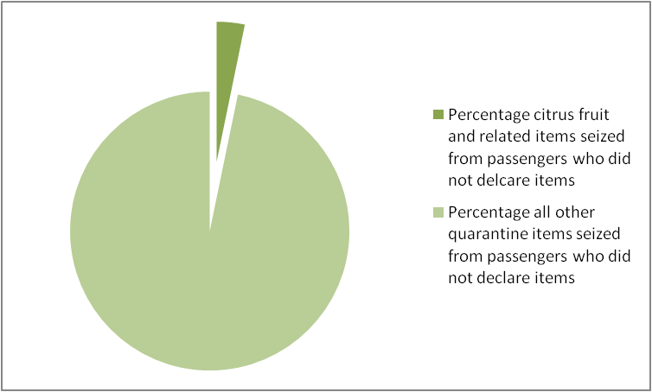

South East Region

During the period January 2010 to April 2011, South Eastern Region airport quarantine officers seized a total of 4892 citrus fruit and related items from passengers – this equates to approximately 81 per week. Passengers did not declare a total of 1162 of these items – this equates to approximately 19 citrus items per week that, if not for the screening process, would most likely have entered Australia. The remaining 3730 citrus fruit and related items were declared by passengers, usually through a declaration on their Incoming Passenger Card, and disposed of by quarantine officers. This is represented in graph D.

Citrus fruit and related items accounted for 8.33 percent of all non-declared actionable quarantine items seized by quarantine officers at South East Region airport. This is represented in graph E.

Graph D
South East Region
Citrus fruit and related items seized from passengers
January 2010 to March 2011
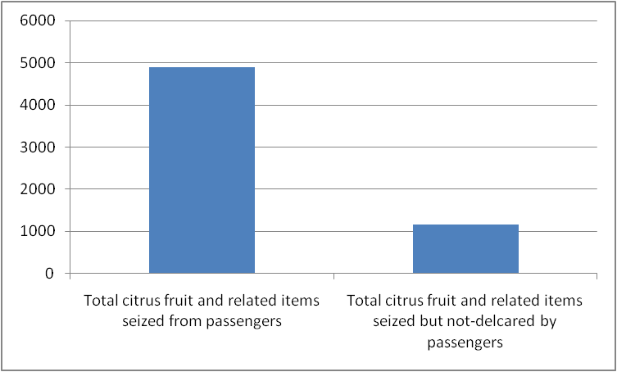

Graph E
South East Region
Citrus fruit and related items seized from passengers as a percentage of all undeclared items seized
January 2010 to March 2011
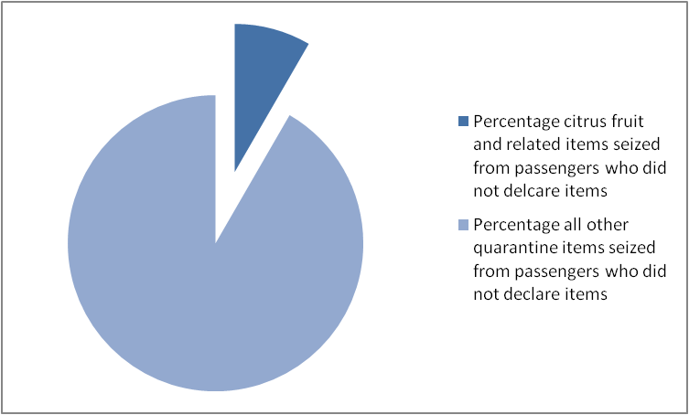

Leakage surveys

The purpose of the leakage survey is to detect items of quarantine concern that were not detected during the normal screening process. Leakage surveys are performed by quarantine officers who have completed specific training.

In simple terms, the officer undertaking a leakage survey randomly selects a passenger every 15 minutes during passenger arrival times for a full baggage inspection. The intent is to examine baggage that was not included in any original inspection.

Central East Region

During the period January 2010 to March 2011, quarantine officers undertaking leakage surveys in the Central East Region seized 11 citrus fruit and related items – this equates to less than one item per month and 1.02% of all quarantine items seized in that region during leakage surveys. This is represented in graph F.

Graph F
Central East Region
Citrus fruit and related items (peel, leaves) seized from passengers as a percentage of all items seized
January 2010 to March 2011
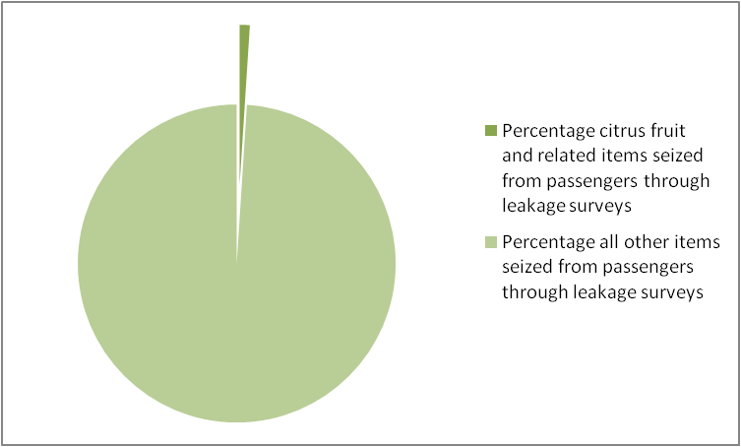

South East Region

During the period January 2010 to March 2011, quarantine officers undertaking leakage surveys in the South East Region seized six citrus fruit and related items – this equates to less than one item per month and 1.69% of all quarantine items seized in that region during leakage surveys. This is represented in graph G.

Graph G
South East Region
Citrus fruit and related items (peel, leaves) seized from passengers as a percentage of all items seized
January 2010 to March 2011
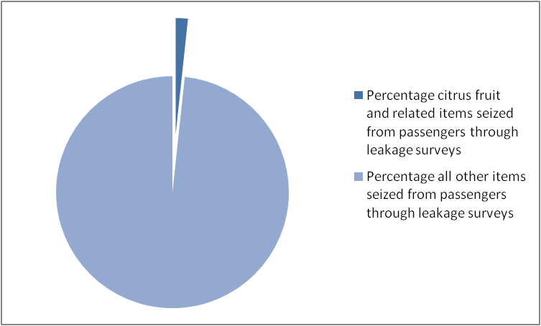

How DAFF detects citrus fruit and leaves carried by air passengers

Profile development

DAFF creates profiles to recommend groups of passengers that should be routinely screened by quarantine officers when arriving at Australian airports. The profiles also recommend the type of screening method (x-ray, manual inspection, detector dogs) to apply to groups of passengers for the optimum detection of actionable quarantine material.

Risk managers create profiles by reviewing a range of information to identify the amount of quarantine material approaching the border with a group of passengers that share similar characteristics (e.g. arriving from a country with a known pest or disease outbreak that is of quarantine concern). They then consider historical data and on the ground observations from quarantine officers to recommend the most effective screening method to detect and intercept the quarantine material.

Passenger assessment (Risk Assessment Officer)

Risk Assessment Officers are trained to assess passengers in and around the baggage reclaim area and in the queue for quarantine screening. Their key function is to assess and release passengers who would otherwise have gone through a quarantine screening process.

Risk Assessment Officers also assess a range of information when considering who should be screened and by what method. For example, quarantine officers may become aware that an airline is handing out citrus fruit to passengers to celebrate a particular cultural event – this intelligence is then considered by Risk Assessment Officers when assessing passengers arriving on this airline.

Also, it is common for passengers with children to carry fruit as snacks, so Risk Assessment Officers may use this knowledge to question a family about undeclared fruit items and use their responses to recommended them for screening through a method best suited to detecting fruit.

Screening

Passengers who have been assessed as requiring screening, either through profiles or risk assessment by a quarantine officer, will usually pass through one of three screening methods:

- X-ray
- Detector dogs
- Manual inspections.

Screening methods are determined by either profiles (see above) or by a Risk Assessment Officer (also see above).

Citrus fruit detected by x-ray and seized from a passenger
Seized at Central East Region airport
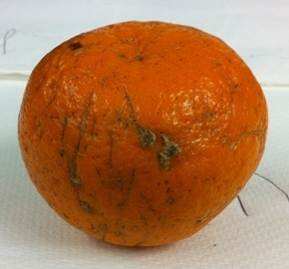

Quarantine action – destruction of goods

The majority of citrus fruit and related items seized at the border are placed in quarantine bins and are destroyed by a third-party contractor acting under a co-regulation agreement with DAFF. An exception would be when there is prosecution pending as a result of the seized item – these items are held in quarantine for the duration of that process.

Quarantine action – verbal warning, written warning, Quarantine Infringement Notices or prosecution

During the period January 2010 to March 2011, Central East Region quarantine officers issued 93 Quarantine Infringement Notices and issued 507 written warnings for passengers carrying citrus fruit and related items. 1 prosecution also commenced during this period.

IIGB summary diagram of the DAFF passenger profiling and processing for routine screening or release

Profile development
National (Border Business & Risk Program)
Local (Regional Risk Managers)
Cohort
for screening
Risk assessment
Profile
Visual
IPC
- Questions
-Seasonal/cultural events
- Passport
Don’t screen
No AQM detected
BORDER
Screen
- X-ray
Manual inspection
Detector Dogs
Leakage survey
AQM detected & quarantined
Action
- Verbal warning
Written warning
- QIN
- Prosecution
Data

Legend

AQM = Actionable quarantine material
QIN = Quarantine infringement notice
IPC = incoming passenger card

Audit interview with DAFF quarantine officers

The main issues that emerged from interviewing DAFF quarantine officers involved in the detection of citrus fruit and leaves carried by air passengers related to:

- Leakage survey
  - Is a critical tool to measure the effectiveness of screening methods.
  - Data from the leakage survey is assuring – good results – shows current methods are working.
  - As quarantine officers are trained to profile, should it be performed by an independent officer to be more effective?
- Sampling of seized quarantine items
  - It would be good to have a better level of sampling/interaction with the Operational Science Group.
- System improvements
  - Systems need to be set up with a continuous improvement loop.
  - Need smarter use of screening methods – e.g. citrus fruit shows up well on x-rays but peel is difficult to detect using this method.
  - Surveillance of airplanes should be undertaken.
  - Need more on offshore education to reduce approach rate of quarantine goods.
- General
  - Detecting deliberate attempts to conceal and bypass quarantine by passengers is a challenge.

Moving towards a risk return environment

DAFF is currently implementing a risk return model across its international airport operations. Essentially, this model seeks to utilise the current activities, such as profiling and screening, in the most effective and efficient way.

The main difference is that the current system operates on an ‘all-in’ approach; that is, a passenger will be screened unless a quarantine officer assesses and releases them. Under the risk return model, a non-declared passenger will not be screened unless a quarantine officer assesses them as requiring screening. The shift from an ‘all-in unless we assess you as being out’ to an ‘all out unless we asses you as being in’ is a significant shift.

In the course of this audit, the IIGB did not extend the review to the rolling-out of the risk return model. However, the IIGB notes that this model will change the current approach to detecting items of a quarantine concern at the border and therefore should be closely monitored to ensure that it provides a high-level of assurance that these items are detected and intercepted at the border.

IIGB audit findings

The following findings are based on a Biosecurity Secretariat Auditor, on behalf of the IIGB, undertaking:

- a desktop review of DAFF’s processes and procedures as they relate to detecting citrus fruit and leaves concealed by air passengers
- audit fieldwork at Central East and South East Region offices.

Quarantine officers at Australia’s international airports operate in a dynamic environment. The movement of people and a broad range of items of quarantine concern across the border presents many challenges. One of these challenges, detecting the high-level of citrus fruit and related items approaching the border, appears to be well-managed by the current approach.

Although there is a high-level of citrus fruit and related items approaching the border, it is not clear what level of biosecurity risk is associated with these items as they are routinely destroyed without being tested for pest or diseases. The IIGB believes that a period of laboratory analysis (for example, over a 10 day period once yearly at two international airports) on citrus fruit and related items seized through leakage surveys could:

- assist in gauging the biosecurity risk of items that have leaked through the initial detection activities
- better inform DAFF’s passenger screening profiles
- foster a closer relationship within DAFF between the Operational Science Program and quarantine officers
- better inform quarantine officers of how and why their efforts assist in stopping potential pest and disease entry by relating real examples of interceptions at the border.

DAFF should also monitor and review the implementation of the risk-return model, as it relates to passenger screening, to ensure that it continues to provide a high-level of assurance that items of a quarantine concern are detected and intercepted at the border.

Recommendation 3

That DAFF considers undertaking periodic laboratory analysis for pests and diseases on citrus fruit and related items seized through leakage surveys.

Recommendation 4

That DAFF ensures that the implementation of the risk return model, as it relates to passenger screening, is monitored and reviewed.

This audit did not examine the risk management measures for the illegal import of propagating material. This aspect may be included in future audits by the IIGB of sea and air cargo risk management procedures and systems.

Movement of citrus fruit, leaves and propagating material through the Northern Australia Quarantine Strategy (NAQS) zone pathway

Background

Northern Australia is considered to be a risk zone for entry of illegally carried citrus fruits and leaves. This assessment is made on the basis that:

- Torres Strait Islanders regularly navigate between the southern coast of Papua New Guinea, the islands of the Torres Strait and the mainland on Cape York. Citrus pests and pathogens on fruit carried by them could transfer to citrus or citrus relatives growing on the islands and eventually to the Australian mainland (Brown, 1998).
- Citrus fruit and leaves may be carried on ships and international yachts. Ships are intercepted at recognised ports, but cruising ships could dump decaying fruit at remote or unauthorised localities.
- Island hopping by people in light aircraft is known to occur.
- Uncontrolled and non-commercial pathways operate in the Torres Strait, such as winds and insect movement.
- Illegal landings of foreign vessels occur, for example foreign fishing vessels

Overview of NAQS

The Northern Australia Quarantine Strategy was established in 1989 to help address the unique quarantine risks in Australia’s northern region. NAQS conducts surveys along our northern coastline and neighbouring countries for early signs of new pests or disease. NAQS also has a high presence in the Torres Strait, monitoring the movement of people and cargo between Papua New Guinea and the Australian mainland and ensuring high public awareness of quarantine arrangements people living in this strategically important quarantine zone.

The NAQS program is overseen and coordinated by a management group based in Cairns that also includes senior Torres Strait and Darwin managers. This group reports to the Executive Manager - Quarantine Operations through the Regional Manager-Northern Region.

The NAQS zone of responsibility is the northern coastal area of Australia from Cairns to Broome, including the islands of the Torres Strait. Darwin airport and seaport biosecurity services are provides by other parts of DAFF and are not the responsibility of the NAQS program.

In the Torres Strait, NAQS has 15 permanent quarantine officers stationed on the 13 inhabited outer islands and 9 permanent quarantine officers stationed on Thursday Island. Almost all of these are members of the relevant local island Indigenous communities.

The role of NAQS is diverse and includes:

- Torres Strait border management of movements of PNG traditional visitors, cargo, air and sea passengers, aircraft, vessels and mail.
- Identification and evaluation of unique quarantine risks in northern Australia.
- Early detection (of targeted pests, weeds and diseases of quarantine concern).
- Contribution to surveillance, and capacity building with neighbouring countries.

The main components of the NAQS program can be schematically represented as:

Science
Surveillance
Monitoring
Border
control
Public
awareness

Citrus canker and the NAQS zone

- Citrus canker was detected on Thursday Island in 1984 but was eradicated before the inception of the NAQS program.
- Citrus canker was detected in the Darwin area during a NAQS survey in 1991 and was subsequently eradicated.
- Lemons and limes are grown in backyards and regularly used by households for cooking across much of northern Australia including the Torres Strait islands.
- NAQS scientific staff considers the risk of entry of citrus canker to be essentially a human movement associated pathway rather than wind or vector, otherwise they would have expected to detect it on more occasions during the 21 year history of surveying and surveillance in NAQs regions.
- NAQS officers report that they have a high level of knowledge of the distribution of citrus plants in Cape York and Torres Strait.
- Citrus canker was detected in Daru, the capital of the Western Provence of PNG, in a small area on the western side of town for 4-5 years of surveys but then in one year made a rapid spread across the town.
- Citrus canker was detected in a survey of Solomon Islands in 2010.

Data sharing between government agencies operating in the NAQS zone

A number of other government agencies operate in the north of Australia, the most relevant to biosecurity being the:

- Department of Immigration and Citizenship
- Department of Foreign Affairs and Trade
- Australian Customs and Border Protection Service
- Australian Fisheries Management Authority
- Great Barrier Reef Marine Park Authority
- State and Territory primary industry and agriculture agencies.

These agencies have varying requirements for the transmission and security of information. This may have implications for what information and data is available to NAQS officers.

Public awareness

‘Quarantine Top Watch!’ is the national public awareness campaign of the NAQS. It is designed to:

- raise awareness of the importance of quarantine within key target groups in northern Australia, and
- encourage residents in those regions to 'keep a top watch' for exotic pests, weeds and diseases that could harm Australia's animal and plant life, and report sightings of unusual pests, weeds and diseases to NAQS officers.

The campaign also aims to inform residents about the important activities undertaken by NAQS in the region.

Science, surveillance and monitoring

NAQS has included Xanthomonas axonopodis pv citri, the bacteria that causes citrus canker, on its target list for plant pathogens and conducts extensive monitoring to prevent its entry.

NAQS officers take the time of year into consideration when surveying for citrus canker:

- Wetter conditions would express canker.
- Drier conditions would make it harder to detect.

Quarantine border control

NAQS officers undertake quarantine inspection and clearance activities, such as passenger screening and quarantine management of goods imported by traditional visitors from Treaty villages in PNG, and those moving between legislated quarantine zones. NAQS services are delivered in-line with DAFF standard operating procedures and work instructions. However, these procedures and work instructions are supplemented by NAQS specific procedures and work instructions to cater for the unique operating environment. These supplementary procedures and work instructions are endorsed by DAFF central office.

IIGB inspection findings
Northern Australia Quarantine Strategy
Northern Region (Cairns)

The IIGB visited DAFF’s Northern Region office in Cairns to observe DAFF’s processes for detecting the movement of citrus fruit, leaves and propagating material through the NAQS zone pathway as outlined above.

The IIGB finds that the biosecurity risks are well managed along this citrus canker pathway under the NAQS program. In particular, the IIGB finds that:

- The public awareness program is effective. The IIGB recognises its vital importance to the success of the NAQS program. In particular the Quarantine and AQIS corporate branding appear to be highly recognisable by local communities. Given the history and success of the NAQS program in dealing with several unique challenges of geographic and cultural dimensions, it is important to retain a high level of community engagement and understanding.
- The high number of Indigenous staff within the NAQS program is a strength, due to the credibility, respect and standing local staff have within their community. The IIGB found this can lead to good awareness of quarantine in the north and a high-level of compliance with quarantine requirements pertaining to movement of plant materials and other goods of biosecurity significance.
- Within the NAQS program, the close interaction of the scientists with procedures and operations is a strength.

The IIGB has identified a potential challenge in the way information and data continues to be captured and shared across the various agencies operating in Australia’s northern region.

NAQS officers reported that they often find it is no longer as easy to obtain the right information for quarantine purposes at the right time, or it is highly summarised or sanitised and therefore of lower value in a quarantine sense. This can reduce the ability of NAQS officers to assess biosecurity risks and respond effectively.

The IIGB did not examine any data sharing arrangements between NAQS and other government agencies operating in the north of Australia, but considers there may be benefit in DAFF working with these agencies on an appropriate (or amended) information and data sharing protocol.

Recommendation 5

That DAFF gives consideration to how any future changes to communication activities (e.g. corporate branding) for DAFF might impact on the NAQS program.

Recommendation 6

That DAFF considers working with other agencies operating in Australia’s northern region on an appropriate (or amended) information and data sharing protocol.

NAQS Operations – Cairns
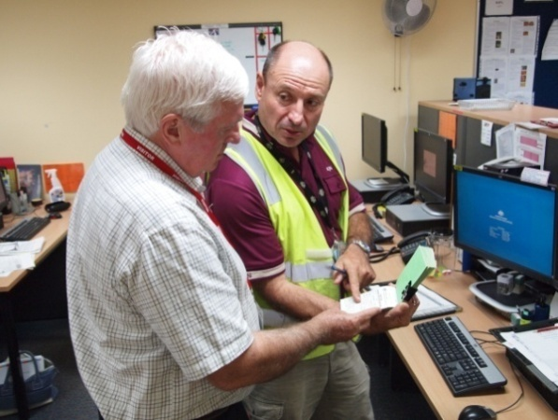

Used fruit handling machine pathway

Case study
Used fruit handling machinery

Purpose of examining used fruit handling machinery

The import conditions (permits) and inspections (both on and off shore) are risk management measures that are in place to control biosecurity risks along a potential entry pathway for citrus canker (leaves, plant parts).

Background

Used fruit handling machines imported from Xanthomonas axonopodis pv citri (citrus canker) host countries could inadvertently transport infected plant parts.

The classification of machinery as ‘fruit handling’ is at DAFF’s discretion. It could include harvesters, fruit picking machines, loaders, tree shaking machinery and graders.

DAFF requires an import permit for the importation of used fruit handling machinery. The permit conditions require, among other things:

- A valid declaration from the exporter stating ‘the machinery has been cleaned and is free of contamination’.
- That each consignment must be free of soil, mud, live insects, plant and animal debris and other quarantine risk material before arrival in Australia.
- That all consignments will be subject to a full unpack and inspection at a metropolitan Quarantine approved premises to ensure that the consignment is free of quarantine risk material.

For the importation of large consignments, DAFF offers an offshore inspection service.

An offshore inspection involves an importer requesting a DAFF officer to inspect machinery/equipment before it is transported to Australia. The offshore inspection is a replication of the inspection procedures that would otherwise be undertaken in Australia. The machinery will still be subject to quarantine on arrival, and a verification inspection will be conducted to ensure the goods arrive in a clean condition.

There are different import conditions for used agricultural equipment. Machinery classified as agricultural machinery may include combines, cotton harvesters and cultivators. This audit did not examine import permit data or risk management measures for used agricultural equipment.

IIGB audit findings

Used fruit handling machines imported from citrus canker host countries could inadvertently transport infected plant parts.

The IIGB found that 11 import permits for used fruit handling machinery were granted for the period 1 January 2010 to 16 March 2011. None of these permits were for citrus handling machines or machines that were destined for citrus growing orchards.

The permits were associated with: beans, capsicums, pecans, cucumbers, almonds, vegetables (various), grapes, tomatoes, blueberries and prunes.

However, the IIGB finds that DAFF’s risk management measures appear to be able to effectively limit the risk of imported used fruit handling machines inadvertently transporting plant parts infected with citrus canker.

Recommendation

The IIGB has no specific recommendations relating to this pathway.

Appendix A Definitions

The biosecurity divisions of the Department of Agriculture, Fisheries and Forestry

The biosecurity divisions within the Department of Agriculture, Fisheries and Forestry are responsible for managing Australia's biosecurity system. They comprise:

- Biosecurity Plant
- Biosecurity Animal
- Biosecurity Food
- Biosecurity Quarantine Operations
- Biosecurity Regional and Business Services
- Biosecurity Strategic Projects

Biosecurity Services Group (BSG)

The Biosecurity Services Group was comprised of a number of divisions within the Department of Agriculture, Fisheries and Forestry. It was formed on 1 July 2009 and integrated the functions of the Australian Quarantine and Inspection Service; Biosecurity Australia; the biosecurity parts of Product Integrity, Animal and Plant Health division; and the Quarantine and Biosecurity Policy Unit.

BSG became known as the biosecurity divisions of the Department of Agriculture, Fisheries and Forestry during 2011.

AQIS

The Australian Quarantine Inspection Service is part of DAFF and operates across a number of the department’s biosecurity divisions. AQIS manages quarantine controls at our borders to minimise the risk of exotic pests and diseases entering the country. AQIS also provides import and export inspection and certification to help retain Australia's highly favourable animal, plant and human health status and wide access to overseas export markets.

DAFF biosecurity officer

An officer employed within one of DAFF’s biosecurity divisions – includes quarantine officers.

Quarantine officer

A quarantine officer is an officer of DAFF appointed under the Quarantine Act 1908. A quarantine officer has legislated and delegated functions and/or powers relating to quarantine – for example, a quarantine officer has the power to require a person to provide additional information about goods imported into Australia.

Nursery stock

Nursery Stock is defined as all propagative plant material, other than seeds, imported for purposes of propagation.

It may include:

- Budwood
- Bulbils
- Bulbs
- Corms
- Cuttings
- Grafting wood
- Leaves
- Pips
- Plants
- Rhizomes
- Roots
- Seedlings
- Slips
- Stems
- Tissue cultures
- Tubers

and any other tissue imported for purposes of propagation.

It does not include propagative plant material imported for purposes other than propagation.

Pest and/or disease

Any species, strain or biotype of plant, animal or pathogenic agent injurious to plants
or plant products.

Exotic pests are those not currently present in Australia. Endemic pests are established within Australia.

Biosecurity risk

Potential harm to the economy, environment, and human health from the negative impacts associated with the entry, establishment or spread of exotic pests (including weeds) and diseases.

Also referred to as quarantine risk.

Risk management measure

A measure that, if implemented, could reduce the level of biosecurity risk associated with a pest or disease.

Also referred to as quarantine measure.

Offshore

Activities and arrangements that seek to prevent biosecurity risks reaching Australia’s border. Also referred to as pre-border.

Border

Activities that seek to intercept biosecurity risks that present at airports, seaports, mail centre and along Australia’s coastline.

Appropriate level of protection (ALOP)

The level of protection deemed appropriate by a country establishing a sanitary (human and animal health) or phytosanitary (plant health) measure to protect human, animal or plant life or health within its territory – also known as the acceptable level of risk.

Australia’s ALOP is currently expressed as providing a high level of sanitary and phytosanitary protection, aimed at reducing risk to a very low level, but not to zero.

Risk analysis

Assessment of the level of biosecurity risk associated with the importation, or proposed importation of animals, plants or goods and, if necessary, identification of risk management options to limit the level of risk to achieve Australia’s appropriate level of protection.

Import risk analysis (IRA)

A type of risk analysis with key steps regulated under the Quarantine Regulations 2000. (Biosecurity Australia’s Chief Executive) determines if a risk analysis will be conducted as an import risk analysis based on criteria outlined in the Import Risk Analysis Handbook 2007 (update 2009). A risk analysis which does not meet these criteria will be undertaken as a non-regulated analysis of existing policy.

Non-regulated analysis

A risk analysis conducted as a non-regulated analysis of relevant existing policy.

Also known as a policy and/or scientific review, or a pest risk analysis.

Alternate host

A species of host other than the principal host on which a pest or disease can survive.

Commercial import

Of, pertaining to, or characteristic of commerce –usually refers to items that are imported for sale or use through a business

Non-commercial import

Not of, pertaining to, or characteristic of commerce – usually refers to items that are imported for personal use.

Citrus fruit and leaves and related items

Includes citrus fruit, such as lemons, limes mandarins and oranges; citrus leaves, both fresh and dry, such as kaffir lime leaves; and other citrus related products seized by quarantine officers.

Appendix B
Reference material

- Pest and Disease Image Library (PaDIL) Risk Analysis – citrus canker
- Senate inquiry report - The administration by the Department of Agriculture, Fisheries and Forestry of the citrus canker outbreak – June 2006
- A Target List Of High Risk Pathogens Of Citrus – DAFF 2002
- AQIS Import conditions database (ICON)

Senate inquiry report - The administration by the Department of Agriculture, Fisheries and Forestry of the citrus canker outbreak – June 2006
A TARGET LIST OF HIGH RISK PATHOGENS OF CITRUS – DAFF Office of the Chief Plant Protection Officer 2002
Data supplied by DAFF Central East and South East Regional offices
This does not reflect the processing and management of passengers who declare items of a quarantine concern
A TARGET LIST OF HIGH RISK PATHOGENS OF CITRUS – DAFF Office of the Chief Plant Protection Officer 2002
International Plant Protection Convention

