

Effectiveness of biosecurity controls for importation of tomato and carrot seeds

Audit report
No. 2015–16/04

© Commonwealth of Australia 2016
Ownership of intellectual property rights
Unless otherwise noted, copyright (and any other intellectual property rights, if any) in this publication is owned by the Commonwealth of Australia (referred to as the Commonwealth).
Creative Commons licence
All material in this publication is licensed under a Creative Commons Attribution 3.0 Australia Licence, save for content supplied by third parties, logos and the Commonwealth Coat of Arms.
Creative Commons Attribution 3.0 Australia Licence is a standard form licence agreement that allows you to copy, distribute, transmit and adapt this publication provided you attribute the work. A summary of the licence terms is available from creativecommons.org/licenses/by/3.0/au/deed.en. The full licence terms are available from creativecommons.org/licenses/by/3.0/au/legalcode.
Cataloguing data
Interim Inspector-General of Biosecurity 2016, Effectiveness of biosecurity controls for importation of tomato and carrot seeds, Department of Agriculture and Water Resources, Canberra.

Internet
Effectiveness of biosecurity controls for importation of tomato and carrot seeds is available at igb.gov.au/Pages/completed-audits-and-reviews.aspx.

Interim Inspector-General of Biosecurity
Department of Agriculture and Water Resources
Postal address GPO Box 858 Canberra ACT 2601
Switchboard +61 2 6272 3933
Email inspgenbiosecurity@agriculture.gov.au
Web igb.gov.au/Pages/default.aspx
Inquiries about the licence and any use of this document should be sent to copyright@agriculture.gov.au.
The Australian Government, represented by the Interim Inspector-General of Biosecurity, has exercised due care and skill in preparing and compiling the information and data in this publication. Notwithstanding, the Interim Inspector-General of Biosecurity, the Australian Government’s employees and advisers disclaim all liability, including for negligence and for any loss, damage, injury, expense or cost incurred by any person as a result of accessing, using or relying upon information or data in this publication to the maximum extent permitted by law.

Note: From 16 June 2016, the Quarantine Act 1908 will be repealed and replaced with the Biosecurity Act 2015, and management of biosecurity risk in relation to imported goods will be governed by the Biosecurity Act 2015. This report refers only to the Quarantine Act 1908 and subordinate legislation.
Contents
Summary 1
Key findings 3
Conclusions 9
Recommendations 10
1 Background 14
2 Audit objectives and scope 31
3 Pre-border controls 34
4 Border controls 38
5 Post-border controls 51
6 International seed movements 56
7 Observations and findings 72
Appendix A: Agency response 103
Appendix B: Guide to acceptable seed analysis certificates issued offshore 109
Appendix C: Department of Agriculture and Water Resources approved seed testing laboratories 110
Appendix D: ISTA-accredited laboratories in Australia 111
Appendix E: List of international seed companies currently certified under Naktuinbouw Authorised Laboratory (NAL) system 112
Appendix F: Variables considered in document assessment for imported tomato and carrot seed 113
Appendix G: Ambiguities in BICON system for tomato and carrot import requirements 116
Glossary 118
References 120

Summary

Background
- Australia is relatively free of many of the serious animal and plant pests and diseases that exist in other countries. This gives our export‐oriented agricultural industries an advantage in global markets and helps maintain the uniqueness of Australia’s natural environment. Managing threats to the community, industry and the environment is an essential function of the quarantine and biosecurity system.
- The introduction of pests can cause serious production losses to plant industries, jeopardise exports of plants and plant products, and have a significant impact on the environment and economy. Australia’s geographic isolation and lack of shared borders provide a degree of natural protection from exotic threats. Our national biosecurity system also helps prevent the introduction of pests that can harm agricultural industries and the environment.
- No quarantine system can guarantee complete protection from exotic pests given rapid increases in overseas tourism, imports and exports and mail, and changing transport procedures (such as, refrigeration and containerisation of produce). Pests can also enter the country via natural routes. This is why Australia has a nationally coordinated system of surveillance, inspection and control (pre-border, border and post-border measures) that helps prevent the introduction and spread of unwanted pests that threaten humans, plants, animals or the environment. These biosecurity management activities are the shared responsibility of the Australian Government, state and territory governments, plant industries and the wider community.
- The Australian Department of Agriculture and Water Resources has primary responsibility for managing Australia’s biosecurity regime across the entire continuum— pre-border, border and post-border. The department has regulatory responsibility for pre-border and border activities. State and territory governments are responsible for post-border activities such as surveillance and responses to incursions.
- In recent years, the department’s biosecurity management has placed increasing emphasis on using offshore measures to address risks. Consistent with international agreements, an important approach to offshore mitigation of quarantine risks associated with imported plant material (including seeds) is to ensure that documentation, such as phytosanitary and/or laboratory test reports accompanying imported consignments, certify that the goods are free from contamination, pests or diseases. At the border, the department conducts physical verification inspection of a representative sample of an imported consignment, against the accompanying documentation; this is to confirm that the imported material meets Australia’s import requirements.
- Vegetable seed production is a complex global industry that involves many international pathways and technical challenges. These challenges include minimising the spread of pathogens and pests, and harmonisation of international seed testing standards. In Australia, tomato seed is imported from at least 20 countries, including China, France, Israel, Italy, the Netherlands, South Africa, Taiwan, the United Kingdom and the United States. Imported vegetable seeds (including tomato and carrot seeds) from these countries may have been multiplied or processed in other countries.
- Seed imports present significant biosecurity risks due to the many production and import pathways involved, including contracted farms in countries where biosecurity might not always be consistent with Australian standards. A major biosecurity risk with seed production is infection of seed with pathogens that cannot be detected by visual inspection. These include viruses, viroids and bacteria.
- To assess the effectiveness of current import controls imposed in Australia for tomato and carrot seeds, it is important to have some understanding of the biosecurity measures used in other countries, and the application of international phytosanitary standards.
- The importation of seeds for sowing is considered to be a potential high-risk pathway. Therefore the department, as the main regulatory agency, must apply risk management measures to achieve the ‘appropriate level of protection’ for Australia. Consideration of the level of biosecurity risk is based on a pest risk analysis (PRA) or an assessment of individual products from a specific country. A PRA or an assessment considers specific biosecurity risks and identifies appropriate risk management measures.
- Under the Quarantine Act 1908, the department implements biosecurity and emergency measures to minimise risks and subordinate legislation, including the Quarantine Proclamation 1998. The Quarantine Act governs importation of tomato and carrot seeds into Australia. An import permit is required to import of tomato (Lycopersicon species and Solanum species synonyms) and carrot (Daucus carota) seeds. Imports must comply with conditions listed on the permit. The Biosecurity Act 2015 will replace the Quarantine Act 1908 in June 2016.
- Apart from infestation with pathogens (such as viruses, viroids, fungi, bacteria and phytoplasmas), imported tomato and carrot seeds may be contaminated with biosecurity risk material (such as prohibited/restricted seeds, soil, faeces, feathers or other animal related material and live insect pests). The department has identified specific plant pathogens (or strains of diseases) of biosecurity concern that are not present in Australia that could be introduced via imported tomato and carrot seed. The department classes these pests/pathogens as ‘regulated’ pests. The seed production industry aims to manage a wide range of other pests and diseases that can affect tomato and carrot crops. If and when a new pest is identified, the department assesses the biosecurity risks and applies appropriate control measures.

Purpose
- The purpose of this audit is to inform the Australian Government Minister for Agriculture and Water Resources about the effectiveness of the department’s biosecurity controls in managing risks associated with importing tomato and carrot seeds into Australia. Due to time and resource constraints, much of this report is focused on tomato seed imports; however, many of the biosecurity issues are common to both tomato and carrot seeds.

Key findings

Biosecurity risks associated with seed imports
- Seeds present significant biosecurity risks due to the numerous complex, variable international production pathways, including contracted farms in countries where biosecurity might not always be consistent with Australian standards. A major biosecurity risk with seed production is infection of seed with pathogens (such as viruses, viroids, bacteria, fungi and phytoplasmas) that cannot be detected by visual inspection.

Previous incursions
- Outbreaks of exotic plant pest through imported seeds have not been frequently detected in Australia; when they do occur they can be very disruptive and costly. The official reports of plant pest, pathogen and weed incursions include new pests, extension of host and geographical range. The data are approximate, due to some uncertainties regarding diagnoses. Also, there can often be a significant time lag between the actual pest incursion and a definitive identification of the specific exotic pest(s).
- Retrospective confirmation of entry pathways of exotic plant pests is difficult, and there has been no comprehensive, systematic review of reported incursions during the past five years. The IIGB noted that CSIRO and the Plant Biosecurity Cooperative Research Centre have undertaken two studies, of limited scope. The department has concluded that, during this time, at least nine significant incursions are highly likely to have entered through vegetable seed imports.
- The IIGB was informed that in 2008 when the department agreed to allow tomato seed imports on the basis of visual inspection, there were continuing reports of PSTVd incursions. These reached a peak in 2011–12, and the department concluded that certification based on visual observation of the crop was ineffective. The emergency measures for tomato seed were then changed, to require that each imported tomato seed lot be tested. Since the introduction of mandatory testing, it appears that the incidence of PSTVd incursions has been substantially reduced.

International regulation
- Despite strenuous efforts over several decades, by governments and industry bodies, with the objective of harmonising regulations and encouraging regional or international seed trade, there are still considerable differences in seed laws and regulations. These differences, and countries’ plant health status, mean that seed cannot always move freely between countries.
- International standards relating to trade of plant-based commodities are developed and promulgated by the International Plant Protection Convention (IPPC). Currently, a standard for seeds for sowing does not exist. However, the IPPC has now prepared a draft International Standard for Phytosanitary Measures (ISPM) for international movement of seeds. The draft standard includes:
- guidance to assist national plant protection organisations identify, assess and manage the pest risk associated with the international movement of seeds
- guidance on
  - criteria for the harmonisation of phytosanitary import requirements to facilitate the international movement of seeds
  - criteria for the harmonisation of procedures for re-export of seeds
  - inspection and testing of seeds
- control of seeds for laboratory testing or destructive analysis, and seeds for planting under restrictive conditions.
- It is anticipated that this standard, when finalised, will describe specific phytosanitary measures that may be used to reduce the risks associated with the international movement of seeds.

Need for imported seed
- Australia relies heavily on imported hybrid seeds for a range of vegetable crops including tomatoes and carrots. The popularity of hybrids is due to their vigour, uniformity, disease resistance, stress tolerance and desirable horticultural traits including early fruiting, longer shelf life and consistent yield. Major international seed companies contract out vegetable seed production (including tomato and carrot seeds) in one or more of around 25 countries, including Thailand.

Phytosanitary control in Thailand
- The Thai Government, with the cooperation of industry, has been making determined efforts to establish Thailand as the major regional centre for vegetable seed production. A range of phytosanitary and traceability measures have been implemented, to ensure that clean seed is imported for growing (multiplication), and high-quality seed is exported.

Phytosanitary control in the Netherlands
- The Dutch plant breeding industry is a major, highly-developed and important economic activity in the Netherlands. There is general recognition amongst all government agencies and industry sectors, that the production of high-quality, pathogen-free seed is a national priority.
- The Netherlands national plant protection organisation (NPPO)—the Food and Consumer Product Safety Authority (NVWA)—is an integral part of the Ministry of Economic Affairs. The NVWA is solely responsible for management of matters related to plant health within the context of European Council Directive 2000/29/EC.
- The NVWA is the supervising authority responsible for administration of the Dutch Plant Diseases Act. The NVWA has delegated plant health inspections, in particular import and plant passport checks, to several regulatory agencies:
- Flower Bulb Inspection Service—responsible for plant health checks of flower bulbs
- Quality Control Service—responsible for plant health checks for end products (such as, cut flowers, vegetables and fruit)
- Dutch General Inspection Service for Agricultural Seed and Seed Potatoes—responsible for plant health checks of arable crops (such as, potatoes, maize)
- Netherlands Inspection Service for Horticulture—responsible for plant health checks of horticultural crops, in particular propagation material.
- Netherlands Inspection Service for Horticulture (Naktuinbouw) is an autonomous public agency with a high level of recognised expertise, jointly funded by industry and government. It is regulated by the Netherlands Ministry of Economic Affairs.
- Naktuinbouw develops seed testing protocols independently and with other national and international institutions and private companies. Its other roles include:
- conducting quality inspections of companies that breed and trade propagating material for the floricultural, arboriculture and vegetable crop sectors; material includes seeds, cuttings, seedlings, plants and trees
- issuing plant passports for propagation material to be traded within the European Union
- conducting import and export inspections
- checking quality-plus systems used by companies aim to add value to their products and gain market access in certain countries
- conducting laboratory testing
- conducting health and quality tests
- analysing seeds
- conducting diagnostic tests
- conducting forensic tests
- testing for disease resistance
- conducting plant variety tests
- delivering training courses.

Biosecurity risk management by the department
- Across the biosecurity continuum, the department manages risks associated with importation of vegetable seeds through:
- risk assessment—this includes profiling, surveillance, intelligence, pest risk assessments and
- import permit and conditions, with a range of phytosanitary measures, to achieve Australia’s ALOP
- mandatory documentation (certification)
- additional specific phytosanitary declarations—wherever specific information is required in relation to the mitigation of regulated pests or diseases overseas
- seed treatments
- seed health testing
- border controls, including verification inspection (and treatment, where applicable) of imported consignments at quarantine approved premises (QAPs)
- industry notices and import conditions alerts—issued whenever significant changes are made to import requirements, including the implementation of emergency measures to manage newly-identified risks
- approved pathways—permitting import of vegetable seed lines produced by offshore producers that have been assessed by the department.
- A recent internal review by the department identified several areas where management of biosecurity measures should be improved. The IIGB’s findings are generally consistent with the review findings. The IIGB supports the department’s efforts to address these deficiencies.
- The IIGB found that the department communicates changes to import requirements to regional staff and industry in a timely manner. When required, the department also promptly reissues updated import permits to importers. The department should consult with relevant industry organisations when considering any significant changes to import conditions or reviewing regulatory processes.

Pest risk analyses
- Pest risk analyses (PRAs) are crucial for:
- establishing appropriate import conditions, consistent with Australia’s appropriate level of protection
- identifying significant pests, including those requiring regulation by the department
- assisting contingency planning and design of emergency control measures.
- The department has recently published a draft PRA for importation of carrot seeds, specific to a regulated pest, Candidatus Liberibacter solanacearum (Department of Agriculture and Water Resources 2015b). In addition, it has begun a review of various vegetable seed imports (including tomato seed). Delays in the production of draft PRAs have frustrated industry stakeholders. A formal, more generic PRA (that is, covering all identified pests for a particular vegetable species) would remove ambiguity and provide transparency with regard to:
- significant pests and diseases that the department considers might enter Australia via tomato seed imports
- underpinning justification for import requirements imposed by the department
- appropriate emergency management measures to be implemented, in the event of an incursion of a significant pest.
- The IIGB understands that if a PRA for importation of tomato seed had been completed, it would have addressed the technical concerns raised by industry, and the department would not require ‘non-regulated analysis of the existing policy’ for vegetable seed; a non-regulated analysis of a policy does not involve stakeholder consultation. A PRA would also consider potential biosecurity risks from exporting countries and appropriate risk management measures.

Industry consultation
- Effective communication is critical to biosecurity risk management and should focus on developing a shared view of import requirements and an understanding of the needs and capabilities of all stakeholders. Reluctance to share disease information might be motivated by commercial competition, but most industry participants are likely recognise the greater long-term benefits of a transparent, cooperative approach such as the Netherlands model. The constructive (yet competitive) relationship between seed companies in the Netherlands extends to the national regulatory agencies and international seed industry organisations. The department could use this model to initiate collaboration with stakeholders.
- The IIGB supports the concept of collaborative partnerships for biosecurity risk management in the seed industry, and suggests that the department explore possibilities for implementing more ‘approved pathways’ for importing seed for sowing. To develop such collaborative partnerships would require the department to engage more actively with tomato and carrot seed importers, industry associations and where appropriate, international organisations and agencies. Such a cooperative approach should focus on high-priority areas of mutual benefit, and need not be inconsistent with the differing aims of commercial and regulatory parties.

Post-border controls
- As a major producer and exporter of plants and plant products, Australia places a high priority on plant biosecurity. The department has been developing a post-border biosecurity system that will involve government and industry sharing the responsibility for implementing a range of biosecurity measures.
- The effective management of post-border plant biosecurity relies on a constructive partnership between federal and state governments, plant industries (including seed companies), producers and Plant Health Australia (PHA).
- Continuous surveillance and monitoring is an essential component of the Australian biosecurity system. Surveillance and monitoring involves activities designed to:
- reveal the presence of pests (for early detection)
- demonstrate the absence of pests (for market access)
- determine the distribution of pests (in response to an incursion or for ongoing management)
- identify high-risk pathways and areas where pests are likely to establish (to focus surveillance efforts)
- aid collection, collation, analysis, interpretation and timely dissemination of information on plant pests and the hosts that they affect.

Industry commitment to biosecurity
- The IIGB noted that various biosecurity and quality control measures are used by companies during research and development for plant breeding and hybrid seed production. These include:
- controls to minimise the possibility of infection of breeder, foundation and certified seed during breeding in the glasshouse or field
- testing for various pests/pathogens through various stages of breeding
- standardised protocols for seed health testing
- recording of testing for pests
- identification (traceability) of each seed lot
- use of standard operating procedures
- processes to reduce contamination with quarantine risk material.
- Larger seed companies typically contract out the production and multiplication processes to farmers, farmers’ associations or private firms, often in countries with low production costs. For quick release of seeds of new varieties, companies generally produce seeds in more than one country. Seeds produced in different countries are not usually bulked up but are handled and sold in separate lots/batches.
- The IIGB was informed that many companies invest 15 to 30 per cent of their turnover value in research and development; for example, they develop new hybrids and seed health protocols. Particularly in regard to the latter activity, the IIGB considers that industry should be prepared to freely share information with the department and other seed companies. The companies plan and develop new hybrid varieties three to eight years in advance of their commercial release. The selection is based on market demands for greater choice and desirable traits or suitability for growing in particular regions.

National industry representation
- Currently, there is one peak national organisation for ‘processing tomato’ growers in Australia, but none for fresh field cropping or fresh protected cropping. For industry and government, such an arrangement is unhelpful in dealing with biosecurity issues such as implementing emergency response measures during an incursion. A single peak industry body would enable the department to deal more effectively and efficiently with industry on emergency responses, and any other biosecurity issues affecting the tomato industry.
- AUSVEG—the national peak industry body representing commercial vegetable and potato growers in Australia—is a member of PHA and represents carrot growers. However, neither the ASF nor other national seed organisations are presently members of PHA.

Conclusions
- The Australian Government aims to enhance the productivity of Australian agriculture and improve producers’ access to export markets, particularly in Asia and the Middle East (Agricultural Competitiveness White Paper, Department of Agriculture and Water Resources 2015a). Australia must maintain a strong biosecurity system that preserves and protects our favourable plant and animal health status.
- While Australia relies heavily on imported hybrid seeds for a range of vegetable crops, the importation of such seeds presents significant biosecurity risks due to the numerous complex, variable international production pathways. It is essential that the department manages these risks effectively and efficiently—a difficult task given the potential emergence of new or variant pathogens.
- Previous incursions of exotic plant pests and diseases have been disruptive and costly to governments and industry. In planning future biosecurity arrangements for the tomato and carrot industries (including implementing emergency response measures) the department and industry should share the responsibility and costs. At a minimum, the department needs to improve communication and cooperation with stakeholders to achieve agreed solutions and ensure a better understanding of needs, roles and responsibilities.
- The department has shown a commendable willingness to examine its management of the biosecurity system and rectify the identified gaps. However, it needs to address these issues in a thorough, systematic manner. Wherever feasible and appropriate, the department should actively pursues the concept of a partnership with industry and state/territory government agencies. In this regard, it is pleasing to note the recent establishment of an Imported Seeds Regulation Working Group.
- At an international level, Australia enjoys a reputation for technical expertise and the integrity of its biosecurity system. However, to maximise the potential for future exports of vegetables and vegetable seeds, the department must continue to proactively engage with our trading partners and international industry organisations.
- The importation of vegetable seeds into Australia will continue to pose significant and changing challenges for the department and industry. While the department is taking appropriate action to identify and remedy current deficiencies, the recommendations in this report are intended to complement and support such improvements.

Recommendations
The full department response to the recommendations is at Appendix A.
Recommendation 1
paragraph 7.8 | The department should prioritise completion of the pest risk analysis for importation of tomato seeds by December 2016.  Department’s response: Agreed
Recommendation 2
paragraph 7.46 | The department should review and consolidate import conditions and clearance processes for imported tomato and carrot seeds. The review should focus on:  - establishing a national reference group of subject matter specialists to assess accompanying documents  - developing nationally consistent, species-specific checklists to help assessors determine import requirements and apply correct inspection directions  - improving training of document assessment officers  - accurately recording data for imported seed consignments on the Agriculture Imports Management System (AIMS).  Department’s response: Agreed
Recommendation 3
paragraph 7.51 | The department should review import conditions seed listed on the Biosecurity Import Conditions system (BICON) for tomato and carrot seeds to ensure clarity, consistency, scientific accuracy and usefulness for verification at the border.  Department’s response: Agreed
Recommendation 4
paragraph 7.64 | In consultation with Plant Health Australia and industry, the department should develop national priority plant pest lists for tomato and carrot seeds. These lists should be incorporated into industry biosecurity plans and continuously reviewed.  Department’s response: Agreed
Recommendation 5
paragraph 7.78 | The department should ensure that staff conducting inspections at the border are well-trained, aware of biosecurity risks associated with imported seeds, adhere to standard operating procedures and carry inspection kits to minimise cross-contamination of imported consignments.  The department should update work instructions to ensure up-to-date information is available to inspecting staff.  Department’s response: Agreed
Recommendation 6
paragraph 7.86 | The department should provide proactive leadership to foster a collaborative approach among seed industry stakeholders that focuses on:  - validating the measures applied to seed-borne diseases to meet appropriate level of protection  - encouraging greater exchange of biosecurity information  - harmonising phytosanitary import requirements.  Department’s response: Agreed
Recommendation 7
paragraph 7.92 | The department should expand approved arrangements to include reputable commercial seed companies that use integrated production and quality assurance systems.  Department’s response: Agreed
Recommendation 8
paragraph 7.100 | In consultation with industry, the department should develop a co-regulatory model that involves industry adopting agreed recommendations and principles to improve the regulatory framework for importation of vegetable seeds into Australia.  Department’s response: Agreed

Recommendation 9
paragraph 7.110 | In collaboration with state and territory governments, Plant Health Australia and relevant industry bodies, the department should develop a surveillance policy to aid early detection of exotic plant pests. The surveillance data should also be recorded in a national register to help improve management of risks associated with the seed import pathway.  Department’s response: Agreed
Recommendation 10
paragraph 7.115 | The department should approve offshore testing of smaller lots of tomato seed produced under fully integrated production systems (such as the good seed and plant practices system) and acknowledge that such systems manage phytosanitary risks to an acceptable level.  Department’s response: Agreed
Recommendation 11
paragraph 7.119 | The department should support finalisation of the International Plant Protection Convention’s draft international standard for phytosanitary measures on the movement of seeds.  Department’s response: Agreed
Recommendation 12
paragraph 7.121 | Under the auspices of Plant Health Australia, the minister and department should encourage cross-industry discussions on the benefits of establishing a peak national body for the tomato industry. This would improve national industry coordination, particularly in managing biosecurity risks associated with tomato production.  Department’s response: Agreed

Dr Michael Bond
Interim Inspector-General of Biosecurity
April 2016
Acknowledgements
In undertaking this audit, the IIGB received generous cooperation and helpful advice from national and international industry organisations, seed companies and individuals, and Department of Agriculture and Water Resources staff. Their assistance is gratefully acknowledged. The valuable assistance provided by regulatory agencies, industry organisations and several seed companies in the Netherlands and Thailand, was especially appreciated.
- Background

International seed production
  - Vegetable seed production is a complex global industry that involves many international pathways and technical challenges. These challenges include minimising transmission of pathogens and pests and harmonisation of seed testing standards. In Australia, tomato seed is imported from at least 20 countries, including China, France, Israel, Italy, the Netherlands, South Africa, Taiwan, United Kingdom and the United States. Use of clean seed is an important biosecurity measure because many pathogens can survive in, on or with seed.
  - The production of seed with minimal biosecurity risk is influenced by many factors, such as the macro and micro environment, agricultural practices and systems, locations, certification requirements and disease status of different types of seed (breeder, foundation and certified seed). A seed company often undertakes four separate functions:
- Plant breeding research and development—plant breeding is a major investment for most seed companies, aimed at developing new, commercially-attractive varieties that incorporate improvements such as higher yields, resistance to disease and pests, or traits specific to regional agroclimatic conditions.
- Seed production—seed firms often contract out production and multiplication processes to farmers, farmers’ associations and private firms, often in countries with relatively low production costs.
- Seed conditioning—once harvested, certified seed is conditioned for sale to farmers, a process that typically includes drying, cleaning and sorting the seed; priming; treating (and coating) the seed with insecticides and fungicides; and packaging the seed for distribution and sale.
- Seed marketing and distribution—large seed firms often directly market and distribute their end product to regional, national and international markets.
  - Vegetable seeds present significant biosecurity risks due to these complex, variable pathways, including contracted farms in countries where biosecurity might not always be consistent with Australian standards. A major biosecurity risk with seed production is infection of seed with pathogens (such as viruses, viroids and bacteria) that cannot be detected by visual inspection.

Australian tomato and carrot industries
  - Two thirds of Australian agricultural produce is exported. Australian tomato and carrot growers rely on effective biosecurity controls on the imported seed that they use to sow their crops.
  - In 2013–14, Australia’s total tomato production was valued at $350.6 million of fresh tomato production represented $330.15 million and processed tomato production $20.44 million. During the same year, Australia’s total carrot production was valued at $131.5 million.
  - There are two major sectors of the Australian tomato industry: processing tomatoes and fresh tomatoes. Processing tomato annual production (estimated to be 210 million tonnes) is less than fresh tomato (approximately 250 million tonnes). Although insignificant by world standards, the Australian tomato processing industry is one of the most important processed fruit and vegetable commodities, ranking third after citrus and potatoes.
  - The Australian tomato seed industry is estimated to be worth between $15 million and $20 million a year. Figures are not available for the Australian carrot seed industry.

Key stakeholders
  - Key stakeholders in the Australian vegetable seed industry comprise all parts of the total seed supply chain, including seed producers, growers, processors, individual importers, industry organisations, state and territory agencies and the Department of Agriculture and Water Resources.

Australian entry ports
  - The South East (Melbourne) and Central East (Sydney) regions are the major entry points for tomato and carrot seeds in Australia. Much smaller quantities are received in the North East (Brisbane) and South West (Adelaide and Perth) regions.

Seed imports
  - Between 1 January 2010 and 30 June 2015, the department issued 741 import permits for tomato and carrot seeds (Table 1). At 30 June 2015, 598 permits had expired but the remaining 143 import permits were reissued and active.
Table 1 Status of import permits for tomato and carrot seeds for sowing, issued between
1 January 2010 and 30 June 2015
Species | Commodity description | Status | Import permits active at 30 June 2015 | Import permits expired at 30 June 2015
Tomato | Lycopersicon esculentum | Approved | 1 | –
Tomato | Lycopersicon spp. as listed | Approved | 105 | 408
Tomato | Lycopersicon spp. as listed | Reissued (electronic) | 3 | 33
Tomato | Lycopersicon spp. as listed | Reissued  (manual assessment) | 1 | 156
Tomato | Lycopersicon spp. seed for sowing  (onshore growth and testing of leaf samples) | Approved | 1 | 1
Carrot | Daucus carota | Approved | 32 | –
Source: Department of Agriculture and Water Resources

  - The department records only data for seeds imported for commercial purposes. Table 2, Table 3 and Table 4 show the quantities of tomato and carrot seeds imported between 2010 and 2015.
Table 2 Carrot and tomato seed, by region and import volume, 2010 to 2015
 |  | Central East |  |  | North |  |  | North East |  |  | South East |  |  | South West
Year | Method of record | No. | Kg | Other units | No. | Kg | Other units | No. | Kg | Other units | No. | Kg | Other units | No. | Kg | Other units
2010 | Entries | 9 | 18 567 | – | – | – | – | 1 | 1 | – | 10 | 384 | – | – | – | –
2010 | Lines | 8 | 1 265 | – | – | – | – | 1 | 1 | – | 8 | 359 | – | – | – | –
2011 | Entries | 9 | 8 075 | 1 | – | – | – | – | – | – | 17 | 3 801 | – | – | – | –
2011 | Lines | 17 | 8 023 | 1 | – | – | – | – | – | – | 19 | 3 643 | – | – | – | –
2012 | Entries | – | – | – | – | – | – | – | – | – | 6 | 36 | – | – | – | –
2012 | Lines | – | – | – | – | – | – | – | – | – | 10 | 36 | – | – | – | –
2013 | Entries | 2 | 53 | – | – | – | – | – | – | – | 3 | 206 | – | – | – | –
2013 | Lines | 3 | 53 | – | – | – | – | – | – | – | 10 | 206 | – | – | – | –
2014 | Entries | 2 | 36 | – | – | – | – | 2 | 4 | – | 7 | 308 | – | – | – | –
2014 | Lines | 2 | 36 | – | – | – | – | 8 | 4 | – | 16 | 308 | – | – | – | –
2015 | Entries | 1 | 0 | – | – | – | – | 1 | 1 | – | 3 | 43 | 0 | – | – | –
2015 | Lines | 1 | 0 | – | – | – | – | 1 | 1 | – | 6 | 43 | – | – | – | –
Total | Entries | 23 | 26 731 | 1 | – | – | – | 4 | 6 | – | 46 | 4 778 | – | – | – | –
Total | Lines | 31 | 9 377 | 1 | – | – | – | 10 | 6 | – | 69 | 4 595 | 0 | – | – | –
Note: Data are total volume of all imports or consignments that contained tomato and carrot seed together. Import quantities for tomato and carrot seeds are combined in AIMS and cannot be separately identified. No. number. Kg Kilogram. Other units may include bags, boxes, containers, grams, international units, pounds, pieces, packages and units.
Source: Department of Agriculture and Water Resources
Table 3 Carrot seed, by region and import volume, 2010 to 2015
 |  | Central East |  |  | North |  |  | North East |  |  | South East |  |  | South West
Year | Method of record | No. | Kg | Other units | No. | Kgs | Other units | No. | Kgs | Other units | No. | Kg | Other units | No. | Kg | Other units
2010 | Entries | 97 | 18 906 | 11 | – | – | – | 2 | 12 | 1 | 58 | 10 612 | 43 | – | – | –
2010 | Lines | 128 | 23 946 | 11 | – | – | – | 3 | 12 | 1 | 91 | 10 617 | 43 | – | – | –
2011 | Entries | 80 | 13 459 | 23 | – | – | – | 1 | – | 1 | 51 | 8 861 | 8 | – | – | –
2011 | Lines | 93 | 13 480 | 23 | – | – | – | 1 | – | 1 | 68 | 8 876 | 8 | – | – | –
2012 | Entries | 90 | 2 084 956 | 2 | 1 | 965 | – | 23 | 763 | 41 | 55 | 201 474 | 0 | 2 | 102 | –
2012 | Lines | 101 | 2 084 956 | 2 | 1 | 965 | – | 32 | 763 | 41 | 119 | 201 474 | 0 | 2 | 102 | –
2013 | Entries | 80 | 26 531 | 1 | – | – | – | 20 | 895 | – | 68 | 5 427 | 4 | – | – | –
2013 | Lines | 111 | 26 531 | 1 | – | – | – | 32 | 895 | – | 119 | 5 427 | 4 | – | – | –
2014 | Entries | 84 | 44 206 | 4 | – | – | – | 24 | 3 750 | – | 59 | 7 233 | 0 | 1 | – | 0
2014 | Lines | 132 | 44 206 | 4 | – | – | – | 68 | 3 750 | – | 123 | 7 233 | 0 | 1 | – | 0
2015 | Entries | 50 | 20 043 | 0 | – | – | – | 13 | 967 | – | 37 | 2 635 | 0 | – | – | –
2015 | Lines | 63 | 20 043 | 0 | – | – | – | 34 | 967 | – | 63 | 2 635 | 0 | – | – | –
Total | Entries | 481 | 2 208 101 | 41 | – | 965 | – | 83 | 6 387 | 43 | 328 | 236 242 | 55 | 3 | 102 | 0
Total | Lines | 628 | 2 213 162 | 41 | 1 | 965 | – | 170 | 6 387 | 43 | 583 | 236 262 | 55 | 3 | 102 | 0
No. number. Kg Kilogram. Other units may include bags, boxes, containers, grams, international units, pounds, pieces, packages and units.
Source: Department of Agriculture and Water Resources
Table 4 Tomato seed, by region and import volume, 2010 to 2015
 |  | Central East |  |  | North |  |  | North East |  |  | South East |  |  | South West
Year | Method of record | No. | Kg | Other units | No. | Kg | Other units | No. | Kgs | Other units | No. | Kg | Other units | No. | Kg | Other units
2010 | Entries | 217 | 23 516 | 21 | – | – | – | 4 | 11 | 1 | 173 | 1 837 | 10 | – | – | –
2010 | Lines | 267 | 35 778 | 21 | – | – | – | 4 | 11 | 1 | 210 | 1 857 | 10 | – | – | –
2011 | Entries | 198 | 106 417 | 25 | – | – | – | 10 | 38 | 0 | 217 | 3 317 | 7 | 2 | 1 | 1
2011 | Lines | 237 | 106 448 | 25 | – | – | – | 10 | 38 | 0 | 279 | 3 459 | 7 | 3 | 1 | 1
2012 | Entries | 129 | 848 | 19 225 | – | – | – | 15 | 51 | 0 | 151 | 9 714 | 104 | – | – | –
2012 | Lines | 138 | 848 | 19 225 | – | – | – | 20 | 51 | 0 | 191 | 9 714 | 104 | – | – | –
2013 | Entries | 150 | 668 | 0 | – | – | – | 16 | 15 | 1 | 151 | 1 014 | 0 | 2 | 1 | 0
2013 | Lines | 151 | 668 | 0 | – | – | – | 35 | 15 | 1 | 254 | 1 014 | 0 | 2 | 1 | 0
2014 | Entries | 132 | 533 | 0 | – | – | – | 40 | 138 | 0 | 125 | 24 016 | 4 | 4 | 72 | 6
2014 | Lines | 137 | 533 | 0 | – | – | – | 90 | 138 | 0 | 227 | 24 016 | 4 | 4 | 72 | 6
2015 | Entries | 94 | 386 | 1 | – | – | – | 20 | 67 | – | 125 | 1 189 | 4 | 4 | 1 | 0
2015 | Lines | 100 | 386 | 1 | – | – | – | 42 | 67 | – | 196 | 1 189 | 4 | 4 | 1 | 0
Total | Entries | 920 | 132 368 | 19 272 | – | – | – | 105 | 320 | 2 | 942 | 41 087 | 129 | 12 | 75 | 7
Total | Lines | 1 030 | 144 661 | 19 272 | – | – | – | 201 | 320 | 2 | 1 357 | 41 249 | 129 | 13 | 75 | 7
No. number. Kg Kilogram. Other units may include bags, boxes, containers, grams, international units, pounds, pieces, packages and units.
Source: Department of Agriculture and Water Resources

Legislation
  - Importation of seeds is governed by the Quarantine Act 1908 and regulations. The Act provides for the Governor-General to prohibit (without an import permit), through the Quarantine Proclamation 1998, importation of goods into Australia that are likely to introduce disease or pests.
  - These sections of the Act and the proclamation relate to importation of seeds into Australia:
- the Quarantine Act 1908
- section 48AA—Treatment and destruction of goods.
- section 55A—Power to order goods into quarantine.
- the Quarantine Proclamation 1998
- schedule 4—Quarantinable plant diseases and quarantinable pests
(Section 58)
- schedule 5—Permitted seeds (section 63)
  - The Act enables the Commonwealth to take quarantine measures to deal with diseases and pests in Australia. The Act provides:
- the legal basis for preventing or controlling the entry of plants and plant products into Australia
- the legal basis for managing quarantine risks arising from plant-derived commodities after arrival in Australia
- powers for the Director of Quarantine and biosecurity officers to deal with quarantine matters
- powers and responsibilities of biosecurity officers
- offences and maximum penalties for any contravention of the Act.

Biosecurity continuum
  - Australia’s quarantine and biosecurity system can be regarded as a continuum, from pre‐border to border and post‐border activities (Figure 1).
  - In the pre‐border arena, Australia
- participates in international standard‐setting bodies
- undertakes risk analyses of plants or plant material proposed for import
- monitors the disease and pest status of its trading partners, through bilateral and multilateral cooperation
- develops offshore biosecurity arrangements where appropriate
- works with neighbouring countries to build capacity and reduce the spread of exotic pests and diseases.
  - At the border, Australia screens vessels (ships and aircraft), people and goods (such as cargo and mail) entering the country to detect any threats to human, animal and plant health and the environment.
Figure 1 Department of Agriculture and Water Resources—control measures for vegetable seeds imported into Australia
NPPO National plant protection organisation. IPPC International plant protection convention. ISTA International seed testing association. NAL Naktuinbouw authorised laboratory.
  - The Australian Government also takes targeted post‐border measures, working with state and territory governments and industry to encourage early detection of any incursions and coordinating emergency responses. State and territory authorities undertake inter and intrastate quarantine operations as part of their plant protection responsibilities and depending on pest and disease status in their regions.

Appropriate level of protection
  - The World Trade Organization’s Agreement on Technical Barriers to Trade and the Agreement on the Application of Sanitary and Phytosanitary Measures (SPS agreement) define the concept of an appropriate level of protection (ALOP) (Beale et al. 2008). Similar to other countries, Australia’s ALOP is expressed qualitatively as being a high level of sanitary and phytosanitary protection, aimed at reducing risk to a very low level, but not to zero. Successive Australian governments have adopted this conservative approach to managing quarantine and biosecurity risks, reflecting community expectations about the importance of maintaining Australia’s relative freedom from exotic pests and diseases.
  - Under this approach, commodities may not be imported unless quarantine and biosecurity risks can be reduced to a level consistent with Australia’s ALOP. The Australian Government uses risk analyses to consider the level of quarantine and biosecurity risk that should be associated with importation of plants and plant material. The process used is consistent with Australia’s obligations under the SPS agreement. It takes into account relevant plant health standards developed by the International Plant Protection Convention’s international standards on risk assessment.
  - If the Director of Animal and Plant Quarantine finds that the risks associated with importing a commodity exceed the level of risk acceptable to Australia, appropriate risk management measures are proposed to reduce them to that level. If biosecurity risks cannot be reduced to an acceptable level, those imports are not permitted. The department’s import decision framework is set out under the Quarantine Act 1908
(Beale et al. 2008).
  - Australia exports approximately two‐thirds of its agricultural production. Compliance with SPS rules and obligations allows Australia to expect similar compliance from its trading partners. This provides Australian exporters with significant benefits in accessing overseas markets.

Phytosanitary measures
  - Generally, to prevent the entry, establishment and spread of quarantinable pests and diseases through the seed import pathway, an importing country may apply a combination of measures across the biosecurity continuum. Consistent with an importing country’s ALOP, these phytosanitary measures may include:
- Import from pest-free areas only (ISPM 4 and 10)—the establishment and use of a pest-free area by a national plant protection organisation provides for the export of plants from the exporting country to the importing country without the need for the application of additional phytosanitary measures when certain requirements are met.
- Testing for freedom from regulated pests—this is a practical measure for visible pests or for pests that do not produce visible symptoms on plants.
- Inspection and certification (ISPM 7, 12 and 23)—the exporting country may be asked to inspect the consignment and certify that it is free from regulated pests before export.
- Specified conditions for preparation of a consignment—the importing country may specify steps that must be followed in order to prepare a consignment for shipment. These conditions can include the requirement for plants to be produced from appropriately tested parent material.
- Pre-entry or post-entry quarantine—the importing country may define certain control conditions, inspection and possible treatment of consignments on entry into the country. Pre-entry or post-entry quarantine of dormant cuttings, seeds and even tissue cultures (in vitro plantlets) can help avoid introduction of new viruses or allied pathogens into importing countries.
- Removal of the pest from a consignment by treatment or other methods—the importing country may specify chemical or physical treatments that must be applied to a consignment before it can be imported.

Notification of changes to import conditions
  - Since 2011 the department has implemented various emergency measures. It has also notified stakeholders of changes to import conditions for carrot and tomato seeds through ‘Public quarantine alerts’ (PQAs) and ‘Import clearance notice to industry’ publications such as:
- PQA0851 (November 2012)—Revised emergency measures on tomato seed against columnea latent viroid, pepper chat fruit viroid, potato apical stunt viroid and potato planta macho viroid
- PQA0987 (20 October 2014)—Commencement of emergency quarantine measures for carrot (seed/tissue cultures) and celery (tissue culture) imports
- PQA1008 (2 January 2015)—Notification to staff and importers on changes to Daucus carota (carrot seeds).
  - It is noted that since June 2014, the department convened several teleconferences and circulated updates to industry, regarding the implementation of emergency measures for Candidatus Liberibacter solanacearum on imported carrot seeds. In August 2014, the department individually notified National Plant Protection Organisations of the main trading partners affected by these emergency measures.
  - In December 2015, the department released the ‘Draft pest risk analysis for ‘Candidatus Liberibacter solanacearum’ associated with apiaceous crops’ for a 45-day stakeholder comment period. This PRA is currently being finalised.
  - Emergency measures for import of tomato seeds were first introduced in 2008. They were amended several times in 2012 and industry was notified of additional import requirements.

International standards and codes for preventing dissemination of plant pests and diseases
  - The SPS agreement sets out the rules for plant health standards (phytosanitary measures) that may, directly or indirectly, affect international trade. It allows countries to set their own standards provided they are science‐based. SPS measures should be applied only to the extent necessary to protect human, animal or plant life or health. They should not arbitrarily or unjustifiably discriminate between countries where identical or similar conditions prevail.
  - Australia aims to conduct quarantine risk analysis in accordance with the International Standards for Phytosanitary Measures (ISPM), including:
- ISPM 2 Framework for pest risk analysis (FAO 2007)
- ISPM 11 Pest risk analysis for quarantine pests (FAO 2013)
- ISPM 14 The use of integrated measures in a systems approach for pest risk management (FAO 2002).
  - The pest risk analysis process is a technical tool used to identify specific biosecurity risks and appropriate phytosanitary measures to address those risks. The analysis may be used for organisms not previously recognised as pests (such as plants, biological control agents or other beneficial organisms and living modified organisms), recognised pests, pathways and review of phytosanitary policy (FAO 2007).
  - Certification of seed consignments should be in accordance with ISPM 12 Guidelines for phytosanitary certificates—importers must provide formal documentation to the department, verifying that relevant measures have been undertaken offshore for tomato and carrot seeds before export to Australia (FAO 2014).
  - When technically justified, the department assesses the international standards adopted by the International Plant Protection Convention and integrates them into existing import conditions for various commodities as alternative equivalent measures.

Biosecurity risks
  - Consignments of seeds imported for sowing pose a high biosecurity risk because they may be:
- infected externally and/or internally with fungi, bacteria, viruses, viroids or phytoplasmas
- infested externally and/or internally with nematodes, insects or mites
- contaminated with soil that can carry various pathogenic agents
- contaminated with weed seeds that carry exotic pathogens
- contaminated with other biosecurity risk materials, such as animal material (faeces or feathers) and plant material (leaf, stem material, fruit pulp or pods).
  - The department regulates the following significant pathogens that can be introduced through contaminated seed:
Tomato seed
- columnea latent viroid
- pepino mosaic virus
- pepper chat fruit viroid
- potato spindle tuber viroid
- tomato apical stunt viroid
- tomato chlorotic dwarf viroid
- tomato planta macho viroid
Carrot seed
- Candidatus Liberibacter solanacearum.
  - All pathogens/pests listed in paragraph 1.34 are quarantinable plant diseases and quarantinable pests in schedule 4 of the Quarantine Proclamation 1998. International and Australian seed industries manage a wide range of pests and diseases that are of biosecurity and commercial concern.

Regulatory control of biosecurity risks
  - Imported vegetable seeds pose a high biosecurity risk because they are usually sown in nurseries or directly into fields, in rural environments. This provides a direct potential pathway for exotic pests or pathogens to enter and establish in Australia.
  - The department undertakes risk assessments and imposes various management measures to minimise the entry of regulated diseases and pests into Australia through imported seed:
  - Pest risk analysis—identifies, assesses and classifies potential biosecurity risks associated with trade in a particular commodity. It is conducted within a consultative framework and recommends risk management measures to be applied in meeting Australia’s appropriate level of protection for trade, as outlined in the Import risk analysis handbook 2011 (DAFF 2011). The department undertakes policy reviews and biosecurity risk analyses, using scientific evidence and intelligence data to inform evidence-based risk decisions.
  - Import permits—are required for importation of tomato and carrot seeds. The department’s Biosecurity Import Conditions system (BICON) sets out import requirements for tomato and carrot seeds. The import permit establishes a level of assurance based on the department’s risk assessment (for plant diseases) for each pathway. The permit is a directive to the importer, stipulating conditions that each consignment must meet to allow entry into Australia.
  - Evidence of a commercial trade transaction—each commercial consignment of vegetable seeds imported into Australia is accompanied by documents such as a packing declaration, bill of lading, airway/seaway bill and commercial invoice. To ascertain whether the imported commodity is permitted entry into Australia, the department uses one or more of these documents to obtain information such as the name of the imported commodity, quantity, lot/batch numbers, exporter/importer details and country of export/origin of the commodity imported.
  - Offshore seed health testing—the department accepts seed testing by offshore laboratories in good faith. Importers must present for assessment a phytosanitary certificate that includes the required additional declarations.
  - Phytosanitary certification—all commercial seed consignments must be accompanied by a valid phytosanitary certificate issued by the national plant protection organisation (NPPO) of the country of origin. This certificate must be signed by the NPPO representative (government official) and include all relevant statements required by the import conditions. The phytosanitary certificate must be endorsed with a lot number that links to the supporting offshore laboratory seed test report.
  - Country of origin—the phytosanitary certificate lists the country where the seed was actually grown.
  - Additional declarations—are statements that the department requires to be included either on a phytosanitary certificate or a separate document, wherever specific additional information (for example, area freedom, treatments, sampling as per International Seed Testing Association rules) is required in relation to regulated pests and diseases.
Import permits for tomato seed require phytosanitary certificates to be endorsed with additional declarations and accompanied by supporting test reports for regulated pests. For example, for columnea latent viroid, pepper chat fruit viroid, potato spindle tuber viroid, tomato apical stunt viroid, tomato chlorotic dwarf viroid and tomato planta macho viroid the following additional declaration must be included:
The tomato seed in the consignment in lot(s) [insert lot numbers], of name [insert name], grown in [insert name of country], was tested for columnea latent viroid, pepper chat fruit viroid, potato spindle tuber viroid, tomato apical stunt viroid, tomato chlorotic dwarf viroid and tomato planta macho viroid and was found to be free of these viroids by using a reverse-transcription PCR test for the viroids on a sample of 20,000 seeds drawn from the lot and divided and tested as sub-samples of no more than 400 seeds.
  - International Seed Testing Association orange certification—tomato and carrot seed lots weighing 10 kilograms or more must be accompanied by International Seed Testing Association (ISTA) certification issued by an ISTA-approved laboratory offshore, stating that the consignment is free of contaminant materials. For seed lots that are not tested offshore for the presence of contaminant materials, the department has established standardised sampling parameters. For example, for tomato seed, the sampling rate for onshore testing as per ISTA rules is 15 grams per 10 000 kilograms. A list of ISTA-approved laboratory seed analysis certificates approved by the department is in
Appendix B.
  - Offshore laboratory certification—ensures seed companies that export tomato and carrot seeds to Australia sample and test seed consistent with ISTA methods, the department and the Netherlands Inspection Service for Horticulture (Naktuinbouw) have developed the protocol ‘Detection of other seeds and inert matter in seeds for export to Australia’. Approval under this protocol allows companies certified by the Naktuinbouw Authorised Laboratory (NAL) to export tomato and carrot seeds without the requirement for routine ISTA sampling and purity analysis in Australia.
  - Offshore laboratory test reports linking lot/batch numbers of imported consignments—these are required where an imported consignment has been tested in an overseas laboratory but an additional declaration has not been made on the accompanying phytosanitary certificate, a corresponding laboratory test report is required. An offshore laboratory test report must include the name and address of the testing laboratory, the pathogens targeted, the seed lot tested, the number of seeds tested and the type of test done.
  - Border inspection—on arrival all seed consignments are subject to physical inspection by the department’s biosecurity officers. Inspections aim to verify that Australia’s import requirements have been met and that the product is not infested or contaminated with biosecurity risk material, pests or diseases.
  - Onshore seed testing—is required for imported vegetable seed consignments when offshore testing was not undertaken or in the absence of an additional declaration stating offshore testing was done according to Australian import requirements. Biosecurity officers who undertake physical inspection of imported consignments draw samples for testing for regulated pathogens in approved Australian laboratories; two state laboratories are approved for health testing of imported vegetable seeds (see paragraph 4.33).
  - Post-entry quarantine—the seed may be held in quarantine at point of arrival if post entry quarantine is required. Imported small seed lots that cannot be tested may be grown in post-entry quarantine for disease screening.
  - Export or destruction—after onshore testing, if the test report is positive for the presence of identified pathogens, the importer is directed in writing to either choose to export the contaminated consignment back to the country of origin or allow the department to destroy the consignment. In either case, the importer bears the cost.

Incursions of exotic pests, pathogens and weeds via seed imports
  - Australia has had relatively few reported outbreaks of exotic plant diseases caused by imported seeds; however when outbreaks occur they can be very disruptive and costly. Table 5 shows the number of plant pests, pathogens and weeds that the department has reported to consultative committees dealing with emergency plant pests, tramp ants or exotic plant incursions. These reports include new pests and extension of host and geographical range; data are approximate because there can be uncertainties with diagnoses and accuracy of reporting. There is often a significant time lag between the actual pest incursion and a definitive identification of the specific exotic pathogen.
  - Retrospective confirmation of entry pathways of exotic plant pests is difficult, and there has been no comprehensive, systematic review of reported incursions during the past five years. The department has concluded that at least nine significant incursions are highly likely to have entered through seed imports:
- potato spindle tuber viroid (6 incidents)
- pepper chat fruit viroid (1 incident)
- cucumber green mottle mosaic virus (1 incident)
- melon necrotic spot virus (1 incident).
Table 5 Number of reported incursions of pests, pathogens and weeds in Australia, 2010–2015
Year of reporting | No. pests, pathogens and weeds reported
2010 | 67
2011 | 66
2012 | 86
2013 | 51
2014 | 54
1 January to 30 June 2015 | 44
Source: Department of Agriculture and Water Resources
Potato spindle tuber viroid
  - The first reported incursions of potato spindle tuber viroid disease (PSTVd) in Australia were in 1982, in germplasm collections in quarantine in New South Wales, Victoria and South Australia (Navaratnam 1984). The incursions were eradicated (Catley 1987).
  - Between 2011 and 2014, the department reported six separate incidents of PSTVd incursions to the Consultative Committee on Emergency Plant Pests. These incursions were linked to imported tomato seed pathway (Table 6).
Table 6 Incidents of potato spindle tuber viroid incursions reported to The Consultative Committee on Emergency Plant Pests, Australia
Year | Place | Comment(s)
2011 | Rossmore, New South Wales | Plants 11 months old and at end of cropping cycle when infection identified. Tracing of seeds conducted
2011 | Yandina, Queensland | Plants showed symptoms of planting out seedlings. Seeds and seedlings infected originated from a seedling production nursery in southern Queensland
2011 | Two Wells, South Australia | Infected plants included those grafted onto different rootstocks. Plants originated from seedlings and tracing included seed suppliers as well as seedling suppliers
2012 | Mansfield, Victoria | Infected plants grown from imported seeds in a WA nursery. Seeds tested prior to export
2013 | Cairns, Queensland | From plants grown from seeds ex commercially sold fruit. Seed transmission from parents of Black Zebra plants believed to be source of incursion
2014 | Virginia, South Australia | Tracing considered seed lines but not explicitly link to seed pathways
Source: Department of Agriculture and Water Resources
  - The main host for PSTVd is potatoes, but the disease also affects tomato, capsicum, chilli, aubergine, pepino, avocado and Cape gooseberry, as well as a range of ornamental plants. It is known to be seed transmitted in tomatoes. The current PSTVd pest status in Australian States and Territories is presented in Table 7.
Table 7 PSTVd pest status in Australian states and territories, 31 August 2015
State/Territory | Status | Control measures in place
New South Wales | Absent | No pest records
Victoria | Absent | No pest records
Queensland | Present | Not technically feasible to eradicate
South Australia | Present | Under eradication
Western Australia (Carnarvon region) | Present | Not technically feasible to eradicate
Tasmania | Absent | No pest records
Northern Territory | Absent | No pest records
Australian Capital Territory | Absent | No pest records
Source: Department of Agriculture and Water Resources
  - A comprehensive report on phylogeny, pathogenicity and epidemiology of PSTVd and related pospiviroids in Australia is available at the Cooperative Research Centre for National Plant Biosecurity’s website.

Pepper chat fruit viroid
  - PCFVd was detected in South Australia in September 2013 during surveillance on posiviroid hosts. Tracing demonstrated that the infected tomato seedlings were derived from imported seed. The incursion was declared to be eradicated in August 2015.

Cucumber green mottle mosaic virus
  - Cucumber green mottle mosaic virus (CGMMV) was first reported in watermelon crops in the Northern Territory in September 2014. The incursion of was linked to imported cucurbit seeds, and poses a significant threat to the sustainability of the cucurbit industry in Australia. CGMMV poses a risk to melon industries in Queensland (worth $90 million) and in the Northern Territory (worth $60 million). CGMMV also poses a risk to other cucurbits such as cucumbers, zucchinis, pumpkins and squash.
  - The CGMMV incursion was reported to the Consultative Committee on Emergency Plant Pests (CCEPP) in September 2014. During a trace forward investigation, CGMMV was also detected on a property in Queensland and reported to the CCEPP in April 2015. The virus was subject to an eradication programme until March 2015, when it was detected in both known host crops and in several weed species. In March 2015 the National Management Group for Cucumber Green Mottle Mosaic Virus agreed that it was not technically feasible to eradicate the virus from the Northern Territory. The incident of CGMMV in Queensland was closed because a decision could not be reached as to whether it was an emergency plant pest or technically feasible to eradicate. The Northern Territory has strict movement controls in place to prevent the virus from spreading from affected areas to newer significant cucurbit growing areas.

Melon necrotic spot virus
  - Melon necrotic spot virus (MNSV) was first reported in New South Wales in 2013. In 2015 the CCEPP attempted to close the incident but could not unanimously agree on the status of this pest and whether it was technically feasible to eradicate. The incident remains open and the pest unregulated.
- Audit objectives and scope
  - To examine how effectively the department manages the biosecurity risks associated with importation of tomato and carrot seeds into Australia, the IIGB placed particular emphasis on:
- assessment of exporting countries (competent authorities and/or seed producers/processors), focusing on the potential to use alternative assurance measures
- adequacy of import requirements in managing biosecurity risks
- adequacy and authenticity of accompanying documents (for example, phytosanitary certificates, seed analysis certificates and seed treatment certificates)
- assessment of post-arrival verification and clearance systems used to ensure compliance with import requirements
- pre-border activity—targeted in-country verification visits to establishments and organisations in the Netherlands, Switzerland and Thailand engaged in production, processing, packaging, testing, treatments and/or export of tomato and/or carrot seeds
- border activity—assessment of verification inspection procedures for imported tomato and carrot seeds
- consideration of possible improvements to import requirements, procedures, operations or documents to mitigate biosecurity risk(s); this may involve identification of a systems approach for enhancing assurance/verification to strengthen relevant biosecurity measures (designed to achieve pathogen freedom through the seed production system).
  - The audit did not include:
- assessment of the science related to the import risk analysis and/or assessments in relation to import of seeds of tomato, carrot and other plant species
- illegal import of seed for sowing
- seeds imported via internet or international mail
- international trade aspects (for example, allocation of tariffs)
- commercial or trade considerations.

Audit risks
  - Potential risks that were reviewed as part of this audit include:
- risk-based methodologies are inadequate or not used correctly
- offshore and onshore treatment/test measures do not provide sufficient assurance that biosecurity risks have been reduced to an acceptable level
- accompanying certification and declarations are inadequate in providing assurance about identified and emerging biosecurity risks
- new and potential emerging risks (quality of intelligence, recording, managing and use of intelligence in managing biosecurity risks)
- stakeholders do not support business change and/or do not have the capacity to implement the required changes
- failure of the Australian Government to maintain collaborative and strategic partnerships with trading countries to effectively manage biosecurity risks pre-border
- ineffective inspection before release of consignments
- inadequate knowledge or lack of understanding by personnel along the import pathway, about biosecurity risks associated with importing tomato and carrot seeds for sowing
- failure of legislation and/or ICT systems to support operational requirements
- inadequate liaison/consultation with industry stakeholders
- failure of the department’s internal assurance activities to identify areas of weakness
- insufficient departmental resources to address relevant biosecurity risks, including those created by multilateral trade.

Audit methodology

Pre-border
  - The IIGB as part of assurance (verification) activities, held meetings with government officials, representatives of various seed companies and relevant international and/or regional organisations based in:
- Thailand—to review the effectiveness of biosecurity controls for production of seeds by growers contracted by major seed companies exporting to Australia
- The Netherlands—to review the effectiveness of biosecurity controls in seed processing before export
- Switzerland—to discuss standard procedures for sampling and testing seeds, and uniform applicability of these procedures for seeds traded to Australia.

Border
  - The IIGB undertook audit fieldwork in two regions:
- South East region (Melbourne)
- Central East region (Sydney).
  - During fieldwork at regional offices, the IIGB held discussions with department staff about assessment of border clearance and verification systems that the department uses to ensure compliance with requirements for import of tomato and carrot seeds. Discussions covered:
- import requirements and clearance procedures
- certifications and declarations
- inspection requirements and procedures
- staff experience and training to undertake on-arrival inspections
- criteria and rate of sampling for seed testing (where applicable)
- information systems used in decision-making and recording data/information (such as BICON, ICS and AIMS)
- work instructions and standard operating procedures relevant to inspection procedures
- internal communication
- performance of third-party QAPs for storage of imported products
- record check and sampling for (non)compliance
- areas of possible improvement to current import requirements, procedures, operations or documents to mitigate biosecurity risk(s).

The audit team
Auditors Naveen Bhatia and Greg Healy assisted the IIGB in this audit.
- Pre-border controls
  - Large international seed companies often have breeding and multiplication programmes in several countries, and sell these seeds to growers in many more countries (Figure 2). The international movement of seeds may involve small quantities for breeding and selection, or large commercial quantities (after multiplication) (IPPC 2009).
  - National plant protection organisations (NPPOs) face significant technical challenges associated with the international movement of seeds. For example, seeds produced in one country and exported to a second country for processing, testing and packing may then be re-exported to numerous other destinations over an extended period. When the seeds are produced, the destination country and its import requirements may not be known, especially if several years pass between production and export to the final destination. Breeding, selection and evaluation of seeds is conducted internationally to develop new varieties that are adapted to a range of environments and conditions. As a result, seeds moved internationally may be subject to various phytosanitary issues, including:
- movement of seeds into and out of many countries, for which phytosanitary import requirements and diagnostic and inspection methodologies vary,
- inconsistent phytosanitary measures and measures that cannot be fulfilled retrospectively such as field inspections (IPPC 2009).

International regulation of seed movements
  - International standards relating to trade of plant-based commodities are developed and promulgated by the International Plant Protection Convention (IPPC). A standard for seeds for sowing does not exist. However, the IPPC has now prepared a draft International Standard for Phytosanitary Measures (ISPM) for international movement of seeds. This draft standard includes:
- guidance to assist NPPOs identify, assess and manage the pest risk associated with the international movement of seeds
- guidance on:
  - criteria for the harmonization of phytosanitary import requirements to facilitate the international movement of seeds
  - criteria for the harmonisation of procedures for re-export of seeds
  - inspection and testing of seeds
- control of seeds for laboratory testing or destructive analysis, and seeds for planting under restrictive conditions. This standard does not apply to grain.
  - The final version of this standard is likely to describe phytosanitary measures for reducing risks associated with the international movement of seeds, including phytosanitary measures that may be applied:
- before planting
- throughout growth
- at seed harvest
- post-harvest
- during seed processing
- on arrival in the country of import.
Figure 2 Tomato seed breeding, production and marketing—example of an international production pathway
  - Although the standard is expected to recognise the importance of applying equivalent phytosanitary measures as an option to meet import requirements, NPPOs may establish specific requirements for the importation of small seed lots.
  - It is hoped that this standard will be agreed internationally by member countries, for adoption by the IPPC, within a reasonable timeframe. Australia should provide its active support for this initiative.

Approved arrangement
  - The department has approved a testing system for tomato seed lines from an international company, following an investigation and assessment of a proposal for developing conditions for an approved source.
  - After assessing the proposal, the department issued a permit for the 2013 season to import breeding lines of tomato seed. Subsequently, the department has issued successive permits and developed import conditions for tomato seed lines for sowing.
  - The department has assessed this company’s production system and determined it is equivalent to the biosecurity outcomes achieved by the standard import conditions for tomato seed.

Offshore seed health testing
  - Offshore laboratories must meet the following minimum requirements for acceptance by the department:
For carrot seed
- polymerase chain reaction (PCR) to test for the presence of bacterium Candidatus Liberibacter solanacearum, testing must be performed on a sample of 20 000 seeds
For tomato seed
- enzyme-linked immunosorbent assay (ELISA) or PCR to test for the presence of pepino mosaic virus. Testing must be performed on a sample of 3 000 seeds drawn from the lot and divided and tested as sub-samples of no more than 250 seeds for ELISA and 400 seeds for PCR
- PCR to test for columnea latent viroid, pepper chat fruit viroid, potato spindle tuber viroid, tomato apical stunt viroid, tomato chlorotic dwarf viroid and tomato planta macho viroid. Testing must be performed on a sample of 20 000 seeds drawn from the lot and divided and tested as sub-samples of no more than 400 seeds.
  - The department accepts offshore seed testing for:
- seed purity (contaminants)—this includes testing for presence of quarantine risk materials such as soil, live insects, plant material (for example, fruit pulp, leaf or stem material) and contamination with restricted or prohibited seeds
- seed health (pathogens)—this includes laboratory testing of representative samples from consignments destined for Australian market for all known and significant pathogens that could be transmitted through tomato and carrot seed.
  - Approved offshore seed purity testing laboratories are listed at Appendix C.

Approved offshore treatment
  - Biosecurity risks associated with Candidatus Liberibacter solanacearum can be mitigated by treating carrot seeds with heat. As an alternative to PCR testing, the department requires treatment of carrot seeds at a minimum temperature of 50 °C for at least
20 minutes. Heat treatment may include dry heat, moist heat or hot water treatment.
The temperature must be maintained throughout the treatment cycle.

Approved offshore seed certifying agency
  - To allow expeditious export of tomato and carrot seeds to Australia by seed companies based in the Netherlands, the department and Naktuinbouw have jointly developed a protocol ‘Detection of other seeds and inert matter in seeds for export to Australia’. Under this protocol, Dutch seed companies use an agreed protocol to test seed lots that are then certified by Naktuinbouw for export, without the requirement for routine ISTA sampling and purity analysis in Australia.

Endorsement by government official
  - The department only accepts offshore laboratory test results and/or treatments when the results are endorsed as an additional declaration on an official government phytosanitary certificate issued by the exporting country.
  - It is important that the seed lot number can be linked to the phytosanitary certificate and test report(s). If the lot number cannot be linked to the phytosanitary certificate, the department requires the consignment to be tested onshore.

Good seed and plant practices
  - The good seed and plant practices (GSPP) is a fully-integrated production system developed by large seed companies, specifically to manage the risks posed by Clavibacter michiganensis spp. michiganensis (Cmm) in tomato seed and rootstock for protected crops. This industry initiative involves strict adherence to agreed standards and protocols, with independent audits.
  - Implementation of the GSPP does not reduce Cmm risk to zero, but aims to minimise Cmm risk along the production chain. The success of the GSPP system depends on the active involvement of all partners in the chain, from seed producer to plant growers. While specifically targeted at Cmm, the GSPP management principles and production practices can be effectively applied for managing several other plant pathogens in a range of vegetable crops.
- Border controls

Tariff codes for seeds
  - Goods imported into Australia require classification under the Customs Tariff Act 1995, which is administered by the Department of Immigration and Border Protection (Customs). Australia broadly identifies tomato and carrot seeds through tariff code (harmonised system): 1209.91—Vegetable seeds. However, some countries have further sub-classified this tariff code to 1209.91.60 (for tomato seed for sowing) and 1209.91.90 (for carrot seed for sowing).

Lodgement of consignments
  - The department uses two interlinked electronic information management systems for clearing imported vegetable seeds at the border:
- the Integrated Cargo System (ICS)—managed by the Department of Immigration and Border Protection
- the Agriculture Import Management System (AIMS)—managed by the Department of Agriculture and Water Resources.
  - Imported tomato and carrot seed consignments are declared in the ICS under relevant tariff codes, and ICS automatically refers import consignments of biosecurity concern to AIMS. Some of these referrals are based on tariff codes targeted by profiles set by the department. The department uses AIMS to profile, target and record movement of imported consignments as part of arrival clearance procedures.
  - A memorandum of understanding between the department and Customs establishes and supports the collaborative working relationship and defines the respective border protection and biosecurity responsibilities of each party.
  - Biosecurity officers at the first port of arrival clear imported consignments in their region.

Packaging requirements
  - For all imports, vegetable seeds must be packaged in clean, new bags and labelled with the full botanical name. The department does not require seed to be commercially packaged and labelled—the label may be handwritten.
  - Where the bag markings and documentation do not identify and segregate parts of a consignment into different lines, each species can be classified as a ‘lot’. A batch number may also be provided on packaging which also can be cross referenced.
  - If the lot number is unable to be linked to verify the botanical name or there is no lot number or botanical labelling, the biosecurity officer places the consignment on hold and seeks relevant documentation from the importer. If proper documentation cannot be provided, the department advises the importer to re-export the whole consignment, or it is destroyed with the importer’s consent.

Entry management
  - Imported commercial tomato and carrot seed consignments are processed by the department’s Assessment Services Group (one of four national service streams established on 1 July 2015 under the department’s new national delivery system). Steps in the entry management of imported vegetable seed consignments are:
- Before or soon after arrival of a seed consignment the importer/agent (customs broker) creates a declaration in the ICS, which is used by Customs and the department. The ICS allocates the cargo a unique alphanumeric entry number that the department uses to electronically manage the consignment at the border.
- Full import declarations (goods valued at more than A$1000)—In the ICS, the importer/agent declares which tariff the product is being imported under. This allows the department to profile imported seed consignments under the Quarantine Act 1908. The ICS forwards the import information to AIMS, enabling the department to track, hold and manage the shipment for quarantine purposes. Tomato and carrot seed can also be cleared via self-assessed clearance (SAC). SAC only requires a description and value of the goods. SAC declarations are then screened manually to identify goods descriptions, such as seeds, that require upgrading to a formal entry.
- The importer/agent asks the department for a biosecurity assessment/clearance and submits documents through the Cargo Online Lodgement System (COLS), by email or in person at the regional office front desk.
- Consistent with the department’s Minimum documentary and import declaration requirements policy (Department of Agriculture and Water Resources 2015c) and Entry processing work instructions, an officer at the Assessment Services Group assesses all documents and certificates accompanying imported goods, checks for import permit validity and conditions for imported seed for sowing to ensure compliance with import requirements. This requires the assessing officer to:
  - Confirm the import permit(s) presented is current and valid (including importer, exporter and country details).
  - Validate the phytosanitary certificate presented against conditions on the Biosecurity Import Conditions system (BICON), import permit and the department’s Minimum Documentary and Import Declaration Requirements Policy.
  - Ensure the phytosanitary certificate has statements as per BICON conditions (onshore testing is an option if statements are not evident).
  - Confirm all lot numbers and weights of seeds.
  - Confirm ISTA/Naktuinbouw Authorised Laboratory (NAL) certificates are valid (including country of origin of seed and contaminants not exceeding acceptable tolerance levels).
  - Ensure all imported seed lots weighing more than 10 kilograms are covered by valid ISTA certificates (onshore testing is an option if ISTA certificates are not presented or are invalid).
  - Review laboratory test reports against BICON/import permit requirements (including laboratory name, dates of tests and pathogens targeted).
  - For tomato seed—check that offshore testing was completed for columnea latent viroid, pepper chat fruit viroid, potato spindle tuber viroid, tomato apical stunt viroid, tomato chlorotic dwarf viroid, tomato planta macho viroid and pepino mosaic virus.
  - For carrot seed—check that offshore testing or heat treatment was completed for Candidatus Liberibacter solanacearum.
  - Ensure that if offshore testing for identified pathogens for tomato and carrot was not performed, the seed samples are sent for onshore testing and treatment (carrot only). The consignment remains in quarantine unless test results are negative and the department has issued an AIMS directive to release the consignment.
  - If a deficiency is noted in the accompanying documents, the officer seeks additional information or clarification from the importer/agent.
  - ICS and AIMS are linked, so the department can use the unique entry number allocated to manage the consignment through the border clearance process. After document assessment, the assessing officer issues an AIMS directive advising the importer/agent about the next action (for example, seek additional documents or advise them about physical inspection) the department will undertake, within stipulated time frames, in relation to that consignment.
  - After assessing the accompanying documents, the assessing officer enters directions in AIMS for a biosecurity officer to follow for each consignment at a Quarantine Approved Premises (QAP). In some cases, the importer’s premises is also a QAP.

Verification inspection and border clearance
  - All imported, commercial tomato and carrot seed consignments require inspection. Inspection requirements differ for small retail packets, pelleted seeds, small bags/containers (less than 10 kilograms), bags or containers weighing between 10 and
100 kilograms and bulk consignments (more than 100 kilograms per lot).
  - Service Delivery Division staff in Operations Integration assign consignments to qualified biosecurity officers for inspection.
  - The trained biosecurity officers inspect the imported seed consignments at QAPs
(Figure 3)
  - Biosecurity officers follow these steps:
- Inspect the landed cargo (such as packets or boxes) externally to ensure integrity of containers and freedom from soil, live insects or plant material (for example, fruit pulp, leaf or stem material).
- Assess accompanying documents for currency and completeness.
- Inspect seed consignments using the department’s latest version of Seed sampling and inspection work instruction) for the presence of:
- live insects or snails
- disease symptoms
- contamination (prohibited or restricted seeds, soil particles and animal and plant material).
- when required, draws samples from imported seed lots for onshore ISTA seed purity and/or pathogen testing (Figure 4).
- assesses seed purity analysis report and/or pathogen assay report.
- If, during document process, the report states presence of soil or quarantine risk material beyond permitted tolerance level, the biosecurity officer issues AIMS directive to send the whole consignment for cleaning, destruction or export. If seed assay report is positive (confirms the presence of a pathogen), the whole consignment must be either destroyed or exported.
- updates AIMS by entering text in ‘movement’, ‘testing’ and ‘holding’ lines. A consignment may be released at this point.
  - At various points in the entry management process, and until the consignment is released, AIMS is updated to reflect any directions imposed and decisions taken as a result of the biosecurity assessment or inspection process (Figure 5).

Certifications and declarations
  - The department’s verification and inspection system for imported commercial seeds requires physical reconciliation of each consignment with the following documents
(as applicable):
- import permit
- packing declaration
- bill of lading (or air waybill)
- commercial invoice
- phytosanitary certificate
- ISTA seed analysis certificate
- offshore laboratory testing report
- Naktuinbouw Accredited Laboratory (NAL) quality certificate.
  - In addition, where necessary, the department requires the following documents:
- container cleanliness certificate
- wood packaging treatment certificate (if not ISPM 15 compliant).

Quarantine approved premises

For storage and physical verification
  - The department has specific requirements for QAPs that are used for storage and inspection of imported vegetable seed consignments. The ‘Entry Management’ section of the Australian Biosecurity Import Conditions system (BICON) lists QAP Class 1.1, 1.3 or 2.2 the imported consignments must be transported to on landing for verification inspection.
  - Class 1.1, 1.3 or 2.2 QAPs can be used for correctly-certified Full Container Load (FCL) containers for a full unpack and verification inspection. However, only Class 1.1 QAP is used for FCL consignments if they are incorrectly certified.
Figure 3 Biosecurity officer inspects imported seed consignment at quarantine approved premises, Australia, 2015
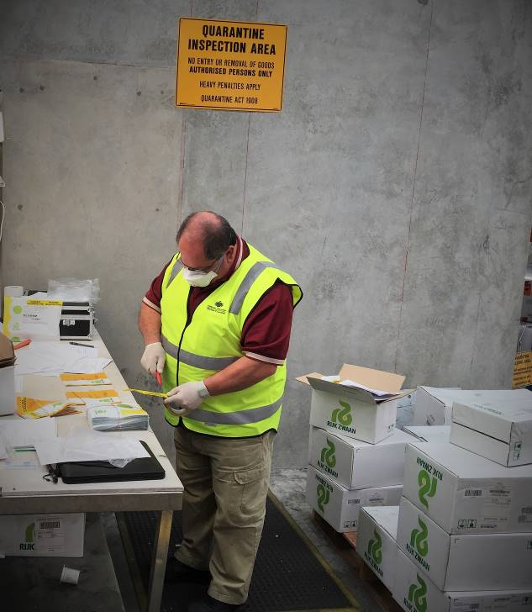
Figure 4 Biosecurity officer samples imported vegetable seed consignment, Australia, 2015
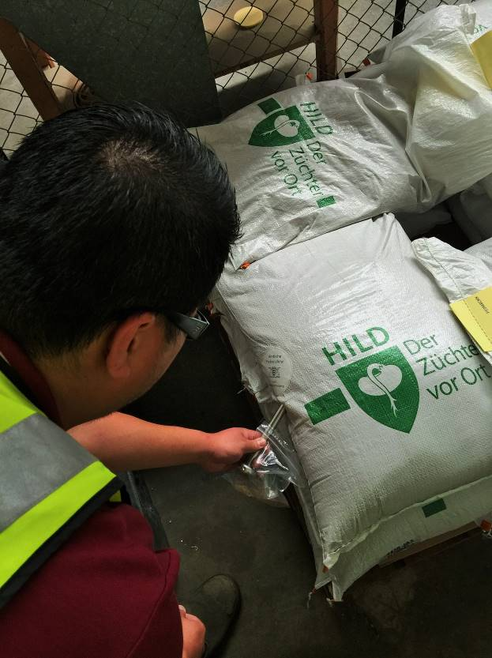
Figure 5 Biosecurity officer records inspection results for imported vegetable seed consignment, Australia, 2015
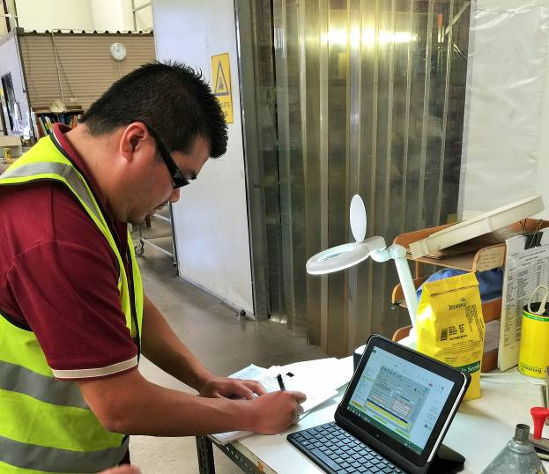
  - In some cases, the importer’s or broker’s premises are approved as QAPs. The department’s Audit Services Group (Service Delivery Division) approves and audits all QAPs, as required, to ensure their ongoing compliance.

For onshore treatment
  - Where imported carrot seeds were not treated offshore, the department allows heat treatment (dry heat, moist heat or hot water treatment) at a Class 4.1 QAP. This ensures that the appropriate treatment is effectively carried out at the required temperatures and duration and is supervised by a biosecurity officer.

Seed contaminants and tolerance
  - The department’s seed contaminants and tolerance tables web page states that ‘seed consignments imported into Australia for all end uses must meet standards for seed contaminants and tolerances’:
- Imported seed must be free of soil. Seed contaminated with soil discernible to the naked eye must either be cleaned, re-exported or destroyed. The department has adopted a 0.1 per cent standard maximum tolerance for soil as contaminant.
- The number of contaminant seeds in one kilogram of imported seed must not exceed the proscribed maximum for that species.

Prohibited seed
  - For prohibited seed species in imported consignments, the department has nil tolerance. A prohibited seed is:
- any species exceeding the tolerance levels for restricted seeds
- any species listed on BICON as prohibited
- any species not listed on BICON or Schedule 5 (‘Permitted Seeds List’) of the Quarantine Proclamation 1998
- any seed that cannot be identified to species level.
  - Until the type of contaminant is determined and directions for treatment are provided, contaminated consignments are held securely and segregated. They remain sealed until cleared for release from quarantine.

Seed testing for contaminants

ISTA Orange certificate
  - The Orange ISTA International Seed Lot Certificate, is a certification of seed testing that provide the specific seed quality test results of a representative sample of a seed lot, for germination, analytical purity, inert matter, other crop seeds and moisture. The Orange certificate is only issued by those laboratories accredited by ISTA. Because most countries have accepted the reliability and accuracy of this certificate, it has become an important tool in assisting international trade and movements of seed. The certificate covers sampling and testing procedures which have been carried out under the authority of the member laboratory in respect of a nominated seed lot.

ISTA seed sampling criteria
  - ISTA sampling is required to demonstrate that the imported seed consignment is free of soil and other quarantine risk material, including weed seeds. The department requires that ISTA sampling and testing is carried out on seed consignments or lots that meet the following criteria:
- all seed consignments containing seeds less than 8 mm in diameter with a weight greater than 10 kilograms. An exception to this rule is consignments accompanied by a department-approved seed analysis certificate
- consignments less than 10 kilograms and/or seed size more than 8 millimetres if seed of other species and/or soil is found upon inspection
- consignments in which the BICON case or import permit specifies ISTA sampling and/or testing is required.
  - All imported seed consignments must be inspected for quarantine risk material, whether ISTA sampling is required or not.

ISTA sampling and analysis
  - The department recognises the International Rules for Seed Testing developed by ISTA as the benchmark for sampling and testing of seeds. The department samples all imported tomato and carrot seed according to these rules and directs seed samples to an ISTA accredited laboratory for independent analysis.
  - Australia has five laboratories approved by ISTA for testing seed samples for purity. Individual lines or lots of imported seed (less 8 mm size) with a combined weight over 10 kilograms are sampled by a biosecurity officer in accordance with ISTA procedures. These samples are submitted to one of the five approved laboratories for analysis. Seed consignments of less than 10 kilograms are only referred to an ISTA laboratory for analysis if contaminants are detected during the on-arrival inspection. Consignments are only released if the results meet the department’s requirements regarding weed seed and soil contamination.
  - The department’s requirement for sampling and testing of commercial seed lots on arrival is based on concerns about overseas sampling, seed lot security post-sampling and awareness and understanding of Australia’s requirements regarding weed seed and soil contamination. Most international seed analyses are performed to commercial (seed purity/quality) certification requirements (for example, Orange ISTA International Seed Lot Certificate), and do not always identify contaminant seeds to species level or state the percentage of contaminant soil. The department publishes tolerances for weed seeds in imported tomato and carrot seeds.
  - To address concerns about seed lot security/integrity post-sampling, the department requires that each consignment be accompanied by a declaration from the seed merchant responsible for storing/exporting the seed stating:
Post sampling, all care has been taken to maintain the security of the following seed lot(s): List the botanical name of the seed and the marks of the lot.

Approved onshore laboratories
  - The department does not approve ISTA-accredited laboratories, but they must be a Class 5.2 QAP for test results from those laboratories to be accepted. Laboratories can choose to become accredited if they meet the laboratory accreditation requirements set by ISTA. Laboratories are accredited for one year, and participate in proficiency testing as required by ISTA. A list of ISTA-approved laboratories in Australia is at Appendix D.

Approved onshore laboratories for testing seed health
  - Seed consignments that are not tested offshore before shipment or do not meet mandatory requirements for importation (for example, incomplete documentation) are required to be tested onshore at one of the laboratories that test imported tomato and carrot seeds:
- Plant Health Diagnostic Service
Department of Primary Industries New South Wales
- Crop Health Services
Victorian Department of Environment and Primary Industries
  - These laboratories can test seed for the presence of pepino mosaic virus, columnea latent viroid, pepper chat fruit viroid, potato spindle tuber viroid, tomato apical stunt viroid, tomato chlorotic dwarf viroid and tomato planta macho viroid on tomato seeds and Candidatus Liberibacter solanacearum on carrot seeds.
  - The importer is responsible for all fees associated with seed testing.

Destruction of contaminated seed
  - All seed lots that test positive for quarantinable virus and/or viroids, and any material that has been in contact with these, must be exported or destroyed. The department has approved the following alternative methods for destruction of contaminated seed lots:
- autoclaving at a gauge pressure of 105 kPa (15 psi) or 121 °C for 30 minutes
- high temperature incineration
- irradiation at 25 kGray (or 2.5 Mrad)
- any other treatment approved by the department.

Administrative arrangements
  - In Australia, the importation of vegetable seeds is jointly managed by three divisions in the department (Figure 6):
- Biosecurity Plant
- Service Delivery Operations
- Compliance.
  - The Plant Import Operations Branch (Biosecurity Plant Division) manages the risk of exotic pests and diseases being introduced into Australia. It does this by regulating importation of seed. Its activities and responsibilities include:
- assessing import permit applications, considering relevant risk advice and issuing import permits for seed; these activities help ensure that import conditions adequately address biosecurity risks
- providing technical advice on importing seed to relevant biosecurity officers, importers and the general public to ensure consistent inspection and clearance and compliance with relevant biosecurity legislation
- developing and maintaining import conditions and protocols for seeds on BICON
- participating in border assessments and appraisals designed to maintain the ongoing integrity of the biosecurity continuum (Figure 1).
  - The Plant Biosecurity Branch (Biosecurity Plant Division) assesses biosecurity risks and develops policies for import of seeds. The branch proposes measures to the Plant Import Operations Branch for managing phytosanitary risks associated with importation of seeds of approved plant species from specific countries of origin.
  - On 1 July 2015, the department introduced a new structure, designed to be more client-focused in the way it delivers its services. Under this new arrangement, the department introduced the following service streams nationally:
- Assessment Services Group—officers from Document Services Group assess the validity and compliance of accompanying documents with Australian import requirements, and issue AIMS directions to inspectors.
- Inspection Services Group—biosecurity officers from this group undertake verification, inspection and clearance of imported seed consignments as per directions provided on AIMS by assessing officers.
- Audit Services Group—audits Quarantine Approved Premises (QAPs) where imported seed is stored before inspection and final release in accordance with import conditions.
- Veterinary, Export Meat and Scientific Services Group—staff at the Scientific Services Group provides identification services and treatment options for foreign pests and diseases in imported consignments of seeds.
Figure 6 Department of Agriculture and Water Resources national and regional responsibilities
  - In addition to the three national service streams, the Service Delivery Division also has an ‘enabling stream’, named Operations Integration. This stream includes Client Contact Management, which provides services such as bookings for inspection of imported goods (by biosecurity officers from the Inspection Services Group) and allocates appropriate officers to inspect imported seed consignments.
  - The Compliance Arrangements Branch (Compliance Division) manages compliance, through auditing, of QAPs where imported seed consignments are stored before release from quarantine.
  - The roles, responsibilities and relationships of the department’s various areas (divisions and branches, and sections) and the responsibilities of the regional offices are shown in Figure 6.

Work instructions and guidelines
  - The department has work instructions and guidelines to help biosecurity officers with verification inspection, treatment (when required) and clearance of consignment containing vegetable seeds for sowing:
- Minimum documentary and import declaration requirements policy
- Assessing contamination in seed consignments work instruction
- Seed sampling and inspection work instruction
- Seed inspection and sampling national job card
- Introduction to phytosanitary certificates guideline.
- Post-border controls
  - As a major producer and exporter of plants and plant products, Australia places a priority on plant biosecurity. The department is developing a post-border biosecurity system whereby government and industry share responsibility for implementing a range of biosecurity measures. This new national plant biosecurity system will be essential to the viability and sustainability of Australia’s grain, horticulture and timber industries.
  - The effective management of post-border plant biosecurity relies on a partnership between federal and state governments, plant industries (including seed companies), producers and Plant Health Australia (PHA). Constructive collaboration between all parties is necessary to maintain and deliver effective outcomes across the various facets of the National Plant Biosecurity Strategy (PHA 2013):
- Surveillance and monitoring
- Stakeholder education and awareness
- Emergency preparedness and response arrangements
- Training and simulation exercises
- Domestic quarantine
- Endemic pest and disease management
- Research and development: breeding for disease resistance.

Surveillance and monitoring
  - Plant biosecurity surveillance is an essential component of the Australian biosecurity system. Surveillance and monitoring involves activities designed to:
- reveal the presence of pests (for early detection)
- demonstrate the absence from pests (for market access)
- determine the distribution of pests (in response to an incursion or for ongoing management)
- identify high risk pathways and areas for pests (to focus surveillance efforts)
- the collection, collation, analysis, interpretation and timely dissemination of information on plant pests and the hosts that they affect.
  - Surveillance may be general, where information on pests is gathered from many sources, or it may take the form of specific surveys to obtain information for specific sites over a defined period. Specific surveys may involve detection, delimiting or monitoring surveys (FAO 1997).

Stakeholder education and awareness
  - In most cases, the first signs of an exotic pest incursion will be detected by a grower. This highlights the importance of maintaining a high level of education and awareness amongst all sectors of industry, also emphasising the critical need to promptly report such findings. Biosecurity measures are designed to protect crops from pests, diseases and weeds. High standards of farm hygiene are needed to prevent the introduction, spread and impact of serious plant pests, diseases and weeds. To reduce the risk of spreading harmful pests and diseases on a farm, the farm operator should:
- use clean seed
- control movements of machinery and visitors on the farm
- control related weeds
- record any known affected areas.
  - Early detection, prompt reporting and implementation of well-planned emergency response measures will increase the likelihood of successful eradication of an exotic plant pest. Such measures will improve the opportunity for an industry to retain market access in the event of a pest or disease outbreak, and reinforce Australia’s international biosecurity status.

Emergency preparedness and response arrangements
  - Effectively managing plant disease and pest incursions is a challenging task. Since 1995, hundreds of exotic pest incursion or barrier incidents have been recorded in Australia. Of these, over 20 have been of sufficient concern to warrant a nationally-coordinated and funded response with combined expenditure exceeding A$200 million. Others have been managed individually by state or territory governments and/or the affected industries (Pheloung 2005).
  - Effective planning for plant pest incursions in Australia is based on:
- monitoring and surveillance to provide early warning of the arrival of new pests
- diagnostics tools and expertise to clearly identify the pest
- information systems that define the pest status of the country
- reporting arrangements to ensure knowledge of new incursions is acted on quickly (Pheloung 2005).
  - Contingency planning can be targeted for certain key pests that are clearly a threat and for which an entry pathway can be clearly identified. A generic response framework is also essential to identify, assess and react to incursions as they occur. In Australia, the Australian Government is responsible for managing risks at the national border while the seven states and territories work individually or together to deal with pest problems within the country. The department has a key role in coordinating the response to a new pest incursion.

Industry biosecurity plans
  - Industry biosecurity plans (IBPs) set out an agreed range of biosecurity activities to mitigate risks from exotic plant pests to particular industries. Six areas are covered by biosecurity planning. Agreed actions may include promoting on-farm biosecurity, developing diagnostic protocols and contingency plans for particular pests, raising awareness of specific pests and appointing biosecurity officers.
  - Various risk mitigation activities are considered during development of an IBP:
  - biosecurity management—biosecurity officers implement and coordinate biosecurity activities for the industry; biosecurity reference groups
  - on-farm biosecurity practices—farm biosecurity manual development; inclusion of biosecurity in industry best management
  - practices and/or quality assurance schemes—promotion of biosecurity signage, farm hygiene and surveillance; development of modules for testing on-farm biosecurity
  - surveillance—collection of surveillance data into a national database; increased general surveillance; implementation of surveillance for high priority pests (for market access and/or early detection)
  - pest-specific document development for high priority pests—contingency plans or business continuity plans; fact sheets and posters; pest risk reviews; diagnostic protocol
  - awareness activities—biosecurity awareness campaign; promotion of biosecurity practices to growers; development of extension material
  - training of industry personnel in the application of the Emergency Plant Pest Response Deed (EPPRD) and Australian Emergency Plant Pest Response Plan (PLANTPLAN); on-farm training programmes for best practice biosecurity.
  - The peak vegetable industry body, AUSVEG, is a member of PHA and has endorsed the Vegetable IBP; this plan includes the carrot industry (AUSVEG 2011). The IIGB understands that an IBP for the tomato industry is almost finalised. However, apart from some individual growers, neither the field cropping nor fresh protected cropping sectors were involved in the preparation of the plan. For such a plan to be fully effective, it is important to have widespread industry participation and ownership.

Emergency Plant Pest Response Deed (EPPRD)
  - Plant Health Australia is custodian of the Emergency Plant Pest Response Deed (EPPRD) and is responsible for coordinating amendments and preparation of ancillary documents. This is a legally binding agreement between Plant Health Australia, the Australian Government, all state and territory governments and most national plant industry bodies. AUSVEG, representing carrot growers, is a signatory to the Deed.
  - The EPPRD covers the management and funding of responses to emergency plant pest incidents, including the potential for owner reimbursement costs for growers. It also formalises the plant industries’ role in decision making, as well as their contribution towards the costs related to approved responses.
  - A major benefit of the EPPRD is to allow a more timely, effective and efficient response to plant pest incursions. It also encourages early reporting of any suspicious signs of exotic pests, and minimises uncertainty over management and funding arrangements for a response.

PLANTPLAN
  - PLANTPLAN is the agreed technical response plan used for emergency plant pest incidents. It provides nationally-consistent guidelines for response procedures under the EPPRD, outlining the phases of an incursion, as well as the key roles and responsibilities of industry and government during each phase. It incorporates best practice in emergency plant pest responses, and is updated regularly to incorporate new information or address gaps identified in emergency plant pest incident reviews.
  - PLANTPLAN is a schedule to the EPPRD and is endorsed by all signatories to the Deed. To help organisations and individuals involved in responding to emergency incursions, PHA has produced a range of supporting documents, including Technical guidelines for development of pest-specific response plans. These guidelines are designed to assist the development of contingency plans, or to develop technical strategies in the event of an incursion. They provide guidelines to assist scientists and regulators develop response strategies for emergency plant pests and provide technical advice during an incursion.
  - The guidelines are based on the four phases of an incursion response in PLANTPLAN – investigation, alert, operational and stand-down. It focuses on the responsibilities of experts in developing incursion response strategies and provides a guide for developing response strategies aligned to the biology, epidemiology and control of different kinds of pests.

Training and simulation exercises
  - To support members in their biosecurity preparedness, Plant Health Australia delivers the National Emergency Plant Pest Training Program to industry and government representatives, growers and other biosecurity stakeholders. The training program includes simulation exercises, face-to-face and online modules.
  - Practical training for industry and government members using simulation exercises, is an important component of the National EPP Training Program. These exercises support the other forms of training delivered and test specific aspects of members’ biosecurity emergency preparedness. Together with discussion exercise activities that are included in the face-to-face training, PHA also works with its members to delivery larger scale functional exercises.

Domestic quarantine and endemic pest management
  - There is an enormous range of pests, diseases and weeds which can affect plant industries in Australia. Some are already present in Australia and may be confined to small areas of the country, while others have not yet been detected. Once present in Australia, they can spread from one region to another through the movement of fruit, vegetables, plants, flowers, plant products and soil.
  - Australia’s size and natural geographic barriers have allowed the regional distribution and isolation of specific plant pests. State and territory agencies impose and regulate domestic quarantine restrictions to protect regional plant-based industries and the environment.
  - Good biosecurity practice is beneficial for the ongoing management of endemic pests and weeds, as well as for surveillance and early detection of exotic pests. Endemic pests cause ongoing hardships for growers. Management of these pests requires a strategic, consistent, scientific and risk-based approach.

Research and development: breeding for disease resistance
  - Research efforts in plant breeding for disease resistance are required because pathogen populations are under continuous selection pressure that can result in increased virulence or appearance of new pathogens. Evolving cultivation practices and changing climate can reduce disease resistance of host species. Breeding for disease resistance usually includes:
  - Identification of plants that may be less desirable in other ways, but which carry a useful disease resistance trait, including wild strains that often express enhanced resistance.
  - Crossing of a desirable but disease-susceptible variety to another variety that is a source of resistance.
  - Growth of breeding candidates in a disease-conducive setting, including pathogen inoculation. Attention must be paid to the specific pathogen isolates, to address variability within a single pathogen species.
  - Selection of disease-resistant individuals that retain other desirable traits such as yield, quality and including other disease resistance traits.
- International seed movements

Australia’s dependence on imported seed
  - Australia relies heavily on imported hybrid seeds for a range of vegetable crops, including tomatoes and carrots. The popularity of hybrids is due to their vigour, uniformity, disease resistance, stress tolerance and desirable horticultural traits including early fruiting, longer shelf life and consistent yield. Hybrid vegetable seed production can be divided into hand pollinated and gene-control pollinated. The gene-control system uses genetic manipulation of a plant to induce self-incompatibility (male sterility), and requires cutting edge facilities and skilled technicians; and is therefore very expensive.
  - In the absence of gene-control system, a tedious manual emasculation and pollination system is used to produce hybrid seed, in countries such as Thailand (Figure 7). This method involves manual emasculation of the anthers (the pollen-producing male organ) (Figure 8) followed by hand pollination (Figure 9) with the pollen of the male parent and then preventing the other pollen from contaminating the hand-pollinated flowers. This method is very labour-intensive and requires a team of skilful growers with patience, commitment and willingness to follow instructions accurately.
  - The major international seed companies contract out vegetable seed production (including tomato and carrot seed) in one or more of around 25 countries, including Egypt, Ethiopia, Guatemala, Italy, Morocco, Thailand and Vietnam. Thailand is one of the major centres for tomato seed production. It is also one of the major centres for seed production of other vegetable species such as eggplant, pepper, watermelon, melon, sweetcorn and cucumber.
  - In order to better understand the global seed production pathways, the IIGB visited Thailand and the Netherlands, as examples of countries with significant involvement in vegetable (tomato) seed production.
Figure 7 Tomato crop in open field, Thailand
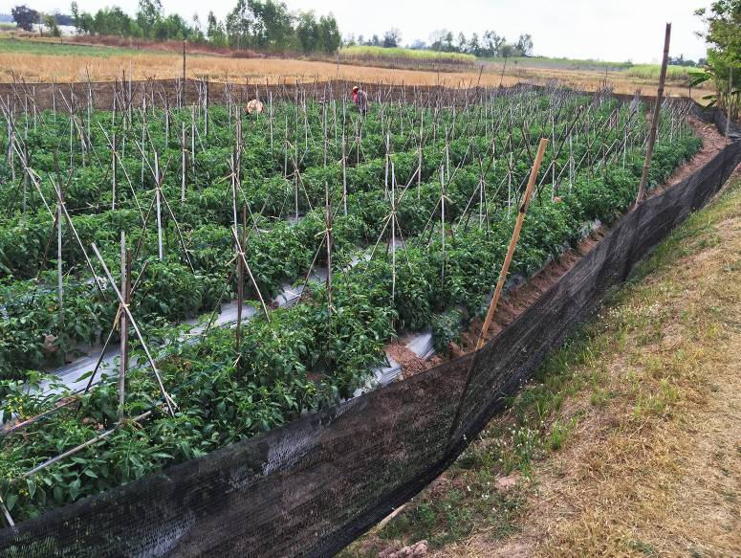
Figure 8 Emasculation of a tomato flower in open field, Thailand

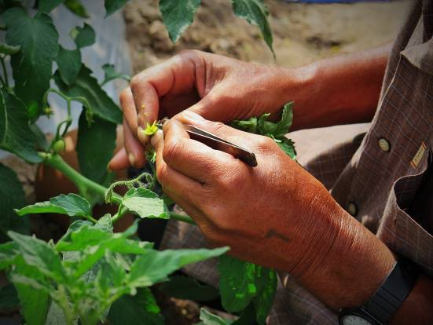
Figure 9 Manual pollination of an emasculated tomato flower in open field, Thailand
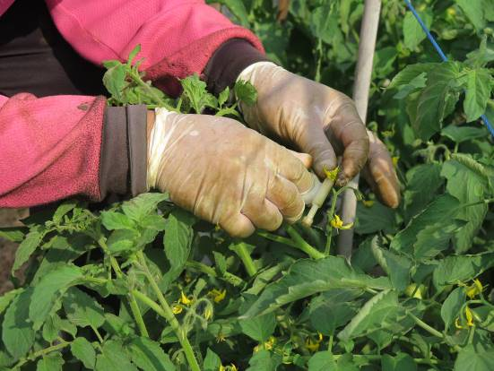

Phytosanitary regulation in Thailand

Biosecurity risk management
  - The Thai Government, with cooperation of industry, has been making determined efforts to establish Thailand as the major regional centre for vegetable seed production. A range of phytosanitary and traceability measures have been implemented, to ensure that clean seed is imported for multiplication, and high-quality seed is exported (Figure 10).
  - As part of quality and biosecurity control system, during each production cycle, various entities inspect the field. These include:
- field supervisors (employees of the contracting company) who regularly inspect fields to:
- ensure crop production practices are carried out by growers and workers as per their contract
- ensure workers perform critical tasks efficiently, particularly emasculation and hand pollination, and provide training when required
- maintain sanitation (Figure 11) and weed control
- record pest and disease incidents, the use of chemicals to control pests, diseases and weeds, fruit yield data etc.
During crop production, field supervisors address all phytosanitary issues and may seek advice from company management, for direction and immediate action. In the event of a pest or disease incursion, field supervisors take the following actions:
- in the case of a viral disease, the affected plants are removed
- for bacterial diseases, plant samples are sent to a laboratory for identification and affected plants are removed
- advise the grower to control vectors and disease by the use pesticides.
- quarantine inspectors (employees of Thailand Department of Agriculture) or specialist plant pathologists (for example, Khon Kaen University staff retained by the Department of Agriculture), to ensure seed crops remain free of seed-borne pathogens. They also collect plant tissue samples from healthy and diseased plants for laboratory testing and provide advice on pest and disease control, when required.
- plant pathologist (employee of the parent company) who also visits fields to ensure
- pest and disease incidents (if any) are managed as early as possible
- production practices meet agreed protocols and requirements.
For quality control, the plant pathologist also collects leaf tissue samples from healthy (and diseased) plants and sends them to the parent company’s laboratory for testing. Pathologists usually inspect field crops grown for seed multiplication on at least two occasions during a production cycle.
Figure 10 Biosecurity risk management in seed production, processing and export
Figure 11 Sanitation measures at the entrance to tomato field, Thailand
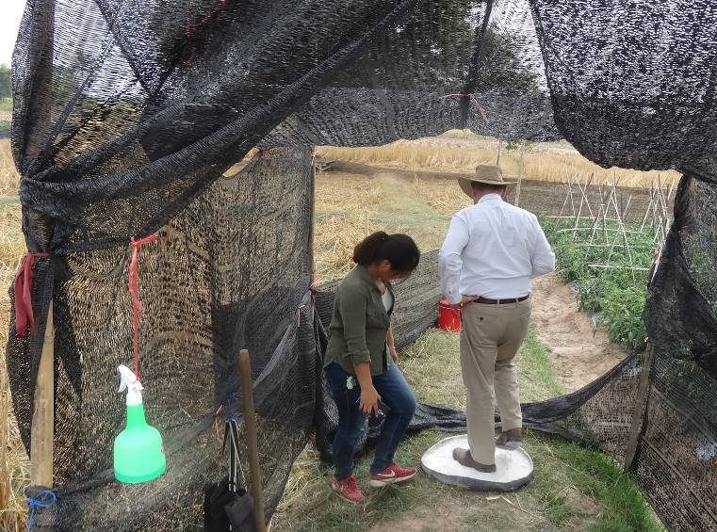

Traceability
  - The reliable and accurate traceability of vegetable seeds along all steps in the (international) production pathway is of critical importance, in maintaining an effective biosecurity system. The ability to trace the history of the origin, production, processing steps, and participants, for each seed lot is a fundamental requirement for producing clean pest-free seed and responding quickly to any breakdown and handling steps involved in the production of seed. Documentation of the pedigree of the seed planted to verify its identity is the starting point of the seed certification process.
  - In Thailand, each field is allocated a unique lot number (Figure 12), which the parent company uses for traceability purposes. Once allocated, the lot number remains unchanged from production through to marketing of each variety. The contractor keeps a record of all activities undertaken from plant production to export of seed lots. As part of their formal contract, the parent company is provided with a complete record of all activities undertaken by the contractor during crop production. All relevant details are entered in a central database, which is accessible to staff working in different areas of the company (receival, processing, laboratories etc.). As the seed moves from one area to another, bar codes on packaging are scanned to ensure consistent identity of each seed lot (Figure 13).
Figure 12 Signage showing lot number of a tomato seed crop in open field, Thailand
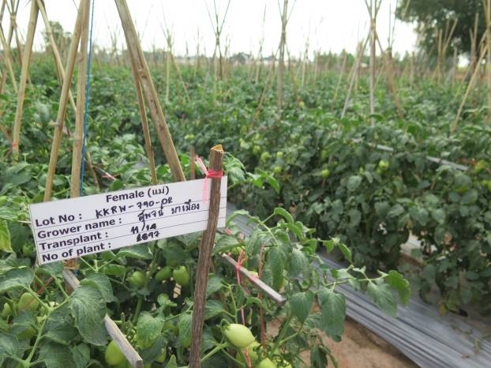
Figure 13 Unique bar codes on tomato seed packaging and document, the Netherlands
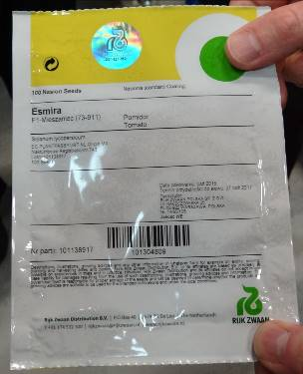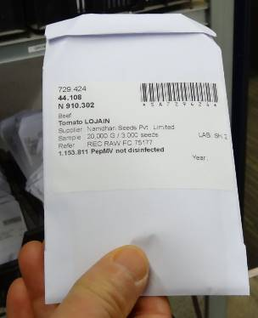
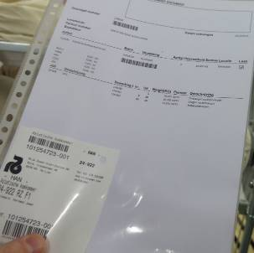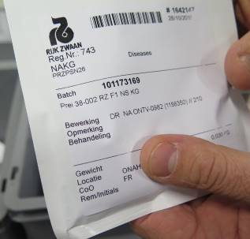

Phytosanitary regulation in European Union
  - All member states of the European Union, including the Netherlands, comply with a harmonised framework for risk assessment of organisms harmful to plants and plant products and the identification and evaluation of risk management options. The guiding principles on assessment practices and approaches when assessing risks to plant health are covered under European Council Directive 2000/29/EC. The framework aims at implementing the fundamental principles of risk assessment as laid down in Regulation (EC) No 178/2002, including the independence and transparency of risk assessments carried out by the European Food Safety Authority (EFSA).
  - Generally, an EU member state initiates the pest risk analysis for a specific pest and other members may contribute to finalise the draft. EFSA’s Plant Health Panel reviews pest risk assessments produced by EU member states or third parties (non-EU countries) using a wide range of specialist expertise and current scientific knowledge in order to provide independent scientific advice to the European Commission.
  - Quarantine organisms are harmful plant pathogens that are either not present in the EU or are not widely distributed. Since the import of such organisms is prohibited, each EU member state (including the Netherlands) is obliged to comply with the import requirements and, in cases where approval is given, to supervise their contained use in a manner that is safe for plant health.
  - Quarantine organisms are listed in the European Union Directive 2000/29/EC and the Netherlands NPPO (Dutch Food and Consumer Safety Authority, NVWA) is responsible for assessing the risks of their import and use, and any restrictions to be applied. In cases where approval is given, the European Union Directive 2008/61/EC allows the NVWA to grant exemption from phytosanitary prohibitions under certain conditions.

Seed industry in the Netherlands
  - The Netherlands is the world’s largest seed exporter, with 24 per cent of the total world export value, compared to the USA (19 per cent) and France (15 per cent). Eight out of ten of the world’s largest vegetable seed companies have their main offices and/or significant facilities in the Netherlands (Kamphuis 2005). The Dutch plant breeding industry has a long history, with some of the current companies founded more than a century ago. Development and production of plant reproduction material is a major, highly-developed economic activity in the Netherlands.
  - Each year, the Netherlands exports seeds and other plant material valued at €1.63 billion. A large proportion of the imported horticultural seeds are grown in other countries on behalf of Dutch seed and propagating companies, on their own farms or by others under contract. After multiplication of hybrid seed varieties all over the world, propagation material is sent to the Netherlands for further treatment (quality control, cleaning) and trade purposes (Figure 14).
Figure 14 Equipment for heat treatment of carrot seed, the Netherlands
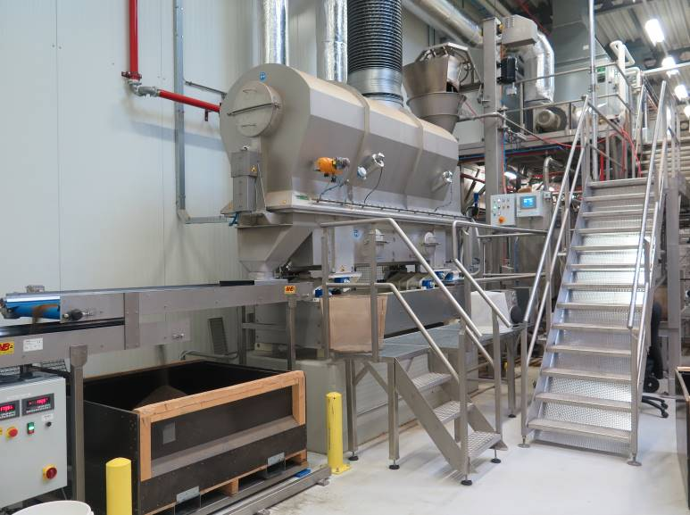
  - During fieldwork, the IIGB was informed that many companies invest 15–30 per cent of their annual financial turnover in research and development, for example, to develop new hybrids, seed health protocol development. These companies plan and develop new hybrid varieties 3–8 years in advance of their commercial release. The selection is based on market trends for greater customer choice and demands for particular varieties with desirable traits and suitability for growing in particular regions.
  - The Netherlands’ national plant protection organisation (NPPO)—the Food and Consumer Product Safety Authority (NVWA)—is an integral part of the Ministry of Economic Affairs. The NVWA is solely responsible for management of matters related to plant health within the context of European Council Directive 2000/29/EC.
  - The NVWA is the overseeing and supervising authority responsible for administering the Dutch Plant Diseases Act (and related regulations). The MEA has delegated plant health inspections, in particular import and plant passport checks —a requirement under European Union Plant Health Directive 2000/29/EG—to the following regulatory agencies:
- Flower bulb Inspection Service—responsible for plant health checks of flower bulbs
- Quality Control Service—responsible for plant health checks for end products (such as, cut flowers, vegetables, fruit)
- Dutch General Inspection Service for Agricultural Seed and Seed Potatoes (NAK)—responsible for plant health checks of arable crops (such as, potatoes, maize)
- Netherlands Inspection Service for Horticulture (Naktuinbouw)—responsible for plant health checks of horticultural crops (in particular propagation material).

Naktuinbouw
  - Naktuinbouw is an independent and autonomous public authority with a high level of recognised expertise, regulated by the Netherlands Ministry of Economic Affairs. The IIGB visited Naktuinbouw’s headquarters to gain understanding of this institute’s role in managing biosecurity risks associated with tomato and carrot seed. In meetings with Naktuinbouw officials, the following topics were discussed:
- Naktuinbouw’s role and functions
- Naktuinbouw’s relationship with the Netherland’s NPPO and international agencies, such as ISTA, International Seed Federation (ISF), International Seed Health Initiative for Vegetables Crops (ISHI-Veg)
- Naktuinbouw Authorised Laboratories (NAL)
- seed purity analysis
- seed health testing—approved protocols, reference collections and proficiency testing programs for NAL certified laboratories the issues of sensitivity of seed health protocols approved by Naktuinbouw for tomato and carrot seeds and meeting seed health requirements of the Australian Government Department of Agriculture and Water Resources for exported consignments
- quality assurance
- training courses.

Naktuinbouw role and functions
  - Inspections
- Quality inspections—Companies that breed and trade propagating material for the floricultural, arboricultural and vegetable crop sectors such as seeds, cuttings, seedlings, plants and trees, must register with Naktuinbouw. Naktuinbouw inspectors check the propagating material for identity, quality and health.
- Plant passports—Propagating material to be traded within the European Union must be completely free of quarantine diseases before it can be marketed. Naktuinbouw monitors this requirement by performing random inspections.
- Import and export inspections
- Quality-plus systems—By participating in the quality-plus systems (Naktuinbouw Elite/Naktuinbouw Select Plant) breeders and propagators aim to demonstrate the higher quality of their propagating material, using the Naktuinbouw certificate.
  - Laboratory testing
- Health and quality tests
- Seed analysis
- Diagnostic tests
- DNA tests—to establish identity of varieties and pathogens through DNA technology.
- Forensic tests
- Disease resistance tests
- Variety testing
- Training courses

Naktuinbouw Authorised Laboratories (NAL)
  - NAL is a system for accredited companies that ensures that a laboratory’s quality management system, the testing protocols and the manner in which quality information is supplied, satisfy the defined conditions and that its performance is checked periodically. Naktuinbouw accredits laboratories at private seed companies globally to enable them to test and certify their own seed lots before they are marketed. A list of international companies with current NAL certified laboratories is at Appendix E.
  - For NAL certification of their laboratory, private companies must meet Naktuinbouw’s
NAL conditions to achieve accreditation:
- quality management system—a seed testing laboratory must have a solid quality management system in place, which guarantees effective risk control of critical points in testing and sampling.
- trained analysts—all personnel and technicians undertaking seed testing in a laboratory must possess requisite qualifications and skills demonstrated through their technical proficiency.
- approved test protocols—all test protocols used in NAL authorised laboratories must be evaluated and approved by Naktuinbouw.
- proficiency testing—the proficiency testing of NAL certified laboratories is based on a similar model as ISTA. It is mandatory for NAL laboratories to participate in Naktuinbouw’s proficiency testing.

Industry biosecurity measures
  - In discussions with seed companies, the IIGB noted that the following biosecurity and quality control measures are applied during research and development (breeding) for hybrid production:
- controls to reduce the possibility of infection of breeder, foundation and certified seed during breeding in glasshouse or field
- testing for various pests/pathogens (for example, viruses, fungi, bacteria or phytoplasms) through various stages of breeding
- use of standardised (harmonised) protocols for seed health testing
- recording of testing (inoculum density in seed) for pathogens/pests
- effective seed lot identification (Figure 13)
- use of standard operating procedures for seed breeding in controlled environments
- processes to reduce contamination with quarantine risk material.
  - Larger seed companies typically contract out the production and multiplication processes to farmers, farmers’ associations or private firms, often in countries with low production costs. For quick release of seeds of newly developed varieties, companies generally produce seeds in more than one country. Except under certain circumstances (such as, to meet demand of one buyer for large quantities of seeds of a particular variety), seeds produced in different countries are not bulked up, and are sold as separate lots/batches.
  - All companies visited by the IIGB in the Netherlands had their own facilities for seed treatment. However, during peak times when a company has to meet the market demand within stipulated timeframes, and is unable to handle large volumes, it might contract out seed treatment to other specialist treatment companies. This is done under a strict regulatory and legally-binding agreement between the companies. During fieldwork, the IIGB noted:
- all five seed companies had laboratories certified under the NAL system to test their own seed lots for quality control before export
- officially registered auditors annually assess the quality management system to ensure it complies with all prescribed conditions. If any shortcomings are identified, the system must be corrected
- participation in the proficiency testing programme is obligatory for all recognised tests. If deviations are noticed, corrective measures are obligatory. Naktuinbouw organises approximately 10 proficiency tests each year.
  - Although there is vigorous competition between major seed companies in the Netherlands, seed health and the enhancement of diagnostic protocols are regarded as ‘non-competitive’ areas. During discussions with several major companies and government regulatory agencies, the IIGB was consistently told that all parties routinely share technical information about disease incidents and the improvement of diagnostic methods. In this area, companies cooperate to find better solutions to safeguard crops from regulated and emerging pathogens. It is generally recognised that a pathogen newly-identified by one company poses a potential threat to other companies (and the national disease status) at some time in the future.

Authorised Service Laboratories Naktuinbouw
  - Authorised Service Laboratories Naktuinbouw (ASLN) focuses on service laboratories that carry out quality tests on seeds, soil and plants. The test results from these ASLN laboratories are accepted by Naktuinbouw, for example, for Naktuinbouw Elite, Naktuinbouw Select Plant audits within a GSPP system.

International seed health testing
  - Routine seed health testing is carried out in most countries for seed certification and plant quarantine purposes. However, the majority of seed health tests used throughout the world have never been subject to rigorous scientific validation. A fully validated test provides for analytical sensitivity, reproducibility and repeatability. Discrepancies between testing methods can occur, leading to costly phytosanitary disputes or liability claims. These issues can be avoided by working toward a system of universally accepted, standardised testing methods on a global level. To ensure that seed health tests are standardised and give reliable and reproducible results in accordance with the given specifications of the test methods, such methods should be subjected to peer review and/or a collaborative comparison between laboratories. Three primary organisations publish standardised seed health tests (Aveling 2014):
- International Seed Testing Association (ISTA)
- International Seed Health Initiative (ISHI)
- National Seed Health System (NSHS) of the United States Department of Agriculture/Animal and Plant Health Protection Service.
  - All ISTA validated methods are published in the International Rules for Seed Testing. Additionally, some ISHI-Veg methods have been accepted as ISTA Rules and as Standards by the NSHS. The procedures followed by ISTA, ISHI and the NSHS to achieve global standards in seed health testing are discussed in paragraphs 6.30 and 6.36.

Diagnostic protocol development and validation
NVWA–Naktuinbouw
  - With access to expertise and advanced laboratory facilities, Naktuinbouw is the Netherland’s lead agency developing more sensitive and efficient protocols for testing for the presence of seed-transmitted and seed-borne pathogens. The focus is both on pathogens already identified (regulated pathogens listed in Q-Bank), and new and emerging pathogens for which harmonised molecular diagnostic methods do not yet exist. Naktuinbouw laboratories collaborate with several organisations including:
- NVWA (Netherlands Food and Consumer Product Safety Authority)
- EPPO (European and Mediterranean Plant Protection Organisation)
- ISTA (International Seed Testing Association)
- ISF (International Seed Federation)
- ISHI-Veg (International Seed Health Initiative for Vegetable Seeds)
- The Food and Environment Research Agency (UK)
- Australian Government Department of Agriculture and Water Resources
- Victorian Department of Environment and Primary Industries (Australia)
- The Institute for Agricultural and Fisheries Research (ILVO)
- International Union for the Protection of New Varieties of Plants (UPOV), Switzerland
- Private seed companies
- Research institutions, including Wageningen University and Research Centre, Netherlands.

Protocol development
  - Naktuinbouw develops diagnostic protocols, both independently and in collaboration with other national and international institutions and private companies. Most large seed companies have modern, well-resourced, NAL-certified laboratories. As part of their research effort, companies allocate resources for work on pathogens, to develop protocols or improve existing protocols. The collaborative research by companies is undertaken systematically and the workload is often shared; that is, specific tasks are identified for each company involved. Plant pathologists from various companies regularly meet to discuss and compare their research results. When a new protocol is developed and tested, details of the method are provided to Naktuinbouw for peer review and validation.

Protocol validation
  - Validation is defined as the confirmation, by research and by supplying objective proof that specific requirements for a particular, intended use are fulfilled (ISO 17025). For validation of protocols developed at Naktuinbouw laboratories (or in collaboration with other institutions or private companies), Naktuinbouw conforms to national guidelines for the validation of detection and identification methods for plant pathogens and pests.
  - Draft protocols are subjected to proficiency testing (ring testing or inter-laboratory comparison) by participating laboratories. On completion of proficiency testing, Naktuinbouw submits the relevant information to the NVWA.
  - NVWA is responsible for assessing and approving protocols developed and/or validated by Naktuinbouw. After approval, all protocols are published on the Naktuinbouw website. Generally, new seed health protocols are also submitted to ISHI-Veg for validation and adoption.

Accreditation systems
  - The Dutch seed industry is strongly supported by its NPPO, which assists industry to achieve its full commercial potential in the international market. During fieldwork, the IIGB noted that in all areas of agriculture, the Dutch government (NPPO), seed producers and scientists (research organisations, such as universities and institutions) work together, for the recognised national and commercial benefit.

United States National Seed Health System (NSHS)
  - The IIGB notes that the United States National Seed Health System (NSHS) provides accreditation in four areas: seed health testing, sampling for seed health testing, visual seed inspection, and phytosanitary inspection of seed crops. Entities with accreditation can carry out these processes for their own seed shipments or as a service to others. NSHS has developed a reference manual outlining procedures that must be followed in conducting these processes under accreditation. Accredited entities, however, must develop individual procedures and demonstrate a quality management system that ensures consistent performance and record keeping. NSHS cooperates with ISTA and ISHI to normalise methods approved by the different entities for standard use internationally.
- Observations and findings

Pest risk analyses (PRAs)
  - PRAs are of crucial importance for:
- establishing appropriate import conditions, consistent with Australia’s appropriate level of protection (ALOP)
- assisting contingency planning and design of emergency control measures
- identifying significant pests, including those requiring regulation by the department.
  - The department has not yet published generic PRAs (a PRA that broadly covers identified pests/pathogens and is not limited to a specific pest/pathogen) for importation of tomato or carrot seeds. However, a review of various vegetable seed imports, including tomato seeds, has recently been initiated. Delays in the production of PRAs have been a source of concern and frustration for industry stakeholders. The need for improved consultation between the department and industry is covered elsewhere in this report. A finalised PRA would remove ambiguity and provide transparency with regard to:
- significant pests and diseases that the department considers might enter Australia via tomato seed imports
- appropriate emergency management measures to be undertaken, in the event of an incursion of a significant pest or disease
- justifying import requirements imposed by the department.
  - For both disease control purposes and to meet commercial demand, there are potential benefits in facilitating the import of new plant germplasm into Australia. It appears that some current import requirements for small seed samples are an impediment to such imports (see paragraphs 7.67 and 7.68), to the detriment of the Australian community and horticulture industries.
  - The IIGB notes the reference in the draft ISPM standard (IPPC 2009) issued by the IPPC:
As well as movement for commercial trade, seeds are also regularly moved internationally for research purposes. When assessing the pest risk and determining appropriate phytosanitary measures, NPPOs should therefore consider whether the material is treated in quarantine and whether it is not for release for planting in the importing country.
A pest risk analysis (PRA) should determine if the seed is a pathway for the introduction and spread of regulated pests and may lead to establishment of regulated pests in the PRA area. The PRA should consider the relationship between the intended use of the seeds (for example, planting, research, testing) and the potential for pests to establish.
  - In considering the need for a PRA for importation of tomato seed, the following aspects are relevant:
- the high biosecurity risk
- the significant increases in the volume of imports since 2010
- increase in number of countries from which these seeds are sourced
- incursions of some regulated pests of tomatoes.
  - The recent incursions of PSTVd and pepper chat fruit viroid, are likely to have been associated with imported tomato seed, and could have possibly been avoided (or the consequences mitigated) if a generic PRA had been available. The completion of a generic PRA for importation of tomato seeds into Australia should be treated as an urgent priority.
  - In order to accelerate production of high-priority PRAs, industry might be encouraged to consider the feasibility of providing financial support to the department for this work. Such funding would have to be provided without any conditions attached, apart from the department providing an indicative timetable and regular progress reports to industry contributors.
Recommendation 1
  - The department should prioritise completion of the pest risk analysis for importation of tomato seeds by December 2016.
Department’s response: Agree
The department agrees with this recommendation.

Import requirements
  - The department has developed import conditions for plants and plant products, which are intended to manage biosecurity risks associated with these materials. Import conditions apply to consignments imported for commercial use or any other purpose within Australia.
  - The preparation, revision and implementation of import conditions for vegetable seeds is a particularly difficult and complex area. The number of plant species, the range of pathogens that can enter by the seed import pathway, and the changing nature of those organisms, add to the continual challenges faced by regulators, importers and producers. The IIGB noted that, despite the resources directed to this area, it appears that the department has had difficulty in meeting the needs and expectations of industry. There is a pressing need for a comprehensive review of the import requirements for seeds, and the underpinning regulatory (clearance) processes. The IIGB welcomes the department’s recent establishment of a government-industry working group, to address these issues.
  - The IIGB recommends that the proposed review considers implementing these initiatives within the department:
- developing a nationally consistent check-list for the import clearance process
- developing a species-specific checklist to aid assessment of import documents
- establishing a national group of subject specialists, available to answer technical queries
- improving training of officers to ensure better data recording in AIMS
- reviewing import conditions in BICON, to improve clarity and consistency.

Check-list for seed import conditions
  - The department assumes that the regulatory systems and procedures of an exporting country should help ensure that tomato and carrot seeds that require phytosanitary certification comply with Australian import requirements. Document verification and physical inspection of seed consignments on arrival are intended to confirm that incoming consignments comply with these requirements.
  - Importers informed the IIGB that, following the launch of the Biosecurity Import Conditions system (BICON) in November 2015, they are finding it easier to use BICON as it is more user-friendly. However, the current import requirements for tomato and carrot seeds have a number of variables (Appendix F) making it complicated for the department’s assessors to apply appropriate directions for inspection staff. These variables can complicate the task of selecting the correct case that applies to a specific consignment for inspection purposes. The system is relatively new, and it appears that additional BICON training might be required, to better explain the system features that can aid in document assessment.
  - It is suggested that the department investigate possible ways to simplify import conditions that are operationally practicable. This might be achieved through development of a nationally-consistent checklist that assessors could use to determine exact import requirements, make decisions to mitigate biosecurity risks and identify corresponding treatments, based on accompanying documentation.

Assessment of documentation
  - A valid permit must be obtained before importation of tomato and carrot seeds. Permit applications for importation of all vegetable seeds are assessed by the department’s Plant Import Operations Branch (Biosecurity Plant Division). Assessors apply appropriate conditions to reduce biosecurity risks consistent with Australia’s ALOP.
  - Import conditions stipulate the requirements that must be met before seed can be released from quarantine. A range of control measures—most of which are based on documentary evidence that required testing and/or treatment has been undertaken—are applied along the import pathway to address identified biosecurity risks.
  - At any stage during a permit assessment, the Plant Import Operations Branch can seek advice from the Plant Biosecurity Branch to clarify any issues, for example, to ensure adequacy of seed health assays used by an approved offshore laboratory.
  - The department now uses the BICON system to process import permit applications and to record each stage of the application process. Usually, an import permit is valid for one year and importers must ensure that all conditions are met for the imported commodity.
  - With the creation of the Service Delivery Division in July 2015, the department has centralised assessment services across the country. Assessment Services Group staff located in any region can now assess documents for consignments arriving at any port and apply directions for inspection, treatment or release.
  - From the selected records reviewed during fieldwork at regional offices, the IIGB noted that the department’s verification system is based on documentary evidence that accompanies consignments. It is assumed that assessing officers are competent in assessing documents; however, during fieldwork in the South East region (Melbourne) the IIGB was told that more than 50 per cent of entries were assessed incorrectly, leading to incorrect directions being applied. It was noted that at one of the regional offices, a customs broker—frequently acting on behalf of an importer and therefore familiar with changes to import requirements—often contacts the department to request reassessment of documents accompanying vegetable seed consignments. In addition, the IIGB was provided with documentation from a private company, showing evidence of poor judgement by department staff in applying inspection directions for tomato and carrot seed consignments.
  - It was noted that errors in document assessment and application of incorrect inspection directions could be attributed to one or more of the following:
- lack of knowledge about import requirements (lack of experience)
- poor judgement about the particular imported species (tomato and carrot)
- work pressure (heavy workload)
- confusion due to changes in the import conditions database
- ambiguity of import requirements for tomato and carrot ‘cases’ in BICON system
- changes to the department’s service delivery model
- lack of details in work instructions
- lack of training
- complexity of import requirements.
  - The situation where an experienced broker is frequently advising department staff to review quarantine directions mistakenly applied in the initial assessment of imported seed consignments, demonstrates a lack of appropriate expertise in assessing import documentation. In addition, such requests for reassessment of documents by importers must further increase the workload of assessors, with no ability for these costs to be recovered.
  - Imported vegetable seeds are potential high-risk commodities as they provide a direct pathway for the possible spread and establishment of plant pathogens through contaminated seeds. Moreover, vegetable seeds are one of the region-specific commodities, in particular, for the South East and Central East regions, because these regions receive the greatest volumes of such seed consignments.
  - The Biosecurity Plant Division as the primary area responsible for managing importation of high-risk commodities such as vegetable seeds, should engage and coordinate more closely with the Service Delivery Division to ensure high-quality and consistent delivery of assessment outcomes. One way of addressing this issue would be to nominate a panel of ‘subject matter specialists’ in the two regions. The subject matter specialists would be experienced assessors who are familiar with import and inspection requirements. These officers could be available to advise and mentor less experienced staff, and perhaps be required to sign-off more complex import approvals.
  - If the errors in document assessment are due to the complexity in import requirements for tomato and carrot seed, the department could address that issue by developing checklists or flowcharts to help minimise errors. Alternatively, the department could develop a work instruction including all steps in the assessment process to help assessors select the correct inspection directions.
  - The department’s staff rotation policy allows staff from an operational area to gain experience by working in other operational and policy areas. This is beneficial for professional development. However, it also leads to loss of experienced staff in an area (such as the Assessment Services Group) that requires specialist skills developed over time. To address this situation, the department should devise a strategy to ensure that less experienced staff (especially in the document assessment group) receive the necessary training and assistance to address biosecurity risks effectively.
  - During fieldwork, the IIGB noted that, under the department’s new service delivery arrangements implemented in July 2015, an officer within the Assessment Services Group (based at any location across the country) could assess documents and apply inspection directions. It is noted that this new arrangement poses a substantial risk for high-risk commodities, where only experienced officers can competently assess the associated complex issues for material such as vegetable seeds. The IIGB notes that the department is now managing the risks associated with imported military equipment by the establishment of a core group of experts—experienced officers who are familiar with biosecurity aspects of military equipment—to help with the assessment of accompanying documents. This arrangement appears to be working well.
  - Several recent significant incursions of regulated pathogens into Australia are believed to have occurred through the seed import pathway. Consequently, the department has modified seed health testing requirements; these import requirements for vegetable seeds in the BICON system have been amended on several occasions since 2011. The department also updates import requirements for seeds when new information (through offshore surveillance and monitoring activities) becomes available for a regulated pathogen. An assessment officer is required to consider the latest import requirements while assessing documents. The IIGB recommends that the department should consider forming a reference group of experienced officers—similar to the one for military equipment—to assist in the assessment of documents for vegetable seed imports, in the Central East and South East regions.

Verification of document assessment: case study
  - The IIGB’s findings are consistent with the conclusions of the department’s internal verification study, undertaken in October 2015. The department’s business assurance team evaluated the accuracy and consistency of document assessment against relevant policies and procedures for imported seeds. For this study, consignments of imported seeds (tariff code 1209) that arrived over a one-week period were reviewed. The study compared the verification of 33 imported consignments against current work instructions and guidelines.
  - The business assurance team reported the following issues:
- an unacceptably low level of accuracy (12 per cent of consignments correctly assessed), reflecting the need for improved training of document assessment staff
- discrepancies between BICON and the AIMS shortcuts direction comments
- Assessment Services Group (ASG) team’s poor understanding or awareness of the inspectorate requirements regarding AIMS comments. Traditionally, in most locations, the local inspectorate Subject Matter Experts (SMEs) within the nursery stock team would conduct a thorough assessment of both documentation and inspection for seed consignments and were less reliant on assessors’ comments in AIMS. However, to avoid duplication of effort, the inspectors now are more reliant on the information provided by the assessors. Therefore, it is important to clarify what information they require from the assessment team for them to conduct their inspections accurately and efficiently.
- lack of ability to direct complex assessments such as seed consignments to more experienced assessors within ASG teams. Most ASG team members have completed the mandatory training, but not all officers have enough experience or confidence to assess seeds entries.
  - Based on the issues outlined in 7.30, the team recommended that:
- ASG should consult with inspectorate SMEs (for example, Grains, Seeds and Weeds team) and determine clear guidelines regarding the information required in seed inspection directions (for example, lot numbers, weight, offshore testing, ISTA certificate numbers).
- The Plant Import Operation Branch in consultation with the Assessment Services Group should review and update BICON direction comments in conjunction with AIMS shortcuts, as necessary.
- ASG supervisors should ensure all ASG staff members who are required to process seeds entries, have been trained and assessed as competent in conducting seeds assessment and processing seeds entries.
- ASG should ensure that a seeds import scenario training programme is rolled out across all ASG teams.
- In the absence of a process for differentiation of complex and simpler assessments, supervisors should work closely with their team members to ensure less experienced officers are confident in seeking assistance from their supervisor or SMEs when they receive a more complex assessment. This is to ensure accuracy of assessment and also to support their learning as they build their expertise in conducting more complex assessments.
  - The IIGB commends the department for undertaking this quality assurance activity for vegetable seeds. Although this study targeted all 33 seed consignments imported into Australia in only one week, the IIGB was informed that in the weeks leading up to planting season, the number of imported consignments increases substantially. Moreover, given the several recent incursions of pathogens (for tomato, in particular) believed to be through the seed pathway, it is important that the department ensures that the associated biosecurity risks are adequately managed.

Information management
  - Documents such as packing lists or invoices accompanying each imported consignment must include quantities for each consignment. All vegetable seeds are categorised under tariff code 1209, which covers ‘seeds, fruit and spores, of a kind used for sowing’. The importer/broker nominates tariff code 1209 at the time of lodgement of each consignment, and Customs flag and refer all seed consignments to the department. Biosecurity officers then ensure that the consignment meets Australia’s import requirements by checking the documents accompanying the consignment and conducting physical inspections as required.
  - Data on volumes of imported tomato and carrot seed did not show any trend (Table 2, Table 3 and Table 4). For example, the volume of imported tomato seed was 23 516 kilograms in 2010, peaked at 106 417 kilograms in 2011 and was 848 kilograms in 2012 and 386 kilograms in 2015 (volumes based on number of entries on AIMS). Similarly, carrot seed imports totalled 13 459 kilograms in 2011 and peaked in 2012 at 2 084 956 kilograms, representing an increase of more than 150 per cent.
  - Imported seed quantities recorded in weight (grams or kilograms) are preferred units of measurement for consignments are traded based on weight. In addition, it allows easy mining of recorded data over a period. However, it appears that import data (quantities) recorded in AIMS are not standardised against one unit of measurement. This is because ICS allows imported quantities to be entered in a range of units such as bags, boxes, containers, grams, international units, pounds, pieces, packages and units. If an importer or agent, whilst creating an entry for their consignment in ICS, does not choose the correct unit of measurement, would result into carryover of information (as entered) to AIMS.
  - Because import quantities are carried over in AIMS in two different formats, as ‘lines’ and ‘entries’, it is evident from the data provided in Table 2, Table 3 and Table 4, that:
- imported quantities recorded for the same consignments vary significantly, depending on whether they are recorded as lines or entries
- data is not recorded in a standardised units of measurement (grams or kilograms), making amounts difficult to quantify
- in some instances, import quantities for tomato and carrot seeds are combined in AIMS and cannot be separately identified.
  - The department has advised the IIGB that biosecurity officers record inspection directions and outcomes on the AIMS; however, most details captured in AIMS are entered on the ICS by customs brokers or importers. Once consignment details are entered by a customs broker, department staff cannot modify the fields to input more useful data. The IIGB was advised that the use of free-text fields and comment lines for recording import permit details on AIMS, together with the lack of specific tariff codes for different vegetable species, makes it difficult to obtain reliable data for import quantities. The IIGB notes that the incomplete or incorrect recording of import quantities of imported tomato and carrot seed consignments is not due solely to a lack of appropriate fields for recording inspection results in AIMS. Department staff sometimes do not always use the correct free-text- fields or comment lines in AIMS, nor do they record the import permit numbers in a consistent manner. This makes data mining difficult or impossible.
  - The IIGB recommends that a training package be developed, that clearly sets out a step-by-step procedure for recording, in AIMS, details such as import permit number, consignment description, and inspection and testing outcomes for seed consignment imported into Australia. This would ensure consistent recording of appropriate data across the regions.
  - The IIGB recently recommended that the department should improve data recording in AIMS (IIGB 2015c). To train staff in consistently and accurately recording directions, observation and assessment/inspection outcomes relevant to all AIMS entries, the department has since developed the following training materials:
- Instructions and guidelines, Entry processing recording outcomes of a document assessment and issuing directions in AIMS
- Module 10 (Document assessment) to train staff in assessing documents in accordance with relevant policies and procedures
- Module 12 (Electronic processing) to train staff in how to determine the reason that an entry has been referred to the department and how to record the outcome of their assessment in AIMS.
  - The department is also developing a verification process to provide assurance for entry processing activities. Included in this verification will be checks that import permit numbers are being recorded consistently. Where a verification activity finds that a permit number or any other relevant information has not been recorded as per the instructional material, feedback is provided to the processing officer through their supervisor.
  - The management of biosecurity risks and effective monitoring of the department’s control measures depend on having accurate, consistent data for high-risk imports. While it is recognised that any modifications to the ICS and AIMS present a significant challenge, the department should consider ways in which the quality of import data could be improved. It is noted that the department has previously agreed with a similar recommendation in previous IIGB biosecurity audit reports (IIGB 2015a, 2015b, 2015c, 2014, 2012).

Noncompliant consignments
  - To facilitate a ‘risk-return’ approach instead of mandated intervention targets, the department analysed trends in noncompliant tomato and carrot seed consignments imported into Australia between July 2010 and June 2015. For tomato seed, the rate of non-compliance varied over a wide range, the lowest being at 20 per cent in 2010–11 to peak at 58 per cent in 2012–13. For carrot seed, the non-compliance was lowest at 9.4 per cent in 2010–11 and varied between 13 per cent and 16 per cent between 2011–12 and 2014–15.
  - Data presented in Table 8 were collated from AIMS and Self-Assessed Clearance (SAC) consignments after they were referred for inspection by Customs to the department. The data represent consignment lines selected based on tariff code 1209. Similarly, SAC data were collated using the keyword ‘seed’ in the declared goods description. It is to be noted that consignment data are ‘line based’, that is, they include all seed-related items for every consignment. Therefore care must be taken when counting consignments as it is easy to misinterpret a count of ‘lines’ as ‘consignments’.
  - Consignment data were analysed and classified into non-compliant and compliant categories by examining each consignment’s direction history in AIMS as recorded by a biosecurity officer at the border. The direction history for these consignments list various reasons for non-compliances—assessed against import conditions for the individual commodity—including:
- a failed inspection
- a missing document (for example, test report, phytosanitary certificate, ISTA testing report, additional declaration, reports or phytosanitary certificate not dated, details of laboratory or target pathogen missing in seed health report)
- an out-of-date document
- a failed treatment
- a failed seed health test (that is, positive test result for target pathogens from onshore testing).
Table 8 Rate of non-compliance in imported tomato and carrot seed consignments, 2010–11 to 2014–15
Status | Species | 2014–15 | 2013–14 | 2012–13 | 2011–12 | 2010–11
Compliant (no.) | Tomato | 221 | 202 | 139 | 191 | 230
Compliant (no.) | Carrot | 79 | 86 | 73 | 55 | 64
Non-compliant (no.) | Tomato | 26 | 48 | 81 | 56 | 47
Non-compliant (no.) | Carrot | 12 | 11 | 12 | 9 | 6
Non-compliance (%) | Tomato | 12.0 | 24.0 | 58.0 | 29.0 | 20.0
Non-compliance (%) | Carrot | 15.0 | 13.0 | 16.0 | 16.0 | 9.4
no. numbers, % percentage
Source: Department of Agriculture and Water Resources
  - Unfortunately, due to the way data are recorded in AIMS, it was not possible to categorise non-compliances. The IIGB noted that a non-compliance could be minor or major:
- ‘minor’ if an assessing officer finds a deficiency in accompanying documentation (for example, missing document, incomplete or an out-of-date document). Importers often are able to provide valid updated or additional documentation from the exporter that meets department’s import requirements.
- ‘major’ if a consignments fails an onshore seed test. A failed consignment is ordered for destruction or re-export.
Recommendation 2
  - The department should review and consolidate import conditions and clearance processes for imported tomato and carrot seeds. The review should focus on:
  - establishing a national reference group of subject matter specialists to assess accompanying documentation
  - developing nationally consistent, species-specific checklists to help assessors determine import requirements and apply correct inspection directions
  - improved training of document assessment officers
  - accurate recording of data for imported seed consignments on the Agriculture Imports Management System (AIMS).
Department’s response: The department agrees with this recommendation.
The department, in reviewing import conditions for imported seeds, will ensure that the review spans the import pathway - from policy analysis through to the publication of import conditions in BICON to their implementation by Service Delivery Operations staff in Assessment Services and Inspection Services Groups. BICON enables instructional material, reference and other technical resources and tools and advice to be linked with each import case to support consistent application of entry and on-shore assessment powers under the legislation.
The review will also consider whether additional training is required to support biosecurity officers in the clearance processes for imported tomato and carrot seed. Following implementation of revised conditions the department will monitor the performance of clearance processes as part of its ongoing audit and verification schedule.
  - The IIGB noted that the department promptly communicates changes to import requirements to regional staff and industry. When required, the department also reissues updated (revised) import permits to importers. When considering any significant changes to import conditions, or reviewing regulatory processes, it is important that the department recognises the value in having full consultation with relevant industry organisations.
  - In undertaking any review of import conditions or regulatory processes, effective internal communications within the department should not be overlooked.

Biosecurity Import Conditions system (BICON)
  - The IIGB received positive feedback regarding the Biosecurity Import Conditions system (BICON), several importers indicating that they now understood the import requirements for tomato and carrot seeds much better. The new BICON system only displays import requirements for the chosen pathway, making it easier to understand. By contrast, the department’s regional staff reported that they now found it difficult to retrieve import requirements for particular commodities, unless all questions addressed correctly for a given pathway.
  - During fieldwork, the IIGB was informed that the tomato case is ambiguous and needs updating (compare the issues listed in Appendix G; also refer to Tomato seed for sowing and Daucus carota seed for sowing cases in BICON system).
Recommendation 3
  - The department should review import conditions seed listed on the Biosecurity Import Conditions system (BICON) for tomato and carrot seed to ensure clarity, consistency, scientific accuracy and usefulness for verification at the border.
Department’s response: The department agrees with this recommendation.
On completion of the pest risk analysis for carrot and tomato seed, the relevant BICON cases will be reviewed as a component of the Import Conditions Review Project to ensure alignment to the risk policy and consistency and clarity of conditions.

Communication with importers
  - The IIGB noted that department officers generally have a good working relationship with several importers in the regions where vegetable seeds are regularly imported. Staff at the South East region are to be commended for establishing constructive relationships with industry stakeholders. The department acknowledges that biosecurity is a shared responsibility, and it is important to maintain good working relationships with importers in managing the wide range of biosecurity risks.
  - Communication is critical to biosecurity risk management and should be focused on developing a shared view of import requirements and understanding of the needs of all stakeholders. While some reluctance to share disease information might be motivated by commercial competition, all industry stakeholders should recognise the greater long-term mutual benefits of a more transparent, cooperative approach. It is suggested that the Netherlands situation, where there is a competitive (yet constructive) relationship between seed companies, would provide a useful model to consider. That cooperation extends to the various national regulatory agencies, and international seed industry organisations.
  - It is recognised that the department continues to make a substantial contribution to technical discussions and international forums such as the IPPC. This policy should be strongly supported, and opportunities for further engagement with international stakeholders explored, particularly in the Asian region. While Australia’s stringent import conditions for vegetable seeds have been subject to some industry concern and criticism, it is important that these requirements are explained and justified, on valid scientific grounds.

Regional offices
  - Across the regions, imports of seeds are jointly managed by the department’s Biosecurity Plant, Service Delivery and Compliance divisions. However, in discussions with relevant divisions, the IIGB noted that communication between these groups could be improved, to ensure more effective information sharing.
  - During fieldwork, the IIGB noted that officers in the regions sometime need immediate guidance or advice on the management of incoming vegetable seed consignments. Such advice is required for imported consignments that are awaiting clearance, and importers wish consignments be released as soon as possible. Some staff based at regional offices informed the IIGB that technical directions provided by department officers at the central office are:
- inconsistent—leading to confusion
- hampered by bureaucratic process—regional staff are required to email their queries because phone queries are not encouraged
- untimely—not always delivered within stipulated time frames.
  - To enhance compliance with biosecurity requirements and control points, regional staff suggested either a regular teleconference with central office personnel or a ‘field day’ presented by appropriate specialist officers from Canberra. This would be particularly useful, following recent significant changes:
- restructured its service delivery model
- launched updated import conditions system (BICON)
- updated work instructions.

Seed industry
  - Stakeholders in the vegetable seed industry include large multi-national companies engaged in seed production, marketing and distribution of seed across the globe, small seed importers, vegetable growers, agro-chemical companies, industry organisations, Plant Health Australia, technology companies and agri-business firms.
  - The department interacts with stakeholders to promote better understanding and awareness of biosecurity risks in the seed trade. This includes:
- communication with stakeholders regarding import conditions and to encourage enhanced compliance with biosecurity requirements and control points
- updating import requirements in BICON as biosecurity risk situations change in source countries (as a result of ongoing surveillance and intelligence activities, IPPC notifications and International Biosecurity Intelligence System alerts)
- issuing BICON alert notices (changes to import requirements, outbreak of a pest in a country or origin or an area within), when required.
  - During fieldwork, the IIGB met several industry stakeholders to be informed about their issues and concerns regarding implementation of the department’s risk mitigation strategies for imported seeds across the biosecurity continuum. The feedback received was:
- There appears to be increased pressure on industry as the department is perceived to be shifting more responsibilities to industry.
- To counter a lack of trust amongst the seed industry, stakeholders would welcome a more transparent, collaborative approach by the department.
- Generally, the only time the department contacts industry is in the event of an incursion, to seek cooperation in implementing emergency response measures.
- There have been long delays in the release of PRAs for vegetable seed species.
- The biosecurity measures included in PRAs are also included in industry biosecurity plans and used in the event of an incursion. In the absence of a PRA, determination and implementation of emergency controls measures often lead to a complete shut down on imports for the affected species, leading to confusion and financial hardship in the industry.
- An agenda of a national list of high-priority exotic pests and diseases would ensure that industry includes these high-priority pests and diseases in their biosecurity plans.
- The department should proactively engage with industry to resolve issues of disagreement and provide information sought by key stakeholders within a reasonable timeframe. For example, the statistical basis for choosing 20 000 seeds for testing for six regulated viroids remains unclear to the seed industry.

Species-specific priority pest list
  - During fieldwork, the IIGB noted that although some genera are regulated for certain pathogens, the department currently does not have national or regional official lists of seed-borne and seed transmitted diseases for most vegetable crops. The department in its exotic plant pests and diseases watch list (published on its website) lists 25 pests and diseases. The fact sheets for these pests or diseases do not list tomatoes or carrots as potential hosts.
  - The department, as the primary regulatory authority for imports of vegetable seeds, should develop a nationally-consistent list of high priority pests. In addition, the following documents should also be developed for the identified high-priority pests and shared with industry:
- pest risk analyses
- contingency measures or business continuity plans (in the event of incursions)
- factsheets
- diagnostic protocols.
  - The diseases and pests of concern to both industry and the department should be discussed and agreed. Publication of such a list would likely attract the interest of researchers and funding organisations, focusing attention on high-priority issues.
Recommendation 4
  - In consultation with Plant Health Australia and industry, the department should develop national priority plant pest lists for tomato and carrot seeds. These lists should be incorporated in industry biosecurity plans and continuously reviewed.
Department’s response: The department agrees with this recommendation but notes that industry biosecurity plans (IBPs) are generally developed by industry and Plant Health Australia in consultation with governments and endorsed through the Plant Health Committee, with an agreed review cycle. High Priority Pests for carrots and tomatoes have been identified, and some likely seed-borne pathogens are listed.
The department has led the development of a Plant Pest Prioritisation Framework. The framework outlines a generic and systematic approach to prioritisation of exotic plant pests to enable governments and other decision makers to focus biosecurity activities to achieve a higher return on investment from a risk management perspective. Activities supported by the Agriculture Competitiveness White Paper will identify, validate and appropriately respond to high priority pests identified in IBPs and through environmental scans of emerging risks.

Seed health assays
  - The department relies heavily on documents that accompany each imported vegetable seed consignment. Every commercial consignment must be accompanied by a phytosanitary certificate, a laboratory test report or a valid additional declaration on phytosanitary certificate stating that the consignment has been tested for quarantinable pathogens as per the import requirements. However, the department requires onshore seed health testing of an imported consignment in one or more of the following circumstances:
- seeds not tested overseas before export
- seeds not accompanied by a valid laboratory test report
- additional declaration regarding seed health not endorsed by the exporting country’s NPPO.
  - Laboratory assays used by New South Wales and Victorian state government department plant pathology laboratories can detect pathogens (see paragraph 1.34) in tomato and carrot seeds. These assays were originally developed and published by research scientists overseas. Scientific staff of these approved laboratories, in consultation with the department’s Plant Biosecurity Branch and based on a review of the scientific literature, further refined and validated these protocols for detection of regulated pathogens. A later review of industry practice and a statistical analysis by officers of the Plant Biosecurity Branch confirmed that the initial decisions on testing procedures were adequate to identify the risk of pathogens entering Australia. Protocols for testing tomato and capsicum seed were changed in 2012, when scientific staff of the New South Wales and Victorian state government departments investigated modified methods and discovered that a large range of viroid species were present in the seed that could be detected in the extracts of sampled imported seed lots.

Seed testing of small seed lots
  - The department has approved a 20 000 seed sample size for offshore PCR testing to address variations in sensitivity between different testing methods. The 20 000 seed sample must only be drawn from a single lot, not pooled from various lots. Imported seed lots that have had a sample of less than 20 000 seeds tested offshore are not accepted and are subject to onshore testing, export or destruction at the expense of the importer.
  - The 20 000 seed sample size is unsuitable for smaller seed lots (up to 300 grams for tomato and up to 250 grams for carrot), and the department requires smaller seed lots be PCR tested using 20 per cent of the seed lot by weight. Small consignments may be pooled into one lot for testing onshore.

Onshore seed testing
  - If the importer cannot provide satisfactory evidence of offshore seed health testing, a biosecurity officer samples the consignment at the border for onshore testing at one of the two department-approved state laboratories.
  - Seed health sampling and testing is a contentious issue for all stakeholders. During fieldwork, the IIGB was provided with copies of written submissions by industry to the department, some of them several years old. The submissions sought clarification and greater transparency in the department’s policy for seed health testing of tomato and carrot seeds.
  - In the interest of transparency and public scrutiny, including the scientific community, it would seem appropriate that the department’s protocols for seed health testing be published on its website. The IIGB understands that testing protocols are made available on request, but considers that routine publication would be preferable.
  - The IIGB was informed that a single hybrid tomato seed costs around US 80c each; some varieties cost more than US$1.50 per seed. The vegetable seed industry is concerned about the significant additional costs in meeting the department’s requirement of testing a minimum of 20 000 seeds to determine freedom from regulated pathogens in imported tomato seed lots.
  - Submissions to the department from industry representatives such as the International Seed Federation, the Australian Seed Federation, AUSVEG and some seed companies repeatedly question the scientific basis for such a high seed sampling rate. Apparently, the department has not provided a detailed response.
  - The industry has also raised concerns that such a high rate of seed sampling for seed health testing may encourage illegal importation of vegetable seed into Australia.
  - ISHI-Veg is a prominent international seed industry organisation that contributes to the development, validation and harmonisation of seed health protocols. It works closely with Naktuinbouw, the International Seed Federation and has published several protocols for seed health testing. The industry has suggested the department collaborate with ISHI-Veg, particularly on harmonising PCR tests for pospiviroids in tomato seed.

Compliance with instructional material
  - The department has developed a work instruction ‘Import clearance: inspection procedures—seed sampling and inspection’, an e-learning module and a national job card to help biosecurity officers obtain the knowledge required for verification inspection and clearance of imported seed consignments. However, during fieldwork, the IIGB noted several incidents of non-compliance that might have been avoided by improved staff training and assessment.
- For border clearance, the department’s job card clearly states that biosecurity officer must complete a biosecurity fundamentals course before they are permitted to inspect imported seed consignments. The job card also stipulates that staff undertaking inspections at the first port of entry must possess basic understanding of biosecurity principles to ensure that their actions do not cross-contaminate imported consignments and heighten the biosecurity risk. However, a biosecurity officer in one region did not segregate individual consignments and used one scrap paper sheet to decant seeds from several sachets/boxes to inspect visually or under the microscope. This practice could lead to contamination of cleaner consignments if seeds from all consignment were inspected this way.
- It was also noted that during inspection of some imported consignments in the South East region, a biosecurity officer did not conform to work instructions that stipulate the requirements for a kit, including trays for examining seed samples for presence of soil, other seeds and quarantine risk materials. In addition, trays must be decontaminated with ethanol. However, trays were not used and the biosecurity officer did not carry Isowipes or ethanol. Instead, the officer used the same paper sheet for decanting several seed lots of different species for visual inspection. Staff undertaking inspections should ensure that correct procedures are followed, so that biosecurity risks can be detected and mitigated satisfactorily.
- In one of the regions, staff used an older version of the ‘Import clearance: inspection procedures—seed sampling and inspection’ work instructions, published 7 March 2011. The updated version is more comprehensive and includes instructions to report and record inspection outcomes on AIMS.
- The ‘Assessing contamination in seed consignments’ work instructions does not list all five onshore laboratories currently accredited by ISTA, and needs updating.
  - The department cannot afford to be complacent; management and mitigation of biosecurity risks requires constant oversight and efficient strategies to address deficiencies. The department’s Biosecurity Plant Division should actively communicate with and support the Service Delivery Division by responding to technical and operational requirements in a timely manner.
Recommendation 5
  - The department should ensure that staff conducting inspections at the border are well-trained, aware of biosecurity risks associated with imported seeds, adhere to standard operating procedures and carry inspection kits to minimise cross-contamination of imported consignments.
The department should update work instructions to ensure up-to-date information is available to inspecting staff.
Department’s response: The department agrees with this recommendation.
The processes outlined in response to Recommendation 2 will also address this recommendation.

Industry collaboration

Viroid testing
  - The issue of the high sampling rate for seed health testing (laboratory assay) was raised by industry stakeholders, including domestic and international organisations and seed companies. Due to the high cost of hybrid seed, it is in the interest of the industry to have the minimum quantity tested on arrival. The cost of breeders’ seed if imported for field trials (variety testing) in Australia is even more prohibitive.
  - The IIGB noted that in early 2013 a seed producer proposed alternative testing arrangements for smaller seed lots of tomato and capsicum breeder seed imported for small-scale field trials in Australia. The proposal included consideration by the department of:
- sampling regimes (consistent with ISTA standard) for seed testing based on:
- trial seed lots of up to 500 grams (sample of 10 per cent of each lot drawn from the bulk sample)
- trial seed lots of more than 500 grams (sample of 20 per cent of each lot drawn from the bulk sample)
- offshore testing (using RNA extraction method) of a minimum of 1 200 seeds (three subsamples of 400 seeds each) drawn from a pooled sample, for columnea latent viroid, pepino mosaic virus, pepper chat fruit viroid, potato spindle tuber viroid, tomato apical stunt viroid, tomato chlorotic dwarf viroid and tomato planta macho viroid
- pooled seed samples analysed by the department-approved California Seed and Plant Labs (United States)
- importers meeting all other conditions and requirements for importation of tomato seed listed on corresponding import permit(s).
  - In considering the proposal to pool smaller seed samples and offshore testing of seeds for identified pathogens, in early 2013 the department accepted the company’s donation of 40 000 tomato seeds and 80 000 capsicum seeds for testing at two approved Australian laboratories.
  - It is in the interest of both the industry and the department to work together and resolve any issues through regular communication. It is commendable that the industry is cooperating with the department to find alternative ways to import more expensive breeder seed. However, the IIGB noted that:
- to date, the department has not tested the donated seeds
- the department has not returned the donated seed to the seed producer nor informed them of what it intends to do with the seed
- in September 2013 the department proposed to undertake a ‘non-regulated analysis of the existing policy’ through stakeholder consultation, but this has not progressed.
  - The department is establishing a joint working group with industry to consider the future management of biosecurity risks associated with imported seed. This group would include representatives of seed companies, Plant Health Australia, the Australian Seed Federation and the department. Terms of reference are also being developed for this working group. The group will work to achieve a mutually agreeable and harmonised seed health testing protocol. The process will involve industry in viroid ring testing. To effectively manage biosecurity risks associated with imported tomato and carrot seeds, the department may consider the following:
- acceptance of offshore seed test results
- quality of an entity’s internal QA and traceability systems
- regular consultation/liaison
- unannounced random tests/checks
- annual or biennial reviews.
  - The IIGB suggests that tomato seed produced through a good seed and plant practices (GSPP) seed health quality system could be allowed to be tested at a 3 000 seed (1 000 subsample size, as per the internationally validated ISHI-Veg test). A GSPP production site provides a fully integrated quality management system for seed health, with verification by audit organisations.
  - The IIGB considers that stakeholders would benefit from the department:
- being more accountable for seed donations received from the industry because the cost of breeder’s seed, in particular, is considerably higher than hybrid seed
- keeping seed donors informed about whether seeds have been used for testing
- assessing whether the regulatory benefits of trade in tomato seed with reduced regulatory requirements (to achieve Australia’s ALOP) outweigh the biosecurity risks of the potential entry and establishment of regulated plant pathogens
- engaging with the industry to resolve issues about importation of vegetable seeds.
Recommendation 6
  - The department should provide proactive leadership to foster a collaborative approach amongst seed industry stakeholders that focuses on:
  - validating the measures applied to seed-borne diseases to meet appropriate level of protection
  - encouraging greater exchange of biosecurity information
  - harmonising phytosanitary import requirements.
Department’s response: The department agrees with this recommendation.
The department recently convened a working group (Imported Seeds Regulation Working Group) composed of representatives from the Australian Seed Federation, production industries based on seed for sowing, Plant Health Australia, state government and the Australian Government Department of Agriculture and Water Resources. The objective of the working group is to engage across industry and government on the identification and effective regulatory management of seed biosecurity risks. It will meet again on
31 May 2016 to establish a work program.

Approved pathway: cooperative partnership with a seed producer
  - The department has approved a testing system for tomato seed lines from a major international company’s farm in California, United States. Before approving this arrangement, the department also assessed a proposal for developing import conditions for an approved source.
  - As a result of this assessment a permit was issued for the 2013 season to import breeding lines of tomato seed. Since initial granting of this permit, successive permits have followed and the department has developed standard permit conditions (PC6944) for this particular pathway.
  - The key difference between permit conditions relating to standard seeds for sowing and the approved tomato seed lines from this company is a requirement of additional declarations. General seeds for sowing allow for supplier’s names and details to be imputed within the additional declaration; whereas approved tomato seed lines imported under this arrangement are required to state the specific property of origin on all import permits issued for import from this seed producer.
  - The IIGB supports collaborative partnerships for biosecurity risk management in the seed industry, and advocates that the department should explore possibilities of more such ‘approved pathways’. This would involve working with major seed producers in trading countries for vegetable seed pathway would require the department to engage with major tomato and carrot seed importers (individuals and companies), associations representing the tomato and carrot industry in Australia and overseas seed producers/exporters.
This may involve:
- brainstorming current and emerging biosecurity risks to agree on critical aspects of risk management of seed import pathway
- developing national lists of pests and diseases of tomato and carrot
- assessing seed health testing options for regulated pests and diseases (with an option of random testing of imported seed lots in Australia)
- incorporating biosecurity risk management measures in industry biosecurity plans
- developing terms of reference that identify each party’s obligations, especially the requirement that the vegetable seed industry report incursions of new and emerging diseases to the department
- conducting verification visits by department officials to companies’ overseas tomato and carrot seed production farms and laboratories to assess relevant biosecurity risks and management measures
- maximising biosecurity in the department by developing and applying specific import conditions to certain approved pathways.
  - The IIGB anticipates that collaborative partnerships with seed producers in trading countries would benefit the department and the industry in several ways, including:
- reduced intervention (and possibly reduced rates of inspection) for imported seed consignments as a result of border clearance requirements being tailored to identified risks
- quicker release of consignments due to reduced intervention
- cost savings for industry (importers) resulting from reduced inspection costs
- potential benefit to seed companies through increased imports of tomato and carrot seeds by Australian importers
- enhanced supply chain security due to more streamlined and facilitated trade
- opening of new markets as a result of reduced trade barriers and simplified procedures for importing vegetable seeds into Australia
- enhanced shared responsibility and accountability
- fewer infringements of biosecurity law (non-compliances and illegal importation) as a result of improved education and awareness
- reduced regulatory costs resulting in redirection of department resources to higher risk areas.
Recommendation 7
  - The department should expand approved arrangements to include reputable commercial seed companies that use integrated production and quality assurance systems.
Department’s response: The department agrees with this recommendation.
The use of offshore approved arrangements links to the development of a new
pre-border compliance framework which is a key deliverable of the offshore audit and verification project being managed by Plant Import Operations. The project includes a number of import pathways, including vegetable seeds, as case studies to assess the effectiveness of systems in managing biosecurity risks offshore.

Government-industry cooperation
  - The seed industry could play a pivotal role in designing and implementing effective biosecurity measures. A closer working partnership between the department and industry would result in greater understanding of technical issues and significant financial savings for both parties. Phytosanitary regulations should be developed collaboratively and address regulatory and business needs. The regulatory agency and seed industry do not always agree on what constitutes ideal regulatory reforms. They consequently have different views on their respective roles and necessary phytosanitary measures. The perspectives of both parties need to be incorporated for Australia to develop a robust and competitive seed industry.
  - It appears that constraints in funding, expertise and resources have led to delays in completion of PRAs for imported tomato seed. In order to accelerate production of PRAs, industry might be encouraged to consider providing financial support for this work. Such funding would be accepted without any conditions attached, apart from the department agreeing to provide regular progress reports and delivery schedules to industry contributors.
  - Where feasible, the department could offer incentives to seed importers to encourage compliance with biosecurity measures. The balance between regulation and de-regulation (industry self-regulation) is likely to be different, depending on the vegetable species. For small seed lots, a less-demanding sampling regime could be considered, with appropriate audit conditions.

Co-regulation
  - Under a co-regulatory arrangement, regulatory processes would be jointly administered. This collaborative model would have industry adopting agreed recommendations, principles or codes of conduct that form an appropriate regulatory framework for vegetable seed imports. The department would randomly inspect and test consignments for seed health to ensure that imported vegetable seeds consistently meet Australian import requirements. The department would monitor (and record outcomes of random checks and tests at the border) all suppliers against agreed codes of practice and guidelines for maintaining biosecurity standards.
  - Such regulatory compliance would impose additional costs for firms, but these costs are justified as a means of improving phytosanitary requirements. These improvements could enhance business opportunities by opening new markets for vegetable seeds in Australia.
  - Seed industry stakeholders acknowledge the essential role of the department in maintaining high biosecurity standards and providing stringent quality assurance. Stakeholders would benefit from the department exploring opportunities for co-regulation, with appropriate checks and balances.
  - Seed companies that have strong quality assurance systems and high phytosanitary standards, value their good reputations and brand loyalty and are likely to strive to maintain or exceed mandatory biosecurity standards. The department and participating companies would benefit from adopting approved arrangements for specific seed import pathway.
Recommendation 8
  - In consultation with industry, the department should develop a co-regulatory model that involves industry adopting agreed recommendations and principles to improve the regulatory framework for importation of vegetable seeds into Australia.
Department’s response: The department agrees with this recommendation. The concept and benefits of a co-regulatory model will be discussed and progressed through the Imported Seeds Regulation Working Group.

Industry biosecurity plans
  - Industry biosecurity plans (IBPs) are industry-specific documents that identify and prioritise biosecurity risks and provide a framework for risk mitigation and preparedness activities. These high level documents are used to identify current and future biosecurity challenges for the industry. Each IBP describes how a specific industry operates in Australia and identifies exotic plant pests that could negatively affect that industry. An IBP also guides the implementation of future biosecurity activity and post response recovery to prevent or minimise the impact of an EPP Incident.
  - In Australia, development of industry biosecurity plans are coordinated by Plant Health Australia (PHA) and developed through a partnership approach using government and industry resources and expertise. When completed, IBPs are endorsed by government through the Plant Health Committee (PHC) and the relevant peak industry body. IBPs are developed for PHA industry members. They are also developed on request, subject to additional funding, for non-member peak industry bodies. IBPs are reviewed every
four to five years to ensure they are current.
  - The Australian Processing Tomato Research Council is the only industry that represents the biosecurity interests of producers of processing tomatoes. An IBP is currently being developed for this industry. Producers of processing tomatoes are members of Plant Health Australia and signatories to the Emergency Plant Pest Response Deed. Producers’ responsibilities include:
- biosecurity planning and implementation at the national and farm levels
- liaising with federal and state governments on trade issues
- funding and supporting biosecurity initiatives
- participating in national committees and response efforts in an emergency.
  - By contrast, the tomato field cropping and fresh protected cropping sectors are not organised at a national level and do not have representation at Plant Health Australia. Fresh market tomatoes are excluded from the Industry biosecurity plan for the vegetable industry because they are not included under the National Vegetable Levy. It is noted that the carrot industry, through its membership of AUSVEG, is a party to the Vegetable IBP.
  - Recent pest and disease outbreaks of cucumber green mottle mosaic virus and potato spindle tuber viroid and the regulatory actions to address them highlight the cost and impact of seed-borne diseases. The IIGB recommends that the department through Plant Health Australia consider encouraging major ‘fresh market tomato’ growers to join the Australian Processing Tomato Research Council to help manage biosecurity risks associated with tomato production more effectively.

Surveillance and monitoring
  - A fundamental activity of national plant protection organisations is to conduct disease and pest surveillance. For the purpose of international trade, the results of surveillance provide the basis for:
- compiling disease and pest listings
- identifying pest status
- categorising plant pests to determine the parties affected/beneficiaries of an eradication response
- conducting pest risk analyses (FAO 2012).
  - The department leads and coordinates the National Plant Health Surveillance Program (NPHSP). The NPHSP plays a central role in enabling state and territory governments to deliver post-border monitoring and surveillance programs targeting high-priority plant pests (exotic and established). The objective of the NPHSP is to develop and implement a nationally consistent, multi-jurisdictional approach to plant pest surveillance. This approach incorporates pest surveillance activities in the vicinity of ports and in urban areas that have a relatively high risk of pest presence (based on pathway and host considerations).
  - The definitive identification of entry pathways of particular exotic plant pests is difficult. A comprehensive, coordinated surveillance and monitoring programme can provide valuable data that can help map the entry of exotic plant pests. However, the department has not undertaken a systematic review of pathogen incursions for several years.
  - Beale et al. (2008) highlighted the need for Australia to improve its pre-border pest and disease intelligence networks to increase awareness of emerging biosecurity threats. They received several submissions and commented on these in their report to the Australian Government. These quotes from several submissions highlight stakeholder concerns about the management of biosecurity risks:
The balance between being pro-active (new thinking about preparedness) and reactive (managing an outbreak) requires readjusting. More development and reliance on pre-border intelligence will be required… (Australian Institute of Agricultural Science and Technology).
Australia should show greater international leadership in forging a cooperative approach to biosecurity amongst major trading partners and regional neighbours (CSIRO).
Information regarding barrier interceptions is not routinely available and if provided often does not contain sufficient detail to determine if the intercepted organism is of quarantine concern... This lack of information at the barrier makes it extremely difficult to determine if the initial risk analysis and subsequent import conditions are appropriate (Horticulture Australia Limited).
PHA understands that while interception data is still collected it is not widely available, is not uniformly recorded and often predicated on visual diagnosis only, a procedure which may not be appropriate for the detection of all pests (Plant Health Australia).
Recommendation 9
  - In collaboration with state and territory governments, Plant Health Australia and relevant industry bodies, the department should implement a surveillance policy to aid the early detection of exotic plant pests. The surveillance data should also be recorded in a national register to help improve management of risks associated with the seed import pathway.
Department’s response: The department agrees with this recommendation and will continue to coordinate the National Plant Health Surveillance Programme, which aids the early detection of exotic plant pests. This programme includes components that target high risk points of pest entry as well as production areas. The programme is delivered through state and territory governments and focuses on priority pests for industry. This programme will be supplemented by improved biosecurity surveillance and analysis under the Agricultural Competitiveness White Paper.

Tomato seed production in good seed and plant practices-accredited facilities
  - During fieldwork, the IIGB visited three GSPP facilities in Thailand (Figure 15, Figure 16 and Figure 17) and the Netherlands (Figure 18 and Figure 19). In Thailand, GSPP facilities consisted of a number of low-cost net houses and were spread out in a relatively large area. In the Netherland, sophisticated, automated glasshouse facilities employed, state-of-the-art technology and follow strict hygiene and safety protocols that significantly reduce the risk of Clavibacter michiganensis spp. michiganensis infection in tomato seed.
  - Hybrid tomato seed lines are first sown in bags in an on-site nursery (a requirement of the GSPP quality management system) to reduce early contamination in plants. To reduce cross contamination of tomato seed crops between net houses, each net house had a name (and photo) placard of individual workers placed at the entrance—ensuring various plant production activities were undertaken by identified worker only. Usually, only one worker is responsible for managing one net house (Figure 17).
  - GSPP facilities in Thailand were inspected by the Service Officiel de Contrôle et de Certification (SOC; the Official Service for Seed Control and Certification, France) officials at least once a year. GSPP facilities in the Netherlands were inspected by Naktuinbouw inspectors. During production cycle, consistent with defined protocols, a SOC/Naktuinbouw inspector samples plant parts for testing to confirm freedom from Clavibacter michiganensis spp. michiganensis Laboratory assays to ascertain seed health are performed only at SOC or NAL-accredited laboratories, most based in the Netherlands and France. In addition, technicians at the seed company’s laboratory conduct routine genetic purity assays of seed produced in fields abroad (for example, in Thailand).
  - Operators of all GSPP facilities maintain up-to-date records of tomato hybrid crops grown for assured traceability of seed lots.

Recommendation 10
  - The department should approve offshore testing of smaller lots of tomato seed produced under fully integrated production systems (such as the good seed and plant practices system), and acknowledge that such systems manage phytosanitary risks to an acceptable level.
Department’s response: The department agrees with this recommendation and will consider issues associated with offshore testing of small seed lots during the pest risk analysis for tomato seed and during the establishment of offshore approved arrangements for tomato seed.

Draft ISPM standard for seed movements
  - It is recognised that the department continues to make a substantial contribution to technical discussions and international forums such as the IPPC. This policy should be strongly supported, and opportunities for further international engagement explored, particularly in the Asian region. While Australia’s stringent import conditions for vegetable seeds have been subject to some industry concern and criticism, it is important that these requirements are explained and justified, on valid scientific grounds.
  - IPPC’s Expert Working Group released a draft ISPM standard on the international movement of seed in 2009, and it has undergone a revision. Currently, the draft is out with member countries for consultation. This standard, once finalised, aims to provide guidance to NPPOs on criteria for harmonising import requirements, as well as export and re-export procedures to facilitate the international movement of seed.
  - This standard recognises that the seed industry today is a global business. As equivalency of phytosanitary measures is an important principle in the standard, NPPOs must be encouraged to recognise different phytosanitary measures could be equivalent. The standard should therefore stress on the need for multiple options so that an exporter can meet import requirements.
Recommendation 11
  - The department should support finalisation of the International Plant Protection Convention’s draft international standard for phytosanitary measures on the movement of seeds.
Department’s response: The department agrees with this recommendation.
The department has been strongly engaged in the development of the international standard for phytosanitary measures on the international movement of seeds. It has provided comments on the draft standard to ensure it best aligns with our measures. We anticipate that the final draft standard will be released for final country comments later this year with potential adoption at the Commission on Phytosanitary Measures meeting in April 2017.

Figure 15 GSPP-accredited net house for tomato seed production, Thailand
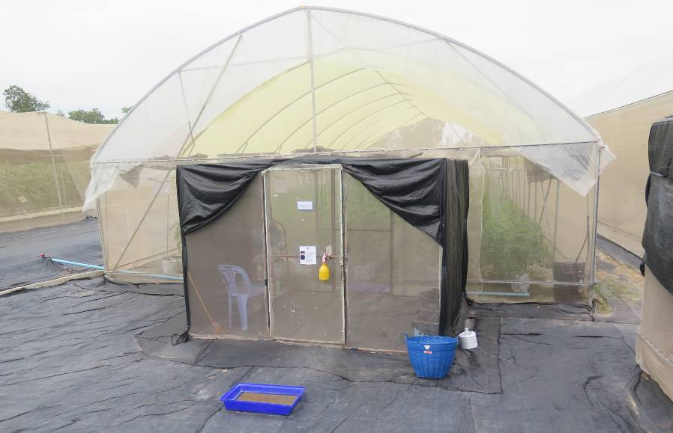
Figure 16 Tomato seed crop in a GSPP-accredited net house, Thailand
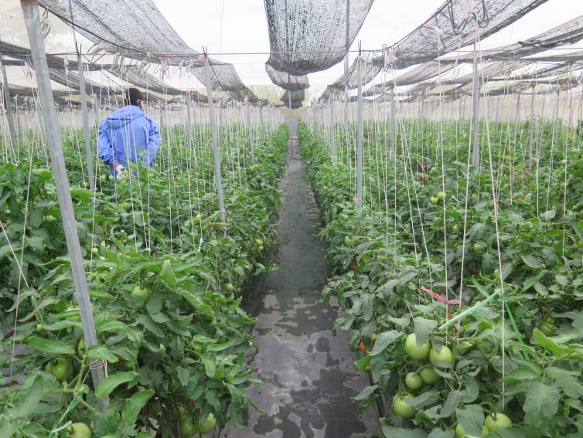
Figure 17 Tomato seed crop in a GSPP-accredited net house is managed by one worker, Thailand
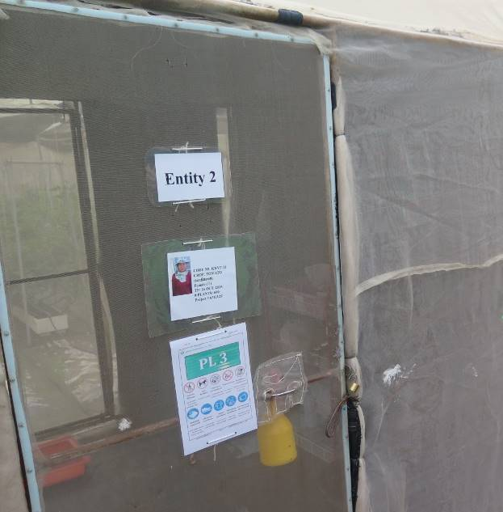
Figure 18 GSPP-accredited glasshouse for tomato seed production, the Netherlands

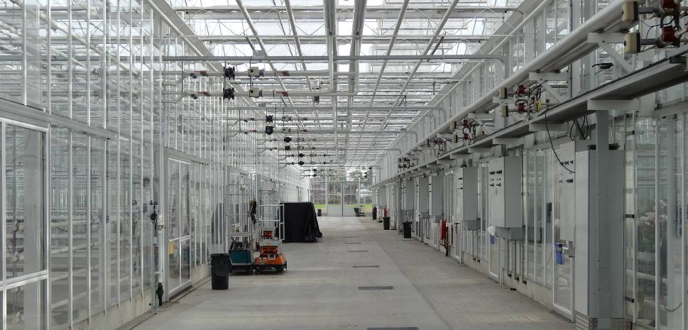
Figure 19 Tomato seed crop in a GSPP-accredited glasshouse, the Netherlands

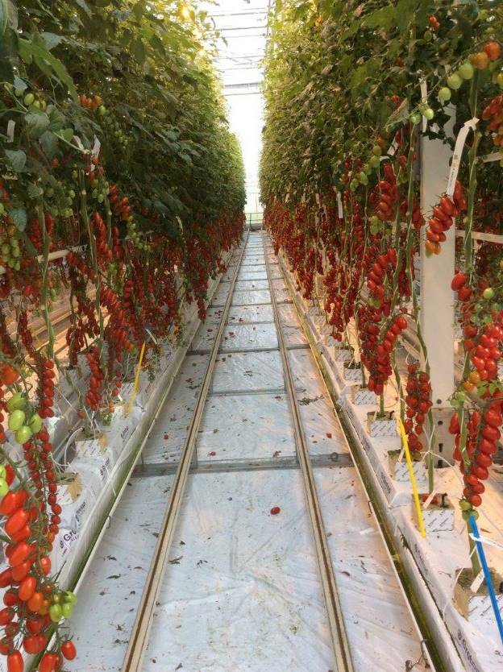

National industry representation
  - Currently, there is one peak national agency for the ‘processing tomato’ sector in Australia but none for fresh tomato growers. From both an industry and government perspective, such fragmentation is unhelpful in dealing with issues such as implementation of emergency response measures, in the event of an incursion. A single peak industry body would enable the department to deal more effectively and efficiently with industry, in relation to biosecurity issues (incursions) affecting the tomato industry. There would appear to be benefit in the minister and department, in consultation with PHA and relevant stakeholders, encouraging tomato industry groups to consider the establishment of a single national representative body.
Recommendation 12
  - Under the auspices of Plant Health Australia, the minister and department should encourage cross-industry discussions on the benefits of establishing a peak national body for the tomato industry. This would improve national industry coordination, particularly in managing biosecurity risks associated with tomato production.
Department’s response: The department agrees with this recommendation.
There is currently no national peak industry body representing fresh tomatoes, including through membership of Plant Health Australia and as a signatory to the Emergency Plant Pest Response Deed. The department will work with Plant Health Australia to determine the barriers to the industry establishing a peak industry body and working through their biosecurity risks and issues, including becoming a deed signatory and Plant Health Australia member.
Noting the Australian Processing Tomato Research Council represents the biosecurity interests of the producers of processing tomatoes. They are members of Plant Health Australia and signatories to the Emergency Plant Pest Response Deed.

Appendix A: Agency response
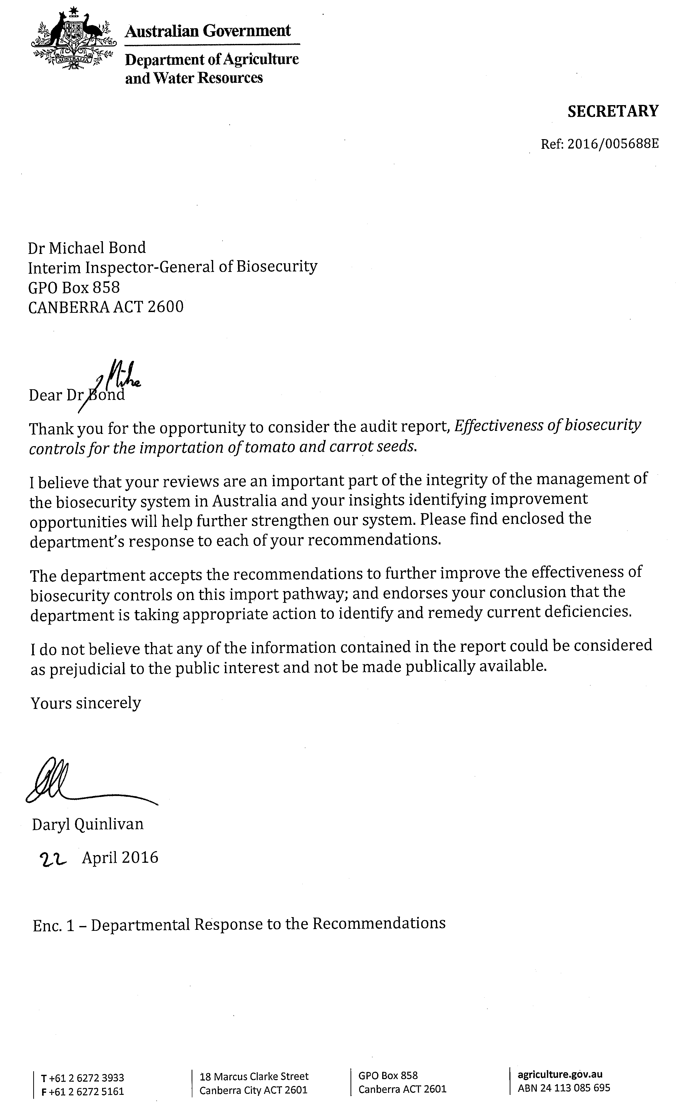

Appendix B: Guide to acceptable seed analysis certificates issued offshore
The Department of Agriculture and Water Resources endorses the following International Seed Testing Association (ISTA)-approved laboratory offshore seed analysis certificates:
- ISTA Orange International Seed Lot Certificate for pelleted seed (vegetable, herb and pasture or forage)—issued by an ISTA-accredited laboratory. The consignment must also meet requirements under BICON.
- ISTA Orange International Seed Lot Certificate for each seed lot used in seed products such as magic eggs, seed in a can, seed kit, seeded paper or novelty seed product—issued by an ISTA-accredited laboratory. The consignment must also meet requirements under BICON.
- ISTA Orange International Seed Lot Certificate for all seed types other than those listed in points 1 and 2—issued by an ISTA-accredited seed testing laboratory approved by the department to test for all seed types other than those listed in points 1 and 2. The consignment must also meet requirements under BICON.
- Seed Analysis Certificate for all seed types other than listed in points 1 to 3—must be issued by an ISTA-accredited seed testing laboratory. The consignment must also meet requirements under BICON.
- Naktuinbouw Authorised Laboratory Quality Certificate for all seed types—issued by an approved laboratory in the Netherlands under the NAL—Department of Agriculture and Water Resources protocol for all seed types including pelleted seed. The consignment must also meet requirements under BICON.
Source: Seed sampling and inspection work instruction (internal document), Department of Agriculture and Water Resources

Appendix C: Department of Agriculture and Water Resources approved seed testing laboratories
Testing laboratory | Address | Country | Certificate type
Laboratorio Central de Análisis de Semillas Instituto Nacional de Semillas | Venezuela 162 CP 1063 Buenos Aires Argentina | Argentina | ISTA
20/20 Seed Labs, Inc. | 507 11th Avenue, Nisku, AB Canada T9E7N5 | Canada | ISTA
Laboratorio di Ricerca e Analisi Sementi (LaRAS) | DipSA, Universitá di Bologna Viale Fanin, 40 40127 Bologna | Italy | ISTA
Bejo Zaden B.V. | Trambaan 1, 1749 CZ Warmenhuizen, Netherlands | Netherlands | NAL
Enza Zaden Beheer B.V. | Haling 1 E, 1602 DB, Enkhuizen, Netherlands | Netherlands | NAL
Monsanto Holland B.V. | Leeuwenhoekweg 52, NL – 2661 CZ Bergschenhoek, Netherlands | Netherlands | NAL or ISTA
Rijk Zwaan Production B.V. | Burgemeester Crezeelaan 40, 2678 KX De Lier, Netherlands | Netherlands | NAL
Naktuinbouw | Sotaweg 22, PO Box 40, 2370 AA Roelofarendsveen, Netherlands | Netherlands | ISTA
AsureQuality New Zealand Ltd., National Seed Laboratory | Tennet Drive PO Box 609, Palmerston North | New Zealand | ISTA
AsureQuality Ltd., Lincoln | Lincoln University, P.O. Box 6, Lincoln | New Zealand | ISTA
New Zealand Seedlab Ltd. | P.O. Box 16101, Christchurch | New Zealand | ISTA
Seed Tech Services | Massey University, Palmerston North | New Zealand | ISTA
Agri Seed Testing, Inc. | 1930 Davcor Court SE, Salem, Oregon, 97302 | United States | ISTA
Oregon State University Seed Laboratory | 3291 Campus Way, Corvallis, Oregon, 97331 | United States | ISTA
Monsanto Vegetable Seeds, Inc. | 2700 Camino Del Sol Oxnard, California, 93030 | United States | ISTA
SGS Mid-West Seed Services, Inc. | 236 32nd Avenue, Brookings, South Dakota, 57006 | United States | ISTA
Instituto Nacional de Semillas - INASE | Camino Bertolotti s/n y Ruta 8, Km 29 91001 Barros Blancos, Canelones | Uruguay | ISTA
Source: Biosecurity Import Conditions (BICON) system

Appendix D: ISTA-accredited laboratories in Australia
Name | Address | List of tests
AGWEST Plant Laboratories | Seed Testing Station  Department of Agriculture and Food  Bentley Delivery Centre  Western Australia 6151  Phone: +61 8 9368 3844 | Sampling  Purity and determination of other seeds  Germination  Weight determination
AsureQuality Ltd | Seed Laboratory Tullamarine  3–5 Lilee Crescent  Tullamarine  Victoria 3043  Phone: +61 3 8318 9000 | Sampling  Purity and determination of other seeds  Germination  Viability  Verification of species and variety  Moisture content determination  Weight determination  Vigour testing
Queensland Seed Technology Lab | 2 Stewart Street  Queensland 4352  Phone: +61 7 4613 9052 | Sampling  Purity and determination of other seeds  Germination  Viability  Moisture content determination  Weight determination
SA Seed Laboratory | Primary Industry and Resources South Australia  Plant Research Centre Waite Campus  Urrbrae  Adelaide 5001  Phone: +61 8 8303 9549 | Sampling  Purity and determination of other seeds  Germination  Viability  Moisture content determination  Weight determination
Tasmanian Seed Laboratory | Department of Primary Industry, Water and Environment  165 Westbury Road  Prospect  Tasmania 7250  Phone: +61 3 6336 5248 | Sampling  Purity and determination of other seeds  Germination  Viability  Verification of species and variety  Moisture content determination  Weight determination  Vigour testing
Source: ISTA Online

Appendix E: List of international seed companies currently certified under Naktuinbouw Authorised Laboratory (NAL) system
Company | Location
Bejo Zaden B.V. | Warmenhuizen (Netherlands)
Enza Zaden Seed Operations B.V. | Enkhuizen (Netherlands)
Nunhems Netherlands NL B.V. | Haelen (Netherlands)
Rijk Zwaan Production B.V. | De Lier (Netherlands)
Syngenta Seeds B.V. | Enkhuizen (Netherlands)
Monsanto Holland B.V. | Bergschenhoek/Enkhuizen (Netherlands)
Incotec Europe B.V. | Enkhuizen (Netherlands)
Hazera Seeds B.V. | Made (Netherlands)
Vilmorin S.A. | La Menitre (France)
Germains Seed Technology | Aalten (Netherlands)
Sakata Vegetables Europe S.A.S. | Uchaud (France)
Sakata Seed Corporation | Yokohama (Japan)
Nunhems USA | Parma (USA)
Seminis Vegetable Seeds Inc. (a wholly owned subsidiary of Monsanto Company) | Woodland, CA (USA)
Hazera Seeds Ltd. | Berurim (Israel)
Takii Europe B.V. | De Kwakel (Netherlands)
Source: Naktuinbouw

Appendix F: Variables considered in document assessment for imported tomato and carrot seed
Parameter(s) | Criteria pertinent to parameter(s) |  | Variables
Parameter(s) |  |  | Tomato seeds |  |  | Carrot seeds
Combined weight of imported consignment | Individual lines or lots of seed | - 10 kilograms or less  - Over 10 kilograms | As applicable |  |  | As applicable
Seed purity testing | Conforming to ISTA sampling requirements | - Visual inspection for seed lots with a combined weight of 10 kilograms or less  - Full analysis at an approved laboratory for seed lots with a combined weight of 10 kilograms or more | As applicable |  |  | As applicable
Seed purity testing | Minimum number of seeds to be tested | na | 10 000 seeds or 15 grams of seed |  |  | 10 000 seeds or 30 grams of seed
Seed health testing | Offshore testing | Target pathogen(s) | Pepino mosaic virus |  | Columnea latent viroid, pepper chat fruit viroid, potato spindle tuber viroid, tomato apical stunt viroid, tomato chlorotic dwarf viroid and tomato planta macho viroid | Candidatus Liberibacter solanacearum  (testing required only if seeds are not heat treated)
Seed health testing | Offshore testing | Specific assay | ELISA test | PCR test | PCR test | PCR test
Seed health testing | Offshore testing | Minimum number of seeds (per lot) that must be tested for target pathogens | 3000 seeds | 3000 seeds | 20 000 seeds | 20,000 seeds
Seed health testing | Offshore testing | Sampling requirements | Sub-samples of no more than 250 seeds | Sub-samples of no more than 400 seeds (unless the testing laboratory is approved for sub-sample sizes greater than 100 seeds) | Sub-samples of no more than 400 seeds | not specified
Seed health testing | Offshore testing | Pooling of seed lots | Not permitted for ELISA and PCR tests |  |  | na
Seed health testing | Onshore testing | Same testing requirements and parameters as for offshore testing but | Smaller consignments may be pooled into one lot for testing purposes  Seed lots 300 grams or less can be tested onshore using 20 per cent of the seed lot by weight |  |  | Seed lots 250 grams or less can be tested onshore using 20 per cent of the seed lot by weight
Approved seed treatment | Only used if carrot seed is not tested for presence of Candidatus Liberibacter solanacearum | Offshore | na |  |  | Seed treated at a minimum temperature of 50 °C for at least 20 minutes
Approved seed treatment |  | Onshore | na |  |  | Seed treated at a minimum temperature of 50 °C for at least 20 minutes at a Class 4.1 QAP
Approved pathway | na | na | Alternative import conditions for breeder’s seed (tomato) imported from approved production systems |  |  | None
Requirements of mandatory additional declarations | Declared either on accompanying phytosanitary certificate | na | Endorsement by NPPO, through additional declarations on a phytosanitary certificate, regarding seed health assay undertaken as per Australian requirement for (must exactly match the wording on an import permit)
Seed certification requirements | Coated seed | Seed health and purity testing—offshore and onshore | Test seed overseas prior to treating  or  Supply a raw seed sample for testing  or  Importer to contact Plant Import Operations prior to shipment to discuss testing treated seed onshore |  |  | Consignments may be permitted entry without ISTA sampling and analysis if accompanied by an acceptable NAL or ISTA seed analysis certificate.  But a NAL quality certificate from Netherlands must conform to certain requirements.  ISTA seed analysis certificate from Argentina, Canada, Italy, Netherlands, USA or Uruguay must conform to certain requirement including be endorsed with specific statements.  ISTA Orange International Seed Lot certifications do not require this endorsement.
Documentary requirements | For all consignments tested and/or treated offshore | na | Consignment to be accompanied by phytosanitary certificate endorsed with additional declaration and accompanied by supporting test report(s)  or  Consignment accompanied by phytosanitary certificate which is endorsed with a lot number that links to the supporting test report(s) |  |  | Official government phytosanitary certificate is accepted instead of onshore heat treatment or PCR testing  Offshore PCR testing on the consignment with government phytosanitary certificate must be accompanied with corresponding laboratory report  Full consignments packed in khapra beetle country must have a phytosanitary certificate carrying an endorsement that it is free from khapra beetle.
Inspection requirements | Designated classes of quarantine approved premises | na | None |  |  | Correctly certified full containers forwarded to a Class 1.1, 1.3 or 2.2 QAPs.  Incorrectly certified full containers forwarded to a Class 1.1 QAP.
na, Not applicable.
Source: Biosecurity Import Conditions system (BICON), Department of Agriculture and Water Resources
Appendix G: Ambiguities in BICON system for tomato and carrot import requirements
Import requirement (scenario) | Tomato | Carrot | Tomato and carrot
Permitted species lists | Scientific names list not reduced to species under that genus after a specific genus is selected in BICON. This appears to be an issue in the majority of seed cases in BICON with the exception of the Tomato Seed for Sowing case, which suitably shows only the Lycopersicon spp. in the list. This issue slows the assessment process, may cause computer malfunction in loading the full species list page, and is cumbersome to search through to find the appropriate species. | n.a. | Wording ‘covered by or excluded from this case’ in the actual appendix but the link to the appendix specifies ‘for permitted species’… is ambiguous
Onshore/offshore testing question | The question on onshore/offshore testing of imported tomato seed cannot be answered by an assessment officer at this early stage in the assessment process prior to assessing any documentation against the import conditions. This question is targeted to the importer, not the assessing officer and should potentially appear further in the case or be removed.  An assessing officer would need to have completed a doc assessment for this question; they would normally complete the assessment prior to contacting the broker for further information. | n.a. | n.a.
Pelleted seeds question | n.a. | Often not answerable until inspection as required information is not always specified in commercial documentation. Pelleted seed may not be declared in commercial documentation and will not be detected until the inspection stage. This may impact whether the ISTA testing direction is included/not required.  This is a question that frequently cannot be answered at the document assessment stage. | n.a.
Fungicide treatment question | Often not answerable until inspection as treatment/ coating detail is not always specified in commercial documentation. May not be detected until the inspection stage. | n.a. | n.a.
Fungicide treatment scenarios | The department requires a sample of unpelleted (not treated with fungicide) seed to accompany a lot/batch of treated seed for ease of testing. However, such a sample is generally not provided by the exporter, and often the department does not enforce this requirement. Furthermore, an unpelleted sample (from the same lot as imported pelleted seed) is also desirable for workplace health and safety point of view.  The IIGB agrees that this issue can be addressed in other ways rather than including this potentially redundant step. | n.a. | n.a.
Onshore testing direction comments | Direction comments for permitted species (not treated prior to shipment) appear to have been incorrectly copied across from the Import Conditions page of the case. Current comments only address the instructions for small (less than 300 grams) size consignments. | n.a. | n.a.
Offshore treatment options and requirements | Option 1—appears to not require a lot code reference to be evident on the phytosanitary certificate. This may cause issue with linking phytosanitary certificate comments to the specific consignment. However, issue with not requiring lot code more likely to apply to clients who are regular importers of the same type of consignment (such as, those who regularly import tomato seeds from the Netherlands in same (or similar) quantities each time.  Option 2—laboratory report requirement comments do not provide enough information as to viroid testing requirements as a standalone option. One must obtain the viroid testing requirements from the information in the statements listed in Option 1 to gather sufficient processing information. | n.a. | n.a.
na, Not applicable.
Source: Department of Agriculture and Water Resources

Glossary
Term | Definition
AIMS | Australian Import Management System, managed by the Department of Agriculture and Water Resources
BICON | Biosecurity Import Conditions system, managed by the Department of Agriculture and Water Resources
competent authority | Official service or authority established by the government of an exporting state, which has the responsibility and competence to ensure or supervise implementation of animal, plant or public health standards
ICS | Integrated Cargo System, managed by the Department of Immigration and Border Protection
IPPC | International Plant Protection Convention  The primary purpose of this convention is a multilateral treaty for international cooperation in plant protection. The Convention makes provision for the application of measures by governments to protect their plant resources from harmful pests (phytosanitary measures) that may be introduced through international trade.
ISPM | International Standard for Phytosanitary Measures  International Standards for Phytosanitary Measures are prepared by the Secretariat of the IPPC as part of the United Nations Food and Agriculture Organisation’s global programme of policy and technical assistance in plant quarantine. This programme makes available to FAO Members and other interested parties these standards, guidelines and recommendations to achieve international harmonisation of phytosanitary measures, with the aim to facilitate trade and avoid the use of unjustifiable measures as barriers to trade
International Seed Testing | Provides an internationally recognised and trusted standard for seed sampling and seed testing; ISTA develops, adopts and publishes standard procedures for sampling and testing seeds, and promotes uniform application of these procedures for evaluation of seeds moving in international trade
Naktuinbouw Accredited | An accreditation system for private seed laboratories; selected laboratories are approved under the NAL–Department of Agriculture and Water Resources protocol
Orange International Certificate (OIC) | Certificate issued when the sample is drawn officially from the lot and tests carried out under the authority of the same member station. This represents the seed lot as a whole, including:  - seed lot preparation  - lot size  - lot identification  - seed sampling  in accordance with strict guidelines.  Certificates are issued by an offshore laboratory; however, only those issued by ISTA-accredited seed testing laboratory will be recognised
PCR | polymerase chain reaction testing process for seeds
PRA (pest risk analysis) | Process that enables the Australian Government to formally consider risks that could be associated with proposals to import new products into Australia; PRAs are conducted by the Department of Agriculture and Water Resources
priming | Seed priming is the pre-treatment of seeds by various methods to improve the seed germination rate, the percentage of germination and the uniformity of seedling emergence
QAP | A quarantine approved premises is a place approved, under section 46A of the Quarantine Act 1908, as a place where goods of a specified class that are subject to quarantine may be treated or otherwise dealt with
seed | A commodity class for seeds for planting or intended for planting and not for consumption or processing.
seed analysis certificate | Certificate issued by an ISTA-accredited seed testing laboratory; certificates must meet the conditions outlined under the appropriate BICON case
seed lot | An identifiable quantity of seed of one variety, of known origin and history and controlled under one reference number in a seed quality assurance scheme
tolerance level | Maximum percentage of a disease, pest, restricted and prohibited seed or soil allowed for all end uses.

References
AUSVEG 2011, Industry biosecurity plan for the vegetable industry, available at ausveg.com.au/biosecurity/.
Aveling, TAS 2014, ‘Global standards in seed health testing’, in ML Gullino, G Munkvold (eds), Global perspectives on the health of seeds and plant propagation material, Plant Pathology in the 21st Century, Springer.
Beale, R, Fairbrother, J, Inglis, A & Trebeck, D 2008, One biosecurity: a working partnership, Commonwealth of Australia, Canberra, available at agriculture.gov.au/about/publications/quarantine-biosecurity-report-and-preliminary-response.
Catley, A 1987, ‘Outbreaks and new records. Australia: eradication of potato spindle tuber viroid’, Food and Agriculture Organization Plant Protection Bulletin 35, 32.
DAFF 2011, Import risk analysis handbook 2011, Department of Agriculture, Fisheries and Forestry, Canberra, available at agriculture.gov.au/biosecurity/risk-analysis/ira/process-handbook.
Department of Agriculture and Water Resources 2015a, Agricultural Competitiveness White Paper, available at http://agwhitepaper.agriculture.gov.au/
— 2015b, Biosecurity Advice 2015/23—Draft pest risk analysis for Candidatus Liberibacter solanacearum associated with apiaceous crops, Department of Agriculture and Water Resources, Canberra, available at http://www.agriculture.gov.au/biosecurity/risk-analysis/memos/ba2015-23.
–– 2015c, Minimum documentary and import declaration requirements policy, available at http://www.agriculture.gov.au/import/arrival/clearance-inspection/documentary-requirements/minimum-document-requirements-policy
FAO 1997, International Standards for Phytosanitary Measures: Guidelines for surveillance, ISPM no. 6, Secretariat of the International Plant Protection Convention, Food and Agriculture Organization, Rome, available at ippc.int/en/core-activities/standards-setting/ispms/#592.
–– 2002, International Standards for Phytosanitary Measures: The use of integrated measures in a systems approach for pest risk management, ISPM no. 14, Secretariat of the International Plant Protection Convention, Food and Agriculture Organization, Rome, available at ippc.int/en/core-activities/standards-setting/ispms/#592.
–– 2007, International Standards for Phytosanitary Measures: Guidelines for pest risk analysis, ISPM no. 2, Secretariat of the International Plant Protection Convention, Food and Agriculture Organization of the United Nations, Rome, available at ippc.int/en/core-activities/standards-setting/ispms/#592.
–– 2012, Regional status of pest surveillance in the context of ISPM No. 6: International Standard for Phytosanitary Measures—Guidelines for Pest Surveillance, Analysis of the responses to the Implementation Review and Support System (IRSS) questionnaire from APPPC countries, available at http://www.fao.org/3/contents/91c3b3ad-5abd-5b86-963d-bc893d2d82d3/i2731e00.htm
–– 2013, International Standards for Phytosanitary Measures: Pest risk analysis for quarantine pests, ISPM no. 11, Secretariat of the International Plant Protection Convention, Food and Agriculture Organization of the United Nations, Rome, available at ippc.int/en/core-activities/standards-setting/ispms/#592.
–– 2014, International Standards for Phytosanitary Measures: Guidelines for phytosanitary certificates, ISPM no. 12, Secretariat of the International Plant Protection Convention, Food and Agriculture Organization of the United Nations, Rome, available at ippc.int/en/core-activities/standards-setting/ispms/#592.
IIGB 2015a, Effectiveness of biosecurity controls for importation of natural sausage casings, Interim Inspector-General of Biosecurity report, Canberra, available at igb.gov.au/Pages/completed-audits-and-reviews.aspx.
–– 2015b, Effectiveness of biosecurity controls for imported fresh cut flowers, Interim Inspector-General of Biosecurity report, Canberra, available at igb.gov.au/Pages/completed-audits-and-reviews.aspx.
–– 2015c, Effectiveness of biosecurity controls for importing stockfeed of plant origin, Interim Inspector-General of Biosecurity report, Canberra, available at higb.gov.au/Pages/completed-audits-and-reviews.aspx.
–– 2014, Effectiveness of biosecurity controls for imported animal breeding material (mammalian semen and embryos), Interim Inspector-General of Biosecurity report, Canberra, available at igb.gov.au/Pages/completed-audits-and-reviews.aspx.
–– 2012, An examination of factors that led to release into Australia of a consignment of soil (declared as fertiliser) and interception at the border of another consignment of soil (declared as fertiliser), Interim Inspector-General of Biosecurity report, Canberra, available at igb.gov.au/Pages/completed-audits-and-reviews.aspx.
IPPC 2009, International Plant Protection Convention, International Standards for Phytosanitary Measures: Draft ISPM—International movement of seeds 2009–003, Secretariat of the International Plant Protection Convention, Food and Agriculture Organization of the United Nations, Rome, available at ippc.int/static/media/files/publications/1292408061_1291027896_MC2010_12_Specificati.doc.
Kamphuis, BM 2005, The seed sector in the Netherlands. An overview of production, trade and related institutions, Agricultural Economics Research Institute (LEI), The Hague. Report of the Agricultural Economics Research Institute no. 5.05.09, available at wageningenur.nl/en/Publication-details.htm?publicationId=publication-way-333431343037.
Navaratnam, SJ 1984, New records—potato spindle tuber. Quarterly Newsletter Asia and Pacific Plant Protection Commission, no. 27, pp. 5–6.
PHA 2013, National Plant Biosecurity Strategy, Plant Health Australia, available at planthealthaustralia.com.au/national-programs/national-plant-biosecurity-strategy/.
Pheloung, P 2005, ‘Contingency planning for plant pest incursions in Australia’, Proceedings of the workshop on invasive alien species and the International Plant Protection Convention, Braunschweig, Germany, 22–26 September 2003.

