

Review report No. 2018–19/05

# Pest and disease interceptions and incursions in Australia

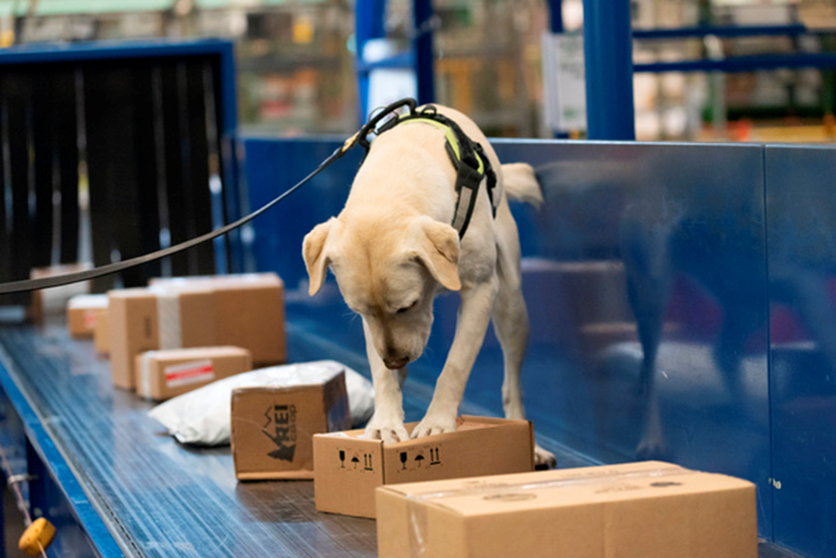

© Commonwealth of Australia 2019

**Ownership of intellectual property rights**

Unless otherwise noted, copyright (and any other intellectual property rights, if any) in this publication is owned by the Commonwealth of Australia (referred to as the Commonwealth).

**Creative Commons licence**

All material in this publication is licensed under a Creative [Commons Attribution 4.0 International Licence](https://creativecommons.org/licenses/by/4.0/legalcode) save for content supplied by third parties, logos and the Commonwealth Coat of Arms.

Inquiries about the licence and any use of this document should be emailed to [copyright@agriculture.gov.au](mailto:copyright@agriculture.gov.au)

C:\Documents and Settings\west merryn\Local Settings\Temporary Internet Files\Content.Word\by.png

**Cataloguing data**

This publication (and any material sourced from it) should be attributed as: Inspector-General of Biosecurity 2019, Pest and disease interceptions and incursions in Australia, Department of Agriculture and Water Resources, Canberra, April. CC BY 4.0.

ISBN: 978-1-76003-164-0

This publication is available at [igb.gov.au/Pages/current-completed-reviews.aspx](http://www.igb.gov.au/Pages/current-completed-reviews.aspx)

Inspector-General of Biosecurity

c/- Department of Agriculture and Water Resources

PO Box 657 Mascot NSW 1460

Telephone +61 2 8334 7409

Email [inspgenbiosecurity@agriculture.gov.au](mailto:inspgenbiosecurity@agriculture.gov.au)

Web [igb.gov.au](http://www.igb.gov.au/Pages/default.aspx)

The Australian Government represented by the Inspector-General of Biosecurity (IGB), has exercised due care and skill in preparing and compiling the information and data in this publication. Notwithstanding, the Inspector-General of Biosecurity, the Australian Government’s employees and advisers disclaim all liability, including for negligence and for any loss, damage, injury, expense or cost incurred by any person as a result of accessing, using or relying on any of the information or data in this publication to the maximum extent permitted by law.

**Credits**

The source of data for all figures and tables is the Department of Agriculture and Water Resources unless otherwise noted.

**Acknowledgements**

In undertaking this review, the Inspector-General received cooperation and advice from officials of the Australian Government Department of Agriculture and Water Resources. Their assistance is gratefully acknowledged.

Contents

Review process 6

Summary 8

Recommendations and departmental responses 13

1 Background 15

1.1 Government biosecurity regulation in Australia 15

1.2 Border biosecurity risk management 15

1.3 Sharing responsibility for post-border biosecurity 16

1.4 Priority setting for different pests 17

1.5 High-risk and low-risk interceptions 18

2 Mail and passenger biosecurity risk management 19

2.1 Overall process 19

2.2 Mail 19

2.3 Passengers 21

2.4 Intercepting biosecurity risk material case study—meat interceptions 24

2.5 Maximising screening effectiveness 27

3 Conveyance and cargo border biosecurity risk management 30

3.1 Overall process 30

3.2 Risk profiling different types of cargo 32

3.3 Cargo compliance verification 34

4 Pest and disease interceptions 39

4.1 Interceptions from cargo (air and sea) 39

4.2 Priority plant pest interceptions 39

4.3 Priority animal and plant interceptions in post-arrival quarantine facilities 41

5 Border breaches and incursions 44

5.1 Border breaches 44

5.2 Incursions 46

6 Improving biosecurity information management 56

6.1 Better reporting of high-risk interceptions 56

6.2 Complex data recording systems 57

6.3 Biosecurity integrated information system and analytics 59

6.4 Risk-return resource allocation 60

Conclusion 62

Appendix A: Agency response 63

References 66

Glossary 68

**Tables**

Table 1 International mail volumes, screenings and inspections, 2015–16 to 2017–18 20

Table 2 Air arrivals and screening methods, 2012 to 2017 22

Table 3 Top five meat products intercepted at the border, 2012 to 2017 25

Table 4 Volumes of meat and meat products seized at the border, 2012 to 2017 25

Table 5 Meat interception by top 10 country declaration status, 2012 to 2017 26

Table 6 Cargo compliance verification inspections, by state and territory, February 2017 to February 2019 35

Table 7 Non-compliant consignments found via cargo compliance verification, August 2018 to February 2019 37

Table 8 Border interceptions of national priority plant pests, 2012 to 2017 40

Table 9 Animal disease interceptions in post-arrival quarantine, 2010 to 2018 41

Table 10 Plant pests and diseases found in post-entry quarantine, 2015 to 2018 42

Table 11 Plant pest incidents, 2007 to 2016 46

Table 12 Major plant pest and disease incursions, 2010 to 2018 47

Table 13 Animal disease incursions reported to OIE, 2007 to 2017 49

Table 14 Aquatic animal disease detections, 2010 to 2018 50

Table 15 Introduced marine pests, February 2010 to February 2019 51

Table 16 Emergency responses to exotic invasive ants, 2001 to 2018 54

Table 17 Plant and animal pest and disease notifications, 2014 to 2018 56

**Figures**

Figure 1 Government biosecurity risk management across the continuum 15

Figure 2 International mail biosecurity risk management system 20

Figure 3 Seizures of biosecurity risk material at mail facilities, 2012 to 2018 21

Figure 4 Air traveller biosecurity risk management pathway, 2017–18 22

Figure 5 Seizure of biosecurity risk material at airports, 2012 to 2018 23

Figure 6 Sea passenger arrivals, screenings and inspections, 2012 to 2017 23

Figure 7 Top five points of entry for meat interceptions, 2012 to 2017 26

Figure 8 Methods of detecting meat interceptions, 2012 to 2017 27

Figure 9 Imported cargo biosecurity risk management system 31

Figure 10 Cargo compliance verification inspections per quarter, 2013–14 to 2018–19 36

Figure 11 Interceptions from cargo by type of goods, January 2014 to July 2016 39

Figure 12 Top four priority plant pest interceptions, 2012 to 2017 40

**Boxes**

Box 1 African swine fever on the move 24

Box 2 Cargo compliance verification findings lead to stronger risk management 37

Box 3 Varroa mite detection on ship’s cargo—a border breach averted 44

Box 4 Khapra beetle border breaches 45

## Review process

**Purpose**

This review considered recent interceptions, border breaches and incursions of plant and animal pests and diseases to improve the Australian biosecurity system.

This review examined:

* Department of Agriculture and Water Resources (the department) interceptions made at Australian borders to manage the biosecurity risks associated with incoming people, mail, cargo and conveyances
* plant and animal pests and diseases that breached the border and led to incursions in Australia
* system improvements already made or needed in response to interceptions, border breaches and incursions
* departmental mechanisms to manage and share information on interceptions and incursions with state and territory government agencies and other public and private bodies responsible for biosecurity.

**Scope**

The scope of this review covered the department’s operational policies and activities relevant to pests and diseases intercepted at the border and management of risks after incursion into Australia. It excluded the responsibilities of state and territory governments, individuals and biosecurity industry participants. The review considered:

* trends in total and high-risk interceptions, border breaches and incursions from 2012 to 2017
* assessment of data collection and management systems, and their integration for ease of data extraction to inform biosecurity risk management, policy formulation and development
* operational policies on pest and disease interceptions, border breaches and incursions
* mechanisms for sharing information with state and territory government agencies, industry bodies, Animal Health Australia and Plant Health Australia
* system improvements needed following interceptions, border breaches and incursions.

**Review methodology**

During this review, I consulted extensively within and outside the Department of Agriculture and Water Resources. In particular, I:

* conducted an entry meeting and subsequent in-person or phone meetings with key stakeholders to
  + communicate the review’s objectives and scope
  + outline responsibilities
  + identify risks related to the review and any appropriate mitigation strategies
  + obtain initial background information about management of risks of plant and animal pests and diseases entering Australia
  + provide all parties opportunities to discuss, brainstorm and clarify the proposed review process
* discussed preliminary data and information requirements with relevant departmental officers and requested data and information
* conducted a desk audit of relevant departmental data and documentation (such as standard operating procedures, policies and communications material)
* visited airports and seaports in Sydney, Melbourne, Brisbane, Newcastle and Port Kembla and the Sydney Gateway mail centre to undertake fieldwork to observe and verify the department’s procedures and operations in managing pest and disease risks
* held meetings with key industry stakeholders on how industry bodies interact with the department to apply brown marmorated stink bug (BMSB) management measures
* considered potential risks, including whether
  + the department’s border risk-based intervention measures are inadequate or not applied correctly by staff to identify high-risk exotic pests and biosecurity risk material
  + the department’s risk-based methodologies and post-border intervention measures are inadequate to detect high-risk exotic pests in cargo and conveyances post-release
  + the department’s data recording and risk management methods for exotic pests and biosecurity risk material entering Australia are inadequate or not applied correctly
  + powers under the *Biosecurity Act 2015* are inadequate to manage risks in a timely and efficient manner
  + the department lacks timely internal mechanisms to identify and respond effectively to emerging risks
  + the department has insufficient resources or capabilities to address current and new or emerging biosecurity risks
  + standard operating procedures and instructional material used by departmental staff are difficult to follow or outdated
  + ICT systems fail to support operational requirements and departmental processes efficiently
  + stakeholders fail to provide the department with appropriate or timely information to allow it to carry out its responsibilities
  + the department fails to provide stakeholders with appropriate or timely information to allow them to carry out their responsibilities.

As required by the *Biosecurity Act 2015* I presented my draft report to the Director of Biosecurity for departmental consideration. The department’s response to my recommendations is included in this report. I provided a copy of my final report to the Director of Biosecurity and the Minister for Agriculture and Water Resources.

**Review team**

Dr Naveen Bhatia and Glenn McMellon assisted the IGB in this review.

## Summary

**Background**

Annually, over 18,000 vessels, 1.8 million sea cargo consignments, 41 million air cargo consignments, 152 million international mail items and 21 million passengers arrive in Australia, and numbers are growing every year. Intercepting pests and disease-carrying material along these pathways before they enter and cause incursions in Australia is a huge challenge for the Australian Government Department of Agriculture and Water Resources (the department).

Risk prioritisation internationally and nationally of the vast array of potential pests or pathogens depends on their potential to cause serious harm to the Australian economy, human health and environment if they enter and establish. The department implements pre-border, at-border and post-border measures to reduce the risks to Australia of exotic pests and diseases, or the biosecurity risk material that might carry them.

Pre-border certification and offshore implementation of international standard measures to meet Australia’s import requirements effectively prevent many, but not all, pests and diseases from reaching Australia. Inevitably, many biosecurity risks are intercepted at the border, some serious pests pass through the border but are found before they establish, and some (previously exotic) pests and diseases are only found after they have entered and spread into Australia. Once pests pass the border, state and territory governments have legal powers to deal with them, often jointly with the Australian Government and with industry.

The Australian Government Department of Home Affairs (Home Affairs) considers for national security purposes all vessels, goods, people and mail approaching Australia. It refers those requiring biosecurity risk management to the department. For most pathways and commodities, the department inspects only a proportion of referred imports and arrivals, based on complex profiling assessing the risk they may carry unwanted pests or pathogens and sometimes on the intended destination in Australia, so that intervention activity can be directed to the riskiest pathways and commodities.

**Mail and passenger biosecurity risk management**

The department actively encourages incoming passengers to declare potential biosecurity risks and inspects baggage and mail for food and other biosecurity risk material. It screens international mail and passengers and their baggage using X-rays, detector dogs and manual inspections. Biosecurity officers use screening information to select mail and passengers’ baggage for inspection for undeclared biosecurity risk material. They also carry out approach surveys and end-point surveys (also known as leakage surveys), thoroughly inspecting a proportion of randomly selected items, to find the true incidence rate of target pests, biosecurity risk material or non-compliant imports in different pathways.

Meat products form about 20 per cent of interceptions in the mail and passenger pathways. Meat that has not been sourced or treated according to prescribed import conditions could introduce foot-and-mouth disease, African swine fever or other serious diseases to Australia, with devastating economic consequences. Between 2012 and 2017 the department intercepted more than 272 tonnes of meat products at the border, and about two-thirds of this came from countries not free of foot-and-mouth disease. Detector dogs intercepted 53 per cent and X-rays 32 per cent of the undeclared meat in this period. The department should consider using detector dogs to screen a greater proportion of incoming passengers and mail, and deploying more detector dogs in cargo pathways.

**Conveyance and cargo border biosecurity risk management**

Ships, sea containers and break-bulk cargo may carry hitchhiker pests and contaminants, and various cargo arriving by many pathways may have different biosecurity risks. It is difficult to establish the proportions of undeclared or uninspected classes of imports or arrivals and to estimate the extent that risk profiling would have resulted in a lower incidence of pests or other biosecurity risk material.

Most cargo arrives in air or sea containers. Much air cargo, such as fresh produce and flowers, is considered high biosecurity risk and is inspected at high levels. However, the Department of Home Affairs refers only about 22 per cent of arriving sea containers to the department for biosecurity consideration, based on risk profiling of importer or broker declarations. Of those referred, the department releases a further 14 per cent without further intervention after assessing import documents.

The department’s cargo compliance verification (CCV) program, where biosecurity officers thoroughly inspect a small random sample of sea containers and estimate the compliance rate for the remaining incoming sea containers, can verify that importer declarations are compliant, and departmental profiling and assessment controls are operating effectively. However, since 2016 frontline biosecurity resource constraints have greatly reduced the numbers of containers being sampled, especially at Sydney and Melbourne, the busiest ports. Only a third of targeted CCV inspections were carried out in 2017 and 2018. The program found some level of non-compliance in 13 per cent of consignments inspected. Considering the ever-increasing volume of containerised cargo entering Australia, the risk of pests and diseases entering in uninspected containers is growing, and the prospect of catching importers who fail to declare goods correctly is diminishing.

**Pest and disease interceptions**

A pest, a pathogen or biosecurity risk material (which may harbour pests or diseases) is considered intercepted when it is found before it passes through the Australian border and beyond biosecurity control. Live or dead insects, other animals and other biosecurity risk material without import permits, like meat and milk products, as well as soil, seeds or other plant matter, which may harbour pests or pathogens, may be intercepted at the border. Visible biosecurity risk material such as soil and seeds (often found on the outside of sea containers and vehicles) may contain pathogens, nematodes, ants or pest eggs or larvae.

Types and rates of interceptions of pests, pathogens and biosecurity risk material vary greatly by pathway. Between 2014 and 2017 almost 90 per cent of interceptions were insects, spiders and flowering plants. Of these, 30 per cent were detected in cut flowers, 10 per cent in fruits or nuts and 10 per cent in vegetables imported into Australia. The main organisms intercepted on cut flowers were thrips (40 per cent), mites (23 per cent) and true bugs (8.6 per cent). The air cargo pathway accounted for 45 per cent of all interceptions, the sea container pathway 19.8 per cent and the break-bulk sea cargo pathway 14.6 per cent.

Live organisms and other material may be sent for further scientific identification and may be further classified as high risk or low risk, based on whether they are or contain priority pests or pathogens. Between 2012 and 2017 the number of interceptions annually rose from 25,281 to 37,014, of which about 0.6 per cent were high-priority plant pests.

A wide range of pests and pathogens are found during post-arrival quarantine of different species of live animals and plants. However, few actual interceptions occur, because of effective pre-border risk-management measures.

**Border breaches and incursions**

A pest or disease is considered to have breached the border if it has passed through the border undetected but is later detected in or on its original consignment or carrier material. Targeted surveillance and importer biosecurity awareness are used to detect high-risk pest border breaches before they can establish in or on Australian host material and cause damage.

For example, the serious grain pest Khapra beetle is known to have breached the Australian border three times (in 2007 in Perth, 2016 in Adelaide and 2018 in Melbourne). In each case:

* the infested goods were not normally subject to biosecurity control
* the immediate port of origin was not a risk port for Khapra beetle
* the source was eventually thought to be a sea container that had carried an earlier consignment of grain (or goods) from a Khapra beetle-infected country
* initial diagnosis was slow but was followed by a quick and effective government response to prevent further spread, and
* all infestations were eradicated within two years of entry, without reaching Australia’s grain industries.

Communication about a border breach should balance the need for rapid mobilisation of an emergency response, including surveillance by relevant governments and industry, with a need not to miscommunicate its wider significance. Despite the pest being in the country, it has not established in its target host and so may not require immediate international notification, which could cause unwarranted trade repercussions.

An incursion occurs when a pest or disease has passed through the border, migrated from its original carrier and established in other hosts or host material in Australian territory. Its origin may be unknown, including from natural or unregulated pathways.

Incursions can be perceived as failures of the biosecurity system. However, despite being an island, Australia cannot keep all biosecurity risks at bay. Migratory birds can bring new strains of avian diseases, and insect vectors may be windborne. Some classes of pests or pathogens may be invisible on clothing or goods and undetectable during border inspection.

Most incursions are detected by industry or the public and reported initially to state or territory government staff, who then report them to the department. Industry and community biosecurity awareness, general or targeted surveillance programs, and rapid and accurate diagnosis, are critical to early detection and reporting.

Government and industry preparedness plans are critical to effective incursion responses. Decision-making committees with government and industry representatives become involved in cost-shared emergency responses, determining when a response should be continued, modified or transitioned to management—as happened with Russian wheat aphid and tomato potato psyllid.

The department categorises plant pest incursions as either pathogens or invertebrates. Plant pathogens, mainly fungi, account for about two-thirds of incursions. They are difficult to contain or eradicate due to their ability to spread by wind, soil and water. The 2010 incursion of myrtle rust in NSW quickly spread to Queensland, Victoria and Tasmania, where it continues to affect native plant species.

Exotic ants are considered some of the world’s most invasive pests. Since 2001 Australia has recorded 20 border breaches and incursions of yellow crazy ants, electric ants, browsing ants or red imported fire ants (RIFA). Most have been eradicated but some have been transitioned to management. The most serious RIFA incursion, detected in 2001 in south-east Queensland, is still in response phase, with funding committed until 2026. By then, Australian and state and territory governments will have spent at least $800 million over 25 years on ant incursions.

Australia has had far fewer animal disease incursions than plant pest incursions, but they tend to have far-reaching ramifications. The 2007 equine influenza incursion was eradicated in nine months and lessons from it led to major reforms to the Australian biosecurity system. By late 2018, the 2016 incursion of white spot disease in prawns in south-east Queensland was still not proven eliminated from wild crustaceans, with ongoing impacts on local prawn production, wild harvesting and marketing.

**Improving biosecurity information management**

Interceptions and incursions often do not directly correlate but interceptions may indicate increased risks of border breaches or incursions. The department must constantly improve mechanisms for quicker escalation and wider communication of selected interception data to domestic stakeholders. Timely reporting of interception data back to importers and countries of origin can also help prevent future export of pests and diseases to Australia.

Improvements to data capture and quality are critical to improving risk analysis and interception strategy by pest, disease, commodity or pathway. Departmental data quality has numerous problems due to aged data recording and management systems, where various data are recorded in different formats, databases and spreadsheets, taxonomy has been confused, and entry, retrieval and processing steps have been duplicated or fragmented. The department also needs to strengthen processes for data capture from approved arrangements because many goods pass through these without being examined by departmental officers.

The government has funded a Biosecurity Integrated Information Systems and Analytics program from 2016 to 2020 to help modernise departmental biosecurity data capture and management systems and create a single repository of the 30 departmental pest and disease lists, supporting extra analytic capacity. This will allow the department to provide better reporting and feedback to other stakeholders to improve risk management. However, the scope of this program will be insufficient to address many pressing needs for improved biosecurity information systems and further systems investment will be needed.

The department uses its risk return resource allocation (RRRA) methodology to balance the probability of finding risks against the effort required to find them, improving biosecurity system effectiveness and efficiency. The department should further verify that detection systems deployed according to RRRA modelling are resourced and performing to predicted levels to avoid inadequate risk management.

**Conclusion**

The department must keep strengthening arrangements for intercepting pests, diseases and biosecurity risk material, pathway by pathway, to ensure that effort is being directed to areas of highest risk as volumes of arriving vessels, goods, passengers and mail continually increase. It should increase efforts to adjust rates and methods of screening and other interventions, based on risk profiling information about approach rates of key priority pests and diseases, and verification processes such as end-point surveys that regularly assess leakage rates of targeted material and pests. The department should prioritise and properly resource these screening methods and verification processes irrespective of other crises. Failure to implement them may increase risk of incursions. Automated methods of profiling, screening and other interventions should be further developed and implemented.

Where risks or occurrences of increased approach or increased leakage are determined, the department should rapidly communicate these to other stakeholders, such as industry, overseas governments and state and territory governments. This will enable stakeholders to undertake pre-border prevention activities and post-border surveillance activities that complement those of the department.

The department will need to continually transform the information systems that underpin its biosecurity activities. This will strengthen active management and communication of biosecurity risk, enabling effective stakeholder participation in biosecurity risk management.

## Recommendations and departmental responses

The full departmental response to the recommendations is at Appendix A.

**Recommendation** 1

The department should improve the rate and effectiveness of screening mail and passengers, by both X-ray and by detector dogs. The department should increase the number and prioritise the use of detector dogs to fully use the mobility and versatility of dogs to screen across a range of environments including carousels, cargo and conveyances for targeted and random screening.

**Department’s response: Agreed.**

**The department is trialling 3D x-ray technology to improve screening rates and build computer algorithms to automatically detect biosecurity risk items (a world first for biosecurity management). This trial has had early success with faster, more comprehensive screening of traveller baggage and development of the first algorithm, and will shortly extend to the mail environment. The technology is also helping the department to better detect specific high risk threats such as African swine fever risk material.**

**The department has started to expand the detector dog program as part of a suite of controls to detect high risk pests. Trials are already underway to use existing detector dogs to screen for brown marmorated stink bugs (BMSB) at the Port of Brisbane, and random screening of travellers outside normal departmental profiles at Perth Airport. Funding for further expansion of the detector dog program will be a matter for government.**

Recommendation 2

The department should ensure that targeted annual rates of cargo compliance verification inspections at all ports are maintained at recommended levels commensurate with increasing container arrival numbers and that all non-compliances are actioned systematically and analysed regularly for trends and opportunities to improve compliance. The department should consider expanding the program beyond full container loads to include additional arrival pathways.

**Department’s response: Agreed.**

**The department is committed to the expansion of the cargo compliance verification (CCV) program and maintaining targeted annual rates of inspections as volumes increase.**

**The department has a system in place to capture and action reported cases of non-compliance identified through CCV inspections. This information is used for trend analysis and to identify opportunities to improve compliance. Similarly, arrangements for end-point surveys are in place for international travellers and mail. The transition to automated profiling for travellers in 2018 also allows the department to quickly implement and/or change cohort and random profile selection rates for biosecurity screening at the border.**

Recommendation 3

The department should continually improve mechanisms for timely management and sharing of information on interceptions of pests and biosecurity risk material with state and territory government agencies and with relevant industry and other public and private bodies responsible for biosecurity.

**Department’s response: Agreed.**

**The department has recently started and will continue to work with state and territory partners and other stakeholders on mechanisms to enable greater sharing of biosecurity pest and disease interception information.**

Recommendation 4

The department should continue the Biosecurity Integrated Information System and Analytics and develop an extension to the system to enable improved data capture, analysis and reporting on the management of risks of specific pests and diseases and of biosecurity risk material entering Australia.

**Department’s response: Agreed.**

**The department is already improving data capture and information management -approaches that support biosecurity activities and incursion responses through the BIISA program.**

Recommendation 5

The department should strengthen the implementation of verification programs and data capture about them to ensure that biosecurity risk interception and management systems are performing as intended to support Risk Return Resource Allocation modelling, and that this modelling is not based on outdated or over-optimistic assumptions.

**Department’s response: Agreed.**

**The department established a Biosecurity Operations Assurance Model in 2017 to provide a consistent approach to verification and capture qualitative and quantitative data to measure the performance of current management systems. The department will look to strengthen this model to ensure it is operating as intended and data capture supports RRRA and other modelling activity.**

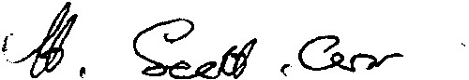

Dr Helen Scott-Orr

Inspector-General of Biosecurity

29 May 2019

## Background

### Government biosecurity regulation in Australia

Australia relies on a strong biosecurity system to ensure that it remains free from many major animal, plant and environmental pests and diseases that can affect the economy, environment and community. In 2015 the Australian biosecurity system was estimated to be worth up to $17,500 per year to the average farmer (Hafi et al. 2015).

The national biosecurity system is complex and multilayered. It involves many pre-border, border and post-border activities to reduce the risk of biosecurity threats entering Australia. The Australian Government Department of Agriculture and Water Resources (the department) manages biosecurity risk before and at Australian borders, where it intercepts potential pests and biosecurity risk material that could carry pests and diseases into the country. The department’s risk-based management system aims to focus biosecurity resources on the pests, diseases and pathways that could cause the greatest damage to Australia. It classifies pest and biosecurity risk material interceptions according to risk. Once pests pass the border, state and territory governments have legal powers to deal with them. Mechanisms exist for jointly managing serious biosecurity risks through an inter-governmental agreement on biosecurity (IGAB) and wider arrangements for industry involvement. Government responsibility for managing interceptions, border breaches and incursions is shown in Figure 1.

Figure 1 Government biosecurity risk management across the continuum



### Border biosecurity risk management

In 2017–18 more than 18,000 vessels, 1.8 million sea cargo consignments, 41 million air cargo consignments, 152 million international mail items and 21 million passengers arrived in Australia (Department of Agriculture and Water Resources 2018a). Imports are expected to grow significantly over coming years. By 2026 Australian ports will process 66,000 different combinations of imported products from various countries of origin, increasing supply chain complexity. By 2032 the number of imported sea containers entering Australia will be 19.4 million—an increase of approximately 5.3 per cent per year.

These vessels, containers, imported goods, mail and passengers may all bring in pests or diseases of biosecurity concern. Strong biosecurity border controls to intercept pests and diseases are a critical element of the overall risk management system. However, checking every ship, container, article and passenger is not practical.

A pathway is a means by which an organism or biosecurity risk material can enter Australia. Pathways can be subdivided by risk to reflect sub-pathways, such as sea containers from a particular vessel or country. Interceptions can be made through cargo, container, conveyance, mail, passenger and approved arrangements pathways.

All people, mail, vessels and goods approaching Australia are considered for national security purposes by the Australian Government Department of Home Affairs (Home Affairs). Those considered to require biosecurity risk management are referred to the department. For most pathways and commodities, the department inspects only a proportion of imports and arrivals, based on an assessed risk that they may carry unwanted pests or pathogens and sometimes on their intended destination in Australia.

To determine the need for further biosecurity intervention, the department conducts complex risk profiling by pathway, so that complementary and linked software systems in both departments can ensure the correct referral of higher-risk entries from Home Affairs to the department. It is important but often difficult to establish the proportions of undeclared or uninspected classes of imports or arrivals, and to test the extent of risk-profiling implementation and its success in leading to a lower incidence of pests or biosecurity risk material in uninspected categories. Verifying the effectiveness of biosecurity risk capture along different pathways is important for overall biosecurity risk management.

### Sharing responsibility for post-border biosecurity

Many industry bodies are formally involved in managing post-border biosecurity. Animal Health Australia (AHA) and Plant Health Australia (PHA) are responsible for national coordination of government-industry partnerships for animal and plant biosecurity. AHA is custodian of the Emergency Animal Disease Response Agreement (EADRA) and PHA is custodian of the Emergency Plant Pest Response Deed (EPPRD). These are formal agreements between AHA and PHA, the Australian Government, all state and territory governments and relevant animal and plant industry signatories. AHA and PHA also manage AUSTVETPLAN and PLANTPLAN, technical response plans and operational guidelines for EADRA and EPPRD.

The National Environmental Biosecurity Response Agreement (NEBRA) between the Australian Government and state and territory governments establishes the national arrangements for responding to significant pest and disease incursions that predominantly affect the environment or public amenity.

Technical expert committees assess potential and actual incursions to determine if an incursion has occurred and the technical options for containing and eradicating it.

The Consultative Committee on Emergency Plant Pests (CCEPP) coordinates national responses to emergency plant pest incursions and assesses technical feasibility for eradication. CCEPP members include Australian and state and territory chief plant health managers and representatives from the department, PHA and relevant plant industry bodies.

The Consultative Committee on Emergency Animal Disease (CCEAD) provides the technical link between industry, the Australian Government and state and territory governments for decision-making during animal health emergencies. It coordinates and makes decisions on the national, technical response to emergency animal disease incidents of animal health, public health or trade significance.

The Aquatic Consultative Committee on Emergency Animal Diseases (AqCCEAD) provides advice on emergency aquatic animal health events, including suspected exotic disease outbreaks, serious outbreaks of Australian origin, aquatic animal disease incidents of public health or trade significance, and immediate disease threats to Australian fisheries and aquaculture.

The Consultative Committee on Introduced Marine Pest Emergencies (CCIMPE) provides advice on emergency introduced marine pest detections, investigation and management, which are handled under NEBRA. CCIMPE also advises the National Biosecurity Management Group (NBMG) on incursion eligibility for NEBRA cost sharing.

The National Biosecurity Management Consultative Committee (NBMCC) advises and coordinates the technical aspects of environmental pest and disease outbreak response. Members include the Australian Government Chief Veterinary Officer and Chief Plant Protection Officer, an equivalent environmental officer, a CSIRO representative and representatives (Chief Biosecurity Officer, Chief Veterinary Officer or Chief Plant Health Manager) from all jurisdictions. This committee reports to the NBMG.

The CCEPP, CCEAD and AqCCEAD and CCIMPE technical committees report to the National Management Group (NMG) on potential or actual biosecurity emergencies. The NMG consists of one representative from each of the Australian, state and territory governments and one from each private body that would contribute to the costs. For nationally significant incursions, the NMG and NBMG (for environmental incursions) determine whether it is feasible to contain and eradicate each with an emergency response, or whether the most cost-effective response is to transition to management—effectively a failure of the biosecurity system.

### Priority setting for different pests

**Animal diseases and pests** are prioritised internationally by the World Organisation for Animal Health (OIE). The OIE aims to control epizootic diseases and prevent their spread by collecting, collating and disseminating data on animal disease outbreaks and notifiable animal diseases.

The Animal Health Committee (AHC) maintains a national list of notifiable animal diseases. AHC members are the Australian, state and territory government chief veterinary officers and others from CSIRO’s Australian Animal Health Laboratory, the Australian Government Department of Agriculture and Water Resources and the Australian Government Department of the Environment and Energy. AHC observers are from Animal Health Australia, Wildlife Health Australia and the New Zealand Ministry for Primary Industries.

The AHC list includes diseases listed in the EADRA, OIE-listed diseases that are exotic to Australia, other serious endemic animal diseases—for surveillance to detect unusual mortality or sickness—and diseases of public health significance.

The Sub-Committee on Aquatic Animal Health (SCAAH) maintains the national list of reportable aquatic animal diseases. It provides scientific and technical advice to AHC and has representatives from the Australian, state and territory and NZ governments, the Australian Animal Health Laboratory and Australian universities.

As at December 2018 Australia had 98 notifiable diseases of terrestrial animals, five of bees and 52 of aquatic animals (24 finfish, 13 mollusc, 12 crustacean and three amphibian diseases).

**Plant pests and diseases** are prioritised internationally under the International Plant Protection Convention (IPPC)—a multilateral treaty to protect cultivated and natural plant resources from the introduction and spread of plant pests while minimising interference with international trade and travel. Australia bases its phytosanitary measures on international standards developed under the IPPC’s framework for standards and implementation.

The Plant Health Committee (PHC) is Australia’s peak government plant biosecurity policy and decision-making forum. Its members are the Australian Chief Plant Protection Officer and chief plant health managers from each state and territory. In 2015 the PHC developed a national priority plant pest list consisting of 42 pests and diseases of biosecurity concern. Because fruit flies and drywood termites are collections of several exotic species, the list covers more than 100 separate species. The department uses this list to focus its plant biosecurity efforts.

**Marine pests** and exotic **environmental pests and diseases** are also prioritised. A draft Australian Priority Marine Pest List includes three established and six exotic marine pests of national significance. The department is leading a consultative national process to develop a national list of exotic pests and diseases of environmental concern, which would be completed by the end of 2019.

### High-risk and low-risk interceptions

Interceptions can be broadly classified as high risk and low risk. High-risk interceptions are priority pests, risky goods that are undeclared or not imported in accordance with import protocols and conditions, and biosecurity risk material that has a higher risk of containing exotic pests or diseases.

Stringent import protocols govern certain high-risk goods due to their potential to host certain diseases. These goods include:

* raw beef and pig meat (foot-and-mouth disease and other serious animal diseases)
* raw poultry meat (avian influenza and other avian diseases)
* live animals and germplasm (numerous diseases)
* live plants, cuttings or seeds for sowing (numerous plant diseases).

Lower-risk interceptions are other pests considered unlikely to cause serious damage because their potential effect on agriculture, the environment and human health is lower or because the pests are already established in Australia. This lower-risk class also includes goods of lower biosecurity risk, such as imported goods not covered by an import permit. This is because the risk that they contain pests or diseases is lower due to processing, end uses or lower potential to host certain pests. These goods include:

* cooked meat (risk reduced by cooking process)
* some human or animal therapeutics (risks mitigated by manufacturing process)
* mushrooms (some varieties permitted)
* wooden items (may have been treated to exclude exotic pests such as borers).

Other biosecurity risk material may also be ranked as high risk or low risk. For example, a sea container with a high level of soil contamination (2 mm depth or greater) on the outside poses a far greater risk of carrying undetected exotic invasive ants, nematodes, soil-borne fungi and immature stages of many serious insect pests than a sea container with minimal soil contamination that may have been splashed with mud in transit.

## Mail and passenger biosecurity risk management

### Overall process

The types of goods arriving into Australia via international mail and with travellers are constantly changing. Online products are evolving and online businesses are expanding. Goods that are in demand now may not be in demand in the future and different countries present different risks. Tourism and other inbound travel from different countries changes over time, but is steadily increasing. For these reasons, profiles are reviewed annually to ensure the department targets mail articles and travellers presenting the highest biosecurity risks.

The department screens selected international mail and passengers on arrival by X-ray, detector dogs and manual inspection. This helps biosecurity officers find passengers who are carrying undeclared biosecurity risk material. However, passengers may carry goods that are difficult to detect through X-ray screening or are not detector dog targets. Officers may then need to consider other information such as profiles, visual assessment and knowledge of seasonal and cultural events to select passengers for manual screening.

The Mail and Passenger System (MAPS) is the department’s electronic data collection tool used to record data about detections of biosecurity risk material and pests from mail at all international mail centres and from travellers at airports and seaports. A MAPS record is created when a biosecurity officer issues a direction for goods that contain biosecurity risk material, including if non-compliance action is taken or if an import permit is provided.

Each record also includes any actions relating to the direction, such as recommended treatments, goods stored in the detained goods office and any communication that has occurred with the person in charge. Data collected in MAPS are also used to develop mail and passenger profiles, calculate performance indicators and help allocate resources.

Verification surveys are conducted tohelp the department estimate the amount of undeclared biosecurity risk material that has not been detected by biosecurity clearance processes and inform profile performance for annual reviews. The surveys may be applied randomly to a small sample of all mail and passengers, or based on risk profiling to selected pathways or sub-pathways, such as mail from countries experiencing a disease outbreak.

End-point (leakage) surveysare used daily on a random sample of travellers and mail, and conducted at the end of all biosecurity clearance processing streams. Officers thoroughly inspect baggage and mail to detect any biosecurity risk material missed by routine processes.

### Mail

The department and Home Affairs work closely with Australia Post to facilitate the movement of international mail into Australia’s postal network. Each agency has a different role and sometimes competing objectives. This relationship is formalised by a memorandum of understanding and regular meetings of a national tripartite forum.

The department develops national mail profiles to target high biosecurity risk material in non-letter class mail. Profiles are calculated using data recorded by biosecurity officers in MAPS and volume data provided by Australia Post for each arriving cohort of mail. The risk profiles are used to select various classes of mail for screening by X-ray, detector dogs or manual inspection for biosecurity risk material. Letters receive the least amount of screening and inspections because they are considered the lowest biosecurity risk item.

Between 2015–16 and 2017–18 around 150 million international mail items were handled annually through Australia Post’s gateway facilities in Sydney, Melbourne, Brisbane or Perth. Express post and parcel screening more than halved, but screening of other articles doubled (Table 1) because of risk profiling.

Table 1 International mail volumes, screenings and inspections, 2015–16 to 2017–18

| **Year** | **Mail class** | **Incoming volume (no.)** | **Screened (%)** | **Inspected** |
| --- | --- | --- | --- | --- |
| 2015–16 | Letters | 81,391,463 | Less than 0.1 | 1,090 |
| OA | 53,507,149 | 16.3 | 27,343 |
| EMS | 2,491,251 | 73.9 | 32,052 |
| Parcels | 1,977,069 | 81.9 | 44,524 |
| Total | 139,366,932 | 8.8 | 105,009 |
| 2016–17 | Letters | 76,270,015 | Less than 0.1 | 579 |
| OA | 77,641,139 | 14.7 | 37,795 |
| EMS | 2,310,652 | 22.4 | 18,913 |
| Parcels | 2,007,367 | 24.2 | 28,193 |
| Total | 158,229,173 | 7.8 | 85,480 |
| 2017–18 | Letters | 68,398,542 | Less than 0.1 | 399 |
| OA | 79,588,103 | 32.9 | 56,043 |
| EMS | 2,278,204 | 31.6 | 20,202 |
| Parcels | 2,013,296 | 40.9 | 27,756 |
| Total | 152,278,145 | 18.2 | 104,400 |

**EMS** Express mail service. **OA** Other articles.

The overall international mail biosecurity risk management system is shown in Figure 2.

Figure 2 International mail biosecurity risk management system

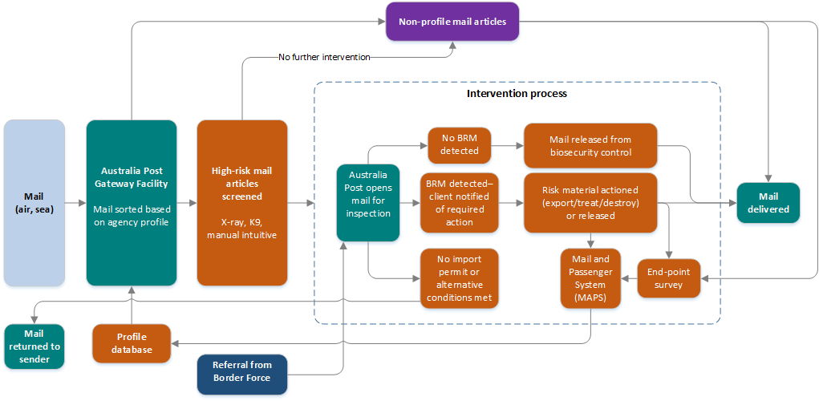

#### 2.2.1 Intercepting biosecurity risk material in incoming mail

Between 2012 and 2018 more than 288,000 mail seizures were recorded in the MAPS database. From 2012 to 2015 recorded mail seizures decreased by 42 per cent (Figure 3). From 2016 to 2018 this trend reversed, with an increase of 144 per cent in seizures. From 2012 to 2018 plant and plant products accounted for more than 65 per cent of total international mail seizures, and live animal and animal products made up more than 20 per cent.

Figure 3 Seizures of biosecurity risk material at mail facilities, 2012 to 2018

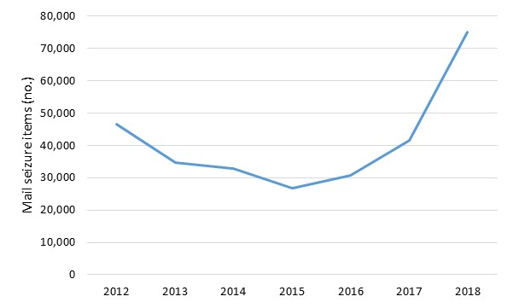

### Passengers

Passengers and crews entering Australia by air or by sea cruise vessels are included in the passenger or traveller pathway. Crews and passengers on cargo vessels or private yachts are managed through the sea conveyance pathway. The bulk of passengers arrive by air.

Travellers and their baggage can be inspected by detector dog or X-ray screening, a biosecurity officer’s assessment or an incoming passenger card declaration.

#### 2.3.1 Air travellers

Using data recorded by biosecurity officers in MAPS and volume data provided by Home Affairs, the department develops flight-based traveller profiles to target flights coming from countries experiencing disease or pest outbreaks and cohorts with a history of carrying undeclared high-risk biosecurity material. MAPS data include seizure details, survey volumes and detections, and non-compliance actions. It also captures the results of verification surveys. These include approach surveys, where random samples of baggage are selected before any routine processing point and screened to determine approach rates of biosecurity risks, and end-point surveys—as in the mail pathway.

The movement of air travellers and their baggage through border biosecurity controls in 2017–18 is shown in Figure 4. Over 80 per cent of the 21 million incoming travellers were released unassessed or screened, 14 per cent were screened, and 7 per cent (1.4 million) had their bags, personal items or clothing inspected. This yielded 220,000 instances where biosecurity risk material was destroyed, treated or exported.

Figure 4 Air traveller biosecurity risk management pathway, 2017–18

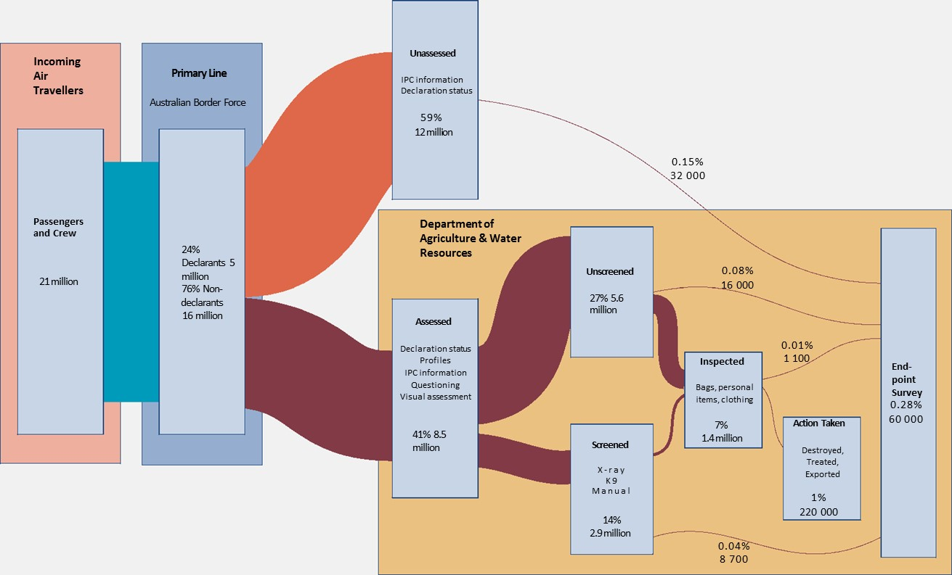

Between 2012 and 2017 air traveller arrivals increased steadily from about 15.5 million to more than 20 million. Absolute numbers of people screened by dogs increased slightly, but the percentage screened by dogs decreased from 11.3 per cent to 9.2 per cent over this period. Similarly, numbers of people screened by X-ray almost doubled, but the percentage screened by X-ray fell from 6.4 per cent in 2012 to 4.5 per cent in 2017 (Table 2).

Table 2 Air arrivals and screening methods, 2012 to 2017

| **Pathway and screening** | **Unit** | **2012** | **2013** | **2014** | **2015** | **2016** | **2017** |
| --- | --- | --- | --- | --- | --- | --- | --- |
| Air passengers | no. | 15,462,543 | 16,087,624 | 16,909,297 | 17,585,089 | 18,746,479 | 20,104,322 |
| Dog screening | no. | 1,749,688 | 1,751,759 | 1,448,998 | 1,705,717 | 1,749,753 | 1,849,981 |
| % | 11.3 | 10.9 | 8.6 | 9.7 | 9.3 | 9.2 |
| X-ray screening | no. | 578,661 | 814,262 | 770,119 | 687,999 | 780,754 | 910,936 |
| % | 6.4 | 5.1 | 4.6 | 3.9 | 4.2 | 4.5 |

**Intercepting biosecurity risk material from air passengers**

Between 2012 and 2018 more than 1.9 million items of biosecurity concern were seized at airports. Between 2012 and 2013 items seized decreased by 11 per cent. Between 2014 and 2017 items seized at airports increased by 14 per cent before dropping by more than 7 per cent in 2018 (Figure 5). The reduction in 2018 could be because of increased public awareness campaigns, education resources at airports, or changes to import conditions on some commodities, but these data are not available to analyse causal relationships.

Figure 5 Seizure of biosecurity risk material at airports, 2012 to 2018

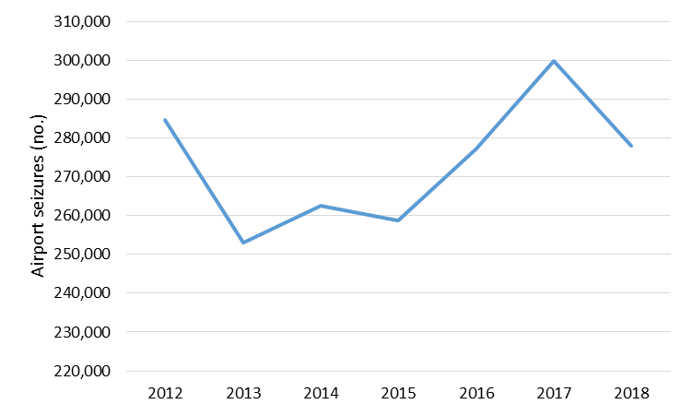

#### 2.3.2 Sea passengers

Sea passengers (cruise ship passengers and crew) are a lower risk pathway. Between 2012 and 2017 sea passenger arrivals fluctuated significantly, from 860,000 in 2012 to less than 600,000 in 2014 and back to 800,000 in 2017. Screening rates decreased from 39 per cent to 23 per cent. Methods also varied, moving from mainly dog or X-ray screening in 2012 to almost 100 per cent inspection in 2017 (Figure 6).

Most seizures (75 per cent) were from sea passengers arriving in Sydney from Pacific Island countries such as Fiji, New Caledonia and Vanuatu—countries on many cruise liner itineraries.

Figure 6 Sea passenger arrivals, screenings and inspections, 2012 to 2017

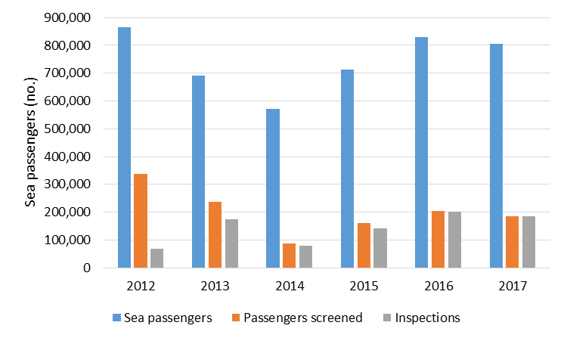

### Intercepting biosecurity risk material case study—meat interceptions

The department devotes significant effort to intercepting biosecurity risk material that may carry disease. For example, importation of meat and meat products into Australia is highly regulated to prevent the introduction of serious diseases such as foot-and-mouth disease (FMD). This highly contagious disease affects cattle, sheep, goats, pigs, deer, buffalo and camelids. A large outbreak of FMD could cost the Australian economy up to $52 billion over 10 years (Buetre et al. 2013). FMD outbreaks in the United Kingdom have been linked to imported infected meat being fed to pigs (swill feeding) (Hernández-Jover et al. 2016).

African swine fever is an acute viral haemorrhagic fever with a high pig mortality rate (Box 1). No vaccine is available and the virus can survive for up to six months in the environment and pork products and for several years in frozen carcases (Spickler 2015). A key transmission route is the use of infected pork products as pig feed.

Box 1 African swine fever on the move

African swine fever (ASF) was first reported in Kenya in 1909 and by the early 1960s it had spread to central Europe through Spain and Portugal. In 2007 it was introduced to Georgia when ship waste was fed to pigs, and since then it has spread north and west into Europe and eastwards. Many countries across the world have had outbreaks.

In January 2018 ASF outbreaks were reported throughout Eastern Europe—mostly small outbreaks in wild boar and domestic pigs. In September 2018 ASF was reported in wild boar in Belgium and Australia suspended the import of pig meat from Belgium. In August 2018 China notified the World Organisation for Animal Health (OIE) of its first occurrence. By April 2019 ASF had spread to all Chinese provinces, resulting in the death of over a million pigs. By late April 2019 ASF was found in Vietnam and Cambodia, and was threatening other south-east Asian countries.

In October 2018 the Japanese Government reported that ASF had been detected in sausages in the luggage of an air passenger travelling from China to Japan. The Chinese Government Ministry of Agriculture and Rural Affairs found that 62 per cent of the first 21 outbreaks were related to kitchen waste (swill) being fed to pigs. The practice has now been banned.

Between 21 January and 3 February 2019 the Australian Animal Health Laboratory identified ASF virus fragments in 40 pork products from 283 samples seized by biosecurity officers at Australian airports and international mail centres. Two of these samples also carried foot-and-mouth disease virus fragments.

To eradicate an ASF incursion, the entire affected pig population must be destroyed. In Australia, eradication would be virtually impossible if feral pig populations became infected. Swill feeding has been banned in Australia since the 1960s, but actions to enforce this ban are variable across different states and territories. Jurisdictions should ensure that they undertake compliance and awareness activities for swill fever to help minimise this risk. Meanwhile, the Australian Government must increase and sustain efforts to intercept meat and meat products across all pathways.

Between 2012 and 2017 biosecurity officers recorded 328,984 interceptions of meat and meat products at the border. These included salami, sausages and small quantities of meat products imported as preserved meats, and cooked meats consisted largely of poultry, pork and beef (Table 3). Of the 272 tonnes of meat and meat products intercepted from 216 countries, more than 170 tonnes (62.5 per cent) of interceptions originated from FMD-affected countries. The top five countries (China, New Zealand, Vietnam, Indonesia and Malaysia) accounted for more than 67 per cent of all meat interceptions. China accounted for the highest total quantity of interceptions (84.1 tonnes; more than 30 per cent of total quantity).

The average weight of meat and meat product intercepted was 828 grams, but the highest weight was 15 tonnes (salami/sausage/small goods). More than 93 per cent of this product was destroyed—the rest was exported, treated, released or secured for follow-up.

Table 3 Top five meat products intercepted at the border, 2012 to 2017

| Meat products | Interceptions (no.) | Weight (tonnes) | Weight (%) |
| --- | --- | --- | --- |
| Salami/sausage/small goods | 95,256 | 92.6 | 34.0 |
| Poultry | 68,312 | 50.1 | 18.4 |
| Pork | 50,043 | 46.7 | 17.2 |
| Beef | 46,382 | 34.8 | 12.8 |
| Meat jerky/biltong | 49,280 | 25.5 | 9.4 |
| Other | 19,711 | 22.5 | 8.3 |
| **Total** | 328,984 | 272.3 | 100 |

Between 2012 and 2017 seizures of meat and meat products at airports increased, accelerating markedly between 2015 and 2017. The significant increase appears to have been primarily driven by improved passenger risk profiling based on verification surveys. In contrast, meat seizures at international mail facilities decreased by 27 per cent and at seaport facilities by 49 per cent (Table 4).

Table 4 Volumes of meat and meat products seized at the border, 2012 to 2017

| **Inspection location** | **2012 (kg)** | **2013 (kg)** | **2014 (kg)** | **2015 (kg)** | **2016 (kg)** | **2017 (kg)** | **Change (%) from 2012 to 2017** |
| --- | --- | --- | --- | --- | --- | --- | --- |
| Airports | 45,604 | 45,332 | 45,146 | 46,683 | 52,176 | 60,532 | 32.7 |
| International mail facility | 6,243 | 5,710 | 6,181 | 5,657 | 4,878 | 4,544 | –27.2 |
| Seaports | 77 | 74 | 31 | 37 | 39 | 39 | –49.4 |
| **Total** | 51,924 | 51,116 | 51,258 | 52,377 | 57,093 | 65,115 | 25.4 |

Meat interceptions occurred at 43 points of entry, but 81 per cent occurred at four international airports. Sydney Airport accounted for more than a third of these interceptions (Figure 7).

Figure 7 Top five points of entry for meat interceptions, 2012 to 2017

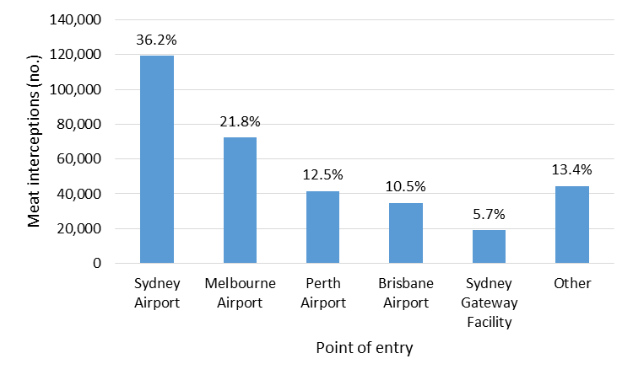

The department uses various methods to intercept meat and meat products at the border. To further mitigate risk, the department is focusing on improving passenger biosecurity risk material declaration rates on incoming passenger cards. Between 2012 and 2017 most interceptions (70.5 per cent) were declared but 22 per cent were undeclared (Table 5).

Table 5 Meat interception by top 10 country declaration status, 2012 to 2017

| Country | Total interceptions (no.) | Undeclared (no.) | Undeclared (%) | Other (no.) | Other (%) |
| --- | --- | --- | --- | --- | --- |
| China | 107,096 | 27,913 | 26.1 | 8,153 | 7.6 |
| Philippines | 12,579 | 4,564 | 36.3 | 783 | 6.2 |
| France | 11,919 | 3,687 | 30.9 | 1,917 | 16.1 |
| United States | 15,058 | 3,636 | 24.1 | 1,081 | 7.2 |
| Malaysia | 17,616 | 3,553 | 20.2 | 1239 | 7.0 |
| Vietnam | 17,264 | 2,740 | 15.9 | 650 | 3.8 |
| Indonesia | 10,796 | 2,509 | 23.2 | 633 | 5.9 |
| Singapore | 15,604 | 2,056 | 13.2 | 1,142 | 7.3 |
| New Zealand | 14,010 | 789 | 5.6 | 504 | 3.6 |
| South Africa | 7,699 | 168 | 2.2 | 243 | 3.2 |
| Other | 99,352 | 20,656 | 20.8 | 8,596 | 8.7 |
| **Total** | 328,632 | 72,271 | 22.0 | 24,941 | 7.6 |

‘Other’ includes misdeclared, declared prompted, declaration not attached and unknown.

Between 2012 and 2017 almost half of all meat interceptions were detected by manual inspection of declared goods (Figure 8). However, the most effective method of intercepting undeclared meat was by detector dogs (53 per cent) followed by X-ray (32 per cent). The Australian Border Force, which works closely with the department at the border, found 6 per cent of undeclared interceptions.

Figure 8 Methods of detecting meat interceptions, 2012 to 2017

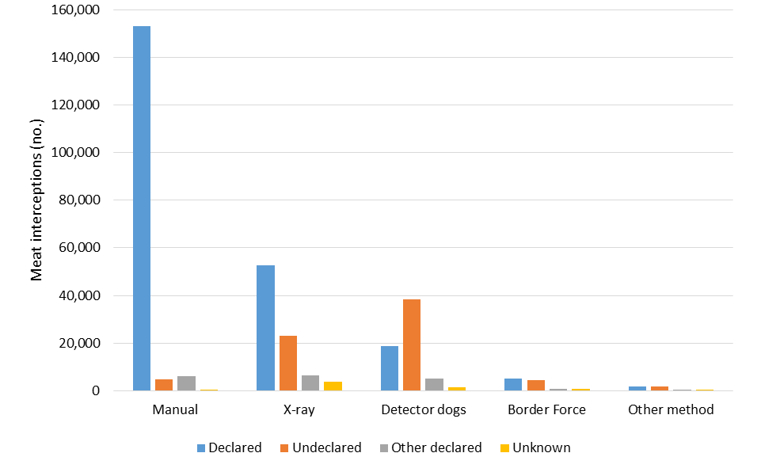

### Maximising screening effectiveness

Improving the effectiveness of screening mail and passengers at first points of entry for a large range of biosecurity risk material is critical. For this, X-rays and detector dogs are the most practical methods.

#### 2.5.1 Better X-ray technology

In a world-first biosecurity collaboration, Australia and New Zealand are each trialling a three-dimensional (3D) X-ray unit, the Rapiscan Real Time Tomography RTT®110 for 12 months at Melbourne and Auckland international airports. The Rapiscan uses 3D X-rays to produce images in real time as each item passes through the X-ray unit. The aim is to develop an extensive 3D image library of targeted biosecurity risk items and create algorithms to auto-detect them.

The Emerging X-ray Innovation Trial Project is funded under a $7.5 million modern, seamless border clearance measure. Auto-detection will streamline passenger, air cargo and mail pathways into Australia and allow biosecurity officers to do their work more effectively and efficiently.

#### 2.5.2 More use of detector dogs

Trained detector dogs have a working life of about six to eight years and have a distinct advantage in detecting undeclared biosecurity risk material including the ability to:

* screen large numbers of passengers and their baggage in a short period
* be trained as multipurpose detectors (because of their excellent sense of smell and strong retrieval drive)
* screen large items at airports and mail centres
* be impartial (the dogs are not subject to profile bias).

Passengers, baggage and mail, from countries or with factors that profiling has identified as posing a heightened biosecurity risk approach rate, are screened by detector dogs at static points within airports and mail centres. At airports, passengers are directed to a dedicated marshalling point for screening. Detector dogs conduct screening intermittently at mail centres on moving conveyor belts carrying targeted mail items.

Mail and traveller risk profiles do not identify which detection tool (detector dog or X-ray) is the best to screen specific mail or traveller cohorts. Instead, officers choose the best detection tool in the environment at the time, based on a range of factors including resource availability. Insufficient data are available to determine the proportion of passengers (non-declarants) that are diverted for manual inspection or X-ray screening.

However, the mobility offered by detector dogs is currently underused. Screening of free line passengers, carousels and cargo environments by dogs is either not used at all or not used often. This could be improved with extra dog detection screening focused on carousels for luggage coming off flights from countries deemed to be high risk. This would have little impact on the smooth flow of passengers through the airport but could substantially improve detection rates of undeclared risk material.

In 2018 the department had 43 detector dogs operating in international airports, seaports, mail centres and courier depots. This was a decrease of 37 (46 per cent) since 2012. The proportion of air passengers screened by dogs dropped from 11.3 per cent in 2012 to 9.2 per cent in 2017, because of the increased numbers of passengers needing screening.

Profile-based intervention rates are not currently measured for the mail and traveller pathways. Data to determine the proportions of total and high-risk passengers and mail screened by detector dogs are not readily available nor reviewed on a regular basis. Based on the declining proportion of dogs compared with the increasing volumes of passengers and mail (especially the ‘other articles’ mail class), it is assumed the rate of intervention is declining. This must increase the risk that unscreened passengers and mail bearing meat products and other biosecurity risk material may be passing through biosecurity controls.

Biosecurity risks associated with air passengers and luggage would be more efficiently managed if the department invested in more trained detector dogs to perform searches on all passengers and their luggage across international airports. The presence of detector dogs at airport arrival lounges works as a strong deterrent for incoming passengers and promotes the government’s war on infested and prohibited undeclared goods carried by passengers.

Recommendation 1

The department should improve the rate and effectiveness of screening mail and passengers, by both X-ray and by detector dogs. The department should increase the number and prioritise the use of detector dogs to fully use the mobility and versatility of dogs to screen across a range of environments including carousels, cargo and conveyances for targeted and random screening.

**Department’s response: Agreed.**

The department is trialling 3D x-ray technology to improve screening rates and build computer algorithms to automatically detect biosecurity risk items (a world first for biosecurity management). This trial has had early success with faster, more comprehensive screening of traveller baggage and development of the first algorithm, and will shortly extend to the mail environment. The technology is also helping the department to better detect specific high risk threats such as African swine fever risk material.

The department has started to expand the detector dog program as part of a suite of controls to detect high risk pests. Trials are already underway to use existing detector dogs to screen for brown marmorated stink bugs (BMSB) at the Port of Brisbane, and random screening of travellers outside normal departmental profiles at Perth Airport. Funding for further expansion of the detector dog program will be a matter for government.

## Conveyance and cargo border biosecurity risk management

### Overall process

#### 3.1.1 Pathway risk management

**Sea vessels and aircraft, cargo containers and break-bulk cargo** may carry hitchhiker pests and contaminants. Exotic hitchhiker pests and contaminants that may carry diseases are often intercepted on the surfaces of commercial air freight cans or sea containers. They are also intercepted on or in sea vessels (such as in ballast water) or aircraft. Hitchhikers include any pests or items (for example, live animals, personal effects and smuggled goods) not on the passenger, container or cargo entry pathways. The adequacy of the department’s hitchhiker pest and contaminant biosecurity risk management and recent interception history of priority hitchhiker pests was reviewed in 2018 (IGB 2018).

**External risks of sea containers** require special management. The department provides sea container risk profiles to Home Affairs’ Integrated Cargo System (ICS) based on a Country Action List (CAL) of 43 ‘high-risk’ countries, so called because they contain giant African snails. The department’s S-Cargo software program receives details about containers that meet its risk profile from ICS and these containers are held at the port of entry for inspection for a six-sided inspection, unless they were treated in an approved Sea Container Hygiene System before import into Australia. Containers destined for unpacking in a rural destination are profiled in AIMS and are subject to rural tailgate inspection before they are released from biosecurity control.

Since 2015 the department has been trying to upgrade the S-Cargo software to better manage external sea container risks, but increasing demands to manage emerging pests such as BMSB have prevented this. The net result is that risk profiling and management of the external and internal biosecurity risks of sea containers is inefficient and inadequate.

**Air cargo containers** are subject to random and targeted inspections for external and internal biosecurity risk. The department determines intervention rates based on the carrier and the cargo country of origin. Intervention rates are low because of the low pathway risk, but they cannot be accurately determined because the number of air container arrivals is not recorded in ICS.

**Cargo (air and sea)** includes declared and undeclared cargo and any packaging. Cargo is the most complex pathway because it can be divided into many commodity groups such as nursery stock, live animals, fresh fruit and vegetables, frozen foods (raw or processed) and machinery. Each sub-pathway may have commercial, non-commercial, containerised, break-bulk and bulk components. Much fresh produce, such as cut flowers, fresh fruit and vegetables, arrives by air, is profiled as high risk and sent to approved arrangements for inspection. The cargo pathway also includes transhipped cargo enroute to another country.

#### 3.1.2 Importer declarations of goods

Importers, their brokers or freight forwarders must submit reports on all sea and air cargo entering Australia, before the goods arrive, to Home Affairs’ ICS. Reports include basic information such as the goods’ origin, description, supplier, importer and discharge location.

Where biosecurity or imported food consignments are electronically declared as full import declaration (FID) and long form self-assessed clearance (SAC) entries, customs brokers and commercial importers must also use the department’s cargo online lodgement system (COLS), instead of email, to lodge import documents for assessment. Documents for many goods must comply with requirements in the department’s Biosecurity Import Conditions database (BICON).

Imported goods valued at or below $1,000 that arrive in Australia by sea or air are considered non-commercial and must be declared to ICS on a SAC declaration.

#### 3.1.3 Referral of goods for biosecurity assessment by risk profiling

The department provides profile rules for different goods to ICS and reviews profiles based on compliance history and the overall hit rate of each profile. The ICS has a ‘profiling engine’ that electronically refers commercial consignments with potential biosecurity risks to the department’s agriculture import management system (AIMS) for further assessment by biosecurity officers. AIMS automatically assigns a unique identifier for each entry.

The ICS also checks SAC-free text declarations for presence of words and phrases that could indicate a biosecurity risk and for referral to the department. The rapid increase of parcel mail ordered online and entering the country via private company warehouses makes this an important emerging pathway. The department also conducts verification activities on this incoming cargo at Conference of Asia Pacific Express Carrier (CAPEC) depots to monitor SAC profile performance and ensure that risks are being effectively targeted.

After assessing the documentation of each consignment referred from ICS to AIMS, biosecurity staff may direct goods to be released from biosecurity control without further intervention or to be screened, inspected, treated or held for destruction or re-export (Figure 9).

Figure 9 Imported cargo biosecurity risk management system

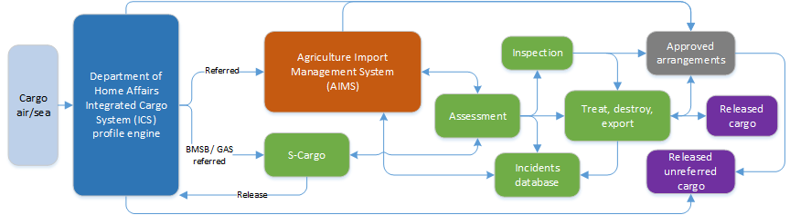

BMSB: Brown marmorated stink bug. GAS: Giant African snail.

#### 3.1.4 Biosecurity intervention and results reporting

Biosecurity officers must record each biosecurity risk found in or on cargo and conveyances in AIMS. Staff at approved arrangements are also expected to report any biosecurity risk to the department. Any live or dead pest specimen may be sent to the department’s operational science service (OSS) section to determine if it is exotic and if the goods or conveyances on which it was found need to be re-assessed before being released from biosecurity control. Samples of goods and diseased-looking plants may be sent for laboratory testing to ensure they are free from disease. This information is then recorded in an Incidents database that is a module of AIMS. However, the Incidents database does not record most interceptions of biosecurity risk material.

AIMS records interceptions of biosecurity risk material at the border, but the reporting ability of AIMS makes it difficult to determine rates of detection of different types. This can complicate risk profiling and assessing the effectiveness of the biosecurity system.

### Risk profiling different types of cargo

The profiling criteria for cargo vary depending on the nature of the goods, mode of arrival, compliance history and offshore control measures. To ensure that the highest risks are targeted, the department’s Animal and Plant Biosecurity Divisions provide annual risk ratings for each animal-based and plant-based commodity. This section provides examples of criteria used for general cargo (non-animal and non-plant goods).

#### 3.2.1 Containerised goods

Most goods imported into Australia arrive in containers. Goods are referred to the department depending on:

* the type of good and any BICON entry
* associated biosecurity risk assessment
* risk profile questions—for example, ‘Are the goods new, re-manufactured, refurbished or reconditioned?’

All high-risk goods are referred for inspection. Other goods may be referred for inspection at reduced inspection rates. Assessment is based on factors such as importer compliance history and risk status of the goods.

#### 3.2.2 Bulk commodities

The department’s Bulk Commodities National Coordination Centre assesses all bulk consignments and the Assessment Services Group (ASG) manages containerised fertiliser assessments.

##### Fertilisers

The department provides fertiliser biosecurity risk profiles to ICS based on:

* state of the product—liquid or solid
* package size—higher or lower than 100 kilograms
* origin—chemical or mined
* storage at place of production—inside or outside
* end use—soil conditioner or potting use.

Inorganic fertiliser assessment and management policies outline the process for classifying these imports and the regime that will apply to each fertiliser import risk classification level.

##### Stock feed

Stock feed is considered a high biosecurity risk commodity because it provides a direct pathway for the introduction and spread of exotic pests and diseases that can harm humans and animals.

Australia permits imports of plant-based stock feed processed offshore, applying strict import conditions based on the country of origin, nature of the crop, field production method, harvest method and post-processing handling, and other factors.

Whole grains are permitted under strict import conditions, but hay for stock feed use has never been imported into Australia because of the risk of introducing plant and animal pathogens, viable crop seed, insect pests and weeds.

The department assesses each stock feed import application against long-established policy. It applies the policy’s strict assessment, monitoring and control requirements to manage the biosecurity risks—only allowing the import if it is confident the risks can be managed.

#### 3.2.3 Break-bulk cargo

Break-bulk cargo goods are those loaded individually and not in containers or in bulk. The department profiles break-bulk cargo based on:

* country of origin
* presence of seasonal pests
* condition of the goods—used or new
* whether they have been subject to offshore hygiene measures
* historical usage of the goods (for agricultural and mining goods)
* complexity (for imported machinery).

***Machinery and vehicles*** are profiled in the ICS for assessment based on country of origin and condition (new or used). All used or field-tested machinery and vehicles are considered high risk for contamination and hitchhiker pests so all are referred for assessment. Small samples of vehicles cleaned through approved offshore cleaning arrangements are inspected to verify effective cleaning. All other used vehicles undergo mandatory inspection.

The department does not profile new vehicles for assessment. However, it has a voluntary arrangement with industry that most new vehicles imported as break bulk undergo departmental surveillance before leaving the wharf to confirm the absence of biosecurity contaminants.

***Imported tyres*** are profiled for biosecurity intervention based on the condition of the tyres (new, used [on or off a rim] or retreaded), and the mode of shipping (break bulk or containerised). Consignments with possible biosecurity risk are referred to AIMS for intervention. All used tyres must undergo mandatory offshore fumigation.

Oversized tyres are considered high risk because the risk of carrying exotic mosquito eggs, larvae or adults is high. All oversized tyres are referred to the department for assessment, based on:

* country of origin
* condition of the tyres (under or over six months old)
* whether tyres have been subject to offshore treatment.

### Cargo compliance verification

#### 3.3.1 Developing the cargo compliance verification (CCV) program

More than 90 per cent of sea containers arriving in Australia are not inspected for biosecurity risks because they are profiled or assessed as posing negligible or very low biosecurity risk. The risk that non-compliant containerised goods may have been released directly from Home Affairs border control or from the department’s biosecurity control without appropriate intervention is assessed through the CCV program. This is a statistically-based end-point survey that is intended to enable the department to evaluate the effectiveness of its operational biosecurity controls, including broker arrangements, document assessment and community protection profiles.

From 2005 an Import Clearance Effectiveness (ICE) program began leakage surveys on a limited range of cargo types to help assess effectiveness of quarantine measures (ANAO 2005).

The CCV program began in 2013 (DAFF 2013), when the department improved the ICE program by:

* introducing sampling profiles into the ICS to randomly select consignments for inspection
* automating sampling to remove manual selection bias and free up staff for inspections
* requiring selected consignments to be held seals-intact at agreed locations for inspection
* setting an annual target of 6,000 total consignments to be inspected
* better aligning CCV inspection targets to volumes of imports arriving at Australian ports without significantly changing the overall number of inspections undertaken.

The CCV program is intended to provide assurance through the full inspection of a nationwide, randomly selected sample of consignments—in full container load (FCL) and full container load consolidated (FCX) but not less than container load (LCL) containers. These samples are drawn from the populations of consignments that are either:

* not otherwise referred to the department from the Home Affairs integrated cargo system (ICS) because of information provided by brokers
* referred to the department’s agriculture import management system (AIMS) and released from biosecurity only after a departmental documentation assessment.

The program can identify emerging biosecurity risks and non-compliance from consignments that are not normally seen by the department and provides valuable indicators of non-compliant behaviour. Survey data and findings are shared with stakeholders and policy risk owners to strengthen biosecurity controls.

#### 3.3.2 CCV sample size not meeting targets

In August 2015, because of resource constraints, the department reduced the sample size from 6,000 to 4,200 CCV inspections annually. The increased estimated margin of error of the results (from 11.3 per cent to 13.2 per cent) was still considered acceptable.

In a 2016 report *Management of biosecurity risks associated with timber packaging and dunnage*, the Interim Inspector-General of Biosecurity (2016) recommended:

(Recommendation 4) The department should consider expanding the cargo compliance verification programme beyond full container loads to include additional arrival pathways.

The department agreed with this recommendation and noted:

The department has recognised the benefits of the cargo compliance verification (CCV) programme and has been expanding it to other cargo pathways. This recommendation is considered completed (Appendix A: Agency response).

However, this did not happen. On the contrary, from late 2016 CCV inspections were highly reduced, especially in NSW and Victoria, due to:

* investigations and response to the white spot disease (WSD) outbreak on prawn farms in Queensland in 2016–17, and subsequent massive redirection of already scarce biosecurity resources to manage previous uncooked prawn imports (IGB 2017)
* greater efforts against brown marmorated stink bug (BMSB) from 2017–18 to 2018–19.

Table 6 shows that between February 2017 and February 2019 just 4,572 CCV inspections were conducted (less than half the target number for the two-year period). Less than 17 per cent of targeted inspections were in each of NSW and Victoria. These states received the bulk of containers, so this introduced substantial geographic bias into the program.

Table 6 Cargo compliance verification inspections, by state and territory, February 2017 to February 2019

| **State or territory** | **CCV not conducted** | | **CCV conducted** | | **Total** |
| --- | --- | --- | --- | --- | --- |
| **No.** | **%** | **No.** | **%** | **No.** |
| Australian Capital Territory | 0 | 0 | 2 | 0 | 2 |
| New South Wales | 3,925 | 83.3 | 789 | 16.7 | 4,714 |
| Northern Territory | 8 | 21.1 | 30 | 78.9 | 38 |
| Queensland | 450 | 21.3 | 1,671 | 78.8 | 2,121 |
| South Australia | 276 | 47.1 | 309 | 52.8 | 585 |
| Tasmania | 21 | 44.7 | 26 | 55.3 | 47 |
| Victoria | 3,904 | 83.1 | 792 | 16.9 | 4,696 |
| Western Australia | 191 | 16.6 | 953 | 83.3 | 1,144 |
| **Total** | **8,775** | **65.7** | **4,572** | **34.2** | **13,347** |

Figure 10 highlights the impact of the prawn response from late 2016 on CCV inspection rates. From January to September 2017 only a quarter of targeted inspections were conducted and from October 2017 to June 2018 less than half of targeted inspections were conducted.

Figure 10 Cargo compliance verification inspections per quarter, 2013–14 to 2018–19

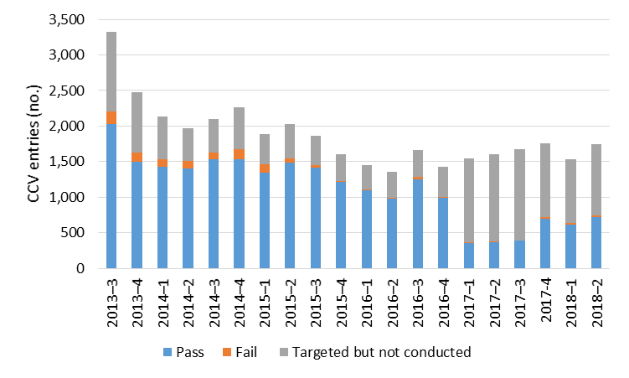

This pattern, which was continued through to early 2019 because of BMSB pressures, poses a potentially serious risk to the integrity of one of Australia’s key biosecurity controls. The actual (as opposed to planned) rates of CCV inspections mean an increased likelihood of undetected non-compliance in declaration of cargo in sea containers. This can lead to complacency or higher levels of deliberate misrepresentation by unscrupulous importers. The situation is even more risky when considered against the ever-increasing volumes of containers arriving in Australia.

#### 3.3.3. CCV non-compliance reporting improvements

The CCV program verifies the compliance of consignments against their import documentation and primary assessments. Historically, CCV only reported ‘high non-compliance’ as measured using an AIMS direction ‘further management required’. This indicates that a consignment should be directed to an approved arrangement for management of non-compliance.

In April 2015 the department introduced a hash codes system to improve recording of CCV non-compliance data in the direction comments of AIMS. For example, departmental officers can record whether timber packing or non-compliances such as undeclared items or contamination were found. The system also included a new fee code (SURV—no charge per 15 minutes) to record the time spent at CCV inspections, although costs are not recovered.

In August 2018, to further improve CCV reporting, the department began monitoring low non-compliance inspection outcomes as well as high. Low non-compliance is determined by the direction result ‘inspection not OK’, which covers any non-compliance that can be managed on-site such as seals broken, low-level contamination and bypass inspections. Table 7 shows that 13 per cent of consignments given CCV inspections between August 2018 and February 2019 were found to have some form of non-compliance.

Table 7 Non-compliant consignments found via cargo compliance verification, August 2018 to February 2019

| Category | Consignments (no.) | CCV inspection rate (%) |
| --- | --- | --- |
| High non-compliance | 56 | 4.4 |
| Low non-compliance | 110 | 8.7 |
| Compliant consignments | 1,095 | 86.9 |
| Total | 1,261 | 100 |

In February 2019 the department further improved CCV inspection data recording in AIMS to align with the AIMS Incidents module. The department also updated the work instruction, reference document and job card to align with the primary data recording system in AIMS that is used for both general cargo inspections and now CCV. These improvements in non-compliance data recording contribute to stronger biosecurity risk management (Box 2).

However, current data collection systems do not identify the party or parties responsible for non-compliance. Therefore, analysing trends in non-compliance by different groups, such as brokers, is not easy. Such trend analysis would be desirable to target future broker education and accreditation to reduce non-compliance.

Box 2 Cargo compliance verification findings lead to stronger risk management

Case 1

In August 2018 a CCV inspection in Perth found 93 cartons of undeclared frozen foodstuffs in a consignment, including items such as meat dumplings, whole baby grouper, whole Indian mackerel and frozen fruit products. This led to a formal investigation of the entity involved and increased inspection of consignments from the importer and supplier. Steps were also taken to revoke the associated approved arrangement.

Case 2

In February 2019 a CCV inspection in Queensland found flat-packed furniture made of solid timber with heavy plastic coating to simulate wood grain imported by a large national retailer. It was thought that the plastic coating would not allow effective penetration of the required fumigant. This detection resulted in a biosecurity education response to the retailer and increased consignment intervention of this imported commodity to verify the effectiveness of the treatment applied prior to export.

Case 3

In February 2019 an officer in Sydney identified potentially non-compliant noodle products at a CCV inspection of a consignment that had previously been investigated and found them to contain undeclared meat ingredients. This led to a post-border investigation of the warehouse where duck meat, chicken wings and feet and snails were traced back to an importer of interest. Further action was undertaken to secure the biosecurity risk items and investigate the entities involved.

Despite these successes, it is concerning that more than 13 per cent of containers examined through the CCV program showed some level of non-compliance related to their initial import declarations or document assessments. When coupled with sub-optimal CCV inspection rates and the ever-increasing volume of containerised cargo entering Australia, this indicates a large and growing risk of unwanted pests and diseases entering. This is predictable, given a lack of incentives for importers to declare goods correctly when the probability of them getting caught is low.

Recommendation 2

The department should ensure that targeted annual rates of cargo compliance verification inspections at all ports are maintained at recommended levels commensurate with increasing container arrival numbers and that all non-compliances are actioned systematically and analysed regularly for trends and opportunities to improve compliance. The department should consider expanding the program beyond full container loads to include additional arrival pathways.

**Department’s response: Agreed.**

The department is committed to the expansion of the cargo compliance verification (CCV) program and maintaining targeted annual rates of inspections as volumes increase.

The department has a system in place to capture and action reported cases of non-compliance identified through CCV inspections. This information is used for trend analysis and to identify opportunities to improve compliance. Similarly, arrangements for end-point surveys are in place for international travellers and mail. The transition to automated profiling for travellers in 2018 also allows the department to quickly implement and/or change cohort and random profile selection rates for biosecurity screening at the border.

## Pest and disease interceptions

### Interceptions from cargo (air and sea)

Goods are a direct pathway for pests and diseases. They can be a biosecurity risk or a vector for a pest or disease. For example, cut flowers and foliage may be diseased or contain pests such as aphids or thrips, which could themselves be a vector for another disease. Thrips can transmit tospoviruses, causing spotting and wilting, reduced vegetation and death of plants.

Between 2012 and 2018 the Incidents database recorded more than 104,000 identified pests in air cargo and 35,800 identified pests in sea cargo. Of these pests, 76 per cent involved invertebrate (mainly insect) species. This high proportion of insect interceptions largely reflects the higher risks of organisms surviving in fresh produce and flowers that arrive by air, with a shorter travel time and often less pre-treatment.

From January 2014 to July 2016 the top three known commodities for organism interceptions were cut flowers (29.8 per cent), fruits and nuts (10.1 per cent) and vegetables (9.8 per cent). These accounted for almost half of the total organisms intercepted (Figure 11). The main organisms intercepted on cut flowers were thrips (40 per cent), mites (23 per cent) and true bugs (8.6 per cent). The department also recorded approximately 24,000 incidents of intercepted pests as ‘others’ and ‘unknown’. The types of goods and pathways are unclear.

Figure 11 Interceptions from cargo by type of goods, January 2014 to July 2016

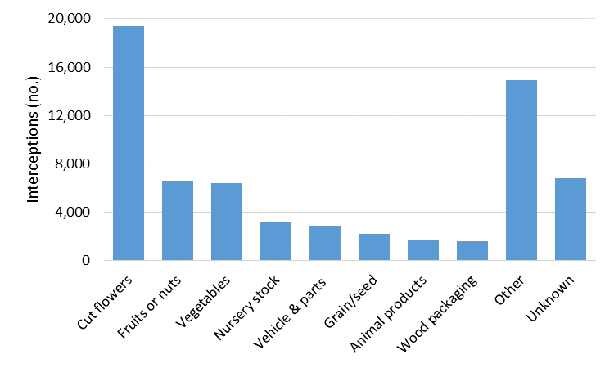

### Priority plant pest interceptions

Table 8 summarises identified national plant priority pests intercepted at the border from 2012 to 2017. The total amount of national priority plant pests intercepted represents less than 0.7 per cent of total interceptions recorded in the Incidents database. Figure 12 shows the top four pest interceptions for the same period. These accounted for more than 76 per cent of the high priority plant pests recorded in the Incidents database.

Table 8 Border interceptions of national priority plant pests, 2012 to 2017

| **Priority plant pest (pest ranking)** | **2012** | **2013** | **2014** | **2015** | **2016** | **2017** | **Total** |
| --- | --- | --- | --- | --- | --- | --- | --- |
| Exotic bees (17) | 74 | 63 | 60 | 105 | 77 | 51 | 430 |
| Brown marmorated stink bug (10) | 6 | 24 | 40 | 94 | 47 | 80 | 291 |
| Giant African snail (9) | 27 | 34 | 46 | 21 | 26 | 32 | 186 |
| Drywood termites (29) | 12 | 11 | 16 | 10 | 15 | 14 | 78 |
| Panama disease (18) | 1 | 11 | 8 | 9 | 10 | 14 | 53 |
| Asian gypsy moth (6) | 15 | 14 | 8 | 6 | 0 | 0 | 43 |
| Subterranean termites (30) | 6 | 9 | 8 | 5 | 8 | 5 | 41 |
| Citrus canker (14) | 0 | 19 | 4 | 5 | 5 | 6 | 39 |
| Exotic invasive ants (7) | 1 | 8 | 5 | 6 | 5 | 4 | 29 |
| Golden apple snail (25) | 3 | 6 | 2 | 0 | 0 | 10 | 21 |
| Fruit flies (3) | 4 | 2 | 3 | 2 | 1 | 4 | 16 |
| Huanlongbing vector (Asian citrus psyllid, Diaphorina citri) (5) | 4 | 2 | 3 | 2 | 1 | 4 | 16 |
| Exotic sawyer beetle (39) | 1 | 1 | 10 | 1 | 0 | 1 | 14 |
| Khapra beetle (2) | 0 | 0 | 3 | 1 | 6 | 1 | 11 |
| Citrus longhorn beetle (31) | 1 | 0 | 8 | 0 | 0 | 0 | 9 |
| Bee mites (8) | 2 | 1 | 1 | 2 | 2 | 0 | 8 |
| UG99 (wheat stem rust) (12) | 0 | 1 | 1 | 0 | 0 | 0 | 2 |
| Russian wheat aphid (13) | 0 | 1 | 0 | 0 | 0 | 0 | 1 |
| Leaf miner (20) | 0 | 0 | 0 | 0 | 0 | 1 | 1 |
| Burning moth (40) | 0 | 0 | 0 | 0 | 0 | 1 | 1 |
| **Total** | 157 | 207 | 226 | 269 | 203 | 228 | 1,290 |

Figure 12 Top four priority plant pest interceptions, 2012 to 2017

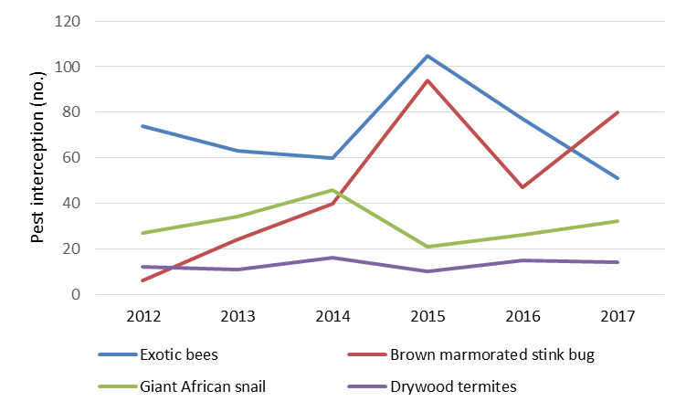

### Priority animal and plant interceptions in post-arrival quarantine facilities

The department has special post-arrival quarantine arrangements for live animals and animal genetic material, and live plants and plant genetic material. This is because of the higher risk they pose of carrying latent diseases into the country that may only become evident after some time. Interception of specific pests or diseases in post-arrival quarantine:

* protects Australia’s animal and plant populations
* allows assessment of import conditions and their application to determine whether they should be reviewed and modified.

From 2010 to 2016 departmental officers made 18 animal disease interceptions, including 15 in imported dogs (Table 9).

Table 9 Animal disease interceptions in post-arrival quarantine, 2010 to 2018

| **Year** | **Disease** | **Animal** | **Number** | **Country** | **Result** |
| --- | --- | --- | --- | --- | --- |
| 2010 | *Ehrlichia canis* | Dog | 1 | Afghanistan | Dog exported |
| 2010 | Newcastle disease | Pigeons | 1 consignment | United States | Pigeons euthanised, facility decontaminated |
| 2011 | *Ehrlichia canis* | Dog | 1 | Belgium | Dog exported |
| 2011 | *Ehrlichia canis* | Dog | 1 | France | Dog exported |
| 2011 | *Ehrlichia canis* | Dog | 1 | American Samoa | Dog exported |
| 2011 | *Ehrlichia canis* | Dog | 1 | Czech Republic | Dog exported |
| 2011 | Canine leishmaniasis | Dog | 1 | Poland | Dog exported |
| 2011 | Canine leishmaniasis | Dog | 1 | Serbia | Dog exported |
| 2012 | *Ehrlichia canis* | Dog | 1 | Singapore | Dog euthanised |
| 2012 | Canine leishmaniasis | Dog | 1 | Portugal | Dog exported |
| 2013 | *Salmonella pullorum* | Chicken eggs | 1 consignment | UK | Consignment destroyed, facility decontaminated |
| 2013 | Leptospirosis | Dog | 1 | Italy | Dog released after 14-day treatment |
| 2013 | *Ehrlichia canis* | Dog | 1 | Singapore | Dog euthanised |
| 2014 | *Ehrlichia canis* | Dog | 1 | The Netherlands | Dog exported |
| 2015 | *Ehrlichia canis* | Dog | 1 | Malaysia | Dog exported |
| 2015 | *Ehrlichia canis* | Dog | 1 | Malaysia | Dog exported |
| 2016 | *Ehrlichia canis* | Dog | 1 | Malaysia | Dog exported |
| 2016 | *Ehrlichia canis* | Dog | 1 | Malaysia | Dog exported |
| 2016 | Rabies virus | Cat | 1 | Argentina | Cat euthanised |
| 2017 | Rabies virus | Dog | 2 | Argentina | Dogs exported |
| 2017 | *Ehrlichia canis* | Dog | 1 | Czech Republic | Dog exported |
| 2017 | *Ehrlichia canis* | Dog | 1 | Malaysia | Dog exported |
| 2017 | *Ehrlichia canis* | Dog | 1 | Guam | Dog exported |
| 2018 | *Ehrlichia canis* | Dog | 1 | Greece | Dog exported |
| 2018 | *Ehrlichia canis* | Dog | 2 | Papua New Guinea | Dogs released after treatment |

The department’s post-entry quarantine (PEQ) facility opened in Mickleham, Victoria in 2015. From 2015 to 2018 the PEQ facility detected 224 plants with a pest or disease. Of these, 159 detections were non-actionable and continued under quarantine. The remaining plants were destroyed or are under treatment (Table 10).

Table 10 Plant pests and diseases found in post-entry quarantine, 2015 to 2018

| **Year** | **Disease** | **Host plant** | **Number** | **Country** | **Result** |
| --- | --- | --- | --- | --- | --- |
| 2015 | Cherry leaf roll virus | Prunus | 1 | Germany | Destroyed |
| 2015 | Citrus tristeza virus | Citrus | 1 | Japan | STG treatment |
| 2016 | Grapevine virus B | Grapevine | 1 | Japan | Destroyed |
| 2016 | Grapevine virus E | Grapevine | 3 | Japan | Destroyed |
| 2016 | Grapevine leaf roll-associated virus 3 | Grapevine | 3 | Japan | Destroyed |
| 2016 | Grapevine leaf roll-associated virus 3 | Grapevine | 1 | Japan | Destroyed |
| 2016 | Cherry leaf roll virus | Prunus | 1 | France | Destroyed |
| 2016 | Arkansas fig virus 1 | Ficus | 3 | South Africa | Destroyed |
| 2016 | Fig leaf mottle-associated virus 1 | Ficus | 3 | South Africa | Destroyed |
| 2016 | Fig leaf mottle-associated virus 2 | Ficus | 3 | South Africa | Destroyed |
| 2016 | Arkansas fig virus 2 | Ficus | 2 | South Africa | Destroyed |
| 2016 | Fig mild mottle virus | Ficus | 1 | South Africa | Destroyed |
| 2016 | Grapevine virus E | Grapevine | 3 | Japan | Destroyed |
| 2016 | Grapevine leaf roll-associated virus 3 | Grapevine | 2 | Japan | Destroyed |
| 2016 | Grapevine virus B | Grapevine | 1 | Japan | Destroyed |
| 2016 | Grapevine virus E | Grapevine | 1 | United States | Destroyed |
| 2017 | Grapevine pinot gris virus | Grapevine | 1 | Italy | Destroyed |
| 2017 | Grapevine pinot gris virus | Grapevine | 1 | Greece | Destroyed |
| 2017 | Grapevine fan leaf virus | Grapevine | 1 | Greece | Destroyed |
| 2017 | Grapevine virus F | Grapevine | 1 | Greece | Destroyed |
| 2017 | Grapevine rupestris vein feathering virus | Grapevine | 2 | Greece | Destroyed |
| 2017 | Citrus viroid OS | Citrus | 1 | Republic of Korea | Destroyed |
| 2017 | Citrus viroid II | Citrus | 3 | Republic of Korea | STG virus elimination in progress for 1 of 3 cultivars. 2 destroyed |
| 2017 | Citrus viroid III | Citrus | 3 | Republic of Korea | STG virus elimination in progress for 1 of 3 cultivars. 2 destroyed |
| 2017 | Citrus tristeza virus | Citrus | 5 | Republic of Korea | STG virus elimination in progress for 3 of 5 cultivars |
| 2017 | Citrus tristeza virus | Citrus | 3 | Republic of Korea | STG virus elimination in progress |
| 2017 | Hop stunt viroid | Citrus | 1 | Republic of Korea | STG virus elimination in progress |
| 2017 | Diaporthe passiflorae | Vaccinium | 1 | New Zealand | Destroyed |
| 2017 | Paraconiothyrium sporulosum | Vaccinium | 1 | New Zealand | Destroyed |
| 2018 | Fig leaf mottle-associated virus 1 | Ficus | 2 | South Africa | Destroyed |
| 2018 | Fig mild mottle virus | Ficus | 1 | South Africa | Destroyed |
| 2018 | Colletotrichum camelliae | Camellia | 1 | United States | Destroyed |
| 2018 | Grapevine leafroll-associated virus 11 | Grapevine | 2 | Italy | Status under review |
| 2018 | Citrus tristeza virus | Citrus | 1 | Republic of Korea | STG virus elimination in progress |
| 2018 | *Phyllactinia actinidiae-latifoliae* | Actinidia | 1 | China | Destroyed |

**STG** treatment: Standard treatment guidelines.

## Border breaches and incursions

### Border breaches

Border breaches occur when organisms are detected post-border in original host material and then eradicated before they spread to local host populations and cause an actual incursion (Caley, Ingram & De Barro 2015).

Prompt pre-border detection, reporting and intervention by appropriate treatment may avert border breaches. For example, when flying insects are detected on ships, or at or near ports, through programmed surveillance activities, the department’s maritime arrivals reporting system (MARS) allows ships’ masters to report any such incidents (Box 3). A number of pest-specific traps are deployed near ports and monitored for target pests.

Box 3 Varroa mite detection on ship’s cargo—a border breach averted

The varroa mite parasite can attack the European honey bee—which is important to our agriculture, environment and honey industries. The mite can only reproduce in a honey bee colony, where it weakens the bee by sucking blood and spreading ribonucleic acid (RNA) viruses such as deformed wing virus.

Several species comprise the varroa mite group, including *Varroa jacobsoni* and *V. destructor*. The species *V. jacobsoni* has been subject to eradication in Townsville, Queensland, since 2016 and is now in proof-of-freedom stage. *V. destructor* is considered the greater threat for apiculture.

On 27 June 2018 at the port of Melbourne, ship’s crew detected European honey bees in crates of industrial equipment on a ship arriving from the United States. Before docking, the ship master had reported the presence of several dead bees and the ship was immediately investigated on arrival. The ship had undergone a fog treatment before its voyage.

Diagnostic testing confirmed the bees were infested with *V. destructor*. No other species of parasitic mites were detected. The Australian Government Department of Agriculture and Water Resources set up a two-kilometre surveillance zone in the surrounding area. Surveillance activities included testing of established sentinel hives, establishment of new sentinel hives and floral sweep netting. Laboratory results from the established sentinel hives were negative forvarroa mite.

Early detection of exotic honey bee parasites and pests entering Australia is crucial to limiting their spread and impact on the Australian honey bee industry. Commercial and backyard beekeepers play a significant role in recognising and reporting any suspected infestation by varroa mite or other pests and diseases.

Actual border breaches can be considered ‘lucky escapes’ or ‘near misses’ from full incursions, and often rely on alert members of the public to raise the alarm and notify government, which can respond quickly and effectively.

Targeted surveillance and importer biosecurity awareness are also very important in detecting border breaches by high-risk pests before they establish in or on Australian hosts or host material and cause damage.

Communication about border breaches requires balancing the need for rapid mobilisation of an emergency response including surveillance by relevant governments and industry, with a need not to miscommunicate its wider significance. Although the pest has passed border biosecurity control and is in the country, it has not established in its target host and therefore may not require immediate international notification that could cause unwarranted trade repercussions. For example, since 2007 three Khapra beetle border breaches (Box 4) have been effectively contained and eradicated without affecting Australia’s multi-million dollar grain export markets. In all cases, shipping containers carrying the infested goods were identified as the likely contamination source, having passed through overseas ports where Khapra beetle is known to exist.

Box 4 Khapra beetle border breaches

Khapra beetle (*Trogoderma granarium*) is a destructive pest that can rapidly reproduce and infest a range of agricultural commodities including grains, seeds, dried fruits and nuts. An outbreak could cost Australia $15.5 million over 20 years through grain production and export market losses (Hafi & Addai 2014).

Case 1

In April 2007 a family that had migrated from Scotland to Perth, Western Australia, found live beetles inside their house. The family called a local pest controller who had attended a WA Government program on how to identify and report exotic pests. He notified the Department of Agriculture and Water Resources. A biosecurity officer subsequently took a sample and a taxonomist confirmed the pest. An interim permethrin fogging treatment was applied to the house. The Consultative Committee on Emergency Plant Pests recommended the pest be eradicated under the Emergency Plant Pest Response Deed. In 10 days an emergency response plan was developed and the entire house was sealed in plastic and fumigated with methyl bromide. The eradication program costed more than $207,000 (Day & White 2016).

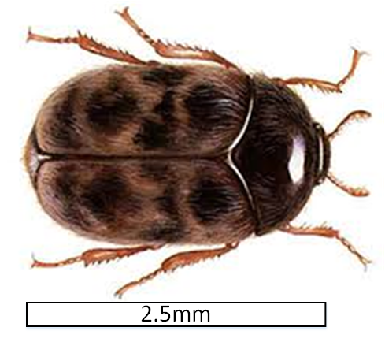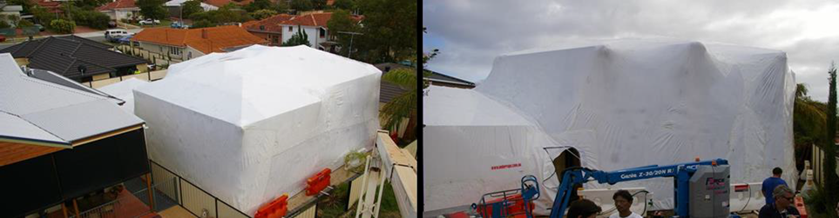

Case 2

In April 2016 a Khapra beetle border breach was detected in Kingscote, South Australia. The beetles had arrived from New Zealand in a consignment of imported plastic food grade containers and reached two metropolitan locations in Adelaide and one on Kangaroo Island before being reported. Once the department had identified the beetles, a national response was initiated under the EPPRD. The entire warehouse that had received the infested shipment was covered in a tarpaulin and fumigated with methyl bromide and the other sites were thoroughly cleaned. After the fumigation, the department installed more than 300 pheromone traps across 65 sites. By May 2017 it had collected and analysed more than 6,700 samples—with no Khapra beetle detected. Monitoring of this site ceased in May 2018.

Case 3

In April 2018 an importer unloaded a container of polypropylene granules (used to manufacture plastic products) at a commercial premises in Dandenong, Victoria. The importer noticed some contamination when the granules were decanted into a silo, but not the insect larvae present in the granules. He transferred the granules into another shipping container and sealed and sent it to an approved arrangement site, where later the insect larvae were found. The original imported container was traced to premises at Leeton, NSW.

The NSW Government Department of Primary Industries (NSW DPI) conducted thorough surveillance and trapping activities at the Leeton site and no Khapra beetles or larvae were detected. The DPI and Agriculture Victoria continued surveillance and trapping activities at the Dandenong and Leeton sites until the end of spring 2018. Khapra beetles are most likely to emerge from their dormant state during spring, because of warmer temperatures.

### Incursions

An incursion occurs when a pest or disease passes through the border, migrates from its original carrier and then establishes in other hosts or host material in Australian territory (Caley, Ingram & De Barro 2015). Industry and community biosecurity awareness is critical for early detection and reporting. Government and industry preparedness plans are critical for early and effective responses.

#### 5.2.1 Emergency responses

The need for emergency responses to post-border detections of exotic pests and diseases is determined by relevant national committees. Emergency biosecurity responses are mounted against major plant or animal pest and disease incursions. Between 2010 and 2018 the highest number of incursions that warranted an emergency response were in Queensland (25 per cent), followed by the Northern Territory and Victoria (16.7 per cent), and NSW (12.5 per cent). South Australia and the Torres Strait recorded the lowest number of incursions (8.3 per cent).

The most common groups for detecting incursions were state and territory government officers (34 per cent), the general public (29 per cent) and researchers (11 per cent). Weeds were largely identified by the public and fungi were largely identified by state or territory government officials. The public were the most common detector group in Queensland, possibly because of the high number of weeds in that state.

#### 5.2.2 Plant pest and disease incursions

The department’s Office of the Chief Plant Protection Officer uses a pest tracking data tool to report to the National Management Group (NMG) and other organisations. From July 2007 to August 2016, the Plant Pest Emergency Response Program recorded 607 plant pest incidents (Table 11). Incidents were listed as pest notifications (38.4 per cent), followed by incursions (37.7 per cent) and weed notifications (22.9 per cent). Only six detections (0.9 per cent) were made at the border. Pathogens accounted for most incursions (66 per cent) and included more than 300 different species. Invertebrates accounted for 26 per cent and weeds for 23 per cent (Table 11).

Table 11 Plant pest incidents, 2007 to 2016

| **Incident type** | **2007 (no.)** | **2008 (no.)** | **2009 (no.)** | **2010 (no.)** | **2011 (no.)** | **2012 (no.)** | **2013 (no.)** | **2014 (no.)** | **2015 (no.)** | **2016 (no.)** | **Total (no.)** | **Total (%)** |
| --- | --- | --- | --- | --- | --- | --- | --- | --- | --- | --- | --- | --- |
| Pest notification | 5 | 4 | 14 | 17 | 23 | 50 | 34 | 28 | 38 | 20 | 233 | 38.4 |
| Incursion | 9 | 19 | 27 | 16 | 27 | 20 | 13 | 28 | 42 | 28 | 229 | 37.7 |
| Weed detection | 0 | 23 | 14 | 38 | 30 | 25 | 4 | 1 | 4 | 0 | 139 | 22.9 |
| Border detections | 1 | 1 | 0 | 3 | 0 | 1 | 0 | 0 | 0 | 0 | 6 | 0.9 |
| **Total** | 15 | 47 | 55 | 74 | 80 | 96 | 51 | 57 | 84 | 48 | 607 | 100 |

Most plant-related emergency responses were because of incursions of diseases or viruses (Table 12). The department classifies insects and bee mites as plant pests.

Table 12 Major plant pest and disease incursions, 2010 to 2018

| Year | Pest/disease | Incident type | Pathway | Location found | Response outcome (February 2019) |
| --- | --- | --- | --- | --- | --- |
| 2010 | Myrtle rust (*Austropuccinia psidii*) | Incursion | Unknown | Central coast, New South Wales | Transition to management 2010 |
| 2010 | Chestnut blight (*Cryphonectria parasitica*) | Incursion | Unknown | Owens Valley, Victoria | Response phase |
| 2011 | Cocoa pod borer (*Conopomorpha cramerella*) | Incursion | Unknown | Queensland | Eradicated 2014 |
| 2013 | Banana freckle (*Phyllosticta cavendishii*) | Incursion | Unknown | Darwin, Northern Territory | Eradicated 2019 |
| 2013 | Red witchweed (*Striga asiatica*) | Incursion | Unknown | Mackay, Queensland | Response phase |
| 2013 | Melon necrotic spot virus | Incursion | Unknown | Curlwaa, New South Wales and Mildura, Victoria | Declared not eradicable in 2018 |
| 2014 | Giant pine scale (*Marchalina hellenica*) | Incursion | Unknown | Melbourne, Victoria | Transition to management 2018 |
| 2014 | Cucumber green-mottle mosaic virus | Incursion | Contaminated seed | Katherine, Northern Territory | Declared not eradicable in 2015 |
| 2014 | Vegetable leaf miner (*Lyriomyza sativae*) | Incursion | Unknown | Torres Strait | Transition to management |
| 2015 | Panama disease (*Fusarium oxysporum* f. sp. *cubense* Tropical Race 4) | Incursion | Unknown | Tully, Queensland | Declared not eradicable in 2015 |
| 2015 | Fruit flies (*Bactrocera dorsalis*, *Bactrocera trivialis*, *Zeugodacus cucurbitae*) | Seasonal Incursion | Natural and human pathways | Torres Strait | Seasonal eradication |
| 2015 | Red imported fire ant (*Solenopsis invicta*) | Incursion | Unknown | Brisbane airport, Queensland | Declaration of eradication pending |
| 2015 | Browsing ant (*Lepisiota frauenfeldi*) | Incursion | Unknown | Darwin, Northern Territory | Response phase |
| 2016 | Khapra beetle (*Trogoderma granarium*) | Border breach | Shipping container | Adelaide, South Australia | Eradicated 2018 |
| 2016 | Russian wheat aphid (*Diuraphis noxia*) | Incursion | Fresh cut flowers | Tarlee, South Australia | Declared not eradicable in 2016 |
| 2016 | Varroa mite (*Varroa jacobsoni*) | Incursion | Unknown | Townsville, Queensland | Response phase |
| 2016 | Red imported fire ant (*Solenopsis invicta*) | Border breach | Unknown | Port of Brisbane, Queensland | Declaration of eradication pending |
| 2017 | Tomato potato psyllid (*Bactericera cockerelli*) | Incursion | Unknown | Perth, Western Australia | Transitioned to management in 2017 |
| 2017 | Brown marmorated stink bug (*Halyomorpha halys*) | Border breach | Unknown | Glendenning, New South Wales | Declared not established 2018 |
| 2018 | Brown marmorated stink bug (*Halyomorpha halys*) | Border breach | Imported goods | Jandakot, Western Australia | Declaration of not established pending |
| 2018 | Citrus canker (*Xanthomonas citri* subsp. *citri*) | Incursion | Unknown | Darwin and Katherine, Northern Territory  Northern Western Australia | Response phase |
| 2018 | Khapra beetle (*Trogoderma granarium*) | Border breach | Shipping container | Victoria and New South Wales | Response phase |
| 2018 | Psa 3 (*Pseudomonas syringae* pv. *actinidiae* biovar 3) | Incursion | Unknown | Bunbartha, Victoria | Declared not eradicable 2019 |

In 2017 the NMG determined that certain priority exotic plant pests were not technically feasible to eradicate, and consequently they were transitioned to management. These include Russian wheat aphid and tomato potato psyllid.

The Russian wheat aphid (*Diuraphis noxia*) is a major pest of cereal crops that inhibits growth and can kill plants. In May 2016 a local agronomist detected this aphid in a wheat crop south of Tarlee, South Australia. A month later, the NMG determined that it was not technically feasible to eradicate the aphid. Since then it has spread to major cropping areas of southern New South Wales, Victoria, South Australia and Tasmania. The transition to management plan has focused on helping farmers to develop management plans and long-term control options.

In February 2017 tomato potato psyllid (TPP) was detected in a range of commercial and backyard tomato crops across the Perth metropolitan area. TPP is a tiny insect pest that attacks the *Solanaceae* family of plants including potato, tomato, eggplant, capsicum, chilli and tamarillo. It also attacks sweet potato and other plants in the *Convolvulaceae* family.

In September 2017 the NMG decided that it was not technically feasible to eradicate TPP and agreed to a transition to management phase. The WA Department of Primary Industries and Regional Development developed a transition to management plan designed to limit and manage the impact of the tomato potato psyllid across Australia.

#### 5.2.3 Terrestrial animal disease incursions

From 2007 to 2017 Australia experienced a limited number of animal disease incursions of national significance, as reported to the World Organisation for Animal Health (OIE) (Table 13).

Table 13 Animal disease incursions reported to OIE, 2007 to 2017

| Year | Disease | Location | Animal | Result |
| --- | --- | --- | --- | --- |
| 2007 | Equine influenza virus | New South Wales, Queensland | Horses | Eradicated |
| 2008 | Bluetongue (serotype 7) | Northern Territory | Cattle | New strain—endemic |
| 2009 | Bluetongue (serotype 2) | Northern Territory | Cattle | New strain—endemic |
| 2009 | Influenza A virus (H1N1) | Dubbo, New South Wales; Greater Shepparton, Victoria; Jondaryan, Queensland; Rockhampton, Queensland; Wambo, Queensland; Young, New South Wales | Pigs | Endemic |
| 2011 | Pigeon paramyxovirus | Melbourne, Victoria | Pigeons | Endemic |
| 2012 | Avian influenza, H7N7 | Maitland, New South Wales | Chickens | Eradicated (20 March 2013) |
| 2012 | Low pathogenic notifiable avian influenza (H5N3) | Woodend North, Victoria | Free range ducks | Eradicated (5 June 2013) |
| 2013 | Highly pathogenic avian influenza (H7N2) | Young, New South Wales | Free range chickens | Eradicated (21 February 2014) |
| 2013 | Low pathogenic notifiable avian influenza (H5N3) | Henley Brook, Western Australia | Duck and chickens | Eradicated (27 June 2013) |
| 2014 | Rabbit haemorrhagic disease strain | Sydney, New South Wales | Rabbits | New strain—endemic. No attempts were made to eradicate or control this disease due to endemicity and use as biological control agent |
| 2015 | Bluetongue virus (serotype 5) | Northern Territory | Cattle | New strain—endemic |
| 2015 | Bluetongue virus (serotype 12) | Northern Territory | Cattle | New strain—endemic |
| 2015 | Rabbit haemorrhagic disease | Australian Capital Territory | Rabbits | New strain—endemic. No attempts were made to eradicate or control this disease due to endemicity and use as biological control agent |
| 2016 | Tularaemia (*Francisella tularensis*) | Sydney, New South Wales | Possums | Detected in historical samples (collected 2002 and 2003) |
| 2017 | Pigeon rotavirus | Western Australia (initial case, followed by other jurisdictions) | Pigeons | Endemic |

#### 5.2.4 Aquatic animal disease incursions

Aquatic animals can also be affected by infectious diseases caused by viruses, bacteria, fungi, protozoa and parasites. Some may be of Australian origin but not detected previously, while others are brought into the country via infected animals or products. An incursion of an aquatic animal disease can only be easily eradicated if the hosts are contained within an immediate environment, such as an aquaculture pond or breeding tank. Eradication from aquaculture facilities does not necessarily mean eradication from the wild. If the disease emerges in or escapes into the wild, it may be hard to eradicate. Proof of freedom as well as risk management relies on passive or targeted surveillance, which can last many years (Table 14).

Table 14 Aquatic animal disease detections, 2010 to 2018

| **Year** | **Disease** | **Location** | **Animal affected** | **Result** |
| --- | --- | --- | --- | --- |
| 2007 | Abalone viral ganglioneuritis | Port Fairy, Victoria | Abalone | Eradicated |
| 2007 | Oyster oedema disease | Western Australia | Pearl oysters | Passive surveillance |
| 2008 | Abalone viral ganglioneuritis | Tasmania | Abalone | Eradicated |
| 2008 | White tail disease | Queensland | Freshwater prawns | Passive surveillance |
| 2008 | Infectious hypodermal and hematopoietic necrosis | Queensland | Tiger prawns | Passive surveillance |
| 2009 | Infectious hypodermal and hematopoietic necrosis | Queensland | Prawns | Passive surveillance |
| 2010 | Pacific oyster mortality syndrome | New South Wales | Oysters | Passive surveillance |
| 2010 | Abalone viral ganglioneuritis | New South Wales | Abalone | Eradicated |
| 2010 | *Edwardsiella ictaluri* | Northern Territory | Ornamental catfish | Eradicated |
| 2010 | Abalone viral ganglioneuritis | Tasmania | Abalone | Passive surveillance |
| 2011 | Epizootic ulcerative syndrome | New South Wales | Freshwater fish | Passive surveillance |
| 2011 | *Edwardsiella ictaluri* | Northern Territory | Ornamental catfish | Eradicated |
| 2011 | Pacific oyster mortality syndrome | New South Wales | Oysters | Passive surveillance |
| 2012 | Megalocytivirus | Queensland | Ornamental fish | Eradicated |
| 2012 | Yellow head virus complex genotype 7 and 2 | Queensland | Tiger prawns | Passive surveillance |
| 2013 | Pacific oyster mortality syndrome | New South Wales | Oysters | Passive surveillance |
| 2014 | *Edwardsiella ictaluri* | Queensland | Ornamental catfish | Eradicated |
| 2015 | *Perkinsus beharensis* | New South Wales | Native flat oyster | Surveillance |
| 2015 | *Perkinsus olseni* | Victoria | Native flat oyster | Transition to management |
| 2015 | *Bonamia exitiosa* | Victoria | Native flat oyster | Eradicated |
| 2015 | *Penaeus monodon* mortality syndrome | Queensland | Tiger prawns | Passive surveillance |
| 2016 | Pacific oyster mortality syndrome | Tasmania | Oysters | Targeted surveillance |
| 2016 | *Penaeus monodon* mortality syndrome | Queensland | Tiger prawns | Under surveillance |
| 2016 | *Perkinsus olseni* | Western Australia | Native flat oyster | Targeted surveillance |
| 2016 | White spot syndrome virus | Queensland | Tiger prawns, native crabs | Targeted surveillance |
| 2018 | Pacific oyster mortality syndrome (POMS) | Port Adelaide River estuary | Feral pacific oysters | Targeted surveillance |

#### 5.2.5 Marine pest incursions

Australia’s unique marine environment supports numerous industries, such as fishing, aquaculture and tourism that are important to our national and regional economies. However, Australia’s vast marine environment and marine-dependent industries face an ongoing threat from unwanted marine pests (Table 15). The risk of these pests being introduced, establishing and damaging our marine environments has increased because of the increase in international and domestic maritime traffic and a greater need for marine infrastructure (Department of Agriculture and Water Resources 2018b).

Marine pests of national significance that have established in Australian waters include:

* Japanese kelp (Undaria pinnatifida)
* European shore crab (Carcinus maenas)
* Northern Pacific sea star (Asterias amurensis).

Exotic marine pests of national significance include:

* Chinese mitten crab (*Eriocheir sinensis*)
* Harris mud crab (*Rhithropanopeus harrisii*)
* Asian green mussel (*Perna viridis*)
* Brown mussel (*Perna perna*)
* New Zealand green mussel (*Perna canaliculus*)
* Black striped false mussel(*Mytilopsis sallei*).

The Emergency Marine Pest Plan (EMPPlan)—adapted from the Australian emergency plans for terrestrial and aquatic animal diseases, the Australian Veterinary Emergency Plan (AUSVETPLAN) and the Australian Aquatic Veterinary Emergency Plan (AQUAVETPLAN)—provides detailed information and guidance for emergency response to key marine pest species or groups of pest species.

Table 15 Introduced marine pests, February 2010 to February 2019

| Year | Pest | Location | Result |
| --- | --- | --- | --- |
| 2010 | Asian green mussel (*Perna viridis*) | Darwin, Northern Territory | Transient |
| Black-striped mussel (*Mytilopsis sallei*) | Darwin, Northern Territory | Eradicated |
| Asian green mussel (*Perna viridis*) | Dampier, Western Australia | Transient |
| Asian green mussel (*Perna viridis*) | Dampier, Western Australia | Transient |
| Asian green mussel (*Perna viridis*) | Darwin, Northern Territory | Transient |
| Asian flat oyster (*Ostrea denselamellosa*) | Darwin, Northern Territory | Transient |
| Barnacle (*Balanus improvisus*) | Fremantle, Western Australia | Transient |
| Barnacle (*Balanus improvisus*) | Fremantle, Western Australia | Transient |
| Asian green mussel (*Perna viridis*) | Cairns, Queensland | Transient |
| European fan worm(*Sabella spallanzanii*) | Port Lincoln Wharf, South Australia | Established |
| 2011 | Asian green mussel (*Perna viridis*) | Henderson, Western Australia | Transient |
| Red macroalga (*Grateloupia turuturu*) | Gem Pier, Williamstown, Victoria | Established |
| Asian green mussel (*Perna viridis*) | Rockingham, Western Australia | Transient |
| Toxic dinoflagellate (*Alexandrium insuetum*) | Port Philip Bay, Victoria | Established |
| Asian green mussel (*Perna viridis*) | Garden Island, Rockingham, Western Australia | Transient |
| Toxic dinoflagellate (*Alexandrium insuetum*) | Port Phillip Bay, Victoria | Established |
| Asian green mussel (*Perna viridis*) | Garden Island, Rockingham, Western Australia | Transient |
| Asian green mussel (*Perna viridis*) | Darwin Harbour, Northern Territory | Transient |
| Asian bag or date mussel (*Musculista senhousia*) | Darwin Harbour, Northern Territory | Established |
| Asian bag or date mussel (*Musculista senhousia*) | Metung, Gipsland Lakes, Victoria | Established |
| Northern Pacific seastar (*Asterias amurensis*) | San Remo, Westernport Bay, Victoria | Transitioned to management |
| Dinoflagellate (*Alexandrium tamarense*) | Portland Harbour, Victoria | Endemic |
| Dinoflagellate (*Alexandrium catinella*) | Port Headland, Dampier and Fremantle, Western Australia | Established |
| Dinoflagellate (*Alexandrium minutum*) | Portland Harbour, Victoria | Established |
| European fan worm, Giant Mediterranean fan worm (*Sabella spallanzanii*) | Port of Portland Victoria, Victoria | Established |
| Grape Algae (*Caulerpa racemosa* var. *cylindracea*) | Port of Portland Victoria, Victoria | Established |
| Dead Man's Fingers (*Codium fragile* ssp. *fragile*) | Port of Portland Victoria, Victoria | Established |
| 2012 | Dinoflagellate (*Alexandrium catenella*) | Fremantle, Western Australia | Established |
| Ascidian (*Didemnum perlucidum*) | Western Australia—multiple locations (Swan River, Hillarys boat harbour, Port Hedland, Dampier and Fremantle Ports, Cockburn Sound, Garden Island) | Established |
| Northern Pacific seastar (*Asterias amurensis*) | Tidal River, Victoria (within the Wilsons Promontory National Park Victoria) | Eradicated |
| Ascidian (*Didemnum perlucidum*) | Darwin Harbour, Northern Territory | Established |
| Asian green mussel (*Perna viridis*) | Darwin Harbour, Northern Territory | Transient |
| Asian green mussel (*Perna viridis*) | HMAS Cairns, Tropical Reef Slipway, Queensland | Transient |
| Lady crab (*Charybdis japonica*) | Mosman Bay in the Swan River, Perth, Western Australia | Eradicated |
| Bay barnacle (*Amphibalanus improvisus*) | Broome, Western Australia | Transient |
| 2013 | European fan worm (*Sabella spallanzanii*) | Botany Bay, New South Wales | Established |
| Asian green mussel (*Perna viridis*) | Barrow Island, Western Australia | Transient |
| Northern Pacific seastar (*Asterias amurensis*) | Tidal River, Victoria (within the Wilsons Promontory National Park Victoria) | Eradicated |
| Asian green mussel (*Perna viridis*) | Barrow Island and Henderson, Western Australia | Transient |
| Pacific oysters (*Crassostrea gigas*) | Westernport and Tidal River, Victoria | Established |
| Asian green mussel (*Perna viridis*) | Darwin Harbour, Northern Territory | Transient |
| Asian green mussel (*Perna viridis*) | Hay Point, Queensland | Transient |
| Asian green mussel (*Perna viridis*) | Gove Harbour, Northern Territory | Transient |
| 2014 | Asian green mussel (*Perna viridis*) | Fremantle, Western Australia | Transient |
| New Zealand green-lipped mussel (*Perna canaliculus*) | Port of Brisbane, Queensland | Transient |
| Asian green mussel (*Perna viridis*) | Darwin Harbour, Northern Territory | Transient |
| New Zealand green-lipped mussel (*Perna canaliculus*) | Port Philip Bay, Victoria | Transient |
| Barnacle (*Fistulobalanus kondakovi*) | South Alligator River, Northern Territory | Established |
| Bay barnacle (*Amphibalanus improvisus*) (*Balanus improvisus*) | Port of Hobart, Tasmania | Transient |
| Asian green mussel (*Perna viridis*) | Kwinana, Western Australia | Transient |
| Asian green mussel (*Perna viridis*) | Port of Dampier, Western Australia | Transient |
| Asian green mussel (*Perna viridis*) | HMAS Cairns, Tropical Reef Slipway, Queensland | Transient |
| Asian paddle crab (*Charybdis japonica*) | Swan river, Western Australia | Eradicated |
| 2015 | Asian green mussel (*Perna viridis*) | Port of Fremantle, Western Australia | Transient |
| Asian green mussel (*Perna viridis*) | Port Henderson, Western Australia | Transient |
| Asian green mussel (*Perna viridis*) | Fremantle, Western Australia | Transient |
| Dead Man's Fingers (*Codium fragile* ssp. *fragile*) | Mistaken Island, Albany, Western Australia | Established |
| Northern Pacific seastar (*Asterias amurensis* ) | Gippsland Lakes, Victoria | Eradicated |
| Slime feather duster worm (*Myxicoloa infundibulum*) | Ballast Head, Kangaroo Island, South Australia | Established |
| 2016 | Fire crab (*Pyromaia tuberculata*) | Bruny Island, Tasmania | Established |
| Asian green mussel (*Perna viridis*) | Cockburn Sound, Western Australia | Transient |
| Bay barnacle (*Amphibalanus improvisus*) (*Balanus improvisus*) | Hobart, Tasmania | Transient |
| 2017 | European Green Shore crab (*Carcinus maenas*) | Macquarie Harbour, Tasmania | Established |
| Asian green mussel (*Perna viridis*) | Fremantle Port, Western Australia | Transient |
| Asian green mussel (*Perna viridis*) | Amrun Port, south of Weipa, Queensland | Eradicated |
| Stalked sea squirt (*Styela clava*) | Hobart, Tasmania | Established |
| Transparent sea squirt (*Ciona savignyi*) | Hobart, Tasmania | Established |
| *Sabellidae* genera (unknown *Branchimma* sp. & unknown *Parasabella* sp.) | Adelaide, South Australia | Established |
| Northern Pacific seastar (*Asterias amurensis*) | Tidal River (Wilson's Promontory), Victoria | Eradicated |
| 2018 | Northern Pacific seastar (*Asterias amurensis*) | Tidal River (Wilson's Promontory), Victoria | Eradicated |
| Wakame (*Undaria pinnatifada*) | Port Welshpool, Victoria | Eradicated |
| Nudibranch (*Spurilla braziliana*) | Aldinga reef and Lady Bay (Normanville), South Australia | Established |
| Asian paddle crab (*Charybdis japonica*) | Blackwall Reach, Swan River, Western Australia | Eradicated |
| 2019 | Northern Pacific seastar (*Asterias amurensis*) | Lakes Entrance, Victoria | Ongoing **a** |

**Transient**: detections were made on ships that were either cleaned or moved out of port (all but one Asian green mussel detections, some barnacle detections). It also refers to detections where detections are made but do not persist (for example, paddle crabs in Western Australia appear intermittently but locations where they may have established are not known; Asian green mussels in Cairns died out). **a** management of pest underway.

**Eradication**:

* for Pacific sea stars in Victoria: in these locations the species have been collected and no more are found. In some cases active eradication has been pursued
* for other species (for example, wakame in Port Welshpool, Asian green mussel in Queensland), no more organisms found beyond the initial detections and removal.

**Transitioned to management**: because many of these species are notifications of detection only and not subject to a formal response there is no transition to management per se. Some of them are considered established but still may be managed through ballast water management measures.

**Established**: introduced species that have become established in Australia. May have been no formal declaration that they are established particularly where there has not been a formal response.

**Endemic**: species known or believed to be native to Australia.

**Ongoing**: recent detections so surveillance to determine status is ongoing. Cannot assign status on basis of current information (as at March 2019).

#### 5.2.6 Environmental pest and disease incursions

Environmental pest and disease incursions into Australia have been described in the Inspector-General of Biosecurity’s hitchhikers and contaminants (IGB 2018) and environmental biosecurity reports (IGB 2019). A case study on exotic invasive ants is included in the environmental biosecurity report (IGB 2019). Exotic ants are some of the world’s most invasive pests and have devastating economic, environmental and social impacts. Red imported fire ants (*Solenopsis invicta*) (RIFA) pose a risk to human health because they are aggressive; delivering repeated painful stings that can cause anaphylactic shock. They prey on vertebrates, invertebrates and plants and compete for food with native herbivores and insects. The cost of controlling Australia’s worst established invasive species—rabbits, cane toads and feral cats—collectively is an estimated $964.4 million each year. If RIFA are not eradicated, the cost of managing the impacts could easily surpass this.

From 2001 to 2018 RIFA invasions were detected on 16 separate occasions (Table 16). Between 2001 and 2017 Australian and state and territory governments, in a cost-shared response, spent more than $366 million to contain an incursion in the south-west suburbs of Brisbane, which may have occurred a decade earlier. In July 2016 Australian and state and territory agriculture ministers together committed a further $411.4 million until 2026 to the National Red Imported Fire Ant Eradication Program. This high cost is due to the extent of the first RIFA incursion before control attempts began and shows the value of early detection.

Table 16 Emergency responses to exotic invasive ants, 2001 to 2018

| ****Start date**** | ****Location**** | ****Pest**** | ****Detection type**** | ****Emergency response outcome**** |
| --- | --- | --- | --- | --- |
| 2001 | South-east Queensland | RIFA | Incursion | Response Phase 1 (2001–17) and Phase 2 (2018–27) |
| 2001 | Port of Brisbane | RIFA | Incursion | Eradicated 2012 |
| 2001 | Cairns | Yellow crazy ant | Incursion | Transition to management |
| 2004 | Port of Brisbane | RIFA | Border breach | Eradicated 2004 |
| 2006 | Cairns | Electric ant | Incursion | Response phase |
| 2006 | Yarwun, Queensland | RIFA | Incursion | Eradicated 2010 |
| 2006 | Melbourne | RIFA | Interception | Eradicated 2006 |
| 2007 | Darwin | RIFA | Interception | Eradicated 2007 |
| 2009 | Lytton, Queensland | RIFA | Border breach | Eradicated 2009 |
| 2009 | Port of Brisbane | RIFA | Interception | Eradicated 2009 |
| 2009 | South Australia | RIFA | Interception | Eradicated 2009 |
| 2013 | Yarwun, Queensland | RIFA | Incursion | Eradicated 2017 |
| 2011 | Roma, Queensland | RIFA | Border breach | Eradicated 2011 |
| 2011 | Western Australia | RIFA | Interception | Eradicated 2011 |
| 2014 | Port of Brisbane | RIFA | Interception | Eradicated 2014 |
| 2014 | Port Botany, New South Wales | RIFA | Incursion | Eradicated 2017 |
| 2015 | Melbourne | RIFA | Interception | Eradicated 2015 |
| 2015 | Darwin Port | Browsing ant | Incursion | Response phase |
| 2016 | Brisbane Airport | RIFA | Incursion | Response phase |
| 2018 | Lismore, New South Wales | Yellow crazy ant | Incursion | Response phase |

**RIFA** Red imported fire ants

## Improving biosecurity information management

### Better reporting of high-risk interceptions

The department has developed, and continues to review, standard processes for internal and external notification of significant pests or diseases. However, its processes for collecting and reporting on rates of interceptions of material posing high biosecurity risks, such as undeclared meat or high levels of soil contamination, are far less developed.

Biosecurity pest and disease notifications (BPDNs) provide speedy internal notification of detections of significant pests or diseases to establish whether further operational, compliance or policy action is needed. BPDNs are prepared by departmental Operational Science Service (OSS) officers where:

* the detection of an exotic plant pest or disease is considered significant, because it is
  + an emergency plant pest or animal disease, or
  + listed on a departmental Biosecurity Pest Bulletin—a short descriptive report of a specific pest, with information such as distribution, range, likely mode of entry, actions to be taken and identifying photographs. At October 2018, 100 such bulletins were on the department’s website, or
* an exotic animal is detected or a live animal is imported without appropriate animal health certificates.

The senior entomologist or plant pathologist approves BPDNs to go to the department’s Biosecurity Reports team for internal distribution to relevant policy and operational areas, especially to the Australian Chief Plant Protection Officer (CPPO), Chief Veterinary Officer (CVO) or Chief Environmental Biosecurity Officer (CEBO). The CPPO, CVO and CEBO are responsible for external notification of these detections to relevant state and territory departments within a certain timeframe.

The Biosecurity Reports team maintains a register of all BPDNs and develops monthly and quarterly reports of significant interceptions. These reports are distributed within the department and externally to state and territory departments through national committees.

Between 2014 and 2018 plant pest and disease notifications increased substantially (Table 17). The increase in 2018 was largely due to the increased targeting and approach rate of brown marmorated stink bugs. Animal notifications also increased rapidly. Between 2014 and 2017 animal BPDNs involved only reptiles and amphibians. In 2018 animal notifications increased for birds (30) and mammals (7).

The BPDN process was designed to meet the Australian Government’s reporting obligations under response deeds. The Biosecurity Reports team is reviewing this process to provide greater clarification and include reports of environmental pests and diseases.

Table 17 Plant and animal pest and disease notifications, 2014 to 2018

| **Biosecurity pest and disease notification** | **2014 (no.)** | **2015 (no.)** | **2016 (no.)** | **2017 (no.)** | **2018 (no.)** |
| --- | --- | --- | --- | --- | --- |
| **Plant pests and diseases** | **197** | **236** | **228** | **274** | **395** |
| **Animal pests and diseases** | **14** | **17** | **8** | **22** | **59** |
| **Total** | **211** | **253** | **236** | **296** | **454** |

The department provides timely advice on interceptions in post-entry quarantine facilities to country of origin competent authorities and importers to enable them to improve biosecurity risk management and future compliance with Australian import conditions. However, it may not inform the many post-border stakeholders who also have an interest in ensuring that these pests and diseases do not establish in Australia. Reporting of border interceptions needs to be strengthened so that public awareness of biosecurity threats is maintained.

State and territory government agencies also receive and collect information about pest and disease interceptions post-border from structured and ad hoc surveillance programs, from industry and the general public. Processes are well-established for communicating and managing suspect detections of many serious exotic and emergency animal diseases and plant pests. However, less urgent information goes unreported and is difficult to capture even on a state basis. This information can be gathered and analysed over time and used in framing biosecurity policy. Greater sharing and joint consideration of the significance of interception data between Australian and state and territory biosecurity staff would help to manage national biosecurity threats more effectively.

It is difficult, expensive and time-consuming to harmonise, let alone standardise, underpinning biosecurity-related information systems in the different jurisdictions. This is because of their linkages into agency-specific or government-specific broader systems. Nevertheless, systems should be developed to allow better data sharing between national committees on priority animal, plant and environmental pests and their management. The department should lead development of more standard reports and dashboards on key issues. This is currently undertaken for internal departmental purposes, but should be extended to involve states and territories—without necessarily requiring over-standardisation of information systems.

Recommendation 3

The department should continually improve mechanisms for timely management and sharing of information on interceptions of pests and biosecurity risk material with state and territory government agencies and with relevant industry and other public and private bodies responsible for biosecurity.

**Department’s response: Agreed.**

The department has recently started and will continue to work with state and territory partners and other stakeholders on mechanisms to enable greater sharing of biosecurity pest and disease interception information.

### Complex data recording systems

Departmental biosecurity risk management information systems are a mix of old, adapted and new technologies. In the past, integration between systems was limited and departmental areas were isolated from each other.

Nairn et al. (1996) reviewed the Australian quarantine system and emphasised the need for Australia to improve recording and management pests and diseases detection data at the border. They noted:

..that records on the detection of pests and diseases at the border need to be improved to provide adequate data for the development of comprehensive databases and information systems on incursions.

Pest and disease interception data were held in siloed systems in a range of databases. These had poor or no integration. Different technologies and data models were used. In 2016, in New South Wales alone, more than 4,000 import biosecurity risk management spreadsheets were held on unprotected folders. From 2001 to 2016 more than 30,000 spreadsheets were used nationally (Department of Agriculture and Water Resources 2017).

These systems were built up to 25 years ago, and are now inadequate for identifying and responding to changing biosecurity risks. Consequently, the department’s ability to effectively and efficiently monitor and manage biosecurity risk is limited. Both Home Affairs’ and the department’s organisational structures and legislative environment, and trade and passenger volumes have also changed significantly. The systems failings include:

* inefficient and fragmented processing steps
* many manual activities with little system support
* duplication of information entry and retrieval
* numerous data gaps and erroneous data
* inconsistent definitions and entries that inhibit accurate analysis
* lack of suitable data reporting formats
* inability to effectively record evidence and point-in-time information
* poor flexibility for making changes due to changes in legislation, policy, process, templates and timeframes.

For pests and diseases, complexity and inconsistent use of taxonomies can complicate analysis. For example, to identify high priority pests, the department must put in significant effort to identify which taxon the reported pest is aligned with. Not all detections can be identified to the same level—for example, some are identified to family category and others to species. Common and scientific names can also be inconsistent and variable. For example, from 2012 to 2017 the giant African snail was described in the departmental Incident database as *Achatina fulica*, but in March 2017 this was changed to *Lissachatina fulicia* because of international taxonomic changes.

Departmental biosecurity information management systems have been focused at the border and little system support has been provided for activities undertaken offshore or post-border. For example, some departmental functions that administer critical Australian biosecurity measures do not have enabling systems—including functions such as identifying, monitoring and assessing animal and plant biosecurity risks. Staff have adopted manual workarounds and share critical information by email. This can amplify risks associated with administering Australian biosecurity arrangements.

Processes for data capture from approved arrangements may need strengthening because many goods pass through them without being examined by departmental officers. This issue will be examined in a separate IGB review of approved arrangements.

Inconsistent historical data can make analysis difficult. Improvements to data capture and quality are critical to improving risk analysis and interception strategy by pest, disease, commodity or pathway.

### Biosecurity integrated information system and analytics

In October 2015 the Australian Government released its Digital Continuity 2020 Policy (National Archives of Australia 2015) to support its digital transformation initiatives by requiring all agencies to effectively manage their digital information.

In 2017 the department released its *Information and Data Management Agenda* (Department of Agriculture and Water Resources 2017), aiming to bring departmental information management capability to a minimum expected level. It developed an information management framework setting out the core capabilities needed to manage its information and data, including data quality and remediation, metadata management, business intelligence and analytics, and data integration and interoperability.

Under the 2015 *Agricultural Competitiveness White Paper*, the Australian Government provided $200 million to improve biosecurity surveillance and analysis across Australia. The Advanced Analytics and Biosecurity Integrated Information Systems and Analytics (BIISA) program accounted for almost 25 per cent ($48.6 million) of that funding.

BIISA is helping to improve departmental systems to collect, collate, store and analyse information in an integrated manner to support biosecurity activities and incursion responses, and inform decision-making by:

* replacing and modernising existing import data systems such as AIMS and MAPS to improve their business process efficiency and data quality
* delivering a new application to improve the internal approved arrangement assessments and audit activities
* creating a single repository of 30 departmental pest and disease lists.

The pest and disease repository project will provide a single source of information about pests and diseases—including presence or absence in the country, actions required if detected at the border and/or the biosecurity concern to Australia. More than 30 existing departmental biosecurity pest and disease decision lists will be collected and collated. BIISA has developed a prototype that users can access through a web-based interface and so far has migrated six pest lists into it. The full suite of lists is expected to be available for use by June 2019.

The Biosecurity Analytics Centre (BAC) provides the department with advanced analytics services that turns gathered information into usable intelligence. Since 2017 the BAC has delivered more than 60 bespoke reports and dashboards. For example, the BAC developed monitoring and reporting dashboards to systematically identify any rises in the number of imports of cut flowers that fail inspection, by country of origin, importers and suppliers in the imported flower network.

The department uses analytics to help identify the import condition changes that would be most effective in managing risk by modelling the impacts of different changes. Since October 2017 the department has provided detailed feedback to national plant protection organisations so they can address risks before export. Since then the number of cut flowers that failing inspection has decreased from approximately 15 per cent to 5 per cent.

This should improve departmental data integration and analytical capability—leading to improved management of biosecurity risks offshore, at the border and during emergency responses and post-border surveillance onshore. The BIISA program is expected to be fully implemented by the end of 2020.

This review identified several areas where further investment beyond the scope of the original BIISA program would improve future capability. Increasing support for risk profiling such as seen with the Future Passenger program can have enormous benefits in better targeting of screening.

In particular, processes and reports to enable more timely risk analysis and escalation of serious threats should be kept under review and strengthened on an ongoing basis. This must support better consideration of biosecurity risk material and not just specific pests and diseases. Opportunities to capture automated data and overall use of big data will only increase and must be used.

Recommendation 4

The department should continue the Biosecurity Integrated Information System and Analytics and develop an extension to the system to enable improved data capture, analysis and reporting on the management of risks of specific pests and diseases and of biosecurity risk material entering Australia.

**Department’s response: Agreed.**

**The department is already improving data capture and information management -approaches that support biosecurity activities and incursion responses through the BIISA program.**

### Risk-return resource allocation

The department developed its risk-return resource allocation (RRRA) model to balance the probability of finding risks against the effort required to find them, and to improve biosecurity system effectiveness and efficiency. The department must further validate biosecurity risk management systems resourced based on RRRA modelling to ensure they are performing to the levels predicted. Otherwise, risks might not be adequately managed.

The RRRA model calculates the number of pests, diseases and weeds that are likely to have breached Australian borders each year. It then identifies the biosecurity risk by combining the likelihood and consequences of them establishing and spreading. The model uses Bayesian networks to represent the effect of controls in preventing organisms of biosecurity concern from entering Australia. It combines the likelihood of an organism being present on a pathway with the efficacy of controls to calculate the probability of each organism breaching the border.

The model uses approach rates, probabilities and effectiveness of controls drawn from multiple IT system data and expert advice. The model calculates the change to residual risk from a change in controls. This can allow the department to evaluate the effects of new policies or operational procedures before implementing them.

The department monitors and reviews RRRA model implementation as it relates to inspection and screening of each pathway. Much of the critical data required to calculate rates of screening and rates of detection are collected poorly if at all. The RRRA calculations often rely on old or aspirational data.

Recommendation 5

The department should strengthen the implementation of verification programs and data capture about them to ensure that biosecurity risk interception and management systems are performing as intended to support Risk Return Resource Allocation modelling, and that this modelling is not based on outdated or over-optimistic assumptions.

**Department’s response: Agreed.**

The department established a Biosecurity Operations Assurance Model in 2017 to provide a consistent approach to verification and capture qualitative and quantitative data to measure the performance of current management systems. The department will look to strengthen this model to ensure it is operating as intended and data capture supports RRRA and other modelling activity.

## Conclusion

Incursions are generally perceived as failures of the biosecurity system. However, despite being an island, Australia cannot remove all biosecurity risks. Migratory birds can bring new strains of avian diseases and insect vectors may be windborne. Some classes of pests or pathogens may be invisible on people’s clothing or goods and undetectable during border inspection. Nevertheless, risk-based screening and detection systems can intercept many risks.

The national biosecurity system is complex and multilayered. It involves pre-border, border and post-border activities aimed at reducing the risk of biosecurity threats arriving and establishing in Australia. Because of increasing arrival volumes of vessels, goods, passengers and mail, arrangements for intercepting pests, diseases and biosecurity risk material must be constantly reviewed by pathway to ensure that effort is directed to areas of highest risk.

The department should increase its efforts to adjust rates and methods of screening for pests and diseases and for biosecurity risk material that may carry them. These should be based on risk-profiling information and predicted approach rates for key priority pests and diseases and for high-risk material, and on verification processes such as end-point surveys that allow regular assessment of leakage rates for targeted high-risk material and pests. The department should prioritise and resource these screening methods and verification processes irrespective of other crises, because failure to implement them may lead to heightened risks of incursions.

Australian and state and territory governments share responsibility for interception and incursion management with industry and communities. The department should rapidly and regularly communicate increased rates of approach, leakage and interceptions of biosecurity risks to industry and overseas and state and territory governments. This will allow them to escalate their pre-border prevention and post-border surveillance activities to complement those of the department.

Ongoing transformation of underpinning departmental information systems is needed to support active biosecurity risk management and communication, which is essential to ensure effective participation of all stakeholders in the biosecurity risk management process.

The department is constantly adapting its biosecurity system based on lessons learnt from interceptions and incursions. The implementation of the new BIISA program and RRRA model, along with increased passenger awareness and compliance verification programs, will be necessary but not sufficient to strengthen Australia’s biosecurity system. Further strategic investment in people and systems, with surge capacity to handle emergencies while maintaining ongoing business, will also be needed in the foreseeable future.

## Appendix A: Agency response

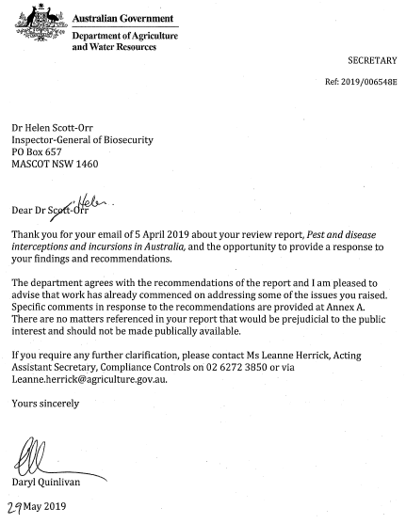

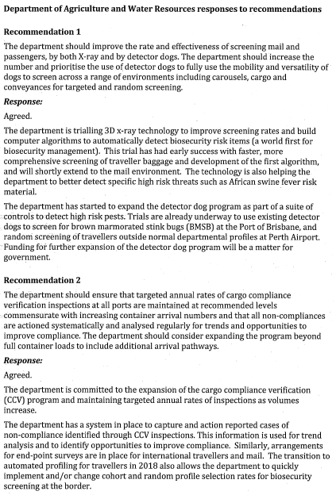

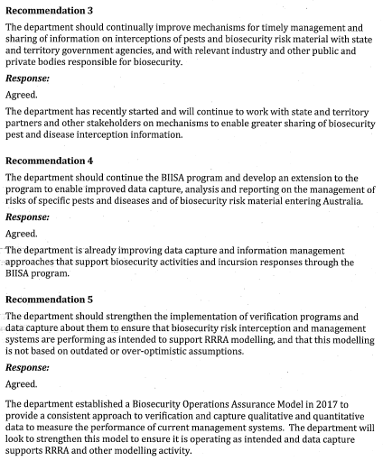

## References

ANAO 2005, [Managing for quarantine effectiveness–follow-up](https://www.anao.gov.au/work/performance-audit/managing-quarantine-effectiveness-follow), Australian National Audit Office, December 2005, accessed on 26 March 2019.

Buetre, B, Wicks, S, Kruger, H, Millist, N, Yainshet, A, Garner, G, Duncan, A, Abdalla, A, Trestrail, C, Hatt, M, Thompson, L-J & Symes, M 2013, [Potential socio-economic impacts of an outbreak of foot‐and‐mouth disease in Australia](http://www.agriculture.gov.au/abares/Documents/RR13.11PotSocEcoImpctOfFMD_v1.0.0.pdf), Australian Bureau of Agricultural and Resource Economics and Sciences, Canberra.

Caley, P, Ingram, R & De Barro, P 2015, [Entry of exotic insects into Australia: Does border interception count match incursion risk?](https://doi.org/10.1007/s10530-014-0777-z) *Biological Invasions*, vol. 17, no. 4, 1087–94, doi.org/10.1007/s10530-014-0777-z, accessed 5 April 2019.

DAFF 2013, *Redevelopment of the Import Clearance Effectiveness (ICE) function*, Notice to industry 02-2013, January, Department of Agriculture, Fisheries and Forestry, Canberra.

Day, C, & White, B 2016, [Khapra beetle, *Trogoderma granarium* interceptions and eradications in Australia and around the world](https://ageconsearch.umn.edu/record/246086/files/SARE%20WP1609_Day%20and%20White.pdf), Working paper 1609, School of Agriculture and Resource Economics, University of Western Australia, doi: 10.13140/RG.2.2.23786.31682, accessed 12 January 2018.

Department of Agriculture and Water Resources 2017, *Information and data management agenda*, Canberra, August.

——2018a, [Annual report 2017–18](http://www.agriculture.gov.au/about/reporting/annualreport/2017-18), Canberra, October.

——2018b, [*MarinePestPlan 2018–2023*: the National Strategic Plan for Marine Pest Biosecurity](http://www.marinepests.gov.au/what-we-do/publications/marine-pest-plan), Canberra, May.

Hafi, A & Addai, D 2014, *NFD economic consequences for species representing different pest groups affecting portfolio industries*,Australian Bureau of Agricultural and Resource Economics and Sciences,Canberra*.*

Hafi, A, Addai, D, Zhang, K & Gray, EM 2015, [The value of Australia’s biosecurity system at the farm gate: an analysis of avoided trade and on-farm impacts](https://data.gov.au/dataset/ds-dga-7defd203-548c-4912-a782-0913b1042b89/details)*,* ABARES research report 15.2, Department of Agriculture, Canberra, June.

Hernández-Jover, M, Schembri, N, Holyoake, PK, Toribio, JL & Martin, PA 2016, [A comparative assessment of the risks of introduction and spread of foot-and-mouth disease among different pig sectors in Australia](https://www.ncbi.nlm.nih.gov/pmc/articles/PMC5031773/), Frontiers in Veterinary Science, vol. 3, no. 85, doi: 10.3389/fvets.2016.00085, accessed 12 June 2018.

Interim Inspector-General of Biosecurity 2016, [*Management of biosecurity risks associated with timber packaging and dunnage*](http://www.igb.gov.au/Pages/completed-audits-and-reviews.aspx), Canberra.

IGB 2017, [*Uncooked prawn imports: effectiveness of biosecurity controls*](http://www.igb.gov.au/Pages/uncooked-prawn-imports-effectiveness-biosecurity-controls.aspx), Inspector-General of Biosecurity, Canberra.

—— 2018, [*Hitchhiker pest and contaminant biosecurity risk management in Australia*](http://www.igb.gov.au/SiteCollectionDocuments/hitchhikers-contaminants-report.pdf), Inspector-General of Biosecurity, Canberra.

—— 2019, [*Environmental biosecurity risk management in Australia*](http://www.igb.gov.au/SiteCollectionDocuments/environmental-biosecurity-risk.pdf), Inspector-General of Biosecurity, Canberra.

National Archives of Australia 2015, [Digital Continuity 2020 Policy](http://www.naa.gov.au/information-management/digital-transition-and-digital-continuity/digital-continuity-2020/index.aspx), Canberra, October.

Nairn, ME, Allen, PG, Inglis, AR & Tanner, C 1996, [Australian Quarantine: a shared responsibility](http://www.agriculture.gov.au/SiteCollectionDocuments/aqis/about/corporate-docs/nairn/nairn_report.pdf), Department of Primary Industries and Energy, Canberra.

Spickler, A 2015, [African swine fever](http://www.cfsph.iastate.edu/DiseaseInfo/factsheets.php), the Center for Food Security and Public Health, accessed 31 January 2019.

## Glossary

| Term | Definition |
| --- | --- |
| AHC | Animal Health Committee of the National Biosecurity Committee develops science-based and nationally consistent policy on animal health issues and advises NBC on animal health. Committee members include chief veterinary officers of Australian, state and territory governments, representatives from AAHL (CSIRO), Department of Agriculture and Water Resources and Department of the Environment and Energy, and observers from Animal Health Australia, Wildlife Health Australia and the New Zealand Ministry for Primary Industries. |
| Agriculture Import Management System (AIMS) | A Department of Agriculture and Water Resources system to record and track workflow biosecurity entries lodged to treat cargo imported into Australia under biosecurity conditions. |
| AqCCEAD | Consultative Committee for Emergency Aquatic Animal Diseases |
| AQUAVETPLAN | Australian Aquatic Veterinary Emergency Plan is a series of manuals outlining Australia’s approach to national disease preparedness. It details technical response and control strategies to be activated in a national aquatic animal disease emergency. |
| AUSVETPLAN | Australian Veterinary Emergency Plan is a series of technical response plans that describe the proposed Australian approach to an emergency animal disease incident. The documents provide guidance based on sound analysis, linking policy, strategies, implementation, coordination and emergency-management plans. |
| BICON | Biosecurity Import Conditions system, managed by the Department of Agriculture and Water Resources. |
| biosecurity | Management of risks to the economy, environment and community posed by pests and diseases entering, emerging, establishing or spreading. |
| Biosecurity Act | The *Biosecurity Act 2015* (Cth). Commenced 16 June 2016 and replaced the *Quarantine Act 1908* (Cth) |
| Biosecurity continuum | Series of locations where biosecurity risks may arise and where biosecurity activities take place pre-border, at the border and within Australia. |
| Biosecurity Integrated information Systems and analytics (BIISA) | A two part program the department is implementing to improve the management of risks through better processes, data sharing and analytics. |
| Break-bulk cargo | Goods that are loaded individually and not in containers or bulk; for example, cars and machinery. |
| CCEAD | Consultative Committee for Emergency Animal Diseases |
| CCEPP | Consultative Committee for Emergency Plant Pests |
| CCIMPE | Consultative Committee on Introduced Marine Pest Emergencies |
| CCV | Cargo compliance verification—a Department of Agriculture and Water Resources statistical based end-point survey conducted on the containerised (full container load [FCL] and full container load consolidated [FCX]) sea cargo pathway to evaluate the effectiveness of its operational biosecurity controls. These controls include community protection profiles, document assessment and broker arrangements. |
| Compliance | Status whereby all aspects of product, facilities, people, programs, and systems meet regulatory requirements and, where applicable, importing country official requirements. |
| Department | Australian Government Department of Agriculture and Water Resources. Former portfolio names:   * 1987 to 1998—Department of Primary Industries and Energy * 1998 to 2013—Department of Agriculture, Fisheries and Forestry * 2013 to 2015—Department of Agriculture |
| Director of Biosecurity | Secretary of the Australian Government Department of Agriculture and Water Resources, responsible for managing biosecurity risks and ensuring Australia’s international rights and obligations are met. |
| Emergency response deeds | Pre-agreed cost sharing and response framework for dealing with an incursion of an emergency animal or plant pest or disease. |
| End-point survey | Used by the department on a sample of travellers and mail to detect any biosecurity risk material missed by biosecurity clearance processes. |
| Freight of all kind (FAK) | A shipping industry term for a carrier's tariff classification for various kinds of goods that are pooled and shipped together at one freight rate. Consolidated shipments are generally classified as FAK. |
| Full container load (FCL) | Sea cargo container with contents from a single supplier and consigned to one entity in Australia. For biosecurity purposes this is the same as FCX. |
| FCL/X | Term used to indicate that a requirement covers both FCL and FCX containers. |
| Full container multiple house bills (FCX) | Sea cargo container with contents from multiple suppliers but consigned to one entity in Australia. For biosecurity purposes this is the same as full container load. |
| Incidents client database | Department of Agriculture and Water Resources database used by import clearance staff and operational scientists to record identified biosecurity pests in the cargo pathway. |
| Integrated cargo system (ICS) | A Department of Home Affairs owned software system. All sea cargo, import and export is reported into the ICS. |
| IPPC | The International Plant Protection Convention is an international plant health agreement that aims to secure coordinated, effective action to prevent and to control the introduction and spread of pests of plants and plant products. |
| Mail and passenger system (MAPS) | Department of Agriculture and Water Resources electronic data collection tool and reporting purposes within the Airports, International Mail, Seaports and Detector Dogs Programs. |
| OIE | World Organisation for Animal Health (also known as Office International des Epizooties) |
| PHC | Plant Health Committee |
| SCAHLS | Sub-committee on Animal Health Laboratory Standards (active 1990 to 2014) |
| Screening | The department uses X-rays, detector dogs and manual inspection to screen international passengers and mail for biosecurity risk material. |