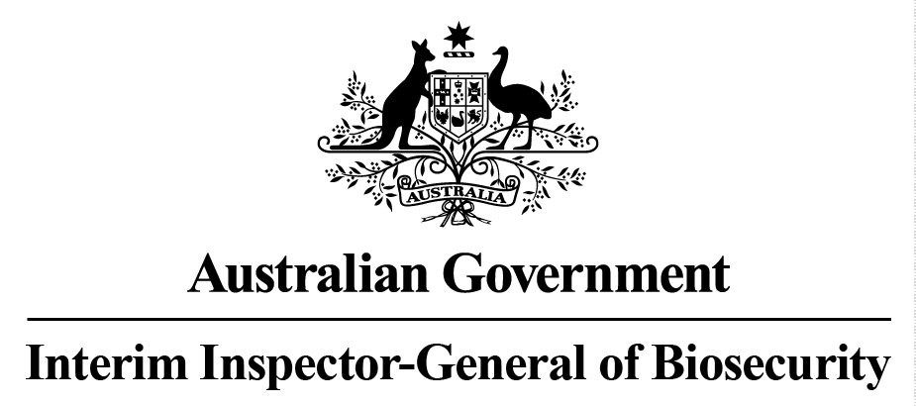

Effectiveness of biosecurity controls
for importation of natural sausage casings
Audit report
No. 2015–16/01

© Commonwealth of Australia 2015
Ownership of intellectual property rights
Unless otherwise noted, copyright (and any other intellectual property rights, if any) in this publication is owned by the Commonwealth of Australia (referred to as the Commonwealth).
Creative Commons licence
All material in this publication is licensed under a Creative Commons Attribution 3.0 Australia Licence, save for content supplied by third parties, logos and the Commonwealth Coat of Arms.

Creative Commons Attribution 3.0 Australia Licence is a standard form licence agreement that allows you to copy, distribute, transmit and adapt this publication provided you attribute the work. A summary of the licence terms is available from creativecommons.org/licenses/by/3.0/au/deed.en. The full licence terms are available from creativecommons.org/licenses/by/3.0/au/legalcode.
Cataloguing data
Interim Inspector-General of Biosecurity 2015, Effectiveness of biosecurity controls for importation of natural sausage casings, Department of Agriculture and Water Resources, Canberra.

Internet
Effectiveness of biosecurity controls for importation of natural sausage casings is available at igb.gov.au/Pages/completed-audits-and-reviews.aspx.

Interim Inspector-General of Biosecurity
Department of Agriculture and Water Resources
Postal address GPO Box 858 Canberra ACT 2601
Switchboard +61 2 6272 3933
Email inspgenbiosecurity@agriculture.gov.au
Web igb.gov.au/Pages/default.aspx
Inquiries about the licence and any use of this document should be sent to copyright@agriculture.gov.au.
The Australian Government, represented by the Interim Inspector-General of Biosecurity, has exercised due care and skill in preparing and compiling the information and data in this publication. Notwithstanding, the Interim Inspector-General of Biosecurity, Australian Government employees and advisers disclaim all liability, including for negligence and any loss, damage, injury, expense or cost incurred by any person as a result of accessing, using or relying on information or data in this publication to the maximum extent permitted by law.
Contents
Summary 1
Key findings 3
Conclusion 7
Recommendations 8
1 Background 10
2 Pre-border controls 16
3 Border controls 22
4 Sausage casing production 28
5 Observations and findings 34
Appendix A: Agency response 44
Glossary 47
References 49

Summary

Background
- The Australian Government’s biosecurity system aims to minimise the risk of entry and establishment of exotic diseases, pests and weeds that could cause significant harm to the Australian economy and the environment.
- The Australian Department of Agriculture and Water Resources has primary responsibility for managing Australia’s biosecurity regime across the whole continuum (pre-border, border and post-border). The Australian Government has regulatory responsibility for pre-border and border activities, while state and territory governments are primarily responsible for post-border activities such as surveillance and responses to any incursions.
- In recent years, the department has placed increasing emphasis on pre-border (offshore) measures to address biosecurity risks (IIGB 2015a, 2015b, 2014, 2012). Consistent with international agreements, offshore biosecurity risk mitigation aims to ensure that all incoming consignments meet Australian import requirements. This is achieved through assessing documents accompanying imported consignments to ensure that appropriate treatments have been carried out or that the goods are free from contamination, pests and diseases. Biosecurity officers use the department’s risk assessment of an imported commodity to determine whether incoming consignments meet Australia’s appropriate level of protection (ALOP) and whether incoming consignments will require inspection before release. The department also conducts random physical inspections of representative samples from incoming consignments to confirm that the imported material meets Australia’s import requirements.
- As part of his annual work plan, the Interim Inspector-General of Biosecurity (IIGB) examined the effectiveness of the department’s biosecurity controls for importation of natural sausage casings into Australia.
- Sausage casings may be of natural or artificial origin. Natural casings are derived from the fibrous, connective tissue layer of the intestinal tract of bovine (cattle), caprine (goats), ovine (sheep) and porcine (pigs) animals. Most parts of the digestive tract may be used as casings for sausages (AQIS 1999).
- Although imported natural sausage casings are unlikely to contain exotic disease agents that are inactivated by a high salt environment (AQIS 1999), an import permit is required and imports must comply with conditions listed on the permit. Between 2012 and 2014, 26 import permits were active for bovine, caprine, ovine and porcine casings. During this period, Australia imported more than 16 million units of sausage casings.
- The department implements measures to minimise biosecurity risks under the Quarantine Act 1908 and subordinate legislation, including the Quarantine Proclamation 1998. The Quarantine Act governs importation of natural sausage casings into Australia. In addition, food (including sausage casings) entering Australia is subject to the Imported Food Control Act 1992, the Imported Food Control Regulations 1993 and the Australia New Zealand Food Standards Code.
- The department assesses biosecurity risks before an import is permitted. Consideration of the level of biosecurity risk is based on the department’s import risk analysis or an assessment of individual products from a specific country. An import risk analysis or assessment considers specific biosecurity risks and identifies appropriate risk management measures that must be applied to meet Australia’s ALOP.
- The import risk analysis for sausage casings (AQIS 1999) identified specific animal diseases (or strains of diseases) of biosecurity concern that could be introduced into Australia via this commodity. These include:
- African swine fever
- classical swine fever
- foot-and-mouth disease
- peste des petits ruminants
- swine vesicular disease
- Teschen disease
- transmissible spongiform encephalopathies, such as bovine spongiform encephalopathy.
- The department manages biosecurity risks associated with entry of imported sausage casings through:
- ongoing surveillance of global risks
- science-based import risk analysis to underpin import policy
- approval and auditing of exporting countries, including competent authorities
- pre-border and border controls for importation
- collaborative networks
- intelligence gathering
- bilateral relationships
- consideration of the history of this trade.

Purpose
- The purpose of this audit is to inform the Australian Government Minister for Agriculture and Water Resources about the effectiveness of the department’s biosecurity controls in managing risks associated with the importation of natural sausage casings into Australia.

Key findings

Biosecurity controls
- The department strives to ensure that biosecurity risks associated with sausage casing imports are addressed offshore and meet Australia’s ALOP (before consignments are released in Australia from quarantine control) through:
- limiting importation to sausage casings derived from approved animal species
- importing only from approved countries; all parts of the production process from sourcing and processing of runners (intestinal tract used to make casings) to packaging and export of casings must take place in approved countries
- requiring government registration of processing establishments in approved countries
- requiring government certification stating that consignments meet Australia’s import requirements before products are exported.
- These combined measures reduce the possibility of exotic pathogens entering Australia. The department has oversight at the border when the casings consignments arrive onshore. Biosecurity officers assess accompanying documents to ensure that all incoming consignments meet Australian import requirements.
- Based on evidence obtained from fieldwork in one of the department’s regional offices and consultation with industry, the IIGB is satisfied that in general the department is effectively applying biosecurity controls to reduce the risks and that these controls are consistent with Australia’s appropriate level of protection for this commodity.
- In the exporting country, fresh runners undergo multistage processing, beginning with cleaning and stripping of the muscularis and serosal layers. The casings can then be preserved (usually dry-salted or soaked in brine) for storage and transport.

Assessment of exporting countries
- The department exercises control over natural sausage casings by permitting imports from approved countries. Biosecurity risk management measures for natural sausage casings imported from an approved country are supported by:
- the department’s import risk analysis for sausage casings (AQIS 1999)
- post-import risk analysis policy determinations for assessing import permit applications
- assessing the exporting country’s freedom from specific animal diseases status, as reported by the World Organisation for Animal Health (OIE), and Australia’s assessment of the exporting country’s freedom from foot-and-mouth disease and bovine spongiform encephalopathy
- the exporting country’s history of trade, international collaboration, networks, intelligence and bilateral relationships.
- Countries permitted to export natural sausage casings to Australia are Austria, Canada, Chile, Denmark, France, Germany, Ireland, the Netherlands, New Zealand, Poland and the United States.

Import risk analysis
- In 1999 the department published an import risk analysis for importation of natural sausage casings (AQIS 1999). It identified relevant animal disease and pest risks and management options, and was used to develop conditions for importing bovine, caprine, ovine and porcine sausage casings. Since 1999, the department has also been applying several revised policies, approved by the Director of Quarantine, to assess import applications for casings derived from approved species imported from selected countries. From time to time, the department has issued notices to industry to inform importers about changes in import requirements. This has included banning imports from countries where there was an outbreak of a significant animal disease, and also allowing imports from new source countries.
- In 2011 the OIE declared that the world was free of rinderpest. As a result, in December 2013 the department removed certification of country freedom from rinderpest from the import requirements.
- The IIGB accepts that the department must consider all potential biosecurity risks associated with the importation of sausage casings. It is outside the scope of this audit to review the import risk analysis (IRA) and policies in relation to importation of natural sausage casings. Nevertheless, the IIGB suggests an update of the IRA should consider:
- removing rinderpest from the OIE List A diseases
- updating the approved countries list to reflect current arrangements from those in place in 1999
- incorporating internal policy advices from the Animal Biosecurity Branch (mainly regarding biosecurity risks associated with imported sausage casings)
- any published peer-reviewed scientific literature about the biosecurity risks of pathogens in natural sausage casings.

Dependence on competent authorities
- The department relies on the integrity and effectiveness of controls exercised by the respective competent authorities in exporting countries. These controls help ensure that consignments of natural sausage casings are fully compliant with Australian import requirements. The competent authorities endorse animal health export certification stating that Australia’s import requirements have been met.
- In 2013 the department conducted a formal in-country systems evaluation of Chile’s competent authority to assess the FMD-free status of that country, as it borders other countries not free from FMD. At the time of evaluation, Chile was an exporter of casings to Australia, and the regulation of casings as a traded commodity was used as a specific example, to assess the competency of its veterinary authority. The department has not conducted in-country evaluations in other source countries.

Clearance procedure
- Consignments of imported sausage casings are profiled for clearance under quarantine and the Imported Food Inspection Scheme (IFIS) and inspected by department officers. Clearance by the department relies on assurances that biosecurity and food safety requirements have been met. These assurances are provided by the importers and competent authorities in exporting countries, and include a veterinary certificate endorsed by an approved or government veterinarian in the exporting country.
- Before a consignment arrives at an Australian port, department officers assess copies of mandatory documents required for that consignment. If a consignment meets documentary requirements, the department issues a movement direction that the importer uses to take delivery from customs bond. The department clears most consignments without a physical verification inspection. However, biosecurity officers randomly inspect a small proportion (up to 5 per cent) of consignments to confirm labelling, packaging and/or non-commodity requirements. For all random inspections, the importer (or broker) is notified in writing.

Import requirements
- An import permit is required to import natural sausage casings into Australia. In determining import requirements, animal disease and pest risks are thoroughly considered. The department publishes import requirements for sausage casings on its Import Conditions Database (ICON). These stipulate the requirements that must be met before an import permit is granted. The department mandates veterinary certification, endorsed by an approved or government veterinarian in the exporting country. For import clearance, a department officer verifies the accuracy of the veterinary certification.
- The department expects that the regulatory systems and processes of an exporting country should help ensure that sausage casings that require veterinary certification and are exported to Australia comply with Australian import requirements. The purpose of document verification on arrival is to confirm that consignments comply with Australia’s import requirements.

Non-compliant consignments
- Imported sausage casing consignments are released if accompanying documents meet Australian import requirements. Department records show that between 2011 and 2014, 62 of 67 (93 per cent) of consignments identified as non-compliant did not conform to Australian requirements for accompanying documentation or veterinary certification. The remaining 7 per cent of non-compliant consignments failed biosecurity inspections.

Post-importation treatment of sausage casings from unapproved countries
- Sausage casings can be imported from approved countries that are assessed as FMD-free. The department requires governments of these source countries to certify country disease status (freedom) pre-export. Casings imported from approved countries do not require post-entry treatment.
- It is possible to import casings from unapproved countries that have low or undetermined animal health status. However, the department mandates post-entry treatment of such imported sausage casings with 80 parts per million chlorine solution for two hours at an approved quarantine approved premises (QAP). The IIGB understands that no importers have chosen to import casings from unapproved countries because the chlorination treatment affects the taste and quality of the sausage casings.

Discard of wastewater following treatment of sausage casings
- To meet the requirements of Australian retail butchers and sausage makers, most Australian importers further process imported casings. This involves bulk consignments of casings being washed, graded, checked for quality (for example, diameter and perforations), extruded on plastic sleeves, resalted and repackaged in smaller packages. Almost every step in the processing of casings for repackaging necessitates the use of large quantities of water. The wastewater generated at these processing plants is usually discarded without treatment. The IIGB noted that the import risk analysis for importation of sausage casings does not consider this practice poses a significant risk (AQIS 1999):
The possibility of environmental contamination with waste from processing plants cannot be completely discounted. However, given the dilution factors operating in disposal of wastewater and the controls on disposal of solid industrial waste, it would be unlikely for infection to be spread to susceptible Australian species via this pathway.

Conclusion
- The Australian sausage casings industry is a relatively small primary industry, where local butchers and sausage makers are supplied by a few importers and local processors. Imports total around $20 million annually, with a total annual value after processing of around $200 million.
- Exotic animal diseases that could be introduced through imported sausage casings include bovine spongiform encephalopathy, foot-and-mouth disease (FMD), peste des petits ruminants, swine vesicular disease, classical swine fever, African swine fever and Teschen disease. Risks are mitigated through:
- multistage processing that leaves casings cleaned of the muscularis and serosal layers of intestinal tissue
- the high salt environment during post-processing, storage and transport
- processing under hygienic, controlled conditions to meet relevant animal and human health regulatory requirements
- certification by an exporting country’s competent authority that addresses Australia’s import conditions
- document verification by Australian biosecurity officers before the consignment is released
- cooking or further processing before consumption by humans
- the ban on swill feeding in all Australian states and territories.
- The 2001 FMD outbreak in the United Kingdom was linked to swill feeding. Five million sheep, cattle, pigs and goats had to be destroyed, devastating whole industries. Feeding swill to pigs is now illegal in all states and territories in Australia.
- Importation of natural sausage casings into Australia has a long history, with no identified disease incursions or reported incidents. The major disease of concern, FMD, is highly contagious. As a result, the department only permits importation of sausage casings from FMD-free countries (without vaccination). The department identifies new and emerging risks in exporting countries through effective surveillance and intelligence gathering, and implements corresponding controls, including banning imports from countries if their risk status changes. However, the department has undertaken limited assurance activities in exporting countries to ensure that processing establishments and relevant biosecurity measures comply with Australian import requirements.
s35. Overall, the IIGB considers that the department effectively manages biosecurity risks associated with importation of natural sausage casings and generally applies appropriate controls. Recommendations made in this report aim to further improve existing controls.

Recommendations
The full department response to the recommendations is at Appendix A.
Recommendation 1
paragraph 5.10 | The department should update the import risk analysis for natural sausage casings, incorporating relevant internal policies and/or guidelines used by policy and operational areas for imports into Australia. An update might consider any relevant scientific literature on the persistence of pathogenic agents in sausage casings published since 1999.  Department’s response: Agree, but not at this time
Recommendation 2
paragraph 5.17 | The department should consider conducting periodic in-country evaluations of approved countries’ competent authorities to ensure they meet Australia’s biosecurity requirements for the production and export of natural sausage casings.  Department’s response: Agree, as part of the existing work program
Recommendation 3
paragraph 5.48 | The department should routinely record the import permit number and inspection outcomes for all natural casing consignments imported into Australia. These data should be available to relevant areas in the department, to assess whether policies and regulations are effectively addressing the biosecurity risks.  Department’s response: Agree

Recommendation 4
paragraph 5.51 | The department should update the ICON database to improve clarity and accessibility of import requirements for importing natural sausage casings into Australia.  Department’s response: Agree
Dr Michael Bond
Interim Inspector-General of Biosecurity
19 October 2015
Acknowledgements
The IIGB would like to thank the industry organisations, companies and individuals and Australian Government Department of Agriculture and Water Resources staff for their cooperation and constructive advice in relation to this audit.
- Background

Biosecurity risks: pre-border
  - Several major overseas outbreaks of foot-and-mouth disease (FMD) in pigs have been attributed to feeding pigs food scraps that include contaminated meat products. Although swill feeding is now banned in Australia, it is possible that owners of small peri-urban holdings might occasionally feed food scraps to their pigs. Pigs can be infected orally and then excrete large quantities of virus in exhaled air (Geering et al. 1995) (AQIS 1999), providing opportunities for the disease to rapidly spread from one animal to another. In addition, swill feeding also poses a risk of transmitting a number of other diseases in farm animals such as classical swine fever, African swine fever, swine vesicular disease, pseudorabies or Aujeszky’s disease, brucellosis, tuberculosis and transmissible gastroenteritis.
  - To pose a risk of disease transmission through meat and meat products, the pathogen must be present in edible tissue, susceptible species must be carnivorous or omnivorous, and oral infection must be possible (MacDiarmid & Thompson 1997). Infective agents (or pathogens of several of diseases of concern) could be present in imported sausage casings, but it is unlikely that susceptible species will consume sufficient quantities to become infected. This risk is further reduced because requirements recommended for reducing exposure to diseases identified in the import risk analysis (AQIS 1999) are applied whenever an import permit is issued for sausage casings.
  - MacDiarmid and Thompson (1997, 2004) list conditions that make a meat product a potential vehicle for the introduction of animal disease:
- the disease must be present in the country of origin
- the disease must be present in the particular animal slaughtered (or animal tissues must have become contaminated during the butchering process)
- the diseased tissues must pass inspection procedures at abattoirs
- the pathogen in the tissues must survive storage and processing and be present at an infectious dose
- the pathogen must be present in the animal tissues (commodities) traded
- the pathogen must be able to establish infection by the oral route
- scraps of the meat product must find their way into a susceptible animal of the appropriate species in the importing country.
  - The likelihood of each of these conditions being met will be different for each pathogen and country of origin (MAF Biosecurity New Zealand 2010).

International standards
  - Risk management measures for importation of natural sausage casings incorporate guidelines in the World Organisation for Animal Health (OIE) Terrestrial Animal Health Code (chapter 6.2). The measures provide a framework which is consistent with the requirements of the World Trade Organisation’s Agreement on the Application of Sanitary and Phytosanitary Measures (the SPS agreement) and the Quarantine Act 1908.

Relevant legislation
  - Importation of natural sausage casings is governed by the Quarantine Act 1908 and relevant legislative instruments/regulations. The Act provides for the Governor-General to prohibit, through the Quarantine Proclamation 1998, importation of goods into Australia that are likely to introduce diseases and/or pests.
  - The following sections of the Quarantine Proclamation 1998 relate to importation of natural sausage casings into Australia:
- Part 6, Animal quarantine
- section 39 - Importation of meat and meat products prohibits (with exceptions) the importation into Australia of a meat or meat product unless the Director of Quarantine has granted a permit to import the meat or meat product into Australia.
- section 38 - Dead animals or animal parts the importation of which is prohibited other than subject to conditions prohibits (with exceptions) the importation into Australia of a dead animal or animal part unless the Director of Quarantine has granted a permit to import the animal or part into Australia. Subsection 2 and table 13 list the exceptions.
  - The Quarantine Act enables the Commonwealth to take biosecurity measures to deal with diseases and pests in Australia. The Act provides:
- the legal basis for preventing or controlling the entry of animals and animal-derived products into Australia
- the legal basis for managing the quarantine risk arising from animal-derived commodities after arrival in Australia
- powers for the Director of Quarantine and quarantine (biosecurity) officers to deal with biosecurity matters
- powers and responsibilities of biosecurity officers
- offences and maximum penalties for any contravention of the Act.
  - In addition, food entering Australia is subject to the Imported Food Control Act 1992 and the Imported Food Control Regulations 1993. Under this legislation, imported food is inspected and controlled under the Imported Food Inspection Scheme, a risk-based border inspection program administered by the Department of Agriculture and Water Resources. Under the scheme, Food Standards Australia New Zealand (FSANZ) provides risk assessment advice to the Department of Agriculture and Water Resources on the level of public health risk associated with certain foods. The department is responsible for inspecting and sampling imported foods to ensure they comply with the FSANZ Food Standards Code.

Appropriate level of protection
  - An import risk analysis identifies, assesses and classifies biosecurity risks associated with the commodity proposed for import. The analysis is conducted within a consultative framework and recommends risk management measures for meeting Australia’s appropriate level of protection (ALOP) for the proposed import, as outlined in the Import risk analysis handbook 2011 (DAFF 2011a). ALOP is integral to the SPS agreement and each member country of the World Trade Organization is entitled to set its ALOP as it sees fit, taking into account the full range of national interest considerations (Beale et al. 2008). A country is then required to act consistently for different commodities and various import circumstances for each commodity, and to adopt risk mitigation measures that are the least trade restrictive.
  - Australia’s ALOP is expressed qualitatively as providing a high level of sanitary and phytosanitary protection, aimed at reducing risk to a very low level but not to zero. Under this approach, commodities may not be imported unless quarantine and biosecurity risks can be reduced to a level consistent with Australia’s ALOP. The Australian Government uses risk analyses to consider the level of quarantine and biosecurity risk associated with importation or proposed importation of animal-derived material, including sausage casings. The process used is consistent with Australia’s obligations under the SPS agreement. It takes into account relevant animal health standards in the OIE’s international standards on risk assessment.

Australian industry
  - The value of annual imports of sausage casings into Australia is around $20 million. The Australian sausage casings industry is relatively small and employs approximately 200 people.

Import volumes
  - Between 2010 and 2014, porcine and ovine casings constituted the bulk of imported natural sausage casings that were identified in AIMS (Table 1). However, the largest volume (11 368 643 numbers) of casings is classified as ‘unknown’ as they were not identified by the importers.
Table 1 Casings derived from approved animal species, by import volume, 2010 to 2014
Commodity | Unit | 2010 | 2011 | 2012 | 2013 | 2014 | Total
Bovine (cattle) | no | na | na | na | 14 328 | na | 14 328
Bovine (cattle) | unit | 4 | 2 | 6 | 2 | 8 | 24
Ovine (sheep) | no | 846 956 | 678 068 | 733 974 | 774 621 | 2 252 318 | 5 508 293
Ovine (sheep) | unit | na | 3 | 4 | 2 | 1 | 13
Bovine, ovine* | no | na | 15 612 | 29 400 | 17 710 | 17 865 | 80 587
Porcine (pig) | kg | na | na | 29 | 13 | 19 | 61
Porcine (pig) | no | 1 414 667 | 1 377 632 | 1 849 902 | 1 743 279 | 1 426 214 | 7 871 583
Porcine (pig) | unit | 6 | 14 | 4 | 10 | 17 | 53
Porcine, ovine* | no | 59 680 | 9 570 | 127 832 | 101 940 | 334 736 | 665 258
Porcine, ovine* | unit | na | 2 | na | na | 2 | 4
Unknown | kg | 971 | 390 | 423 | 1 058 | 1 468 | 4 383
Unknown | lb | 110 | 51 | 59 | 3 | 48 | 287
Unknown | no | 1 624 961 | 1 682 406 | 936 697 | 1 628 087 | 4 646 718 | 11 368 643
Unknown | unit | 8 | 10 | na | 4 | 5 | 28
Note: * casings from individual species were packaged in separate containers. kg Kilogram. lb Pound. na Not available.
no Number.
Source: Department of Agriculture and Water Resources, Canberra

Australian entry ports
  - The South East (Melbourne) and Central East (Sydney) regions are the major ports of entry for natural sausage casing in Australia. By contrast, very small quantities are received in the North East (Brisbane) and South West (Adelaide and Perth) regions.

Import risk analysis
  - An import risk analysis identifies, assesses and classifies potential biosecurity risks associated with trade in a particular commodity. An import risk analysis is conducted within a consultative framework and recommends risk management measures to be applied in meeting Australia’s appropriate level of protection for trade, as outlined in the Import risk analysis handbook 2011 (DAFF 2011a).
  - The department’s 1999 import risk analysis considered diseases exotic to Australia that could possibly persist in the intestines of bovine (cattle), ovine (sheep), caprine (goats) and porcine (pigs) animals and be transmitted through meat and meat products derived from these animals.
  - The department published an import risk analysis for importation of natural sausage casings in 1999 (AQIS 1999). It identified animal diseases and pest risks and management options, and was used to develop conditions for importing natural sausage casings.

Biosecurity policies
  - Foot-and-mouth disease (FMD) is the greatest disease threat to Australia’s livestock industries. The department’s biosecurity import policies incorporate risk management measures for FMD, including the requirement that commodities are sourced from countries recognised by the department as FMD free. Guidelines on the management of the biosecurity risks of foot-and-mouth disease virus in imported commodities (Department of Agriculture 2014a) includes a risk mitigation policy for imported sausage casings.
  - The department is developing Guidelines on the importation of sausage casings for human consumption. These guidelines will provide the department’s import assessment officers with
- updated import conditions for sausage casings for human consumption; and
- an ‘approved country list’ for use in the assessment of import permit applications for natural sausage casings against the updated import conditions.
  - In 2012 the department reviewed the scientific literature on scrapie prion protein in intestinal tissues of sheep and goats under 12 months of age. This review evaluated the existing age restriction for animals from which casings are derived.

Audit objective, scope and methodology
  - The audit aimed to examine the effectiveness of pre-border and border controls that the department uses for managing biosecurity risks for imported natural animal-based sausage casings. As part of the audit, the IIGB:
- assessed the adequacy of import conditions and permits in managing biosecurity risks
- assessed the adequacy of documentation and declarations accompanying imports in addressing associated biosecurity risks
- assessed the verification systems that the department has in place to ensure compliance with applicable import conditions/requirements
- assessed the department’s procedures at the border for processing documents accompanying imported natural sausage casings
- identified possible improvements to Australia’s import requirements, procedures, operations or documentation for natural sausage casings to further mitigate biosecurity risks.
  - The audit did not include:
- assessment of exporting countries (including competent authorities)
- verification of practices and procedures in overseas casings processing establishments that produce natural sausage casings for export to Australia
- review of biosecurity import risk analysis and policies for importing natural sausage casings
- importation of animal meat other than sausage casings
- importation of collagen and/or artificial/synthetic sausage casings
- international trade aspects (for example, allocation of tariffs)
- commercial considerations.

Audit methodology
  - The IIGB undertook audit fieldwork in two regions:
- Sydney (Central East)
- Wangaratta (South East).
  - During fieldwork, the IIGB met with:
- Department staff
The IIGB assessed border clearance and verification systems that the department has in place to ensure compliance with relevant import requirements for importing natural sausage casings. Discussions with department staff covered:
- import requirements and clearance procedures
- certifications and declarations
- inspection requirements and procedures
- information systems used in decision-making and recording data/information, such as the Department of Agriculture Import Management System (AIMS), Import Conditions Database (ICON) and the Integrated Cargo System (ICS).
- work instructions and standard operating procedures relevant to clearance procedures
- record check.
- Importers
The IIGB discussed importers’ expectations of and interactions with the department, including aspects of service delivery.

The audit team
Auditors Naveen Bhatia and Greg Healy assisted the IIGB in this audit.

- Pre-border controls

Biosecurity risk management
  - Factory processing of runners (intestinal tract used to make casings) reduces but does not completely eliminate biosecurity risks associated with the animal species from which the casings are derived. Imported natural casings therefore pose a biosecurity risk that requires additional management. Sausage casings are used for making sausages for human consumption, providing an indirect potential pathway for exotic animal diseases to enter and establish in Australia.
  - The department undertakes risk assessment and management measures to minimise the entry of pests and diseases into Australia through imported natural sausage casings. These risk assessment and management measures are discussed in paragraphs 2.3 to 2.22.

Veterinary services assessment
  - Before approving a source country for export of natural sausage casings to Australia, the department assesses the capacity of the country’s veterinary services to:
- detect and report a change in the country health status
- monitor processing standards and implement corrective actions as required
- provide reliable export certification.
  - When evaluating a country for approval, the department uses one or more of the following assessment methods:
- reviews animal health status of an exporting country—assessed using the OIE World Animal Health Information Database
- gathers intelligence through sources such as the International Biosecurity Intelligence System (IBIS) and Promed
- does desktop audit of assessments of that country conducted by competent authorities in other countries
- conducts an in-country audit to verify desktop audit findings and clarify any uncertainties and/or anomalies.

Import risk analysis
  - In 1999 the department published an import risk analysis for importation of sausage casings into Australia (AQIS 1999). It identified several animal diseases that posed significant risks and options for managing those risks. The import risk analysis was used to develop conditions for importing natural casings derived from approved species and source countries.
  - The exotic diseases of ruminants that could be transmitted through bovine and ovine natural casings include foot-and-mouth disease and peste des petits ruminants.
  - For porcine casings, the import risk analysis covered exotic diseases such as:
- African swine fever
- classical swine fever
- foot-and-mouth disease

- swine vesicular disease
- Teschen disease.
  - The department requires that:
- for bovine casings, the source country is free of bovine spongiform encephalopathy (BSE)
- for ovine and caprine casings, the source country is either scrapie free or the consignment does not contain casings derived from sheep or goats over 12 months of age.
  - In December 2013 the department removed the requirement for certification of freedom from rinderpest from the import requirements, following the OIE’s 2011 declaration that the disease had been eradicated.

Country assessment for food safety
  - Since BSE was identified as a major risk to human health in 1996, Australia has had comprehensive arrangements in place to protect consumers from contaminated food.
  - The Australia New Zealand Food Standards Code standard under the Food Standards Australia New Zealand Act 1991 applies to meat and meat products used in sausages. It covers requirements for food sold as sausages and meat pies and for labelling and sourcing of this food.
  - Clause 11 of Standard 2.2.1 Meat and meat products of the Australia New Zealand Food Standards Code specifies that only bovine meat and meat products derived from animals free from BSE can be sold in Australia. Sausage casings are imported for human consumption, so the department requires they meet Australian BSE food safety policy requirements. Under this policy, countries wishing to export beef to Australia must apply to the Australian BSE Food Safety Assessment Committee for a country BSE food safety assessment. This assessment is conducted by Food Standards Australia New Zealand and includes, when necessary, an in-country inspection. An in-country inspection examines the effectiveness of BSE preventative measures to ensure the safety of beef and beef products that are intended for export to Australia.
  - BSE food safety requirements for human consumption products are considered appropriate to address the biosecurity risk associated with imports of meat and sausage casings.

Approved animal species
  - The department permits the importation of natural sausage casings derived from cattle, sheep, goats and pigs. The import requirements for these species from approved countries are listed on the department’s ICON database.
  - Between 1999 and 2009, the department permitted importation of casings derived from deer. However, in 2009 this import was prohibited due to chronic wasting disease, which was not addressed in the 1999 import risk analysis.

Approved countries for export
  - Australia has import conditions for natural sausage casings imported from:
- Austria
- Canada
- Chile
- Denmark
- France
- Germany
- Ireland
- Netherlands
- New Zealand
- Poland
- United States.
  - Countries approved to export ovine casings to Australia are also approved to export caprine casings to Australia. The import risk analysis (AQIS 1999) does not differentiate between casings derived from the two species.

Import Conditions Database
  - The department’s Import Conditions Database (ICON) lists import conditions for natural sausage casings derived from approved animal species and from each country of export. These requirements are approved by the Director of Quarantine and are made available on ICON to importers and the public.

Import permit
  - An import permit is required for all natural sausage casings imported into Australia. The department issues an import permit for casings derived from an approved species and country. For importation of natural sausage casings from more than one approved country, a separate import permit application must be lodged for each country.
However, natural casings from multiple species that originated in approved countries (other than the country of export) can be imported under one import permit. In such a case, an import permit stipulates specific import conditions for each species that must be met at the time of import. An import permit is usually valid for two years, permitting unlimited importation of a specified product from an approved country.
  - The import permit provides a level of assurance based on the department’s risk assessment for animal pests and diseases (Figure 1). The permit is a directive to the importer that stipulates conditions that their consignment(s) must meet to allow entry into and release in Australia.
Figure 1 Department of Agriculture and Water Resources—process for assessing import permit applications for natural sausage casings
Note: Bovine Derived from cattle. BSE Bovine spongiform encephalopathy. Caprine Derived from goats. FMD Foot-and-mouth disease. FSANZ Food Standards Australia and New Zealand. OIE World Organisation for Animal Health. Ovine Derived from sheep. Porcine Derived from pigs.
Source: Interim Inspector-General of Biosecurity

Government certification
  - Each natural sausage casing consignment must be accompanied by a government certificate declaring:
- that the casings were derived from either bovine, ovine, caprine or porcine animals that were born, raised and slaughtered in an approved country
- that the country where the bovine and ovine natural casings originated is free of foot-and-mouth disease and peste des petits ruminants
- that the country where the porcine natural casings originated is free of foot-and-mouth disease, African swine fever, classical swine fever, swine vesicular disease and Teschen disease
- that the animals from which the casings are derived were subject to ante-mortem and post-mortem inspection at slaughter, and were free from contagious and infectious diseases that could be transmitted via casings
- slaughter dates of the animals from which the casings were derived
- identification/veterinary control number(s) of the establishment(s) in the country where the animals from which the casings were derived were slaughtered
- that all preparation, processing and storage of the casings were carried out in an approved country
- that the casings were processed and packed:
- so that each packing container contains casings derived from a single species of animal
- so that they were not exposed to contamination before export
- in clean, new or disinfected packing containers
- so that the identification/veterinary control number of the establishment where the casings were packed was readily visible on the outer wrapping or package.

Inspection
  - Consignments of natural sausage casings are not usually physically inspected by the department’s biosecurity officers on arrival. The department checks accompanying documents to verify that Australia’s import requirements have been met. Consignments can be randomly inspected to confirm that the product is not infested or contaminated with biosecurity risk material, pests or diseases.

Registration of overseas processing establishments
  - The competent authority in an approved exporting country must register all establishments that process casings for export to Australia. The certifying authority (usually the competent authority) must list the identification/veterinary control number on the export health certificate. The certifying authority is responsible for determining whether the establishment meets Australian import requirements.
  - The department does not undertake risk assessments of overseas processing establishments or receive details of registered processing plants from the approved countries.

Pre-export requirements in approved countries
  - An exporting country is required to manage its export processes in accordance with its own export standards and procedures, and in accordance with international certification obligations under OIE standards and guidelines. A country’s export systems and procedures must ensure that natural sausage casing consignments that require government (veterinary) certification before export to Australia comply with our import requirements.
  - In 2013 the department conducted a formal in-country evaluation of the competent authority responsible for regulating natural casings production and export in Chile. The department has not conducted in-country evaluations in other source countries.

Packaging
  - The department requires importers of sausage casings pack the product to ensure:
- each container only contains casings derived from a single species of animal
- casings are not exposed to contamination before export
- casings are in clean, new or disinfected packing containers
- the identification/veterinary control number of the establishment where the casings are packed is readily visible on the outer wrapping or package
(AQIS 1999).
- Border controls

Administrative controls
  - Importation of natural sausage casings is jointly managed by two divisions in the department:
- Biosecurity Animal Division
- Compliance Division.
  - The Animal Biosecurity Branch (Biosecurity Animal Division) assesses animal biosecurity risks and develops policies and guidelines for importing natural casings. The branch manages the risk of introducing exotic pests and diseases through the regulation of importation of natural sausage casings. Its activities and responsibilities include:
- undertaking animal disease risk assessment/analysis and developing policies
- providing technical advice on importing natural sausage casings to relevant biosecurity officers, importers and the general public to ensure consistent inspection and clearance, and compliance with biosecurity legislation
- assessing and approving source countries
- assessing the performance of competent authorities in exporting countries (ongoing)
- undertaking intelligence and surveillance of animal health status of exporting countries (ongoing)
- issuing notices to industry, when required
- participating in pre-border and border assessments, audits and appraisals designed to maintain the integrity of the biosecurity continuum (Figure 2).
  - The Animal and Biological Import Assessments Branch (Biosecurity Animal Division) facilitates importation of natural sausage casings by:
- assessing import permit applications, considering relevant risk advice and issuing import permits for casings; these activities help ensure that import conditions adequately address biosecurity risks
- developing and maintaining import conditions and protocols for natural sausage casings on the ICON database.
  - Officers of the Compliance and Assessment Management Services (managed by the Compliance Division), based in regional offices, assess the currency, validity and adequacy of documents accompanying imported casings against Australian import requirements, and issue AIMS directions to manage incoming consignments.
  - Roles, responsibilities and relationships between the department’s divisions and branches and the responsibilities of the regional offices are shown in Figure 3.
Figure 2 Department of Agriculture and Water Resources—control measures for natural sausage casings imported into Australia
Note: BSE Bovine spongiform encephalopathy. FMD Foot-and-mouth disease. OIE World Organisation for Animal Health.
Source: Interim Inspector-General of Biosecurity
Figure 3 Department of Agriculture and Water Resources—international, national and regional roles and responsibilities for importing natural sausage casings
Source: Interim Inspector-General of Biosecurity

Import requirements
  - The department’s ICON database sets out import requirements for natural sausage casings from approved countries of export.
  - A permit is required to import natural sausage casings. Sausage casings from approved animal species can be imported into Australia from approved source countries. These are subject to specific import requirements listed on individual import permits. The department considers an exporting country’s animal health status before an import permit is issued for a specific product. The department’s risk mitigation strategy for natural casings is addressed through clarifying:
- country of origin of animals
- species of origin
- country of processing
- country of export.
  - The department also considers whether an exporting country:
- routinely reports to the OIE on significant animal disease outbreaks
- has an effective national veterinary service or animal disease surveillance and/or control programmes in place.
  - An import permit is not issued if the department determines that the risk is too high (consistent with Australia’s appropriate level of protection) to import goods from a given exporting country.

Chlorination as a post-arrival treatment
  - The department’s import risk analysis recommended two post-entry options for managing importation of natural sausage casings:
- Option 1 ‘Quarantine requirements for the importation of natural sausage casings from countries free of major diseases’—governments must certify that the country has disease-free status pre-export. No post-entry treatment is required. Current import conditions are based on this option.
- Option 2 ‘Quarantine requirements for the importation of natural sausage casings from any country’—allows importation of casings from countries not free of major diseases. Imported sausage casings must undergo prescribed chlorine treatment at an approved quarantine approved premises. However, importers have not adopted this option because the chlorination treatment affects the taste and quality of sausage casings.

Trade through multiple countries
  - The extensive global trade in casings makes maintaining and monitoring product integrity and traceability difficult. The department does allow importation of natural sausage casings into Australia through multiple countries. For example, if products are derived from a different country to the country of processing and/or export, then:
- the import permit conditions applied are those for the country with the least favourable animal health status, and the origin of the casings must be adequately verified
- the government certification should cover the source countries and the countries of processing/export to ensure the casings meet Australian import requirements.

Tariff codes for natural sausage casings
  - Goods imported into Australia are classified under the Customs Tariff Act 1995. A memorandum of understanding between the department and the Australian Customs and Border Protection Service establishes and supports collaboration between the agencies and defines their respective biosecurity and border protection responsibilities (DAFF 2011b).
  - All natural sausage casings fall under tariff code 0504, which covers intestines, bladders and stomachs of animals (other than those of fish), whether whole or in pieces (World Customs Organization 2007).

Lodgement of consignments
  - The department uses two interlinked electronic information management systems for clearing sausage casings at the border: the Integrated Cargo System (ICS), managed by the Australian Customs and Border Protection Service (Customs), and the Australian Import Management System (AIMS), managed by the Department of Agriculture and Water Resources.
  - The ICS automatically refers import consignments of biosecurity concern to AIMS. Some referrals are based on tariff codes targeted by profiles set by the department. The department uses AIMS to profile, target and record movement of imported consignments as part of arrival clearance procedures. Authorised officers having access to the department’s latest Cargo Online Management System (COLS) are able to clear imported consignments across all regions.

Entry management
  - Imported consignments are processed by the department’s Compliance and Assessment Management Services (CAMS). Steps in the entry management of natural sausage casing consignments are:
- Step 1—once the cargo has been reported by the shipping company, the importer/agent (customs broker) creates a declaration in the ICS, which is used by Customs and the Department of Agriculture and Water Resources. ICS allocates the cargo a unique alphanumeric entry number that the department uses to electronically manage the consignment at the border.
- Step 2—in the ICS, the importer/agent declares which tariff the product is being imported under. This allows the department to profile imported natural sausage casings under two legislation: the Quarantine Act 1908 and the Imported Food Control Act 1992 (Imported Food Inspection Scheme). The ICS forwards the import information to the AIMS database that enables the department to track, hold and manage the shipment for quarantine and/or Imported Food Inspection Scheme (food compliance and safety) purposes.
- Step 3–after a consignment arrives, the importer/agent contacts the department and submits documents by email, in person at the regional office front desk or via COLS. Mandatory certifications and declarations are presented in paragraph 3.18.
- Step 4—consistent with the department’s Minimum document requirements policy (DAFF 2012), CAMS staff assess all documents and certificates accompanying imported goods, check for import permit validity and conditions for imported sausage casing to ensure compliance with import requirements. If a deficiency is noted in the documentation, the officer requests information or clarification from the importer/agent.
- Step 5—ICS and AIMS are linked, so the department can use the unique entry number allocated to manage the consignment through the border quarantine process. AIMS is updated at various points to reflect any directions imposed and decisions taken as a result of the biosecurity assessment or inspection process. The importer/agent can also track movement of the consignment in AIMS using the airway bill number or unique entry number.
- Step 6—CAMS staff issue a release from quarantine advice to the importer or broker.
  - In general, consignments of sausage casings are not physically inspected before release.

Certifications and declarations
  - During fieldwork, the IIGB noted that the department’s verification system is based on assessment of the following documents accompanying imported consignments:
- valid import permit
- veterinary certificate completed by a veterinarian employed by the government of the exporting country
- packing list or commercial invoice stating consignment volume (weight/units) and animal species.
  - Consignments of imported sausage casings usually are not physically examined; biosecurity officers at regional offices release consignments once documents are checked and approved.

Border clearance
  - Border clearance of all consignments of imported natural sausage casings requires them to meet Australian biosecurity import requirements and food safety requirements.
  - Biosecurity requirements: All consignments of imported natural sausage casings are released once documents are checked and approved. Physical inspection of consignments is generally only carried out when the department randomly targets consignments at an importer’s premises. This is to ensure imported products meet Australian requirements listed on the import permit under which they are imported.
  - Food safety requirements: Casings that have been derived from bovine animals are classified as ‘risk food’, and must be covered by a recognised government certificate addressing Australia’s food safety requirements. Bovine casings from all suppliers are subject to an initial inspection rate of 100 per cent of consignments. However, the inspection rate can be reduced, commensurate with a history of compliance by an individual supplier. Casings derived from other animal sources are categorised as ‘surveillance food’ and subject to an inspection rate of 5 per cent of consignments. These casings do not require a government certificate for food safety requirements.
- Sausage casing production

Anatomy of intestine
  - The shape and size of the intestinal tract varies between different species used in the production of natural sausage casings, but basic anatomy and functions are similar. The intestinal wall is composed of four layers of intestinal tissue. From inside to outside, these are: mucosa, submucosa, musuclaris externa and serosa (Figure 4).
  - Casings processed from sheep intestines comprise submucosa only. Casings made from beef intestines retain all the original layers (Wijnker 2009). Only the small intestines of sheep are used, particularly the duodenum and jejunum and sometimes the ileum. The entire intestinal tract of pigs is used for the production of casings, including the small intestines (duodenum, jejunum, ileum), bung (caecum), large intestines (colon ascendens and transversum), after end (colon descendens) and fat end (rectum). The intestinal tract of cattle is also used entirely with the exception of the ileum. Its shape differs too much from the jejunum to produce the classic beef rounds and is therefore removed before the cleaning process and destroyed. Cattle casings are produced from the weasand (oesophagus) and small intestines (duodenum, jejunum) which are processed into beef rounds, bung (caecum), large intestines (colon) which are processed into beef middles, and bladders (Wijnker 2009).
Figure 4 Anatomy of sheep small intestine
Note: a mesentery and serosa, b inner and outer muscle layers, c submucosal blood vessels, d muscularis mucosae,
e submucosa, f lymphoid nodule (Peyer’s patch), g tunica mucosa (villus and crypt layers). The tunica mucosa, the muscularis, the serosa and Peyer’s patches are removed during processing, so the natural casing consists of only the submucosa (e) for sheep.
Source: Wijnker (2009)

Processing of runners into casings
  - Untreated animal intestines, transported in chilled water (<3 °C) or as frozen goods, to a plant for processing into casings, are called ‘runners’. In the casings industry, a runner is an intestine that has been separated from an animal’s stomach and mesentery, then removed and cleaned to ensure it is free of intestinal waste. Animal intestines received from the slaughterhouse are populated with microbes, waste and specified risk material (see paragraphs 4.6 and 4.7).
  - The steps in the processing of sheep casings are shown in Figure 5, Figure 6, Figure 7, Figure 8, Figure 9 and Figure 10. Key steps in processing casings for all animal species are similar, except that beef casings are turned inside out to facilitate cleaning and pig and sheep intestines have the loose mucosa stripped out.
  - Manufacturing establishments involved in the production of sausage casings may deal with one or more of the following processes:
- production—harvesting of the intestines and production of runners
- cleaning–transforming the runners into salted casings
- sorting/grading—selection of the casings by quality, length and calibre (diameter)
- distribution—sale and distribution of sorted casings, using either Australian or imported products (Walsh 2014).

Specified risk material
  - Specified risk material comprises tissues of ruminant animals (cattle, sheep and goats) that are considered most likely to contain the causative agent of the prion pathogens that cause BSE. Under European Union regulations, specified risk material must be removed from both the human and animal food chains and destroyed.
  - Sheep and goats are included in specified risk material controls as a precautionary risk reduction measure because sheep sometimes receive feed containing ruminant-derived material. BSE has not been found to occur naturally in sheep or goats, but clinical trials indicate that sheep can be infected with bovine spongiform encephalopathy (BSE). Sheep and goats are known to contract scrapie, which is another type of transmissible spongiform encephalopathy. The department has a separate policy for scrapie.
Figure 5 Partially cleaned, sheep runners, Australia
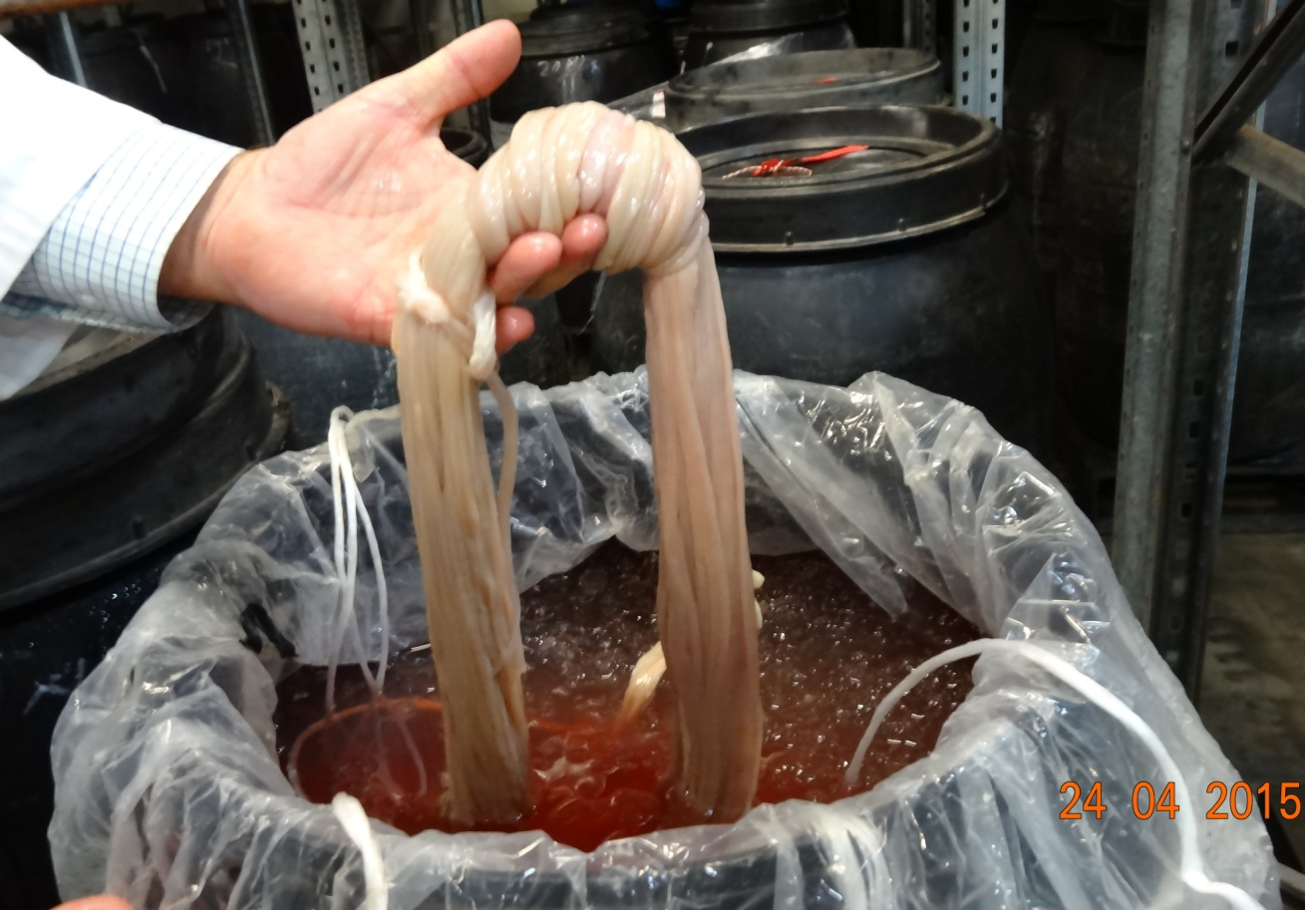
Source: Interim Inspector-General of Biosecurity
Figure 6 Cleaning of imported green sheep runners, Australia
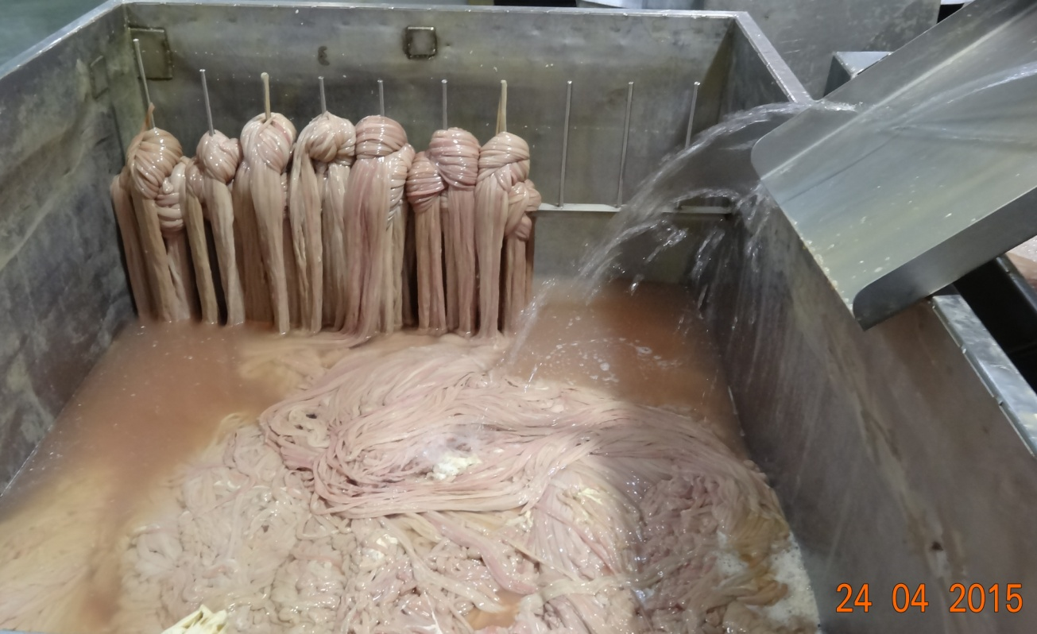
Source: Interim Inspector-General of Biosecurity
Figure 7 Separation of mucosa and threads from sheep intestines on a stripper/crusher machine, Australia
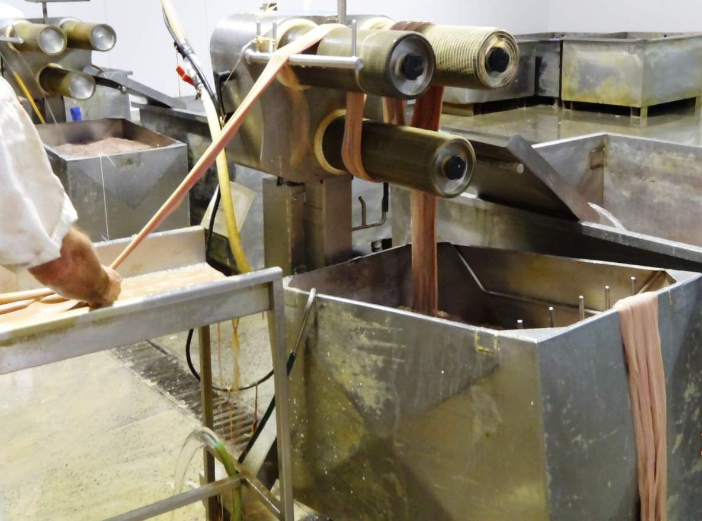
Source: Interim Inspector-General of Biosecurity
Figure 8 Testing sheep casing for quality, Australia
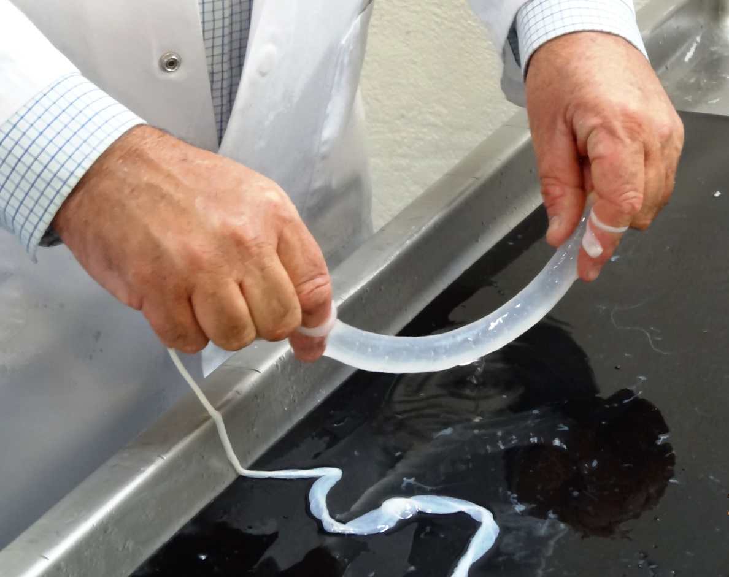
Source: Interim Inspector-General of Biosecurity
Figure 9 Bunches of dried and salted extruded sheep casings on plastic sleeves, Australia
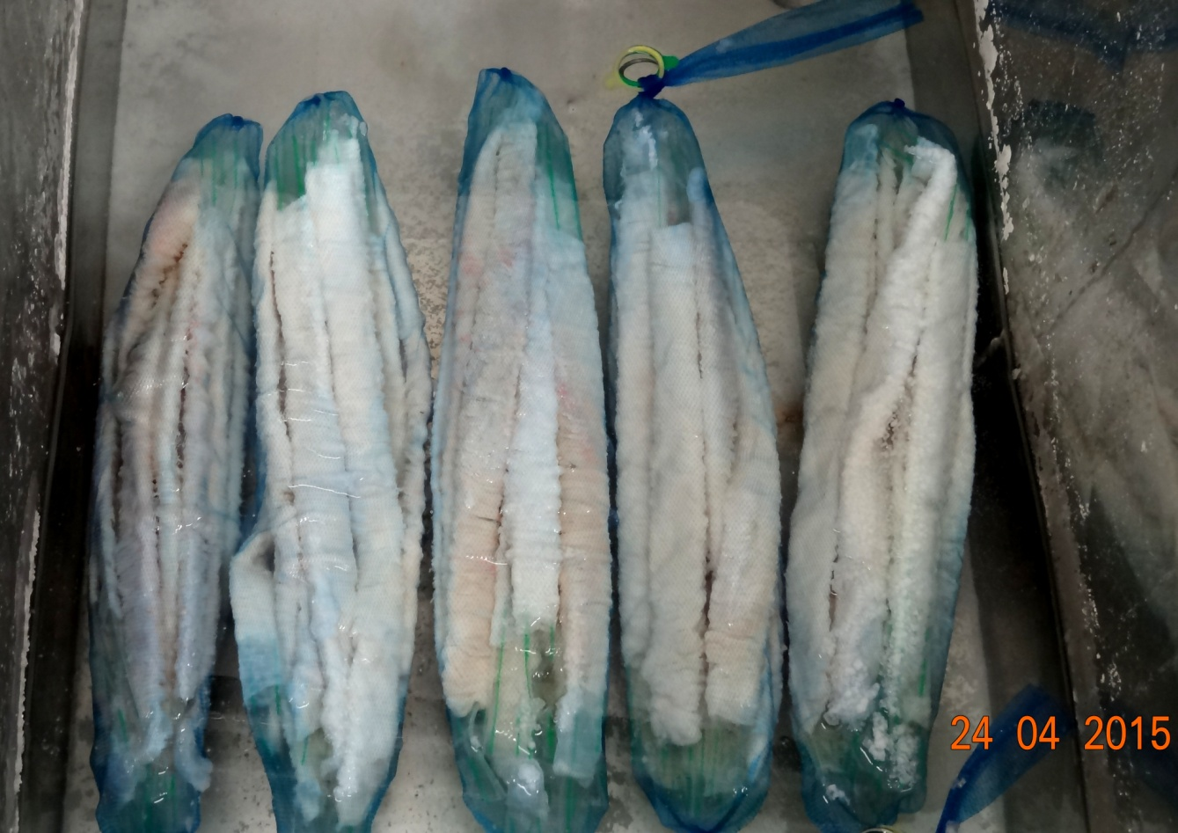
Source: Interim Inspector-General of Biosecurity
Figure 10 Sheep casings on plastic sleeves, stored in brine, Australia
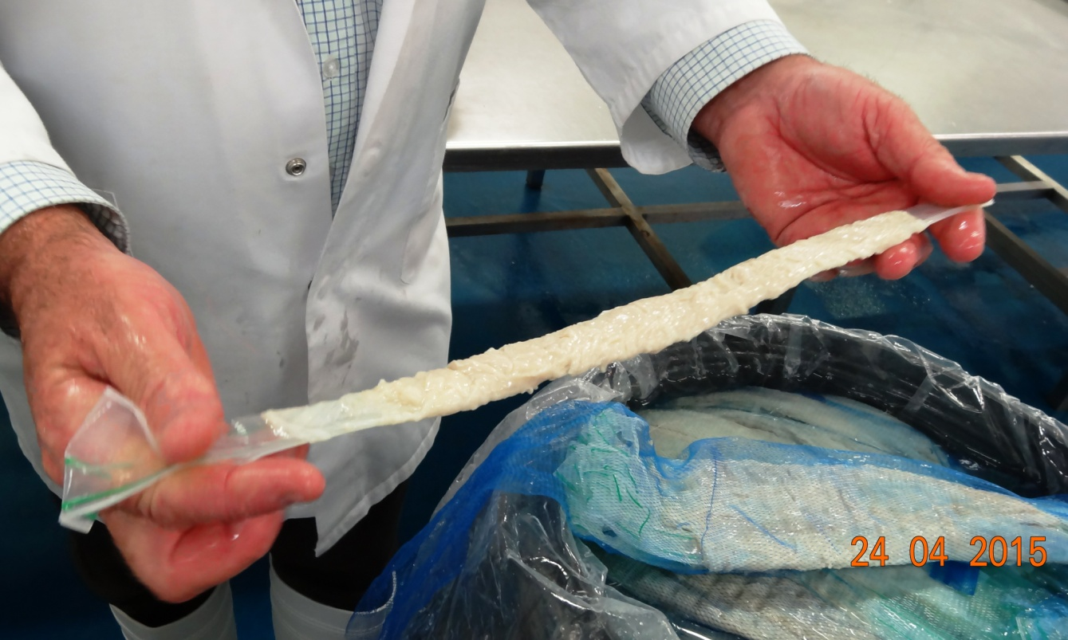
Source: Interim Inspector-General of Biosecurity
Figure 11 Steps in the processing of natural sausage casings
Source: ENSCA (2013) and NZFSA (2009)
- Observations and findings
  - The IIGB and audit team undertook fieldwork at two regional centres. No overseas processing establishments or export pathways were inspected or audited.

Assessment of pre-border biosecurity risks
  - The department’s Biosecurity Animal Division maintains an ongoing risk assessment framework (Figure 1), which it uses to update each exporting country’s animal health status for selected commodities of animal origin, including natural sausage casings. Particular attention is given to exotic animal diseases, including:
For bovine casings
- bovine spongiform encephalopathy
- foot-and-mouth disease
- peste des petits ruminants
For ovine and caprine casings
- foot-and-mouth disease
- peste des petits ruminants
- scrapie
For porcine casings
- African swine fever
- classical swine fever
- foot-and-mouth disease
- swine vesicular disease
- Teschen disease.
  - In 2011 the OIE announced that rinderpest had been eradicated worldwide. As a result, in December 2013 the department removed certificate of country freedom from rinderpest from import requirements. However, this disease is still listed in the import risk analysis (AQIS 1999) because the document has not been updated.
  - The department classifies an exporting country as having high or undetermined animal pathogen risk status in relation to sausage casings of animal origin if that country:
- has one or more of the following endemic diseases:
- transmissible spongiform encephalopathies, such as bovine spongiform encephalopathy (‘mad cow disease’)
- foot-and-mouth disease
- African swine fever
- swine vesicular disease
- classical swine fever
- Teschen disease
- peste des petits ruminants
- does not routinely report to the OIE on significant animal disease outbreaks
- does not have an effective national veterinary service or animal disease surveillance and/or control programmes in place.
  - An exporting country is classified as low animal pathogen risk status if it has none of the diseases listed in paragraph 5.4, reports routinely and in a timely manner to the OIE on significant animal disease outbreaks, has an effective national veterinary service and appropriate animal disease surveillance and control programmes in place.

Animal health risks in source countries
  - Apart from bovine spongiform encephalopathy (BSE), decisions about a country’s health status in relation to importation of natural casings have relied on the OIE-reported health status and Australia’s acceptance (or otherwise) of a country’s freedom from foot-and-mouth disease.
  - For bovine casings, the BSE status of the country of export has been based on the outcomes of the Food Standards Australia New Zealand BSE food safety country assessment and classification process current at the time of importation. Casings are imported for human consumption, so they must meet the requirements of the Australian Government BSE food safety policy. BSE food safety requirements for human consumption products are considered sufficient to address the biosecurity risk associated with importation.
  - All countries except New Zealand and Chile must have approval to export pig meat to Australia before being granted a permit to import sausage casings into Australia. The department has not undertaken an in-country audit of New Zealand to determine the risk of porcine casings. The decision to allow imports of porcine casings from New Zealand is based on:
- well-established trade relationships
- confidence in the competent authority’s capacity to determine New Zealand’s animal health status
- New Zealand’s effective regulation of processing standards.

Import risk analysis
  - The department has not undertaken any risk assessments for natural sausage casings since 1999 (AQIS 1999). The IIGB accepts that the department must consider all potential biosecurity risks associated with the importation of sausage casings. It is outside the scope of this audit to review the import risk analysis (IRA) and policies in relation to importation of natural sausage casings. Nevertheless, the IIGB suggests an update of the IRA should consider:
- removing rinderpest from the OIE List A diseases
- updating the approved countries list to reflect current arrangements from those in place in 1999
- incorporating internal policy advices from the Animal Biosecurity Branch (mainly regarding biosecurity risks associated with imported sausage casings)
- any peer-reviewed scientific papers about the persistence of pathogenic agents in sausage casings published since 1999.

Recommendation 1
  - The department should update the import risk analysis for natural sausage casings, incorporating relevant internal policies and/or guidelines used by policy and operational areas for imports into Australia. An update might consider any relevant scientific literature on the persistence of pathogenic agents in sausage casings published since 1999.
Department’s response: Agree, but not at this time
The department undertakes reviews of existing import requirements and risk analyses to reassess their effectiveness in meeting Australia’s appropriate level of protection. The decision to allocate resources to a review is driven most importantly by changes to biosecurity risk from existing trade. Departmental resources and import market access priorities are also factors which are taken into consideration when deciding whether to conduct a review.
The department is developing Operating Principles/Guidelines to assist operational areas in the management of the existing conditions for the import of natural casings. The department is of the view that there are no significant risk management or market access imperatives for conducting a major review of the sausage casings IRA in the current work program. This will be reassessed along with other competing priorities in the future.

Assessment of import permit applications
  - The department’s import risk analysis (AQIS 1999), policy determination of the animal health status of source countries and on-site audits overseas are central to the assessment of import applications and management of biosecurity risks for natural sausage casings. The department has only audited (in-country) Chile’s animal health status for this commodity.
  - Permit applications for importation of natural sausage casings are assessed by the department’s Animal and Biological Import Assessments Branch. All import applications are assessed on their compliance with Australia’s import requirements, including the risks of introducing animal pathogens (particularly BSE, foot-and-mouth disease, peste des petits ruminants, swine vesicular disease, classical swine fever, African swine fever and Teschen disease). The source country’s animal health status (freedom from these exotic diseases) and measures to prevent post-processing contamination are particularly important.
  - At any stage during an assessment, the Animal and Biological Import Assessments Branch can seek advice from the Animal Biosecurity Branch to clarify any issues, for example, to ensure adequacy of supporting documents.
  - The department uses the ICON permits database (an internal database) to process import permit applications and to record each stage of the application process.

Dependence on competent authorities
  - In managing biosecurity risks, the department often relies on the integrity and effectiveness of competent authorities in exporting countries. Competent authorities play a critical role in the export of natural sausage casings to Australia by applying a range of biosecurity control measures, including:
- registering natural sausage casings processing centres for export to the Australian market
- overseeing and ensuring compliance with Australia’s import requirements before export
- endorsing veterinary certificates for export consignments (completed by a veterinarian employed by the government of the exporting country).
  - In 2013 the department conducted a formal in-country evaluation of the competent authority responsible for regulating natural casings production and export in Chile. The department has not conducted in-country evaluations in other source countries. Casings are sourced from a range of countries with different biosecurity risks. Therefore, the department should consider undertaking more in-country evaluations of competent authorities and their capacity to implement effective biosecurity risk management for the production and export of natural sausage casings.
Recommendation 2
  - The department should consider conducting periodic in-country evaluations of approved countries’ competent authorities to ensure they meet Australia’s biosecurity requirements for the production and export of natural sausage casings.
Department’s response: Agree, as part of the existing work program
The department reviews the foot and mouth (FMD) and bovine spongiform encephalopathy (BSE) status of countries exporting casings to Australia. On the basis of the findings of a desk assessment, in-country verification visits of the competent authorities, if warranted, are undertaken for a number of animal-derived commodities. The department is committed to the process of competent authority evaluation as a biosecurity risk management tool.

Prohibited pig feed/swill feeding in Australia
  - Material of mammalian origin or any substance that has come in contact with this material is considered prohibited pig feed or swill. Pigs must not be fed or be allowed to eat meat or meat products, or anything that has been in contact with meat or meat products. This includes food scraps, bakery waste, waste from restaurants and hospitals and untreated, used cooking oils and fats.
  - Feeding of swill is banned in all states and territories. However, there is a risk that pig owners, particularly those with peri-urban landholdings, could feed their animals imported sausage casings containing exotic pathogens. Swill feeding is thought to have been the cause of the devastating 2001 outbreak of foot-and-mouth disease in the United Kingdom.
  - Meat and mammalian material can contain viruses that are not found in Australian livestock. Diseases such as foot-and-mouth disease, classical and African swine fever and transmissible gastroenteritis can be carried and transmitted by feeding swill to pigs.

Biosecurity risks in processing imported casings in Australia
  - Generally, sausage casings in Australia are imported in heavy-duty plastic barrels. Importers then further process and package casings for retail sale in Australia. This includes sorting, grading, extrusion, salting and retail packaging. Processing of casings requires a lot of water, generating a significant amount of wastewater. During fieldwork, the IIGB observed that this wastewater can be discharged into the sewage system without treatment.
  - The department has strict import requirements for animal-based commodities, including natural sausage casings; a combination of risk management measures are imposed for casings. For an exotic animal disease to become established and spread in Australia through this pathway would require a pathogen to survive salting for a minimum of 30 days and then find its way into a susceptible Australian species through wastewater. The department’s import risk analysis for sausage casings noted:
The possibility of environmental contamination with waste from processing plants cannot be completely discounted. However, given the dilution factors operating in disposal of wastewater and the controls on disposal of solid industrial waste, it would be unlikely for infection to be spread to susceptible Australian species via this pathway (AQIS 1999, p. 51).
  - During fieldwork, the IIGB observed that at one of the establishments where imported
(ex-New Zealand) runners were being processed, a wastewater treatment was operational adjacent to the establishment. A wastewater treatment plant is required for large-scale operations to meet the local council/government’s environmental regulation/requirements. It is not a mandatory requirement for containment and/or treatment of risk of exotic pathogens in imported runners.

Non-compliant consignments
  - The department exercises minimal intervention for imported consignments of natural sausage casings because these products are released on the basis of accompanying documents that verify they meet Australian import requirements. The IIGB noted that between 2011 and 2014, 62 of 67 (93 per cent) of the consignments identified as
non-compliant did not conform to Australian requirements for accompanying documentation or veterinary certification. The remaining 7 per cent of the non-compliant consignments failed inspections.
  - If the department finds that a consignment does not meet import permit conditions, the consignment is ordered into quarantine and the importer notified of the reasons. The importer will then be offered several options for the consignment, depending on the reasons for the consignment failing to meet permit conditions.
  - If the documentation does not meet import conditions, the importer has the option to present documentation again. If the government certificate is invalid, the relevant competent authority may reissue a certificate. If the new documentation meets conditions and there are no other issues with the consignment, it is released from quarantine.
  - For some imported meat products the importer may be given the option to treat the product (by gamma irradiation) to address the quarantine risk. However, no treatment options are available for sausage casings. If the importer cannot provide further documentation that meets conditions, the consignment is ordered to be either re-exported or destroyed at the importer’s expense.

Imported Food Inspection Scheme
  - To monitor importers’ compliance with Australia’s food standards, the Department of Agriculture and Water Resources operates a risk-based border inspection scheme—the Imported Food Inspection Scheme (IFIS). Imported food is inspected to check it meets Australian requirements for public health and safety and compliance with Australian food standards in the Australia New Zealand Food Standards Code. The code applies to all food for sale, including food manufactured in Australia.
  - The legal basis for the food safety inspection of imported food is the Imported Food Control Act 1992. The applicable standards under the Act are those set down in the Australia New Zealand Food Standards Code. Under the Act, importers are responsible for ensuring that all food imported into Australia complies with relevant standards in the code.
  - Food Standards Australia New Zealand advises the department on foods that pose a medium to high risk to public health. The department classifies these as ‘risk food’ under the inspection scheme, and classifies all other food as ‘surveillance’. To identify which food is of interest, and the rate at which foods should be referred (whether at 100 per cent or 5 per cent of consignments), the department applies electronic profiles in the Australian Customs and Border Protection Service’s ICS database. Once food is referred, the department’s systems apply relevant tests and inspection rates based on the risk the food may pose, and for some food, the compliance history of the producer and supplier.
  - Each consignment of natural sausage casings referred to IFIS is visually inspected for suitability and labelling requirements to assess compliance with the Australia New Zealand Food Standards Code. The department does not sample natural sausage casings for analytical testing.
  - Bovine casings are also subjected to a bovine spongiform encephalopathy certification assessment. Documents accompanying consignments of casings are subject to initial inspection at the rate of 100 per cent of consignments, reducing with a history of compliance. Casings derived from all other animal sources are categorised as ‘surveillance food’ and subject to inspection at the rate of 5 per cent of consignments. The department publishes inspection and analytical testing outcomes under IFIS in half-yearly imported food inspection data reports (Department of Agriculture 2014b). For example, between July and December 2014, of the all commodity groups, meat accounted for 4.2 per cent of inspections under IFIS and had 99.7 per cent compliance rate. During the same period, accompanying bovine spongiform encephalopathy certificates had a compliance rate of 99.3 per cent (Department of Agriculture 2014b).

Imports from unapproved source countries
  - If the department has approved a country/species combination for sausage casings, an import permit is issued under Option 1 of the import risk analysis (AQIS 1999). However, if the country/species combination has not been approved, an import permit can only be issued under Option 2 of the import risk analysis. Option 2 stipulates chlorination treatment of imported casings (to destroy disease agents of biosecurity concern) at a quarantine approved premises operated by industry under approved compliance arrangements.
  - To satisfactorily address animal disease risks in imported sausage casings, the import risk analysis notes different treatment regimes used overseas:
The European Union requires that imported sausage casings be treated with either NaCl [sodium chloride] for 30 days, bleached or scraped and dried.
The Japanese system requires that casings are desalinated and soaked for 2 hours in 80 ppm chlorine solution. This system of decontamination has been used in Japan for 30 years, to process casings from countries with a range of exotic animal diseases. This treatment regime should be capable of removing the major exotic disease agents of concern to Australia (AQIS 1999, p. 52).
  - The import risk analysis rejected a treatment regime commonly used in European Union countries:
Salt and/or drying treatments are not sufficient to effectively eliminate all pathogens of quarantine concern to Australia.
  - The import risk analysis advocated a regime similar to the Japanese system for treatment of imported sausage casings, before release into Australia:
Desalination and soaking the casings in 80 ppm available chlorine solution should provide an effective treatment for all pathogens identified in this analysis as a significant quarantine risk (AQIS 1999, p. 52).
  - From an industry perspective, an important issue in the quality of casings is their usability for a wide variety of sausages and consumers’ preferences regarding texture and tenderness (Wijnker 2009). The IIGB noted that Australian importers have not chosen to import from unapproved countries. Therefore, no chlorination facilities for this purpose are operating in Australia, and no import permit for unapproved country/species combinations has been granted.

Inspection
  - Importers’ premises are approved as quarantine approved premises (QAPs) under section 46A of the Quarantine Act 1908. Importers use these premises for storage and further processing of imported casings (grading and packaging for retail sale), from approved countries. Importers are required to maintain relevant standard operating procedures and work instructions relevant to operations at these premises. Currently, there are no QAPs approved for chlorination of imported casings.
  - All imported casings consignments are released if documents confirm that the products meet Australian biosecurity and food safety requirements. Biosecurity officers in the regions randomly inspect imported casings consignments. The IIGB noted that such inspections are usually announced in advance by the department, via the notice to the importer: ‘Hold for visual inspection’. These inspections cover all approved species. Biosecurity officers inspect the imported goods by either:
- overseeing delivery of casings packaged in barrels at an importer’s premises and checking for accuracy and adequacy of labels on barrels, consistent with Australian import requirements
or
- asking the importer to open barrels (seals intact) in their presence, to confirm the contents as described in the accompanying documentation.
  - It is a criminal offence in Australia to supply food that does not comply with relevant food standards. Under the Australia New Zealand Food Standards Code, casings must meet food safety requirements for human consumption. Responsibility for enforcing and policing food standards rests with the states and territories in Australia. For food imported into Australia, the code is further enforced by the Australian Government through the Imported Food Control Act 1992.
  - Importers of casings who also export this commodity usually have third-party hazard analysis and critical control points endorsement. They maintain a range of standard operating procedures and work instructions to comply with various legislative requirements of the business.

Information management
  - Of the four types of natural sausage casings imported into Australia, porcine and ovine casings constitute the bulk of imports. Documents such as packing lists or invoices accompanying each imported consignment must include import quantities for each consignment. All natural sausage casings are categorised under tariff code 0504, which covers intestines, bladders and stomachs of animals (other than those of fish), whether whole or in pieces (World Customs Organization 2007). The importer/broker nominates tariff code 0504 at the time of lodgement of each consignment, and Customs ‘flag’ and refer all casings consignments to the department. Biosecurity officers then ensure that the consignment meets Australia’s import requirements by checking the documents accompanying the consignment and by conducting physical inspections, as required. Import data provided by the department (2010 to 2014) indicate that volumes of porcine casings did not show any particular trend (Table 1). For example, between 2010 and 2014 the volume (numbers) of porcine casings peaked from 1 414 667 in 2010 to 1 849 902 in 2012 and the decreased to 1 426 214 in 2014. Similarly, no consistent increase in import volume was noted between 2010 and 2014 for bovine casings.
  - The IIGB noted that import volume data is inadequately recorded by the department in its Australian Government Import Management System (AIMS). This is evident from the data provided in Table 1, that
- the largest volume (11 368 643 numbers) of casings is classified as ‘unknown’ (that is, the origin of casings is not classified into the animal species that they are derived from)
- the various units used in recording (that is, kilograms, units, numbers and pounds) make imported volumes difficult to quantify
- for several years, the data are ‘not available’.
  - The department has advised the IIGB that officers record inspection directions and outcomes in the AIMS database; however, the majority of the details captured in AIMS are entered in the ICS database by customs brokers or importers. Once consignment details are entered by customs brokers, department staff cannot modify the fields to input more useful data. The IIGB was advised that the use of free-text fields and comment lines for recording import permit details in the department’s AIMS database, together with the lack of a specific tariff code for casings derived from different animal species, makes it difficult to obtain reliable data for import quantities. The IIGB noted that the incomplete or incorrect recording of import quantities of imported consignments of casings is not due solely to a lack of appropriate fields for recording inspection results in the AIMS database. On some occasions, department staff are also neglecting to use the correct ‘free text fields’ or ‘comment lines’ in AIMS, or not recording the import permit numbers in a consistent manner. The IIGB has identified a similar issue of inconsistent or inadequate recording of import data by department staff in previous audits/reviews of other imported commodities (IIGB 2015a, IIGB 2015b).
  - Earlier this year, the IIGB recommended that the department should improve data recording in AIMS (IIGB 2015b). To train staff in consistently and accurately recording directions, observation and assessment/inspection outcomes relevant to all AIMS entries, the department has since developed the following training materials:
- Instructions and guidelines, Entry processing recording outcomes of a document assessment and issuing directions in AIMS
- Module 10 (document assessment) to train staff in how to assess documents in accordance with the relevant policies and procedures
- Module 12 (electronic processing) to train staff in how to determine the reason that an entry has been referred to the department and how to record the outcome of their assessment in AIMS.
  - The department is also developing a verification process to provide assurance for entry processing activities. Included in this verification will be checks that permit numbers are being recorded consistently. Where a verification activity finds that a permit number or any other relevant information has not been recorded as per the instructional material and training, feedback is provided to the processing officer through their supervisor.
  - The management of biosecurity risks and effective monitoring of the department’s control measures are reliant on having accurate, consistent data for high-risk imports. While it is recognised that any modifications to the ICS and AIMS databases present a significant challenge, the department should consider ways in which the quality of import data could be further improved. It is noted that the department has previously agreed with a similar recommendation made in an earlier IIGB report (IIGB 2015b).
Recommendation 3
  - The department should routinely record the import permit number and inspection outcomes for all natural sausage casing consignments imported into Australia. These data should be available to relevant areas in the department, to assess whether policies and regulations are effectively addressing the biosecurity risks.
Department’s response: Agree
The department currently requires documentary assessment staff to record the import permit number in AIMS if this information has not already been recorded by the importer or broker. The department will further investigate the proportion of AIMS entries for imported natural casings that do not have a permit number recorded against them.
Further to this, a reminder on the importance of recording this information will be distributed to staff.
All import permits for natural casings will specify the species from which the casings are derived. As such, this information will be available for all entries where an import permit number is recorded.

Industry consultation
  - During audit fieldwork the IIGB consulted several importers of natural sausage casings. These importers are engaged in processing imported casings for retail sale in Australia and also for export. The IIGB noted several issues and suggestions the importers raised, including:
- need to update the import risk analysis for natural sausage casings
- reconsideration by the department of salting as an effective treatment for neutralisation of pathogens in natural casings
- replacing chlorination with an alternative method as an approved treatment for imported sausage casings from unapproved countries
- removing scrapie (in sheep and goats) as a criterion for approving source countries
- improving accessibility on the department’s ICON database of information on importation of specific products from specific countries.
  - The department’s Biosecurity Import Conditions Database (BICON) will soon replace the ICON database. BICON might address some of the issues raised by importers (see paragraph 5.49). In the interim, ICON should be updated or provide step-by-step instructions on finding information on ICON.
Recommendation 4
  - The department should update the ICON database to improve clarity and accessibility of import requirements for importing natural sausage casings into Australia.
Department’s response: Agree
The department will review, and amend where necessary, the natural sausage casings entry in the import conditions database (BICON) to ensure the requirements are clear and accessible.

Appendix A: Agency response

Glossary
Term | Definition
AIMS | Department of Agriculture Import Management System
audit | Systematic, independent and documented process for obtaining evidence and evaluating it objectively to determine the extent to which criteria are fulfilled; includes a desktop assessment of documentary material and, where necessary, on-site verification through an examination of systems in place
biosecurity | The management of risks to the economy, the environment and the community of pests and diseases entering, emerging, establishing or spreading
biosecurity officer | Formerly known as quarantine officer; a person appointed under the Quarantine Act 1908 who has functions and/or powers of a quarantine officer
CAMS | Compliance and Assessment Management System, managed by the Department of Agriculture and Water Resources
competent authority | Official service or authority established by the government of an exporting country, which has the responsibility and competence for ensuring or supervising implementation of animal, plant or public health standards
consignment | Total quantity of imported sausage casings arriving at the same time in one or more lots, nominated on a single quarantine entry covered by each phytosanitary certificate
ICON | Import Conditions Database, managed by the Department of Agriculture and Water Resources
ICS | Integrated Cargo System, managed by the Australian Customs and Border Protection Service
import permit | In relation to goods, a permit granted by the Director of Quarantine (or delegate) to import prohibited goods into Australia
import risk analysis | Process that enables the Australian Government to formally consider risks that could be associated with proposals to import new products into Australia; import risk analyses are conducted by the Department of Agriculture and Water Resources
inspection | Examination of products or systems for the biosecurity of animal, plant, food and human health to verify that they conform to Australian Government requirements
OIE | World Organisation for Animal Health
pre-border controls | Seek to prevent biosecurity risks reaching Australia’s border; control activities include cooperation in multilateral forums, import risk analyses, intelligence gathering and quarantine and audit activities
quarantine | System of measures used to manage risks of entry and establishment of pests or diseases that threaten animal, plant or human health
risk assessment | Evaluation of the likelihood and the biological and economic consequences of entry, establishment or spread of a pest or disease within the territory of an importing country
risk management | Process of identifying, selecting and implementing measures that can be applied to reduce the level of risk
runner | Intestine which has been separated from an animal’s stomach and mesentery and pulled out, along with the intestinal contents
standard operating procedures | Document that outlines procedures for conducting significant operational activities, taking into account management of risk, legislation and workplace health and safety requirements
verification | Confirmation through provision of objective evidence that specified requirements have been fulfilled; includes inspection and audit activities
work instruction | A succinct easy-to-understand document that complements a standard operating procedure and provides definitive guidance for performing specific operational tasks

References
AQIS 1999, Importation of sausage casings into Australia: import risk analysis, Department of Agriculture, Fisheries and Forestry Australia, Canberra, available at agriculture.gov.au/biosecurity/risk-analysis/ira/final-animal/casings.
Beale, R, Fairbrother, J, Inglis, A & Trebeck, D 2008, One biosecurity: a working partnership, Quarantine and Biosecurity Review Panel report to the Australia Government, Commonwealth of Australia, Canberra, available at agriculture.gov.au/about/publications/quarantine-biosecurity-report-and-preliminary-response.
DAFF 2012, Minimum document requirements policy, Department of Agriculture, Fisheries and Forestry, Canberra, available at daff.gov.au/biosecurity/import/general-info/documentary-requirements/minimum-document-requirements-policy.
DAFF 2011a, Import risk analysis handbook 2011, Department of Agriculture, Fisheries and Forestry, Canberra, available at agriculture.gov.au/biosecurity/risk-analysis/ira/process-handbook.
DAFF 2011b, ‘Memorandum of understanding: collaborative cooperation’, an arrangement for the collaborative working relationship between the Australian Customs and Border Protection Service and the Department of Agriculture, Fisheries and Forestry, Department of Agriculture, Canberra, available at agriculture.gov.au/biosecurity/australia/biosecurity-reform/communications-media-releases-and-publications/mou.
Department of Agriculture 2014a, ‘Guidelines on the management of the biosecurity risks of foot-and-mouth disease virus in imported commodities’, Canberra. Unpublished.
Department of Agriculture 2014b, ‘Imported food inspection data’, available at agriculture.gov.au/import/food/inspection-compliance/inspection-data.
ENSCA 2013, Community guide to good practice for hygiene and the application of the HACCP principles in the production of natural sausage casings, European Natural Sausage Casings Association, Brussels, Belgium.
Geering, WA, Forman, AJ & Nunn MJ 1995, Exotic diseases of animals: a field guide for Australian veterinarians, Bureau of Resource Sciences, Department of Primary Industries and Energy, Canberra.
IIGB 2015a, Effectiveness of biosecurity controls for imported fresh cut flowers, Interim Inspector-General of Biosecurity report, Canberra, available at igb.gov.au/Pages/completed-audits-and-reviews.aspx.
IIGB 2015b, Effectiveness of biosecurity controls for importing stockfeed of plant origin, Interim Inspector-General of Biosecurity report, Canberra, available at higb.gov.au/Pages/completed-audits-and-reviews.aspx.
IIGB 2014, Effectiveness of biosecurity controls for imported animal breeding material (mammalian semen and embryos), Interim Inspector-General of Biosecurity report, Canberra, available at igb.gov.au/Pages/completed-audits-and-reviews.aspx.
IIGB 2012, An examination of factors that led to release into Australia of a consignment of soil (declared as fertiliser) and interception at the border of another consignment of soil (declared as fertiliser), Interim Inspector-General of Biosecurity report, Canberra, available at igb.gov.au/Pages/completed-audits-and-reviews.aspx.
MacDiarmid, SC & Thompson EJ, 2004, ‘Animal health risk analysis’, in WK Jensen, C Devine & M Dikeman (eds), Encyclopedia of meat sciences, vol. 1, Elsevier Academic Press, Amsterdam, pp. 27–31.
MacDiarmid, SC & Thompson, EJ, 1997, ‘The potential risks to animal health from imported sheep and goat meat’, Revue Scientifique et Technique de l’OIE, vol. 16, pp. 45–56.MAF Biosecurity New Zealand 2010, Import risk analysis: sausage casings from small ruminants, rapid risk assessment, Ministry of Agriculture and Forestry, Wellington, New Zealand.
NZFSA 2009, Draft generic RMP model for the processing of edible sheep and lamb casings, New Zealand Food Safety Authority, available at foodsafety.govt.nz/elibrary/industry/processing-edible-sheep-rmp-model-casings.
Walsh, C 2014, The use of animal by-products: the improving opportunities to add value to the beef and sheep slaughtering sectors, EBLEX, Agriculture and Horticulture Development Board, Warwickshire, United Kingdom, p. 73.
Wijnker, JJ 2009, ‘Aspects of quality assurance in processing natural sausage casings’, PhD Thesis, Utrecht University, The Netherlands, available at dspace.library.uu.nl/handle/1874/31822.
World Customs Organization 2007, Harmonized commodity description and coding system: explanatory notes, fourth edition, vol. 1, Brussels, Belgium.

