

# Management of biosecurity risks associated with transhipped ships stores

**Review report**

No. 2014–15/08

© Commonwealth of Australia 2016

Ownership of intellectual property rights

Unless otherwise noted, copyright (and any other intellectual property rights, if any) in this publication is owned by the Commonwealth of Australia (referred to as the Commonwealth).

Creative Commons licence

All material in this publication is licensed under a Creative Commons Attribution 3.0 Australia Licence, save for content supplied by third parties, logos and the Commonwealth Coat of Arms.

by

Creative Commons Attribution 3.0 Australia Licence is a standard form licence agreement that allows you to copy, distribute, transmit and adapt this publication provided you attribute the work. A summary of the licence terms is available from [creativecommons.org/licenses/by/3.0/au/deed.en](http://creativecommons.org/licenses/by/3.0/au/deed.en). The full licence terms are available from [creativecommons.org/licenses/by/3.0/au/legalcode](http://creativecommons.org/licenses/by/3.0/au/legalcode).

Cataloguing data

Interim Inspector-General of Biosecurity 2016, Management of biosecurity risks associated with transhipped ships stores, Department of Agriculture and Water Resources, Canberra.

Internet

Management of biosecurity risks associated with transhipped ships stores is available at [igb.gov.au/Pages/completed-audits-and-reviews.aspx](http://www.igb.gov.au/Pages/completed-audits-and-reviews.aspx).

Interim Inspector-General of Biosecurity

Department of Agriculture and Water Resources

Postal address GPO Box 858 Canberra ACT 2601  
Switchboard +61 2 6272 3933  
Email [inspgenbiosecurity@agriculture.gov.au](mailto:inspgenbiosecurity@agriculture.gov.au)  
Web [igb.gov.au/Pages/default.aspx](http://igb.gov.au/Pages/default.aspx)

Inquiries about the licence and any use of this document should be sent to [copyright@agriculture.gov.au](mailto:copyright@agriculture.gov.au).

The Australian Government, represented by the Interim Inspector-General of Biosecurity, has exercised due care and skill in preparing and compiling the information and data in this publication. Notwithstanding, the Interim Inspector-General of Biosecurity, the Australian Government, its employees and advisers disclaim all liability, including for negligence and for any loss, damage, injury, expense or cost incurred by any person as a result of accessing, using or relying upon information or data in this publication to the maximum extent permitted by law.

Contents

1 Introduction 1

2 Background 2

3 Management of biosecurity risks 4

4 Observations 11

5 Conclusion 19

Appendix A: Processing transhipped ships stores for cruise and commercial vessels 20

Appendix B: Agency response 21

Glossary 22

References 23

1. Introduction

Cruise line operators and other shipping companies operating at Australian ports often tranship food items and other goods through Australia for the use of passengers and/or crew on board departing vessels. The Department of Immigration and Border Protection defines transhipment as ‘the transfer of goods without payment of duty and taxes from the importing ship to another ship engaged in international travel for the purpose of shipment overseas’(Department of Immigration and Border Protection 2016). Under the *Customs Act 1901*, transhipped goods are not considered to be imported and therefore must not pass out of Customs control from importation until export from Australia.

These ships stores (particularly foodstuffs) pose a high biosecurity risk to Australia. They are a potential pathway for the introduction of exotic pests or diseases. Importation into Australia of items such as uncooked meat and seafood, and fresh fruit and vegetables would not usually be allowed. The Interim Inspector-General of Biosecurity (IIGB) undertook a limited review as part of his annual work programme. The review examined the effectiveness of controls that the Department of Agriculture and Water Resources uses to manage biosecurity risks associated with the transhipment of ships stores.

1. Background
   1. In 2008 the department implemented transhipment import conditions. Since then, Australian industry representatives have expressed concern that the conditions do not sufficiently mitigate the biosecurity risks. This report examines those concerns. Outside the scope of this report are industry concerns about commercial and legal issues associated with the increasing number of port visits by cruise vessels and their passengers.
   2. The IIGB understands many companies maintain a single international logistics chain. This achieves benefits of scale and cost savings when purchasing food and other materials. Goods required for individual vessels are sent to the next scheduled international port of call, to be transhipped to the receiving vessel. This replenishment usually occurs at the same port as passenger changes because these ports are typically larger and have good cargo handling facilities.
   3. The issue of biosecurity risks presented by transhipped goods applies to several sectors. However, the risk posed by the cruise industry may be more significant due to the volume and variety of goods required to service increasing numbers of passengers.

### Regulation of transhipped goods

* 1. Before August 2007, the department did not set requirements for transhipped vessel stores. Following an inquiry from the cruise industry in relation to transhipping foodstuffs and other items, the department sought legal advice in relation to the application of the *Quarantine Act* *1908* to transhipped goods. The outcome of this advice was that under the Act, transhipped materials were considered to be ‘imported’ cargo and thus subject to the requirements of the Act.
  2. Following this advice, the department implemented interim import conditions, pending the development of a set of formal requirements for transhipped goods. These new import requirements were implemented in August 2008.
  3. A further review was conducted during 2012/2013 and included an assessment of physical procedures at each Australian port that received ships stores. Following this review, new procedures were developed which categorised goods based on risk. Deconsolidation of Category 2 low risk goods was introduced. The process of movement of transhipped ships stores interstate (‘land bridging’) was also introduced as a result of this review. To incorporate these changes, a new Import Conditions (ICON) case was written and published.
  4. The department manages the transhipment of vessel stores within the Biosecurity Animal and Compliance divisions. The Biosecurity Animal division manages the issuing of permits for transhipped stores and the Compliance division undertakes various border inspection and auditing activities.

### Review objective, scope and methodology

* 1. This limited review examined the department’s current border controls for managing biosecurity risks associated with transhipped vessel stores, including:
* adequacy of biosecurity risk assessment applied to transhipped stores
* adequacy of import requirements and permits in managing biosecurity risks
* adequacy of accompanying certifications and declarations in addressing biosecurity risks
* assessment of border activity such as verification and inspection procedures
* evaluation of biosecurity risks associated with the use and disposal of transhipped stores and any associated waste in Australia and in surrounding waters
* identification of any practical improvements to import procedures, operations and/or documents for transhipped vessel stores.
  1. The review did not examine:
* commercial implications of transhipped stores
* legal aspects related to the importation of ships stores
* importation of goods that are not of biosecurity concern
* post-border surveillance activities undertaken by state or territory authorities
* food safety regulations.
  1. The IIGB visited the North East Region (Brisbane) to inspect import arrangements for transhipped ships stores and meet with relevant industry and department staff. The IIGB observed the crew handling the stores on board a cruise vessel and also interviewed the ship’s Environment Officer.
  2. During fieldwork, the IIGB met with local industry representatives who had expressed concern about the effectiveness of current import conditions for ships stores, particularly food items.

### Review team

* 1. Auditor Jonathan Muller assisted the IIGB with this review.

1. Management of biosecurity risks

### Industry concerns

* 1. In 2008 the department implemented formal import requirements for transhipped stores. Local industry representatives (importers, exporters and customs brokers) expressed concerns about perceived biosecurity risks associated with this policy, and the management of transhipment of ships stores.
  2. Following the initial inquiry from the cruise industry and subsequent legal advice, the department issued a Notice to Industry (Notice 21/2007/08), setting out changed arrangements effective from 1 May 2008. Local industry representatives were concerned that the import conditions contained in the Import Conditions database were confusing and ambiguous, particularly a reference to ‘alternative import conditions’.
  3. Local industry representatives were also concerned that a formal rigorous import risk assessment (IRA) had not been conducted before the amended import conditions were implemented. They claimed that this situation adversely affected Australia’s food safety, biosecurity and marine environment.
  4. The primary concern expressed by industry following the release of import conditions in 2008 was that there was a risk of transhipped goods being diverted for domestic use without being subject to normal import requirements. This concern was addressed during the 2012/13 industry consultation, which lead to the publication of revised import conditions in 2014.
  5. Following the 2014 changes to import conditions, there has been continuing concern. The IIGB understands these concerns primarily relate to waste disposal of transhipped goods (food items) on vessels. Industry representatives have claimed that the risks have been exacerbated by the significant increase in the number of cruise industry vessels visiting Australian ports.
  6. Prawns were cited as a commodity of concern because local industry representatives considered the transhipment conditions insufficient to address the associated biosecurity risk. Reference was made to the risk posed by disposal of prawn products in Australian waters. According to the IRA for prawns (Biosecurity Australia 2009):

The majority of prawns imported for human consumption and purchased as seafood would be ‘used’ in one of three ways; namely, consumption by humans, and disposal to a municipal garbage disposal system or diversion to use as bait or berley. Prawns purchased as seafood might be used, or discarded, in other ways such as the deliberate feeding of seabirds, the ‘disposal’ of uncooked prawn waste from picnics and other outdoor events to open areas where they might be accessible to scavengers such as seabirds, and direct use (whether deliberate or inadvertent) in aquaculture ponds. However, it was considered that a comparatively low volume of commodity would be used or discarded in this manner. These potential pathways were therefore incorporated into the evaluation of the pathway for prawns purchased as seafood but used as bait or berley. (p.73)

* 1. Local industry representative expressed concern that prawns imported under transhipment conditions do not require testing for white spot syndrome virus. These could be consumed and discarded in Australian waters. Under general import conditions, prawns must be tested for this virus.
  2. Industry has also drawn the department’s attention to adverse commercial impacts during the four years following the introduction of the new arrangements. According to industry representatives, Australian companies supplying goods for ships stores have experienced a decline in their business over this period.

### Increased container volumes

* 1. The number of transhipped containers increased significantly in the three and-a-half years to December 2015. October to March is the peak time for cruise activity in Australia. Figure 1 shows that more than 100 containers were transhipped each month between October and March each year from 2012 to 2015. Before October 2012 the monthly number of transhipped containers exceeded 50 only twice (February 2011 and February 2012). In October 2012 two large cruise vessels commenced permanent positioning in Australia, significantly increasing the number of transhipped cargo containers. The number of containers transhipped between April and September in 2013, 2014 and 2015 was not as large as in the peak October to March period, but was many times larger than in the April to September period in preceding years.

Figure 1 Number of transhipped containers recorded in AIMS database, by month, 2010 to 2015

AIMS Agriculture Import Management System for storing records of imported cargo assessed by the Department of Agriculture and Water Resources.

### Import requirements

* 1. Transhipped stores are not considered to be imports under the Customs Act, so they do not enter the normal border clearance process for imported goods. Therefore the department developed import conditions and an associated targeting process to control the content and movement of transhipped stores for use on cruise and commercial vessels. The department considers that transhipped goods require these measures to be in place to ensure that biosecurity risks are minimised, while allowing commercial movements of such goods.
  2. The import conditions imposed by the department are intended to ensure that transhipped stores are not exposed to the Australian environment before being loaded on a departing vessel. Once on board the vessel, the stores are subject to the same biosecurity regulation as the stores that were carried aboard the vessel when it arrived.
  3. To help manage these goods, transhipped ships stores are grouped into three categories. These are based on the department’s assessment of the potential biosecurity risk of the goods in each category (Table 1). To address the identified risks, each category is subject to specific requirements for transhipment.

Table 1 Risk categories for transhipped biosecurity materials

| Category | Risk level | Type of goods |
| --- | --- | --- |
| 1 | Nil risk | Goods of no biosecurity risk. For example, jewellery, clothing and alcohol. |
| 2 | Low risk | Goods normally permitted entry to Australia without an import permit and requiring only documentation or inspection on arrival. For example, frozen (non-salmonid) fish fillets and packaged breakfast cereal. |
| 3 | High risk | Goods either prohibited or not permitted entry into Australia without an import permit. For example, frozen meat, fresh seafood, eggs, fresh fruit and vegetables. |

Source: Department of Agriculture and Water Resources

* 1. Category 1 material does not require an import permit for transhipment. The goods may be deconsolidated at the sole discretion of the owner if permitted under the Customs Act. Any category 1 goods transhipped may be subject to verification or random surveillance by a biosecurity officer to ensure goods descriptions in the manifest are accurate.
  2. Category 2 material requires an import permit for transhipment. If the goods arrive as a full container load (FCL) or in an airfreight unit loading device, they may be deconsolidated at the importer’s discretion but deconsolidation may only occur following inspection by a biosecurity officer. If goods are not deconsolidated, they will be handled using the same procedures as category 3 goods. Goods arriving as less than a container load or loose airfreight are subject to mandatory inspection on arrival.
  3. Category 3 material requires an import permit for transhipment. Deconsolidation of category 3 goods is not permitted except under exceptional circumstances approved by the department. Goods arriving as a full container load or in airfreight unit loading devices may be stored seals intact until exported. Goods arriving as less than container load or loose airfreight must be stored securely as directed by the department. All category 3 goods must be loaded onto the departing vessel under the direct supervision of a biosecurity officer.

### Border processing

* 1. The department uses word-based profiles in the Integrated Cargo System (ICS) to identify transhipped ships stores. Profiling is undertaken against the cargo report in the ICS. These profiles are subject to continuous review as part of general profile quality assurance and in response to operational issues and intelligence.
  2. Where an arriving cargo report matches a profile, the goods are held by the system and the importer is required to create a manual quarantine entry. Once the manual quarantine entry has been created, the ICS ‘hold’ is removed and the quarantine entry is used to direct the goods appropriately to manage any biosecurity risks associated with the cargo.
  3. Transhipped stores must be declared to the department before the arrival date of the goods. This declaration is usually provided using the [Ship stores lodgement cover sheet](http://www.agriculture.gov.au/biosecurity/avm/transhipping-through-australia)*.* The department provides a [template](http://www.agriculture.gov.au/biosecurity/avm/transhipping-through-australia) for this form on its website.
  4. The following information must be provided to facilitate clearance of transhipped stores:
* a valid import permit, either by quoting the import permit number or attaching a copy of a valid import permit
* Australian port of discharge and estimated date of arrival
* vessel/aircraft identification number
* container/ULD numbers and associated ocean/air bills of lading
* a manifest in the form of a detailed packing list, listing the full contents of each container/ULD in the consignment
* documents acceptable for the biosecurity barrier clearance of goods for importation into Australia; for example packing/cleanliness declarations as required by the department’s Non-Commodity Information Requirements Policy (applicable to category 2 goods or if deconsolidation of goods has been requested)
* a declaration stating that ‘the goods in the consignment will not be for consumption, distribution or sale within Australia’
* the location of the wharf, cargo terminal operator (CTO) or registered 77G customs facility within the metropolitan area of the port of arrival where the consignment is to be stored
* If goods are to be deconsolidated, the location of the registered quarantine approved premises (QAP) and the expected date for deconsolidation and inspection by biosecurity officers
* the estimated date and time the consignment is scheduled to be transferred from the wharf, CTO, registered 77G customs facility or QAP to the export vessel
* the location and scheduled date for unpacking and loading onto the export vessel.

This information may be provided by the transhipper, freight forwarder, customs broker or agent.

* 1. The shipping manifest is the key document for determining the level of biosecurity risk associated with a particular consignment. Based on the details listed in the manifest, a biosecurity officer can determine the biosecurity risk and the category of goods present in the consignment.
  2. Once the category of goods has been determined by a biosecurity officer, an appropriate direction can be applied to the manual quarantine entry. Category 1 goods can be released from quarantine and category 2 or 3 goods must either be inspected or held until the time of export. Consignments containing goods of mixed category are handled in the same way as the highest risk category.
  3. Category 2 goods may be deconsolidated at the request of the owner or their agent. If this is requested, the goods must be moved to a QAP of a category suitable for handling the type of risk material present in the consignment. Once at the premises, the goods are inspected by a biosecurity officer to ensure there are no items of biosecurity concern or that any immediate or potential biosecurity concerns that may be present are mitigated or contained.
  4. If a biosecurity risk cannot be contained, poses an immediate threat or is considered unacceptably high by the department, risk mitigation measures must be immediately put in place to adequately address the risk. If this cannot be achieved, the consignment must be immediately exported from Australia as cargo, not ships stores, or destroyed using a method approved by the department.
  5. Any transhipped goods waiting to be exported, whether inspected or not, must be held at a Customs 77G depot. The 77G depot must be within the same metropolitan area as the arrival and export port. Goods at a 77G depot are under Customs bond and must be held securely to ensure that they cannot be diverted for use in Australia.
  6. All transhipped goods will be moved directly from the Customs 77G depot to an export wharf for loading onto the departing vessel.
  7. Upon arrival at the export wharf, unpacking and loading of the transhipped goods is supervised by a biosecurity officer. Where goods have been stored seals intact, the officer will verify that the original import seals are unbroken. Where goods were not sealed, the inspecting officer verifies that the volume of goods exported matches the volume that was imported and that the goods have not been tampered with.

### Land bridging

* 1. Ships stores are usually imported into the port they are intended to be exported from. This is both logistically efficient and a department requirement. The department requires that transhipped goods may only be transhipped between ports within the same metropolitan area. Requests to move goods intrastate and/or interstate may be considered case by case, and only in exceptional circumstances.
  2. The movement of stores between different locations in Australia is termed ‘land bridging’. Land bridging occurs when stores have arrived in one port but are required at a different port. The most common reason for this occurring with ships stores is where a vessel has not berthed according to its original voyage schedule. For example, poor weather may slow a vessel’s progress or prevent entry to a port.
  3. Land bridging refers to the transport of cargo via road, rail or air within Australia. Any request to land bridge cargo must be approved by the department’s relevant operational region. Approval by regions ensures that any land bridge movement can be verified by regional biosecurity staff.
  4. Land bridging is a type of movement under bond, regulated by the Department of Immigration and Border Protection (Customs). Under bond movements allow cargo subject to Customs control to be moved between 77G depots. Customs regulations do not differentiate between 77G locations in different metropolitan areas. This is an issue for the department because movement between 77G depots could involve movement through rural areas. Therefore the department requires prior notification to ensure that any risks posed by the transit route are addressed.
  5. Under bond movements are secure, controlled movements that involve cargo being moved under department seal. Goods leaving a 77G depot must have a seal applied to ensure that the goods are not interfered with during transit. Although this limits the risk of the cargo being exposed to the Australian environment, an accident involving the vehicle carrying the cargo may lead to environmental exposure. This has occurred on a few rare occasions. In the most recent example, a consignment of imported pig meat was spilled in 1998 when a truck overturned in regional New South Wales. In this case all cartons except one were recovered from the site of the accident. The IIGB is not aware of any similar incident since then. Although unlikely, the department recognises that an accident may occur and has emergency procedures in place to address any potential issue should this eventuate.
  6. Department records indicate 1 943 movements of ships stores took place between 2013 and 2015. Most of these movements were within the same metropolitan area and did not require approval from the department. During this period nine per cent of transhipped stores movements appear to involve an interstate movement, but not all movements involved transport by land. In the cases, where movement outside a metropolitan area was required, the department approved all requests after the person in control of the cargo supplied the required information. The IIGB could find no evidence of problems relating to the department’s processes for regulating land bridging of stores.

### Waste management

* 1. The management of waste generated on a vessel is regulated under the *Quarantine Act* *1908* and *Protection of the Sea (Prevention of Pollution from Ships) Act 1983*. The latter Act gives effect to the [International Convention for the Prevention of Pollution from Ships](http://www.imo.org/en/About/Conventions/listofconventions/pages/international-convention-for-the-prevention-of-pollution-from-ships-(marpol).aspx) (MARPOL).
  2. Annex V of MARPOL aims to prevent pollution by garbage from ships; food waste is one of the types of material covered.
  3. The department has developed policies for the management of biosecurity waste, both on shore and on board a vessel.
  4. Onshore waste management must comply with the department’s [Biosecurity Waste Management Business Policy](http://www.agriculture.gov.au/import/arrival/arrangements/biosecurity-waste/biosecurity-waste-management) (Department of Agriculture 2016a). This provides for either biosecurity officer supervision of the waste handling process or operation under an approved arrangement. Organisations operating under an approved arrangement are allowed to undertake waste management procedures without direct departmental supervision.
  5. On a vessel, waste management is included as part of the department’s routine vessel inspection (RVI) protocol. International vessels arriving at their first Australian port are subject to verification of compliance with waste management procedures. This requires any waste on board the vessel and waste held on the deck to be appropriately secured before it is offloaded for collection by onshore collection services.
  6. Until recently, biosecurity officers were required to seal galley grinders during a RVI inspection, to ensure that the vessel was unable to dispose of waste overboard. The seals could be broken once the vessel was outside Australian coastal waters. The time, date and location that seals were broken was recorded by the vessel’s responsible officer. The decision to break seals was also related to the vessel’s obligations under Annex V of MARPOL.
  7. Since March 2016 the risks associated with the disposal of waste while berthed or in Australian waters have been managed through obligations imposed as part of a vessel’s Approval to Berth. An Approval to Berth is issued for vessels entering all Australian ports and includes a direction to the Master that ‘Galley grinders, overboard waste discharge chutes and swing bins must not be used in Australian ports or waters’. A failure to comply with this direction is deemed to be an offence.
  8. Following an RVI at the first port of entry, a vessel may be subject to further random inspection at any other Australian ports visited, before returning overseas.

1. Observations

### Risk assessment and import conditions

* 1. Management of the risks associated with transhipping stores requires different processes to those normally used for importing goods into Australia. This was brought to the attention of the department in 2007 after a cruise vessel company inquired about transhipping stores. As a result, the department sought legal advice and was informed that transhipped goods were subject to the Quarantine Act.
  2. The department’s immediate response to the legal advice was to publish interim import conditions, pending development of formal import conditions. The interim conditions allowed the transhipment of goods but only if they were not prohibited under the Quarantine Act. In addition, goods could only be imported in FCL containers or unit loading devices that were able to be held seals intact before export.
  3. The import conditions were released in August 2008, requiring all transhipped goods to have an import permit. This was more stringent than the historical or interim import conditions. In contrast to the interim conditions, the revised import conditions allowed for importation of prohibited goods.
  4. Import conditions for transhipped goods changed little after their initial publication in 2008, until a full review of import conditions and procedures was conducted in 2012/13. As a result of this review, transhipped goods were categorised based on biosecurity risk. The categorisation of risk allowed the introduction of deconsolidation for category 2 transhipped goods under specific circumstances and land bridging with prior approval. These revised import conditions were implemented in March 2014 and a new ICON case was published. These changes were introduced, following consultation with industry.
  5. Transhipped goods are not intended for use in Australia, so if correctly controlled, they would not be considered a serious biosecurity risk. Current import conditions for transhipped goods aim to ensure that the goods remain isolated and are not exposed to the Australian environment. This approach is similar to the export process used by the department when goods imported for use in Australia are found to be prohibited or cannot be suitably treated.
  6. The IIGB believes that the import requirements contained in current import permits are appropriate for managing the risks posed by transhipped stores.
  7. The IIGB is generally satisfied with the effectiveness of the existing import conditions. However, the ongoing concern from some industry participants involved in consultations indicates that the department needs to improve its consultation process and explanation of any changes. The department appears to have underestimated the importance of the issue to some industry stakeholders. Once aware of the importance of this issue, the department did undertake more extensive consultation when subsequently modifying the import conditions for transhipped cargo as part of the review conducted in 2012/13.
  8. Consultation processes with interested parties outside the department are likely to improve when the *Biosecurity Act* *2015* comes into force in June 2016. The [Biosecurity Import Risk Analysis Guidelines 2015](http://www.agriculture.gov.au/biosecurity/legislation/new-biosecurity-legislation/draft-regulations/bira) (Department of Agriculture 2016b) outline consultation processes required for non‑regulated risk assessments. The non-regulated communication process would be provide a suitable mechanism for managing industry consultation in the future. The guidelines should help the department build industry confidence in its risk assessments by sharing information and explaining how it uses that information to reach decisions. Building improved understanding among stakeholders will benefit all parties involved, particularly in relation to sensitive topics.

### Border activities

* 1. Vessel stores intended for transhipping are first identified when reported in the Integrated Cargo System (ICS). Identification occurs through profiles targeting transhipped goods. These profiles place a hold on the cargo and prevent movement of the goods until they are released by a biosecurity officer.
  2. The department continually monitors the efficiency and effectiveness of ICS profiles used to target transhipped stores. The IIGB observed the department’s modifications to profiles in 2014 and 2015. These changes were made as a result of several consignments bypassing the profile.
  3. To allow transhipped stores to be moved from their initial import location, the hold applied by the ICS profile must be removed. A biosecurity officer may remove the hold once the importer or their agent has created a manual entry in the department’s AIMS system and presented documents for assessment. During document assessment a biosecurity officer can determine appropriate import requirements based on the details contained in the cargo manifest. The manual quarantine entry is used to give effect to the import conditions and the ICS hold can be removed. The process for identifying and clearing transhipped ships stores is outlined in Appendix A.
  4. According to the department’s records, most transhipped stores (95 per cent) are transported in FCL containers. Transport by FCL facilitates easy handling and risk management of the cargo because the cargo can be held seals intact. The integrity of seals intact cargo can be easily verified at the point of unpacking and loading onto the departing vessel (Figure 2 and Figure 3).

Figure 2 Verifying seal at wharf before opening a container



Figure 3 Checking container seal number against documents

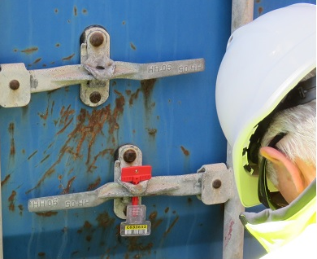

* 1. When the IIGB observed the stores loading procedure at Brisbane cruise wharf, only FCL containers were unloaded for transhipment to the departing cruise vessel. The attending biosecurity officer had access to printed quarantine directions that included container numbers and container seal numbers. The officer also had access, on request, to the paperwork used to assess the goods for transhipment. This paperwork was provided by the customs brokerage representative present at the time of unpacking and transhipment.
  2. The environment in which transhipment occurs is secure, with the unloading area being within a security-controlled wharf zone. Access to the area is via gates or doors guarded by security officers and access is limited to persons requiring access to the area. Most people in this area hold a maritime security ID card. Other visitors must be escorted by a cardholder. The general wharf area is surrounded by a security fence that prevents public access.
  3. Security of transhipped stores between arrival in Australia and loading for export at a wharf relies on the goods being stored at a Customs 77G depot. A 77G depot licence holder is responsible for the physical security of the goods. Members of the public do not have access to goods storage areas, and suitable security structures such as fencing, secure doors and guards are in place.
  4. The security measures appear to limit opportunities for goods to be removed or diverted from the transhipment pathway. Most transhipped goods are transported in sealed FCL containers and the contents of these containers are inspected by biosecurity officers and vessel staff. Vessel owners rely on receiving a full complement of stores. This is a strong incentive to ensure that all stores are loaded as planned and none are damaged or stolen. It is likely that any illegal diversion of transhipped goods would be discovered, given the security measures required for each shipment and the level of inspection applied to goods at the time of unpacking and loading. Since the implementation of transhipment import conditions in 2008, neither the department nor industry have reported any incidents of diversion or missing material. The current security measures appear to be appropriate for managing the risk of goods being diverted from the transhipment pathway.

### Waste management

* 1. The IIGB observed on-board waste management processes on a cruise vessel. Significant effort was put into waste management on this vessel. Much of the effort is in response to environmental concerns and cost incentives for the cruise company. Waste was separated into multiple streams to aid recycling. The IIGB observed separation of waste into:
* food waste (Figure 4)
* plastics
* metals (ferrous and non-ferrous) (Figure 5)
* glass (clear and coloured) (Figure 6)
* clothing/fabric
* technology (mobile phones, computing and electronics)
* chemicals
* timber (Figure 7)

Figure 4 Separated food waste for disposal

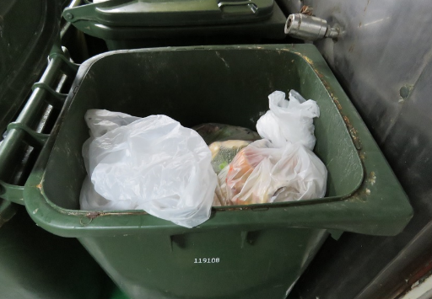

Figure 5 Compacted non-ferrous cans for recycling

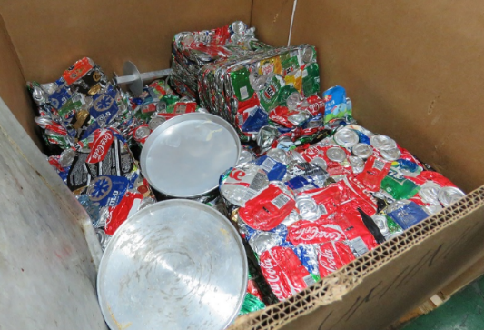

Figure 6 Bulk bags of glass for recycling

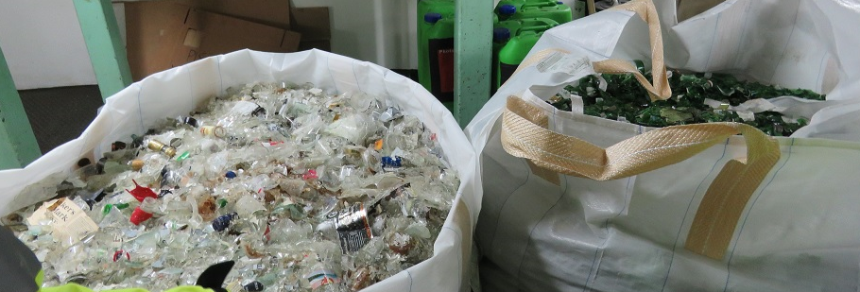

Figure 7 Stacked timber pallets for recycling

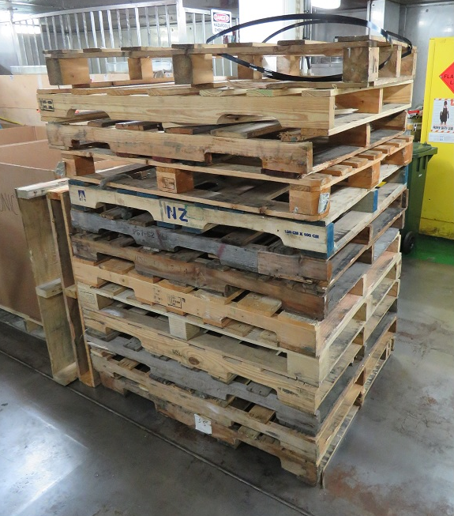

* 1. The food waste and timber waste streams are the primary waste streams of biosecurity concern. It is possible for biosecurity materials to be found in other waste streams. Where this occurs the materials are identified and removed prior to the waste leaving the vessel. For example, the IIGB observed three small pieces of food removed from the recycled glass waste stream. The glass is crushed and raked to ensure that these materials are identified and removed. Similar processes are used for other waste streams. The amount of biosecurity material likely to remain in a waste stream under these processes appears to be negligible, with any residual risk addressed by processing of the waste after offloading.
  2. Waste management in the passenger and deck areas also appeared to be generally well managed. Food waste was regularly collected and separated into suitable waste receptacles before being collected and put into the waste management stream. Cutlery and crockery collection areas in dining venues had separate bins for food waste that were clearly labelled.
  3. The level of overall cleanliness in passenger and deck areas would appear to limit the possibility of food material being accessed by scavenging birds or rodents. The IIGB observed one small tub of mixed food waste (Figure 8) in a partially covered deck area. The tub was quickly removed by staff.

Figure 8 Food scraps collected in deck dining area

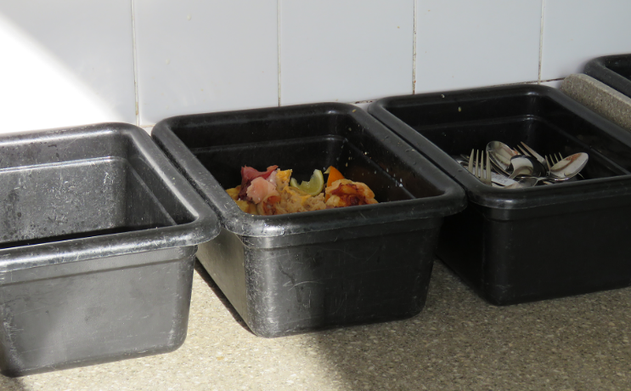

* 1. Under an agreement with the department, cruise vessel companies provide all food in a form that is not conducive to easy removal from the vessel. For example, to help minimise the risk of food being removed from the vessel by departing passengers, all fruit is presented sliced rather than as whole pieces. This preparation is verified by biosecurity officers who inspect vessels as part of the port clearance process.
  2. Disposal of waste on a cruise vessel usually consists of either disposal overboard or off‑loading in port.
  3. Destruction of waste usually occurs via on-board incinerators, which reduce materials to fine ash. Incinerators are usually used to destroy combustible material such as paper and cardboard (Figure 9). The solid ash residue generated by the incinerator accumulates over time and is off-loaded into port waste handling facilities. Ash is not considered of biosecurity concern and may be entered directly into normal municipal waste handling processes.

Figure 9 Cardboard being fed into on-board incinerator

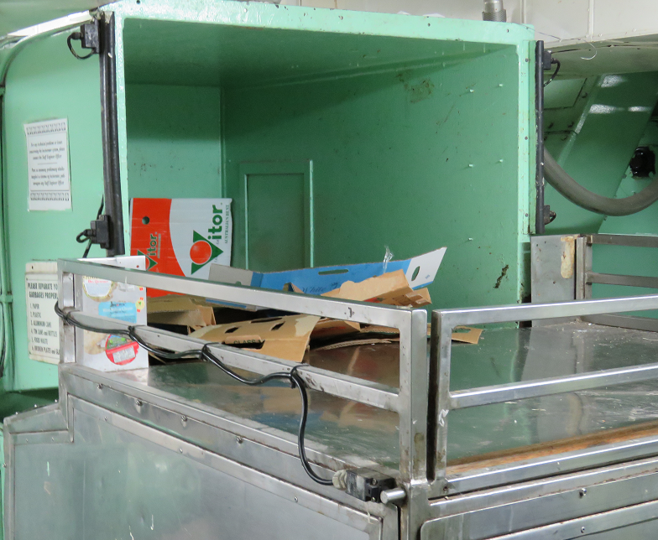

* 1. Disposal of waste overboard is regulated by the international MARPOL Annex V obligations. Annex V allows only food, grey water and general residues (for example, deck wash water) to be intentionally discharged at sea in non-emergency situations. Any discharges of food materials must occur more than three nautical miles from land if the material is ground to less than 25 millimetres in diameter, or at least 12 nautical miles from land if not ground up. Because of these distance requirements, most discharges occur while the vessel is underway. Underway discharge contributes to faster dilution of material in the environment because the discharge is spread over a wider area.
  2. Disposal of non-aquatic origin food waste into a marine environment is unlikely to pose a biosecurity risk because the particle sizes are small, dilution is fast and organisms liable to be infected are not present in that environment. Disposal of material derived from aquatic organisms (fish, prawns or shellfish) may be of a higher risk than non-aquatic origin material because of the potential for contact with viable hosts. But the overall risk is considered to be low.
  3. Industry representatives suggested to the IIGB that prawns might pose a risk if disposed of in the marine environment. Prawns provide a good example of the relative risk associated with disposal of aquatic material in a marine environment. The Generic Import Risk Analysis for Prawns and Prawn Products (Biosecurity Australia 2009) states:

Waste from imported prawns could be discarded as food scraps directly into the aquatic environment. Susceptible prawns or other crustaceans would be unlikely to become infected in this way because such scraps would not be expected to contain pathogenic agents in infective form or in high concentrations (as most would be cooked). Moreover, discarded scraps would more likely be consumed by non-susceptible than susceptible species.

* 1. During on-board fieldwork, the IIGB observed the process for sealing the grinders and machinery used for overboard disposal (Figure 10 and Figure 11). As part of the routine vessel inspection undertaken when a vessel enters port, a biosecurity officer seals the grinders and machinery with numbered seals and records the numbers. These seals prevent overboard discharge while in port. The cruise vessel is also provided with a quarantine direction stipulating under what circumstances the seals may be removed. It is noted that, following the March 2016 changes to RVI procedures, this process is no longer required.

Figure 10 Seal being applied to food grinder chute

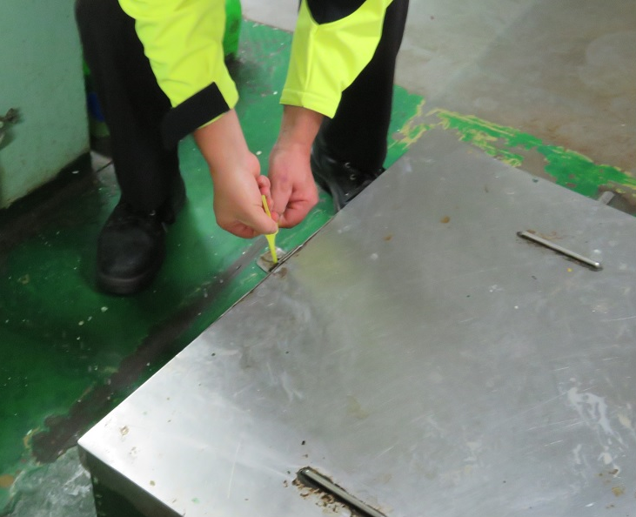

Figure 11 Seal being applied to overboard disposal valve of food grinder

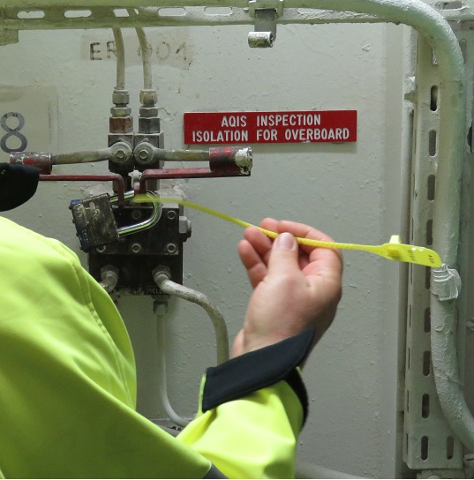

* 1. In port, offloading of waste occurs for those materials that either cannot be disposed of at sea or have some monetary value when recycled. Many of these products are not of biosecurity concern because the material type does not pose a risk or any risks will be removed during the recycling process. Off-loaded materials that are not of biosecurity concern include incinerator ash and recyclables such as clothing, glass, metals and electronic items. Any materials of biosecurity concern are managed separately by a waste process provider operating under an approved arrangement with the department.
  2. The IIGB audited vessel waste management in 2009 and found that collection and transport procedures provided adequate security for biosecurity waste. The IIGB did not conduct a full assessment of waste disposal procedures for this review of transhipped goods. However, the handling of biosecurity waste observed during this review did not raise any concerns.

1. Conclusion
   1. The primary risk associated with transhipped goods is the potential that hosts and/or growth niches in Australia will be exposed to biosecurity risk materials. Exposure could occur through intentional illegal diversion for use in Australia or accidental introduction resulting from damage to goods during transport and storage. Transhipped goods are intended to be exported from Australia, so current biosecurity conditions focus on preventing environmental exposure.
   2. Current import conditions appear to be appropriate for managing the biosecurity risks associated with transhipped goods. These conditions provide negligible opportunity for the diversion of goods. If diversion occurred, the verification and inspection procedures required by the import conditions should ensure that the diversion would be identified promptly and an investigation undertaken.
   3. Goods being transhipped for cruise vessels are predominately shipped in sealed FCL containers. This contributes to the high level of risk management that is achieved by current import conditions.
   4. Disposal of waste from a vessel while in port has long been recognised as a possible pathway for biosecurity risk material to be released into the Australian environment. For many years, the department has imposed controls to regulate removal of biosecurity risk materials from a vessel. Any waste materials that may pose a biosecurity risk are removed from the vessel, either under the supervision of a biosecurity officer or by a company acting under an approved arrangement with the department.
   5. Disposal of waste at sea is regulated under the Protection of the Sea (Prevention of Pollution from Ships) Act 1983*,* which gives effect to the [International Convention for the Prevention of Pollution from Ships](http://www.imo.org/en/About/Conventions/listofconventions/pages/international-convention-for-the-prevention-of-pollution-from-ships-(marpol).aspx) (MARPOL). Annex V of MARPOL regulates how food materials, the largest source of biosecurity material on a cruise vessel, may be disposed of at sea. The requirements of Annex V are sufficient to address the potential risks associated with disposal of biosecurity material at sea because these materials may only be disposed away from land and are quickly dispersed to levels unlikely to pose a biosecurity risk.
   6. The department appears to be satisfactorily managing the biosecurity risks associated with transhipped stores. However, the IIGB notes that Australian industry stakeholders continue to be concerned about the perceived biosecurity risks. In light of these concerns, it is desirable that the department keeps the consultation process under review, and actively explores ways in which it might be improved. Improved communication should be more achievable once the *Biosecurity Act* *2015* comes into force in June 2016.

Dr Michael Bond  
Interim Inspector-General of Biosecurity

April 2016

## Appendix A: Processing transhipped ships stores for cruise and commercial vessels

Figure A1 Processing transhipped ships stores for cruise and commercial vessels, Australia

Transhipped ships stores are profiled in the ICS system by a word matching. If a profile is successfully matched then the consignment is held in the ICS system. 
The hold in the ICS system is removed by a biosecurity officer once they have assessed shipping manifests to identify if any biosecurity risk material is present in the consignment.

Category 1 goods may be released without further bisoecurity intervention.
Category 2 goods may either be inspected to verify freefom from biosecurity risk or they can be held in their original shipping container and unpacked direct on to the departing vessel. If a biosecurity risk is identified during inspection the good must either be treated, exported (not as ship stores) or destroyed.
Category 3 goods must be held seals intact and be exported as ships stores under the supervision of a biosecurity officer.

77G warehouse or depot licenced to hold or pack cargo under customs control. CTO Cargo terminal operator. ICS Integrated Cargo System, managed by the Australian Customs and Border Protection Service.

## Appendix B: Agency response

Figure B1

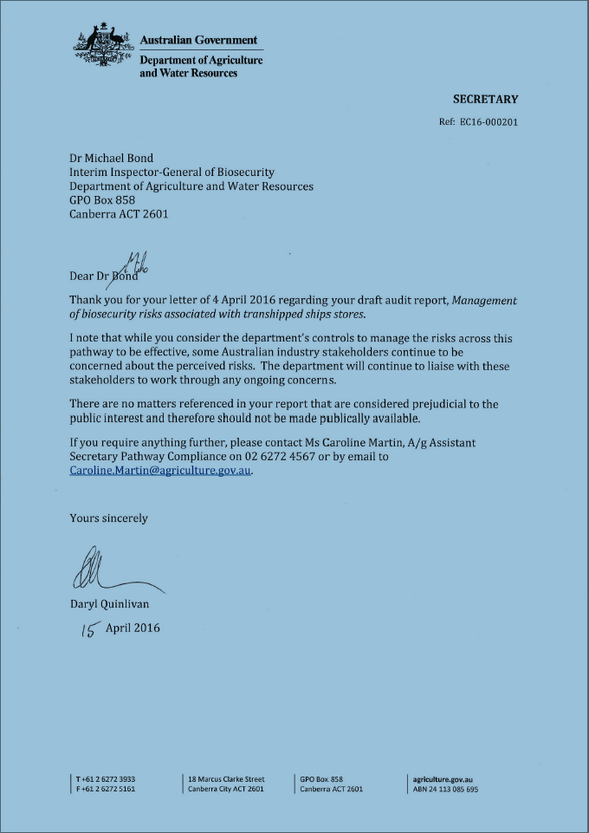

## Glossary

| Term | **Definition** |
| --- | --- |
| 77G depot | a warehouse or depot licenced under section 77(g) of the *Customs Act 1901* to hold or pack cargo under customs control |
| AIMS | Agriculture Import Management System used by the Department of Agriculture and Water Resources to store records of imported cargo assessed |
| FCL | Full container load of one consignment from a single supplier or for a single importer |
| ICS | Integrated Cargo System, managed by the Australian Customs and Border Protection Service |
| QAP | Quarantine approved premises |

## References

Biosecurity Australia 2009, Generic import risk analysis report for prawns and prawn products, Canberra, available at [agriculture.gov.au/biosecurity/risk-analysis/ira/final-animal/prawns](http://www.agriculture.gov.au/biosecurity/risk-analysis/ira/final-animal/prawns).

Department of Agriculture 2016a *Biosecurity Waste Management Business Policy* Canberra, available agriculture.gov.au/import/arrival/arrangements/biosecurity-waste/biosecurity-waste-management

Department of Agriculture 2016b [*Biosecurity Import Risk Analysis Guidelines 2015*](http://www.agriculture.gov.au/biosecurity/legislation/new-biosecurity-legislation/draft-regulations/bira) Canberra, available agriculture.gov.au/biosecurity/legislation/new-biosecurity-legislation/draft-regulations/bira

Department of Immigration and Border Protection 2016, *Export control* *manual,* vol. 12, Australian Customs and Border Protection Service, Canberra, available at [border.gov.au/Busi/Expo](https://www.border.gov.au/Busi/Expo).